Empowering Students www.freekcsepastpapers.com

END OF TERM TWO EXAM
FORM 3 BIOLOGY P3
231/3
NAME…………………………………………………………………..ADM NO…………CLASS…….
- You are provided with: -
- Soaked maize grains
- A piece of liver
Using pestle and mortar, grind maize grains into a soft pulp. Add 10ml of distilled water. Mix thoroughly then filter into a test tube and label it A. Repeat the procedure for a piece of liver and put the filtrate into test tubelabelled B.
Follow the procedure and complete table 1 below.
a) (i) Table 1 (2 mks)
Observation
Add 2ml of hydrogen peroxide into 1ml of filtrate A
Add 2ml of hydrogen peroxide into 1ml of filtrate B

(ii) Comment on your results (4 mks)

……………………………………………………………………………………………………………………………………………………………………………………………………………………………………………………………………………………………………………………………………………………………………………………………………………………………………………………………………………………………………………
……………………………………………………………………………………………………………………………………………………………………………………………………………………………………………………………………………………………………………………………………………………………………………………………………………………………………………………………………………………………………………

b) Using the reagents provided, test for the food substance in the remaining filtrate A. (6mks)
Food tested | Procedure | Observation | Conclusion

State the importance of carbohydrates in the human body (1mk)

………………………………………………………………………………………………………………………………………………………………………………………………………………………………………………………………………………………………………………………

- Study the diagrams of fruits below
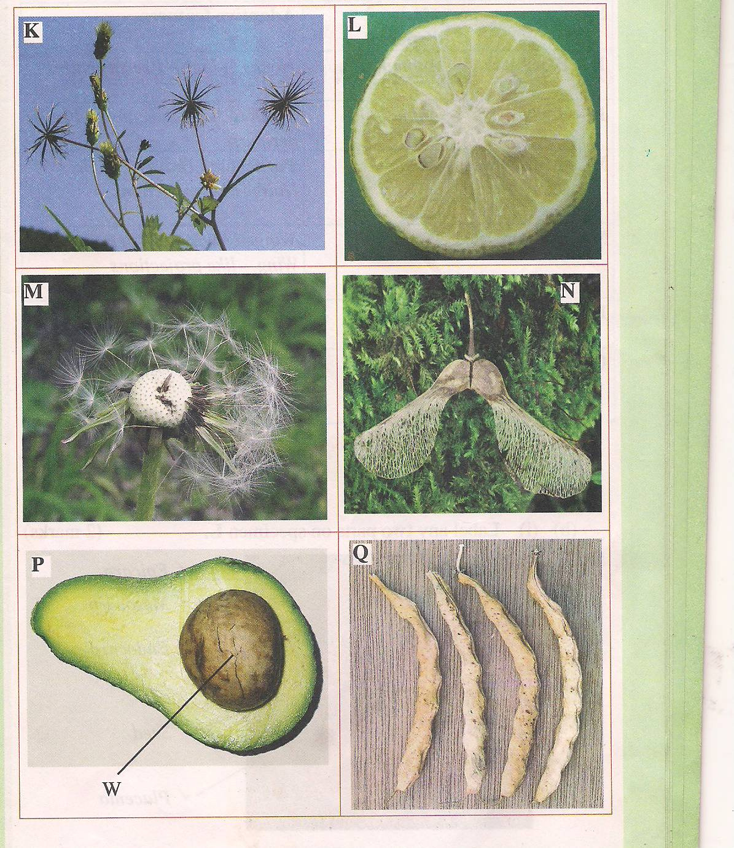

a) Name the type of fruit shown by P and Q (2mks)
………………………………………………………………………………………………………………………………………………………………………………………………………………………………………………………………………………………………………………………
b) State the type of dispersion used by fruit M, K and N. Give adaptation for each of them (6mks)

………………………………………………………………………………………………………………………………………………………………………………………………………………………………………………………………………………………………………………………………………………………………………………………………………………………………………………………………………………………………………………………………………………………………………………………………………………………………………………………………………………………………………………………………………………………………………………………………………………………………………………………………………………………………………………………………………………………………………………………………………………………………………………………………………………

d) State the type of placentation shown by diagram Q and L (2mk)
………………………………………………………………………………………………………………………………………………………………………………………………………………………………………………………………………………………………………………………………………………………………………………………………………………………………………………………………………………………………………………………………………
e) State the significance of fruit and seed dispersal (1mk)
………………………………………………………………………………………………………………………………………………………………………………………………………………
f) Describe the main differences between entomophilous flowers and anemophilous flowers (3mk)
………………………………………………………………………………………………………………………………………………………………………………………………………………………………………………………………………………………………………………………………………………………………………………………………………………………………………………………………………………………………………………………………………………………………………………………………………………………………………………………………………………………………………………………………………………………………………………………………………………………………………………………………………………………………………………………………………………………………………………………………………………………………………………………………………………

- 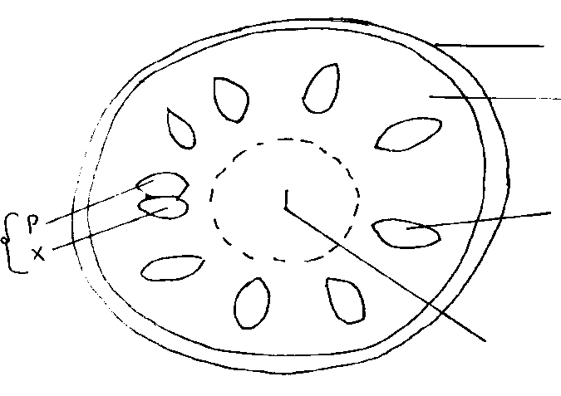The diagram below shows a photomicrograph of a transverse section of a young cowpea stem.
K
Z
M
L
Q

- Name the structures labelled K, L and Q. (3 mks)
K……………………………………………………………
L…………………………………………………………….
Q…………………………………………………………………..
- State the functions of the parts labelled Z and M. (2 mks)
Z…………………………………………………………………..
M……………………………………………………………………
- The magnification of the photomicrograph is X50. Determine the actual diameter of the section in micrometers. (Show your working) (3 mks)

- a) State how the functioning of the phloem tissue is affected if the companion cell is destroyed. (1mk)
……………………………………………………………………………………………………………………………………………………………………………………
b) Give a reason for your answer in iv (a) above. (2mk)
………………………………………………………………………………………………………………………………………………………………………………
………………………………………………………………………………………
- In what ways is the drooping of leaves observed on hot days advantageous to the plant? (2mks)
………………………………………………………………………………………………………………………………………………………………………………

