Empowering Students www.freekcsepastpapers.com

CHEMISTRY
FORM 1 TERM 2
NAME………………………………………………………..SCHOOL…………………………………..ADM NO…………….
- In an experiment to separate a mixture Q of two miscible liquids. Liquids N (B.p 56$°C$) and liquids m (b.p 118$°C$)a student set up the apparatus as shown.
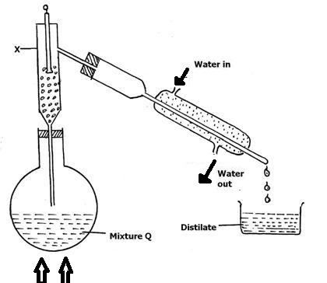
- Name x (1mk)

- What is the purpose of the thermometer?(1mk)

- Identify two mistakes in the set up(2mk)

- Which liquid was collected in the beaker?(1mk)

- What method would the student use to test the purity of the distillates obtained(1mk)

2. The table below shows the values of solution i,ii,iii, and iv
Solution | i | ii | iii | iv
PH | 2 | 7 | 11 | 14

- Which solution is likely to be that of calcium hydroxide?(1mk)

- Select a solution that has no effects on blue litmus(1mk)

- Select the solution in which a sample of sodium oxide is likely to dissolve. Give a reason for your answer(2mks)

3. Brine is made by mixing water and common salt. Give the names of the following
- The solute(1mk)

- The solvent(1mk)
- The solution(1mk)
4. Define the following terms
- Atom(1mk)

- Molecules(1mk)

- Complete the table below(4mk)

English name | Latin name | symbol
Sodium
 | argentum
 |  | copper
gold

5. The table below shows the melting and boiling points of some pure substances at atmospheric pressure. Study it and answer the questions that follow
substance | Melting point($°C$) | Boiling point($°C$)
oxygen | -219 | -183
water | 0 | 100
sodium | 801 | 1465
ethanol | -117 | 78
sulphur | 115 | 444
copper | 1083 | 2600
propane | -183 | -42
- Which of the substance are solids at a room temperature of 22$°C$ (1mk)
- Which of the substance are liquids at a temperature of -100 $°C$(1mk)
- A Sample of water was found to boil at 102$°C$ at atmospheric pressure. What can you say about the water(1mk)

- In what physical state as copper at 1700$°C$(1mk)
- Which of the substance are gases at 150$°C$ (1mk)
6. State any two differences between luminous and non-luminous flames (2 mks)

7. (a)Whatis meant by neutralization (1 mks)

(b)Complete word equation below (2mks)
Sodium + hydrochloric
Hydroxide acid

Copper (ii) + sulphuric
Oxide acid

(c)Using the PH distinguish between a strong and a weak base give two example of each.( 4 mks)

8. a)What method can be used to separate a mixture of ethanol andwater?(1mk)
- i)Explain how a solid mixture of sulphur and sodium chloride can be separated into solid sulphur and solid sodium chloride (3mks)

ii)How can one determine if the solid sulphur is pure?(1mk)

9. The diagram below shows the heating curve of a pure substance. Study it and answer the question that follows

D Z E
444$°C$ -----------------------------------------------------
B X C
115$°C$------------
W
A

(a)What physical changes are taking place at point
X……………………………………………………………………………………………… (1 mks)
Z…………………………………………………………………………………………… (1 mks)
(b) Whatis the physical status of the substance at points?
W………………………………………………………………………………………. (1 mks)
Y………………………………………………………………………………………. (1 mks)
(c) What happens to the temperature between point A and C (2 mks)

(d)Using the simple kinetic theory of matter, explain what happens to the substances between
A-B (2 MKS)

B-C (2 MKS)

(e)The substance under test is definitely not water. Give a reason for your answer (2 mks)

(f)What would happen to the melting point of this substance if it were contaminated with sodium chloride (1 mks)

10. (a)Complete the table below to show the color of the given indicator in acidic and basic solution (2 mks)
indicator | Colour in
 | Acidic solution | Basic solution
Methyl orange |  | yellow
phenolphthalein | colourless

(b)State three uses of bases (3 mks)

11. The diagram below shows a Bunsen burner when in use

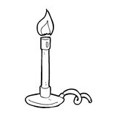
D
C
Name the regions labeled C and D(2mks)
C
D
12. A mixture of paraffin and distilled water was shaken and lot to separate as shown in the diagram below
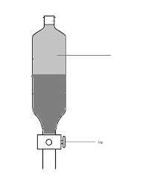
Layer W
(a)Name the main components in layer W (1 MK)

(b)Give a reason for (a) above (1 mk)

13. The diagram shows the physical state of matter. Study it and answer the question that follows
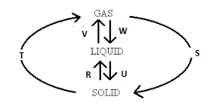
- Identify the processes formats
R
V
W
U
- Name two substances which can undergo the process represented by S and T (1 mks)

14. Give two advantages of carrying out experiment in apparatus made of glass (2 mks)

15 draw the diagram of a pipette and state one reason for its suitability in its use (2mks)
Draw suitability

16. State 3 differences between a temporary change and a permanent change (3mks)
Temporary | permanent
17 samples of urine from three participants F, G and H at an international sports meeting were spotted onto a chromatography paper alongside two illegal drugs A1 and A2 . A chromatograph was run using methanol. The figure below shows the chromatograph.
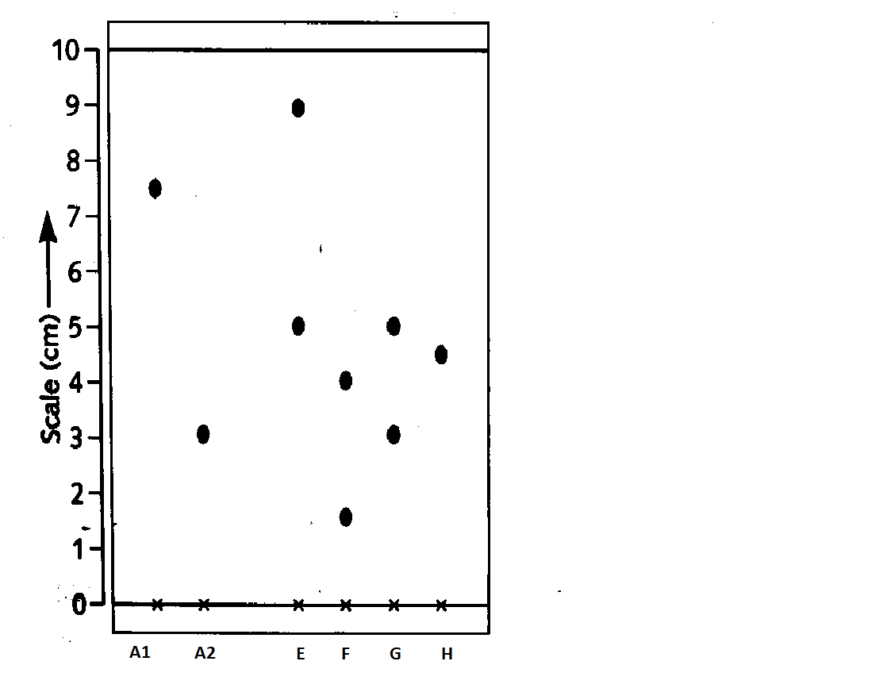

- Identify the athlete who used an illegal drug (1 mk)

- Which drug is soluble in methanol (1 mk)

18 a) describe how coconut oil can be obtained from coconut in the laboratory. (3 mks)

b) State one practical application of the process in a) above (1mk)

