Empowering Students www.freekcsepastpapers.com

COMPUTER STUDIES
Form 2 Paper 1
THEORY
July/August
2 ½ Hours
Name……………………………………………………………………………..School……………………………………………………… ADM No……………... Class……………………………………………………………. Date …………………………………
INSTRUCTIONS TO CANDIDATES
- Write your Name and Adm Number in the spaces provided above.
- This paper consists of TWO sections: A and B
- Answer ALL questions in section A
- Answer question 16 and one other from section B
- All answers should be written in the spaces provided in the question paper

For Examiner’s use only.
Section | Question | Candidate’s Score
A | 1 – 15
B | 16
 | 17
 | 18
 | Total Score

This paper consists of 9 Printed pages.
Candidates should check the question paper to ensure that all the
Papers are printed as indicated and no questions are missing

SECTION A (40 marks)
Answer all the questions in this section.
- (a) What is meant by the term suite as used in application programs. (1mk)
…………………………………………………………………………………………………………………………………………………………………………………………………………………………………………………………………………………………………………………………………….
(b) List two programs under the ms office suite. (1mk)
…………………………………………………………………………………………………………………………………………………………………………………………………………………………………………………………………………………………………………………………………….
- Write the following statement “mock examinations” in (2mks)
i. Title case………………………………………………………………………………
ii. Toggle case……………………………………………………………………………

- a) What is a hard copy (lmks)
…………………………………………………………………………………………………………………………………………………………………………………………………………………………………………………………………………………………………………………………………..
b) State two reasons why hardcopy output is still very necessary today (lmk)
……………………………………………………………………………………………………………………………………………………………………………………………………………………………………………………………………………………………………………………………………
- Define the following terms (2mks)
a) Digital data………………………………………………………………………………………………………………………………………… …………………………………………………………………………….…………………………………………………………………………………b) Analogue data……………………………………………………………………………………………………………………………………… ……… ………………………………………………………………………………………………………………………………………………..

- Define the following terms as pertaining computer software (3mks)
a) User friendliness…………………………………………………………………………………………………………………………… ………………… ………………………………………………………………………………………………………………………………………
b) Portability……………………………………………………………………………………………………………………………………… …………………………………………………………………………………………………………………………………………………………
c) Compatibility……………………………………………………………………………………………………………………… …… …………………………………………………………………………………………………………………………………………………………
- Explain the importance of the following: (2mks)
a) Disk defragmentation………………………………………………………………………………………………………… …………….. ……………………………………………………………………………………………………………………………………………………………….
b) Disk compression………………………………………………………………………………………………………………………………. ………………………………………………………………………………………………………………………………………………………………
- Name and explain the two types of primary memory. (3mks)
…………………………………………………………………………………………………………………………………………………………………………………………………………………………………………………………………………………………………………………………………
- Outline two advantages of hard disk over floppy disk. (2mks)
…………………………………………………………………………………………………………………………………………………………………………………………………………………………………………………………………………………………………………………………………………………………………………………………………………………………...……………………………………………………
- State one function of each of the following terms (3mks)
- Buffer………………………………………………………………………………………………………………………………………………………………………………………………………………………………...…………………………………………………………………………..
- An accumulator……………………………………………………………………………………………………………………………… …………………………………………………………………………………………………….…………………………………………………
- Cache memory...................................................................................................................................... ..................................................................................................................................................................
- What is the meaning of the following as used in word-processing: (2mks)
i) Word wrap………………………………………………………………………………………………………………………………………… ………………………………………………………………………………………………………………………………………………………………
ii) Drop caps…………………………………………………………………………………………………………………………………………….. ………………………………………………………………………………………………………………………………………………………………
- a) State two ways of minimizing dust in the computer laboratory. (2mks)
…………………………………………………………………………………………………………………………………………………………………………………………………………………………………………………………………………………………………………………………………
(b) Why should one switch on the ups before switching on the system unit and the monitor. (1mk)
…………………………………………………………………………………………………………………………………………………………………………………………………………………………………………………………………………………………………………………………………
- State the functions of the following keys in a computer key board
- Insert (1mk)
……………………………………………………………………………………………………………………………………………………………………………………………………………………………………………………………………………………………………………………………………
- Num lock key (1mk)
…………………………………………………………………………………………………………………………………………………………………………………………………………………………………………………………………………………………………………………………………
- Explain the three parts of a task bar. (3mks)
……………………………………………………………………………………………………………………………………………………………… ………………………………………………………………………………………………………………………………………………………………………… ……………………………………………………………………………………………………………………………………… ………… …………………………………………………………………………………………………………………………………………………………………
b)List FOUR factors to consider when purchasing an operating system (2mks)
…………………………………………………………………………………………………………………………………………………………
…………………………………………………………………………………..………………………………………………………………………
…………………………………………………………………………………………………………………………………………………………
- What is the importance of a file extension? (1mk)
…………………………………………………………………………………………………………………………………………………………………………………………………………………………………………………………………………………………………………
e) Distinguish between a folder and a subfolder. (1mk)
…………………………………………………………………………………………………………………………………………………………
…………………………………………………………………………………..……………………………………………………………………

- Distinguish between special and embedded computers (2mks)
…………………………………………………………………………………………………… ……………………………… ………… ……………………………………………………………………………………………………………………………………………………
…………………………………………………………………………………………………… ……………………………… ………… ……………………………………………………………………………………………………………………………………………………
SECTION B (60 marks)
Answer questions 16 and any other question from this section.
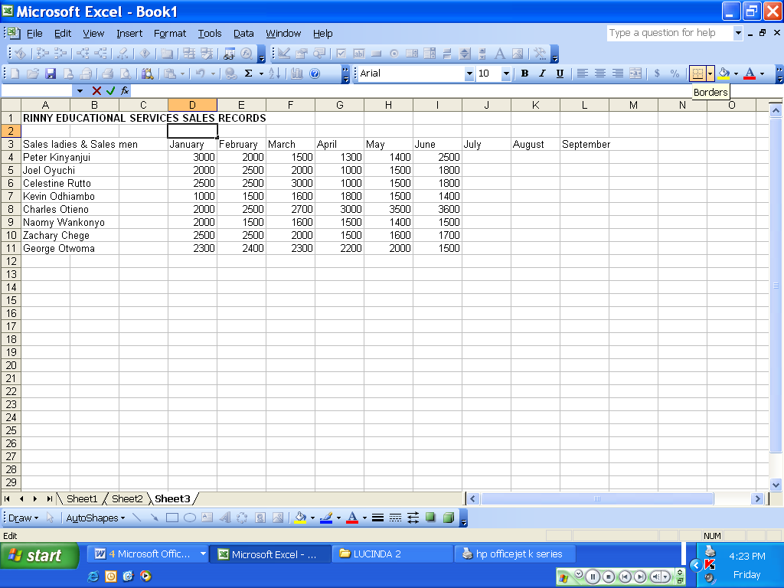
vi
i
ii
iii
v
iv
- The above is a diagram of a spreadsheet program. Use it to answer the following questions
- Appropriately label the parts labeled I,ii,iii,iv,v (5mks)
- …………………………………………………………………………………………………………………………………………………
- …………………………………………………………………………………………………………………………………………………
- …………………………………………………………………………………………………………………………………………………
- …………………………………………………………………………………………………………………………………………………
- …………………………………………………………………………………………………………………………………………………

- Name the function of the part labledI,ii,iii (3mks)
- ………………………………………………………………………………………………………………………………………………………………………………………………………………………………………………………………………………………………………..
- …………………………………………………………………………………………………………………………………………………………………………………………………………………………………………………………………………………………………………..
- …………………………………………………………………………………………………………………………………………………………………………………………………………………………………………………………………………………………………………
- Name THREE examples of spreadsheet application programs (3mks)
- ……………………………………………………………………………………………………………………………………………
- ………………………………………………………………………………………………………………………………………………………………………………………………………………………………………………………………………………….
- …………………………………………………………………………………………………………………………………………………………………………………………………………………………………………………………………………………………
- State and explain any FOURapplication areas of spread sheets (5mks)
- ……………………………………………………………………………………………………………………………………………
- ………………………………………………………………………………………………………………………………………………………………………………………………………………………………………………………………………………….
- …………………………………………………………………………………………………………………………………………………………………………………………………………………………………………………………………………………………
- ………………………………………………………………………………………………………………………………………………………………………………………………………………………………………………………………………………………

- a) Describe any three mouse techniques/skills. (3mks)
………………………………………………………………………………………………………………………………………………………………………………………………………………………………………………………………………………………………………………………………………………………………………………………………………………………………………………………………………………………………………
b) List four key groupings on a computer keyboard citing two examples in each. (4mks)
………………………………………………………………………………………………………………………………………………………………
…………………………………………………………………………………………………………………………………………………………………
…………………………………………………………………………………………………………………………………………………………………
…………………………………………………………………………………………………………………………………………………………………

c) Name and explain the function of the following key symbols.
i) (2mks)

ii) (2mks)

iii) (2mks)
iv) Esc (2mks)

- Study the following diagram and answer the questions that follow
20GB Hard disk
Floppy drive
CD drive
Printer
Mouse
Speaker
Monitor

CPU
128MB RAM
32MB ROM
Scanner

- Name two devices that are used for long term storage (2mks)
…………………………………………………………………………………..………………………………………………………………………………………………………………………………………………………………………………………………………………………

- Name three peripheral devices shown in the diagram that are used for input (3mks)
…………………………………………………………………………………..………………………………………………………………………………………………………………………………………………………………………………………………………………………
…………………………………………………………………………………………………………………………………………
- Name the input device that is not shown in the diagram above that the school secretary would require…………………………………………………………………………………..……………………………………… (1mk)
- Name the TWO categories that monitors classified (2mks)
…………………………………………………………………………………..………………………………………………………………………………………………………………………………………………………………………………………………………………………
…………………………………………………………………………………………………………………………………………
- Highlight FOUR advantages of non-impact printers over impact printers (4mks)
- …………………………………………………………………………………………………………………………………………………………………………………………………………………………………………………………………………………………………………
- ………………………………………………………………………………………………………………………………………………………………………………………………………………………………………………………………………………………………………….
- …………………………………………………………………………………………………………………………………………………………………………………………………………………………………………………………………………………………………………..
- ………………………………………………………………………………………………………………………………………………………………………………………………………………………………………………………………………………………………………
- a)Msambweni auto mechanics intends to purchase an output device to produce their engineering drawings. Which device would you advice them to purchase……………………….(2mks)
b) Name the two types available of the above mentioned device (1mk)
………………………………………………………………………………………………………………………………………………………………………………………………………………………………………………………………………………………………………

