Empowering Students www.freekcsepastpapers.com

END OF TERM II JOINT EXAM JULY
PHYSICS FORM 1 TIME 2 HRS
NAME……… ………………………...…………………....ADM NO:…………CLASS………
INSTRUCTIONS:
Answer all questions below in the spaces provided under each question
- A science laboratory can be a dangerous place if students do not take certain precautions while doing their practical work. Outline any 4 basic laboratory rules that a student should observe (4marks)

Use the information below to answer question 2 and 3
In an experiment to determine the density of a liquid, the following readings were made.
Mass of empty density bottle = 20g
Mass of bottle filled with water = 70g
Mass of bottle filled with a liquid = 695g
2. Find the density of the liquid, given that density of water is 1000kgmˉ³. (3mks)

3. Find the volume of the liquid. (3mks)

4. State two precautions to be observed when using a relative density bottle (2marks)

5. Jane carried out an experiment to estimate the height of a tree. The following measurements were recorded.
Height of the rod = 180cm.
Length of the shadow of the rod = 116cm
Length of the shadow of the tree = 840cm
Using this information, calculate the height of the tree. (3 marks)

- Define mass and state its S.I unit (2marks)

- An irregular shaped stone of mass 60g was completely immersed in a liquid. The levels of the liquid are shown in the figures below.
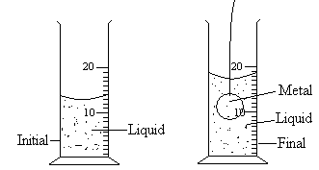

Determine the density of the stone in SI units. (3 marks)

- A butcher has a beam balance and masses of 0.6kg and 2.5kg. How would he measure 1.9kg of meat on the balance at once? (2marks)

- State 5effects of force on a body (5 marks)

- Define the term force and state its SI unit (2marks)

- Name two forces that act between bodies that are not in contact (2marks)

- The diagram below shows a mass of 12g hanged on a set of 6 identical springs. When a mass of 12g was hanged on spring A alone, its extension was 5cm. Find the extension of the combination shown if each spring and each rod has negligible mass (4 marks)
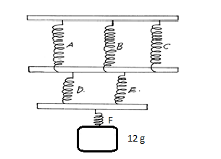

- Give a reason why the weight of a body varies from place to place (2marks)

- Explain why the bristles of a paint brush cling together when removed from water in a bucket (2marks)

15. A girl placed a 5kg television set on a spring balance scale. If the scale reads 778.4kg. What is the acceleration due to gravity at that location (3marks)

16. Figure 2 shows drops of mercury and water on a clean glass surface.
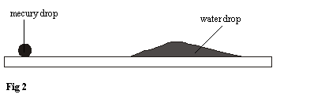
Explain the difference in the shape of the drops (2marks)

17. Differentiate between a scalar and a vector quantity giving an example in each case (2marks)

18. Define pressure and state its SI units (2marks)

19. Hydraulic machines use liquids and not gases for the transmission of pressure. Why are gases unsuitable for use in these machines? (1 mark)

20. the diagram below shows a concrete block of mass 50kg.
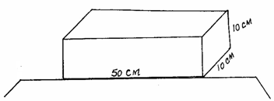

What is the maximum pressure that can be exerted on the bench by the block? (3 marks)

21. Explain why it is easier to cut through a log of wood with a sharp panga than a blunt one (1mark)

22. Figure 1 below shows a U-tube containing oil of light density in equilibrium.
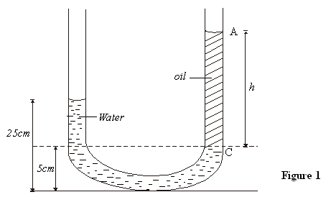
Determine the height h of the oil column AC (density of oil is 600kg/m3 ,density of water is 1000kg/m³) (3marks)

Use the information below which represents hydraulic braking system to answer question 23.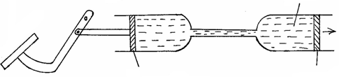
Fluid
Force
produced
Slave piston
Master piston
Pivot
Brake pedal

.23. Explain briefly how the system operates. (3marks)

24 state three factors affecting pressure exerted by a fluid (3marks)

25. (a) Give a reason why water is not suitable as a barometric liquid. (2marks)

(b)Explain why a lift pump is unable to raise water from a borehole where the level of water is 20m below the ground level. (1 mark

26. State one application of a siphon (1 mark)

27. A hole of area 4.0cm²at the bottom of a tank 5.0 m deep is closed with a cork. Determine the force on the cork when the tank is filled with water (density of water = 1000kg/m³ ) (3 marks)

28. The set-up shown in figure 1 below is used to investigate the rate of diffusion of two gases. B and C are cotton wools soaked in hydrochloric acid and ammonia solution respectively.

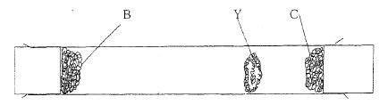
A white deposit Y is formed between B and C. Compare the diffusions of the two gases. (2marks)

29 Explain the following
- When water is added to the brim in a flaskcontaining100g of salt, the final volume of the solution is not as expected. (2 marks)

- One glass of milk makes 20litres of water to become milky. (2marks)

30. Dust particles in still air move randomly. Name the phenomenon and explain its cause. (2 marks)

31. State the kinetic theory of matter (1 mark)

32. How does temperature affect Brownian motion (2 marks)

33. State the difference between heat and temperature (2 marks)

34. Describe briefly how the density of an irregular substance that was picked outside the physics laboratory can be determined. Use diagrams (4marks)

35. Name an instrument that can be used to measure the length of a football pitch (1 mark)

36 Differentiate between a basic physical quantity and a derived physical quantity giving an example in each case (4marks)

37. State two factors that determine the choice of measuring instrument (2 marks)
38. (i) Define time and state its SI unit. (2marks)

- Give a reason why a modern stop watch is preferred for use in measuring time (I mark)

39. give four differences between mass and weight. (4 marks)

