GATANGA SUB-COUNTY EVALUATION TESTS 2016
Kenya Certificate of Secondary Education
Biology p1, p2&p3

31/1
BIOLOGY
PAPER1 (THEORY) JULY / AUGUST 2016 TIME: 2 HOURS

- Name the organelle that would be most abundant in;
  - White blood cells (1mk)
  - Salivary glands (1mk)
- State the functions of the following apparatus;
  - Pitfall trap (1mk)
  - Bait trap (1mk)
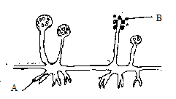
- Study the figure below and answer the questions that follows;

- Identify the kingdom to which the organism belongs to; (1mk)
- Name the structure labelled; A,B (2mks)
- State the functions of the part marked A. (3mks)
- The following process takes place in a plant organelle.
Water → Hydrogen atoms + Oxygen
  - Identify the organelle in which the process takes place. (1mk)
  - Name the process. (1mk)
  - State two conditions required for the process to take place. (2mks)
- a) What is translocation? (1mk)
b) How is the phloem adapted to carry out its functions. (3mks)
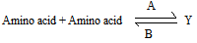
- The equation below represents a process that takes place in the body.

  - Name the product Y. (1mk)
  - Name the processes A and B. (2mks)
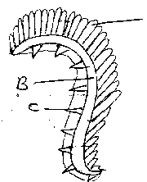
- Study the diagram below and answer the questions that follow;

- Identify the structure. (1mk)
- Name the parts labelled B and C. (2mks)
- Name a structure in insects that serves the same function as part labelled A. (1mk)
- In an experiment using germinating seeds, it was found that 18cm3 of carbon (IV) oxide was released while 17.6cm3 of oxygen was used.
- Calculate the respiratory quotient (RQ). (1mk)
- State the type of respiration occurring. (1mk)
- What is the likely respiratory substrate? (1mk)

Page | 257

Biology p1, p2&p3

- a) Nitrogen in the atmosphere cannot be directly utilized by plants. State two ways through which nitrogen is made available for plant use. (2mks)
b) State the importance of saprophytic bacteria in the environment. (2mks)
- State the functions of the following structures.
  - Epididymis (1mk)
  - Prostrate gland (1mk)
- Name the hormones that control the following activities;
- Metamorphosis in young insect. (1mk)
- Formation of abscission layer in leaves and fruits. (1mk)
- Explain the meaning of the term survival for the fittest. (2mks)
- What is the role of the following factors in breaking seed dormancy?
  - Light (1mk)
  - Water. (1mk)
- Name four mechanisms through which plants excrete. (4mks)
- What do you understand by the following terms?
  - Ecosystem (1mk)
  - Carrying capacity. (1mk)
- Name the causative agent of pneumonia. (1mk)
- a) What is oxygen debt? (2mks)
b) List down three economic importance of anaerobic respiration. (3mks)
- a) What is active transport? (1mk)
b) Outline three roles of active transport in the human body. (3mks)
- State the importance of the roughages in the diet. (1mk)
- State three functions of blood other than transport. (3mks)
- Distinguish between Diabetes Mellitus and Diabetes Insipidus. (2mks)
- What is meant by the term sex linkage? Mention two sex linked traits (3mks)
- Name two hormones involved in reproduction in females. (2mk)
- Name three tissues found in animals. (3mks)
- a) State the process that takes place during prophase 1 of meiosis. (1mk)
b) Give the significance of mitosis. (1mk)
- The developing baby in the womb is connected to the mother by an umbilical cord. Describe two functions of the umbilical cord. (2mks)
- Explain how support is attained in herbaceous plants. (2mks)
- List down two adaptations of the male parts of wind pollinated flower to their function. (2mks)
- Cell membrane is said to be semi-permeable. Explain. (2mks)
- Explain how iris regulates amount of light entering the eye in bright light. (2mks)

GATANGA SUB-COUNTY EVALUATION TESTS 2016
Kenya Certificate of Secondary Education
Biology p1, p2&p3

231/2
BIOLOGY
PAPER2 (THEORY) JULY / AUGUST 2016 TIME: 2 HOURS

- Pea seedlings were treated as follows;
Seedling A - Coleoptiles tip was cut off, metal block placed, then tip placed back. Seedling B - Coleoptiles tip was cut off, agar block placed then tip placed back. Seedling C - Was left intact.
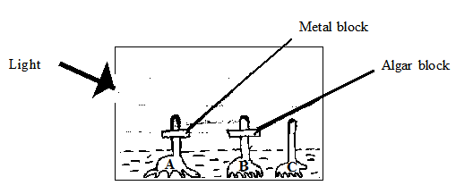
The seedlings A, B and C were placed in dark box with a small hole at one side as illustrated in the diagram below;

  - State what was being investigated in the set up above. (2mks)
  - Using diagrams illustrate how the seedlings A, B and C appear after 48 hours. (3mks)
  - Explain the results in (b) above; (3mks
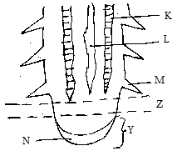
- The diagram below represents a longitudinal section of a dicotyledonous plant root tip.
  - i) Name the parts labelled; K,L and M (3mks)
ii) State the function of the part labelled N. (1mk)
  - i) Name two main supporting tissues in plants. (2mks)
ii) Give two reasons why support is necessary in plants. (2mks)
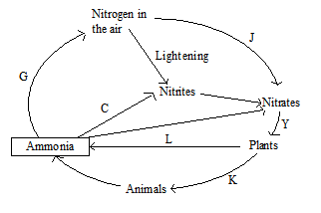
- Use the nitrogen cycle below to answer the questions that follow.

  - Name the processes represented by (3mks)
- G
- Y
- K

Biology p1, p2&p3

  - Name the group of organisms that cause processes (3mks)
- C
- J
- L
  - Name the state in which nitrogen exist in
- Plant tissue (2mks)
- Atmosphere
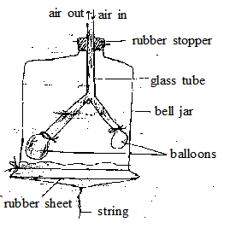
- A form two class set up the apparatus shown below to demonstrate the breathing mechanism of a mammal.

  - What structure in a mammal is represented by each of the following?
- The glass tube. (4mks)
- The balloons
- The bell jar
- The rubber sheet
  - Explain what will happen to the balloons if the rubber sheet is;
- Pulled downwards (2mks)
- Pushed upwards (2mks)
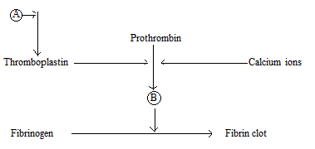
- The diagram below represents the process that brings about blood clotting.

  - Name the substances A and B. (2mks)
  - Name one source of calcium ions in the diet. (1mk)
  - Name one more other role of calcium in the body. (1mk)
  - Name the blood cells that are involved in blood clotting. (1mk)
  - List down three structural adaptations of the red blood cells to their functions. (3mks)
SECTION B
Answer question 6 (Compulsory) and either question 7 or 8
- The amount of water particles that moved across cell membrane was determined at various temperature. The data collected is as in the table below.
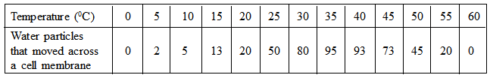
  - Draw a line graph to represent the amount of water particles that moved across the cell membrane against temperature. (5mks)
  - Account for the shape of the curve between;
i) 200 - 350C. (2mks)

Biology p1, p2&p3

ii) 400 - 600C (3mks)
  - i) Name and define the process by which water particles moved across the cell membrane. (2mks)
ii) Other than the temperature, state and explain another factor that affect the rate of the process you named in c (i) above.(2mks)
  - i) If the water molecules were moving across the cell membrane into a plant cell, name the state at which the cell would be if it was at 350 - 400 for 20 minutes. (1mk)
ii) State two forces that would be involved in the plant cell to result in the state of cells you named in d(i)above. (2mks)
  - i) State what would be expected if animals cells were used in d (i) above instead of plant cells. (1mk)
ii) Explain why plant cells behave differently from animal cells? (1mk)
- How is the mammalian skin adapted to its functions? (20mks)
- a) Describe the adaptations of the male reproductive system to its functions. (10mks)
b) Explain the role of the growth hormones in plants. (10mks)

GATAGA FORM FOUR END OF TERM II EXAMINATION 2016
Biology p1, p2&p3

BIOLOGY
PAPER 3 (PRACTICAL)
JULY/AUGUST 2016 TIME: 1 3/4 HOURS

Attempt ALL the activities in this paper.
- You are provided with specimens labelled J1 and J2.
  - Grind J1 in a motor with a pestle into a smooth paste. Add some distilled water to make a suspension. Pour the suspension into two clean test tubes and using the reagents provided determine the food substance present. Use the table below to record your findings. (8mks)

Food Test Procedure Observation Conclusion

  - Wash the pestle and motor thoroughly and prepare another suspension using specimen J2. Use the same reagent as in (a) above to determine the food substances present. Fill in your findings in the table below. (4mks)

Food Test Observation Conclusion

  - i) Name the process the food substance in J1 has undergone to become the food substance in J2. (1mk)
ii) Name the plant hormone involved in the transformation of J1 to J2. (1mk)
- The photographs on the leaf attached are of animals belonging to the same taxonomic unit (class).

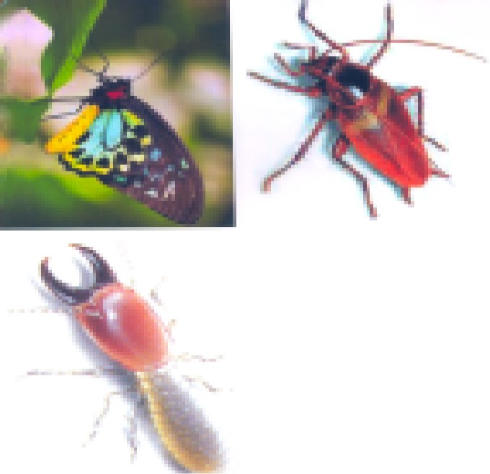
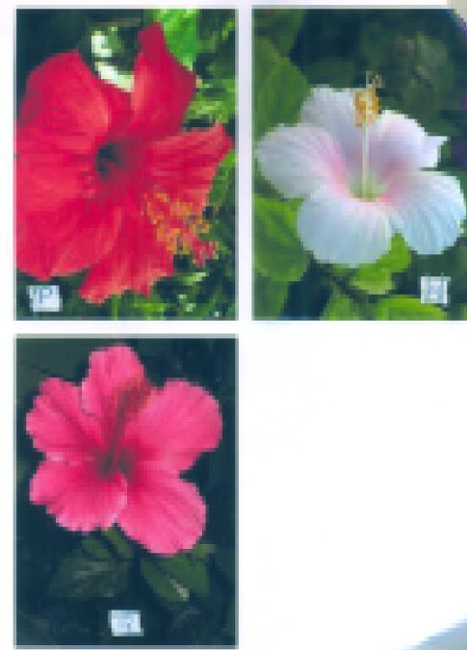

Biology p1, p2&p3

  - i) Name the class to which the organisms in the photographs belong. (1mk)
ii) State three reasons for your answer in a) (i) above. (3mks)
  - State three economic importance of organisms in this class. (3mks)
  - Use the following characteristics to prepare a two step dichotomous key of the animals in the photographs. (4mks) Step 1 - Presence or absence of wings
Step 2 - Type of mouth parts
- The colour of petals in flowers is determined by a pair of gene allele. You are provided with photographs of flowers with different colours but from plants of the same species labelled P, R and Q.
  - Identify the main colour of each of the flower. (3mks)
  - A cross between plant P and plant R produced plant Q. Use appropriate letters to constitute the genotypes of:- (2mks)
    - P
    - R
  - Using the genotypes constituted in (a) above, work out a cross between P and R to obtain the genotypeofQ. (3mks)
  - Supposing Q was self-pollinated, work out the cross to obtain the phenotypic ratio of the F2 generation. Use a Punnet‟s square. (4mks)
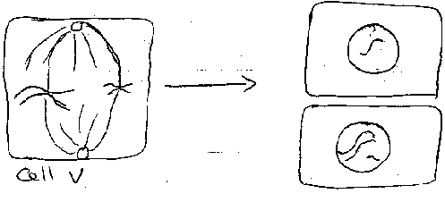
  - Cell V in the diagram below went through the 2nd meiotic division. The results were as in the gamete cells W and X.

CELL W

CELL X

- Name the type of mutation demonstrated in the diagrams. (1mk)
- Supposing gamete X fused with a normal gamete during fertilization, name a disorder in humans resulting from such a condition. (1mk)

