GEM SUB-COUNTY FORM 4 JOINT EVALUATION
Kenya Certificate of Secondary Education
232/1
PHYSICS
Paper 1
July/August 2016
Time: 2 Hours
1. Figure 1 below shows a top view of two steel needles floating on water surface at a distance x metres apart.
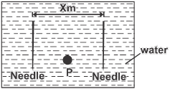

Fig. 1

Very hot water is now poured at point P between the two needles. Explain any change in the distance x. (2 marks)
2. Figures 2a and 2b show a spring when carrying different masses.

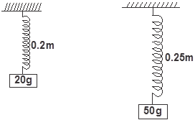

(2a)

(2b)
Determine :
i) the elastic constant of the spring. (1 mark)
ii) the length of the unloaded spring. (2 marks)
3. Figure 3 below shows an air balloon and a wooden block at equilibrium on a hot day.
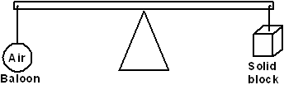

Fig. 3

Explain how the equilibrium would be affected when the weather suddenly becomes cold. (3 marks)
4. Figure 4 below shows a cylindrical container having hot water at 95ºC. End A is shiny while end B is dull black. At equal distances from the container is placed two identical gas jars fitted with thermometers X and Y. Compare the readings of the two thermometers after two minutes. (1 mark)
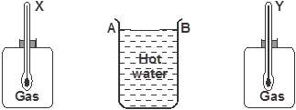

Fig. 4

5. Explain how the propellers on top of a helicopter help in lifting the helicopter above the ground. (2 marks)
6. On the axes provided below, sketch a graph of displacement against time for a body moving with uniform deceleration.
(1 mark)
7. A car got a breakdown along a road inclined at an angle of 30º to the horizontal. The driver used a stone to stop the car as he looked for a mechanic. However, a boy removed the stone and the car still moved down the road without the driver. State what provided the unbalanced force that made the car to accelerate downwards? (1 mark)
8. Figure 5 below shows a screw jack whose pitch is 5mm. If the handle has a length of 40cm and the jack is 80% efficient. Determine the effort needed to raise a car of mass 750kg. (3 marks)
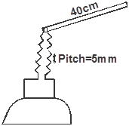

Fig. 5

9. Some potassium permanganate crystals are introduced at the bottom of water in two cans. One can has hot water while the other can has very cold water. Explain the container in which diffusion will diffuse faster. (2 marks)
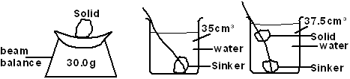
10. Figure 6 below shows a set up used by a form one student to measure the density of a solid that floats on water.

Fig. 6

Determine the density of the solid. (3 marks)
11. State a factor that affects melting point of ice. (1 mark)
12. A hot air balloon made from a very light material displaces 360kg of air and contain 300m³ of air of density 0.25kgm⁻³. Determine the maximum load the balloon can lift. (3 marks)
13. State the SI unit of momentum. (1 mark)
SECTION B: (55 MARKS)
Answer all questions.
14. Figure 7(a) and 7(b) show the readings of a micrometer screw gauge before and after a drop of oil are placed at the jaws.
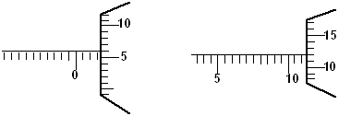

Fig. 7(a)(a) Fig. 7(b)

When the drop was made to fall on a shallow tray having water whose surface was sprinkled with lycopodium powder, it spread on the surface to form a patch of area Acm². Given that the size of one molecule of oil is 3 x 10⁻⁶cm.
a) Determine:
I. The diameter of the one drop of oil (2 marks)
II.The area of the patch A (3 marks)
b) State one assumption made in this experiment. (1 mark)
15. State Archimedes' principle. (1 mark)
b) Figure 8 below shows a spherical ball of radius 10.5cm in two immiscible liquids A and B of densities 1.2g/cm³ and 0.8g/cm³ respectively. If ²/₃ of the ball is inside A and ¹/₃ of the ball is in liquid B.

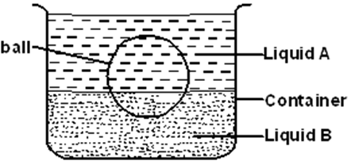

Fig. 8

Determine the weight of the ball. (5 marks)
c) A gas is heated in a sealed container so that its volume cannot change. The graph below shows variation of pressure against temperature of the gas.
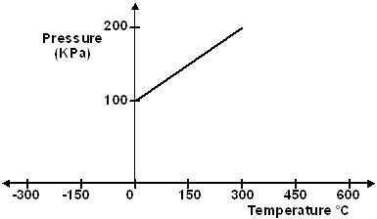

Use the graph to determine
i) The pressure of the gas at 0ºC. (1 mark)
ii) The temperature at which the gas should exert zero pressure. (2 marks)
iii) Give a reason why part (ii) above is not practically obtainable. (1 mark)
16. a) Explain why it is easier to open the door when pushing further away from the hinge. (1 mark)
b) Figure 9 below shows a simple form of a uniform diving board of weight 350N and length 2m.
A diver of mass 60kg walks from point Q towards end R and jumps into water when at a distance of 0.2m from end R.
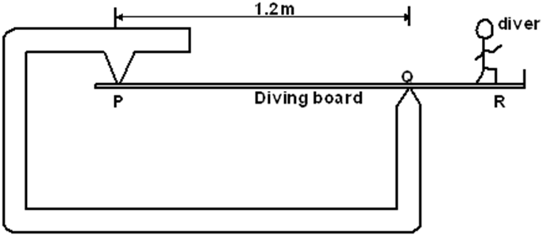

Fig. 9

i) Determine the distance from point Q where the weight of the diving board acts. (1 mark)
ii) In the axes provided below, sketch the graph of force exerted at P against distance of diver from R as diver moves from Q towards R (1 mark)

iii) Determine the force experienced at Q just before the diver jumps in water. (4 marks)
c) Figure 10 below shows a toy bird. State one method of increasing the stability of the bird on the support. (1 mark)
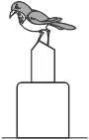

Fig. 10

17. a) Define the terms ‘frequency’ as used in uniform circular motion. (1 mark)
b) Figure 11 below shows a turn table, centre O with a mass of 30g at a distance of 6cm from the centre.
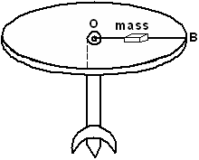

Fig. 11

i) Determine the normal reaction between the 30g mass and the table. (2 marks)
ii) The 30g mass just slides off the table when the turn table rotates at a frequency of 1 revolution per second. Determine:
- The angular velocity. (2 marks)
II. The coefficient of friction between the 30g mass and the table. (3 marks)
iii) Oil is poured on the table and the table is made to rotate at the same frequency of 1 revolution per second. On the figure, mark a point P along line OB where the 30g mass will just slide off. (1 mark)
18. a) Distinguish between elastic and collision and inelastic collision. (1 mark)
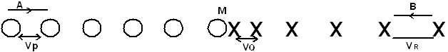
b) Figure 12 below shows two cars A and B moving in opposite direction along a straight road. The diagram shows their respective positions at equal time intervals before the crush until the cars collided at point M. The diagram is drawn to scale of 1:10

Fig. 12

i) Explain which driver had anticipated the collision. (2 marks)
ii) If the time between all the intervals was 0.5 seconds.
- Determine the velocities V_{p}, V_{Q} and V_{R} (4 marks)
II. Car A had a mass of 8000kg while B had a mass of 1200kg. The cars coellesced and moved together a distance of 8m before coming to rest.
Determine:
I. The velocity after collision. (2 marks)
II.The common acceleration (3 marks)
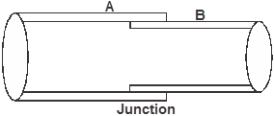
19. a) Figure 13 below shows two conductors A and B tightly fitted onto each other at the junction. When some ice was placed at the junction then it became easy to separate the conductors. Explain which of the two a better conductor of heat was. (2 marks)

Fig. 13

b) Explain why a finger feels colder when dipped in methylated spirit than when dipped in water at the same temperature.
(2 marks)
c) 50g of ice at -5ºC is dropped in a well lagged copper calorimeter of mass 30g having 150g of water at 80ºC. A final steady temperature of 35ºC is attained. Determine specific heat capacity of ice.
(Take specific heat capacity of water = 4200Jkg⁻¹k⁻¹, specific latent heat of fusion of ice =
340,00Jkg⁻¹ and specific heat capacity of copper = 390Jkg⁻¹k⁻¹) (4 marks)

d) Figure 14 below shows a plastic bottle having a weighted cork floating on water inside the bottle.When the sides of the bottle are squeezed the cork sinks.
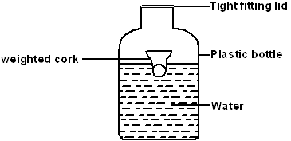

Fig. 14

Explain the observation. (2 marks)

GEM SUB-COUNTY FORM 4 JOINT EVALUATION
Kenya Certificate of Secondary Education
232/2
PHYSICS
Paper 2
July/August 2016
Time: 2 Hours
SECTION A : (25 MARKS)

1. A vertical object placed on a bench is observed to have three shadows of different sharpness in different directions. Explain this observation. (3 marks)
2. The figure below shows two spherical materials, one an insulation conductor and the other a conductor. Negative charges are introduced at point A in each case.
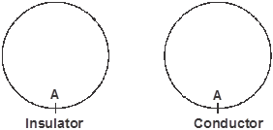

On the same figure indicate the final position of the charges. Explain your answer. (2 marks)
3. Give a reason why attraction in magnetism is not regarded as a reliable method of testing for polarity.
4. A lady holds a large concave mirror of focal length 1m, 80cm from her face. State two characteristics of her image in the mirror. (2 marks)
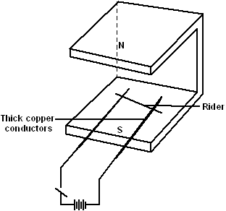
5. The diagram below shows two parallel thick copper conductors connected to a d.c power supply. A rider made from thin copper wire is placed on the conductors.

State and explain what is observed on the rider when the switch is closed. (3 marks)
6. The audible frequency range for a certain person is 30Hz and 16500Hz. Determine the largest wavelength of sound in air the person can detect. (Speed of sound in air = 330m/s) (3 marks)
7. A small coin lies at the bottom of a water pond at a depth of 1.2m. How far from the water surface does the observer see it, given the speed of light in water is 2.3 x 10⁸m/s and velocity of light in air is 3.0 x 10⁸m/s. (4 marks)
8. State the cause of electromagnetic damping in a moving coil galvanometer. (1 mark)

9. Diagram below is a resistor-capacitor circuit. At time t = 0, the switch is closed at A for some time and then opened. The switch is then closed at B for some time.
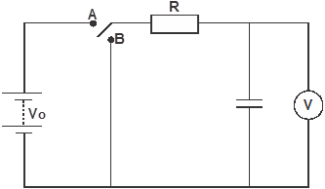

On the axes provided below, sketch graph of voltage V across the capacitor against time t (t₁ and t₂ represent time for opening at A and closing at B respectively). (3 marks)

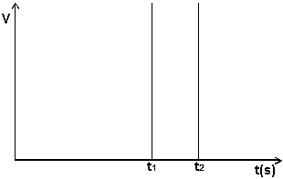

10.
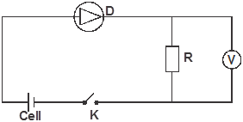

In the above diagram when the switch K is closed, the voltmeter shows a reading but when terminals of cell are reversed and switch K closed the voltmeter reading is zero. Explain these observations.
SECTION B: (55 MARKS)
11. a) State the property of radiation that determines the number of electrons emitted when the radiation falls on a metal surface. (1 mark)
b) The graph below is a variation of stopping potential, V_{s}, against frequency, f, in an experiment on photoelectric effect.
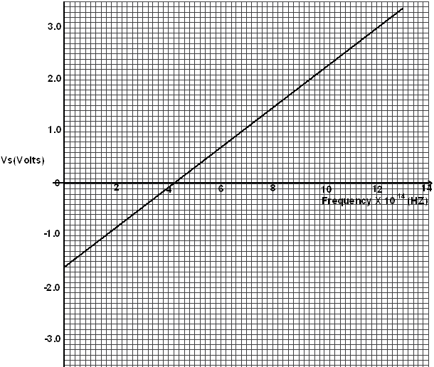

i) Explain what is meant by stopping potential. (1 mark)
ii) Given that the stopping potential V_{s} is related to the frequency by the equation
V_{s} = h f - W_{o}
e e
where e is the charge of an electron.
Determine the plank’s constant h. (e = 1.6 x 10⁻¹⁹C) (4 marks)
iii) From the graph determine the work function w_{o} for the metal in electron volts (eV) (3 marks)
12. a) Diagram below represents a metre bridge used to determine the resistance of an electrical component, X.
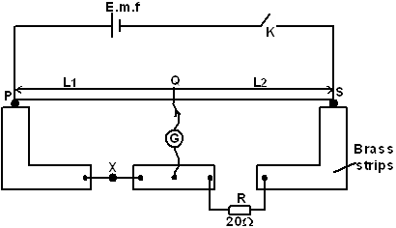

From the diagram,
i) Explain why wide brass strips are used as terminals. (1 mark)
ii) Explain why a cell of low e.m.f is preferable. (1 mark)
iii) If null deflection was obtained when l₁ was 60.0cm. Calculate the resistance of component marked X. (2 marks)
iv) State three ways of ensuring that the error is minimized. (3 marks)
b) A uniform resistance wire of length 2.0m conducts a current of 0.25A when connected in series with a cell of e.m.f of 1.6V. How much current would be conducted if the wire is now cut into 2 equal lengths which are then arranged in parallel. (4 marks)
13. a) State two factors that affect the strength of an electromagnet. (2 marks)
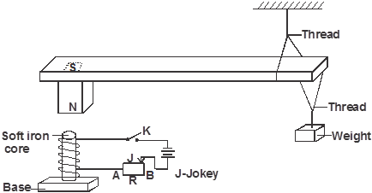
b) Figure below shows suspended metre rule in equilibrium balanced by the magnet and weight shown. The iron core is fixed to the bench.

i) State and explain the effect on the metre rule when the switch S is closed. (3 marks)
ii) State and explain the effect on the metre rule when the terminals of battery are reversed. (2 marks)
iii) Suggest how J on the set up can be varied to have metre rule tilt anticlockwise faster. (1 mark)
iv) Explain your suggestion in b(iii) above. (3 marks)
14. a) The diagram below is a section of a house wiring system.
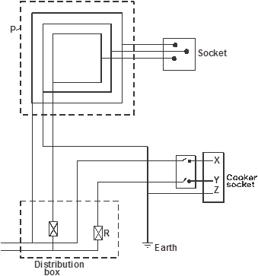

Name:
i) Circuit labelled P (1 mark)
ii) Terminals labelled X and Y (2marks)
iii) State the purpose of R in the circuit, hence explain why R is connected to Y and not X. (2 marks)
iv) Why is the earthing necessary in such a circuit? (1 mark)
b) The cost of electricity per kilowatt hour- kWh is Ksh.8, determines how much a household running a device rated 1500W continuously for 1.08 x 10⁵ seconds, would pay. (2 marks)
c) Explain reason for transmission of electrical power over along distance at very high voltage. (1 mark)
d) Explain why for transmission of electrical power over long distance, alternating current (a.c) is preferred to a direct current (d.c) (1 mark)
e) How many 1000W electric iron rating could be safely connected to a 240V main circuit fitted with 13A fuse?(3 marks)
15. a) State Lenz’s law of electromagnetic induction. (1 mark)
b) The figure below is a simple microphone in which sound waves from a speaker cause the cardboard diaphram to vibrate.

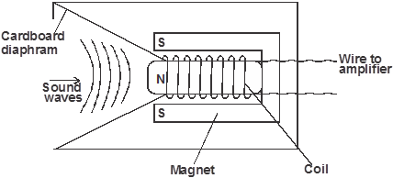

- Explain how a varying current is induced in the coil when the diaphram vibrate to and fro. (3 marks)
ii) State two ways in which the induced current in 15b(i) above can be increased. (2 marks)
c) A transformer with 1200 turns in the primary circuit and 120 turns in the secondary circuit has its primary circuit connected to a 400V a.c. source. It is found that when a heater is connected to the secondary circuit, it produces heat at the rate of 600W. Assuming 100% efficiency, determine the:
i) voltage in the secondary circuit. (2 marks)
ii) current in the primary circuit. (2 marks)
iii) current in the secondary circuit. (1 mark)

GEM SUB-COUNTY FORM 4 JOINT EVALUATION
232/3
PHYSICS
Paper 3
July/August 2016
Time: 2½ Hours
1. You are provided with the following apparatus :
- two retort stands
- two clamps
- two bosses
- inextensible thread (about 120cm long)
- inextensible thread (about 20cm long)
- one 50g mass
- one stop watch
- two metre rules
Proceed as follows:
a) i) Set up the apparatus as shown in figure 1 below.

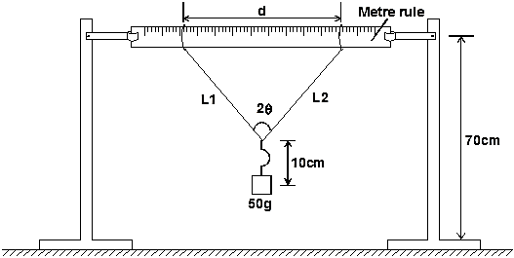

Fig. 1

Attach the ends of the thread to the metre rule and fasten the loops tightly so that the distance between the loops,
d = 80cm. (Note : L₁ = L₂ = 50cm and should remain the same throughout the experiment)
iii) Tie the 50g mass with a thread 20cm long. Fasten the mass at the centre of the thread on the rule such that the length of the pendulum from the point of suspension is 10cm as shown above.
b) i) Measure the angle 2
ii) Pull the mass towards you through a small angular displacement and release it to swing freely.
The mass should oscillate perpendicular to the plane of the metre rule. Time 10 oscillations..
iii) Repeat procedure b(i) and (ii) above by using different values of d and enter your values in table 1 below.
Table 1
d (m) | 0.8 | 0.7 | 0.6 | 0.5 | 0.4 | 0.3
2θ
θ
cos θ
Time for 10 oscillations, t (s)
Periodic time T(s)
T² (S²)
(10 marks)
c) On the grid provided below, plot a graph of T² (y-axis) against cos θ. (5 marks)
d) Find the slope, S, of the graph. (3 marks)
e) Given that S = 1.6π², determine the value of K. (2 marks)
K
2. You are provided with the following:
- a 100ml beaker
- a 600ml beaker
- 2 thermometers range -10ºC to 110ºC
- a 100ml measuring cylinder (can be shared)
- some plasticine
- vernier callipers ( can be shared)
- metre rule or half metre rule
- some boiling water
- 100ml methylated spirit (at room temperature) in a beaker
- stop watch
- a stirrer
Proceed as follows:
a) Using the vernier callipers, measure the internal diameter d₁ and external diameter d₂ of the 100ml beaker.
d₁ = ...... cm
d₂ = ...... cm (1 mark)
Hence determine the thickness, X, of the glass wall of the beaker given that
X = d₂ - d₁
2
X = .....cm (1 mark)
b) Using the measuring cylinder provided, pour 80ml of methylated spirit into the small beaker. Measure the height, h, of the methylated spirit in the small beaker.
h = ..... cm (1 mark)
Hence determine the area, A, of the glass walls in contact with water, given that
A = πd₁h
A = ...cm² (1 mark)
c) Using the plasticine provided, make a circular disc of about the same area as the bottom surface of the smaller beaker and about 1cm thick. Place this disc at the bottom of the larger beaker and place the small beaker on it. (The plasticine may be placed in a thin transparent polythene paper)
Now pour boiling water into the larger beaker until the levels of water in the two beakers are the same. See figure 2 below.
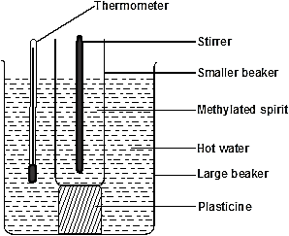

Figure 2

d) Place a thermometer in the hot water and stir gently until the temperature drops to 80ºC. Now start the stop watch and measure the temperature, T_{1,} of the hot water at intervals of 20 seconds. Record the values in the table 2. (Stir the water in the two beakers before taking readings)
Pour out the contents of the two beakers.
e) Measure another 80ml of methylated spirit and put into the small beaker. Place the small beaker inside the larger beaker on the plasticine disc as before.
Again pour boiling water into the larger beaker until the levels of the water and the methylated spirit in the two beakers are the same. Place one thermometer in the methylated spirit and another in hot water. Stir gently until the temperature of the hot water drops to 75ºC. Start the stop watch and immediately read and record in table 2 the temperature T_{2,} of methylated spirit.
(You may now remove the thermometer in the hot water)
Read other values of T₂ at intervals of 20s and record in table 2

Table

Time, t (seconds) | 0 | 20 | 40 | 60 | 80 | 100 | 120 | 140 | 160 | 180 | 200
Temperature T₁ (°C)
Temperature T₂ (°C)

f) Plot a graph of temperature, T_{2,} (y-axis) against time, t. (5 marks)
g) i) Determine the slope, S, of the graph at time t = 90 seconds. (3 marks)
ii) Determine the constant K, given that K = 315 SX
A (T₁ - T₂)
where T₁ and T₂ are the temperatures of the hot water and methylated spirit at t = 90s and X and A are in m and m² respectively. (2 marks)

GEM SUB-COUNTY FORM 4 JOINT EVALUATION
PHYSICS
Paper 3
July/August 2016
CONFIDENTIAL INSTRUCTIONS
The information contained in this paper is to enable the head of the school and the teacher incharge of Physics to make adequate preparations for this year’s Physics Practical examination.
NO ONE ELSE should have access to this paper or acquire knowledge of its contents. GREAT CARE must be taken to ensure that the information herein does not reach the candidates either directly or indirectly. Doing so will constitute an examination irregularity which is punishable.
Each candidate will require the following apparatus :
Question 1
- 2 metre rules
- two retort stands
- two clamps
- two pieces of threads (about 20cm and 120cm long)
- one 50g mass
- one stopwatch
- two bosses
Question 2
- 100ml of beaker (glass)
- 600ml glass beaker
- 2 thermometers range -10ºC to 110ºC
- a 100ml measuring cylinder (can be shared)
- some plasticine
- vernier callipers (can be shared)
- metre rule or half metre rule
- some boiling water
- 100ml methylated spirit (at room temperature) in a beaker
- stop watch
- a glass stirrer

