NANDI EAST, NANDI SOUTH & TINDERET SUB-COUNTIES JOINT EVALUATION 2016 231/1
BIOLOGY PAPER 1
JULY / AUGUST 2016 TIME: 2 HOURS

- Name the cell organelles responsible for:
  - Protein synthesis. (1mk)
  - Destroying worn-out organelles. (1mk)
- (a) What is test cross? (1mk)
(b) State the function of the part marked B. (1mk)
- (a) Explain why tracheids are not efficient in transporting water up the plant. (1mk)
(b) What is the advantage of xylem vessels being dead? (1mk)
- (a) What is meant by the term binomial nomenclature? (1mk)
(b) A dog is called Canis familiairis. Name the taxonomic unit represented by canis. (1mk)
- Define the following terms in relation to a cell. (3mks)
- Isotonic solution:
- Hypotonic solution:
- Hypertonic solution:
- (a) Name the site of gaseous exchange in mammals. (1mk)
(b) State one characteristics of the site named in (a) above. (1mk)
- What is the meaning of the following terms? (2mks)
- Autecology:
- Synecology:
- (a) What is eye accommodation? (1mk)
(b) Explain how the Iris muscle controls the size of pupil when exposed to bright light. (2mks)
- (a) What is seed dormancy? (1mk)
- Name a growth inhibitor in seeds. (1mk)
- Differentiate between hypogeal and epigeal germination in seeds. (2mks)
- The following is an equation representing a type of respiration.
C6H12O6 → 2C3H6O3 + Energy
- Identify the type of respiration. (1mk)
- Suggest one industrial application of the process named in (a) above. (1mk)
- Some form one students wanted to collect the following animals for study in the laboratory. State the suitable apparatus they should use.
  - Flying insects. (1mk)
  - Crawling stinging insects. (1mk)
  - Small animals from tree barks. (1mk)
- (a) Distinguish between homologous and analogous structures in evolution. (2mks)
(b) Give one limitation of fossil records as evidence for organic revolution. (1mk)
- The chemical equation below represents a physiological process that takes place in living organisms. Process R
Q
C6H12O6 + C6H12O6 → C12H22O11 +
Name: (2mks)
  - The process R:
  - Substance Q:
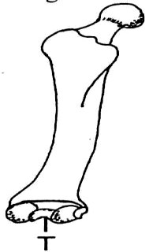
14. The diagram below represents a bone obtained from the hind limb of a goat.

(a) Identify the bone. |  | (1mk)
(b) Name the type of joint formed at the part labelled T. | (1mk)
15. Name two processes by which flowering plants excrete waste products. |  | (2mks)
16. (a) State why the placenta is considered as an endocrine gland. |  | (1mk)
(b) Describe how the embryo in human is protected during pregnancy. |  | (2mks)

- Study the diagram and answer the questions that follow.
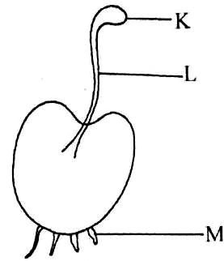
  - State the division the organism belongs. (1mk)
  - Name the part labelled K. (1mk)
  - What is the function of the part labelled M? (1mk)
- (a) Why is blood group AB described as a universal recipient? (2mks)
(b) Suggest why blood does not clot in blood vessels of a healthy person. (1mk)
- Explain how the following adaptations minimize the rate of transpiration.
  - Sunken stomata (1mk)
  - Leaf drooping (1mk)
  - State two environmental factors that influence the rate of transpiration. (2mks)
- (a) Name the causative agent for the following diseases:-
- Amoebic dysentery (1mk)
- Schistosomiasis (1mk)
- Explain why primary productivity in aquatic environment reduce with increase in depth. (2mks)
- Define the term eutrophication. (1mk)
- State two biological importance of tropisms in plants. (2mks)
- (a) Name two disorders in man that occur through gene substitution. (2mks)
(b) Give one advantage of polyploidy. (1mk)
- (a) Name the source of hydrochloric acid in the mammalian heart. (1mk)
(b) The diagram below represents internal structure of a mammalian tooth. (2mks)
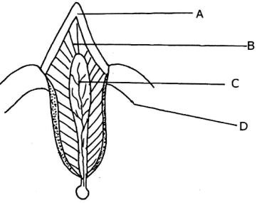
Name the parts labeled B and D.
- An accident victim was found to pass large volumes of dilute urine.
  - What part of brain was injured? (1mk)
  - Explain how the injury of the part of the part mentioned in 25(a) above brought about the release of large volume of urine. (2mks)
- The diagram below shows a seed of a certain plant.
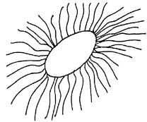
  - Name the likely agent of dispersal. (1mk)
  - Give a reason for your answer. (1mk)
- Explain how the following tissues are adapted to provide mechanical support in plants.
  - Collenchyma (1mk)
  - Sclerenchyma (1mk)
- (a) Define active transport. (2mks)
(b) State two roles of active transport in animals. (2mks)
- (a) Lokori school Biology student used a microscope with x40 objective lens and x5 eye piece lens which had 2mm radius. Calculate the area of the filed of view in micrometers. (2mks)
(b) What is the average size of the cell in micrometers? (2mks)

- Use the graph below to answer the questions that follow.
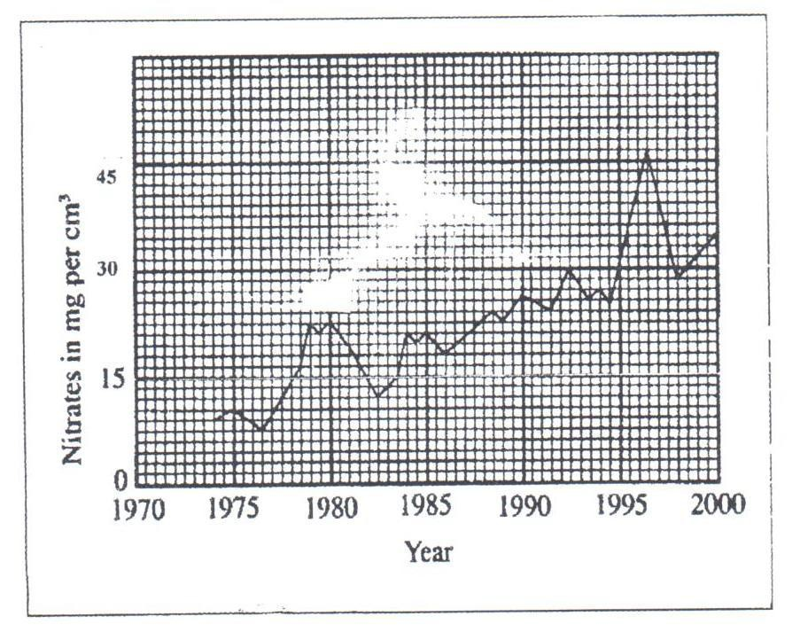
  - Calculate the difference in nitrate concentration between the highest and lowest. (1mk)
  - How can increase in nitrate concentration in the river lead to death of fish? (2mks)
  - Suggest one possible sources of nitrate that lead to the pollution in a river. (1mk)

NANDI EAST, NANDI SOUTH & TINDERET SUB-COUNTIES JOINT EVALUATION 2016
Biology p1, p2&p3

231/2
BIOLOGY PAPER 2 (THEORY)
JULY / AUGUST 2016 TIME: 2 HOURS SECTION A (40 MARKS)
Answer all questions in this section in the spaces provided.
- A man with normal skin colour got married to a woman with normal skin colour. They gave birth to three children; one of them an albino.
- Identify the probable genotype of the parents using letter (A) for normal gene and (a) for defective gene. (2mks) Man:
Woman:
- Using a genetic cross; show the genotypes of the offspring. (3mks)
- Give the phenotypic ratio of the offsprings. (1mk)
- Give two examples of sex linked genes. (2mks)
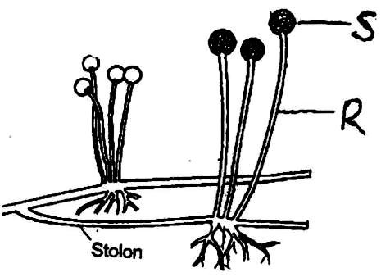
- Study the diagram below of an organism and answer the questions below it.

- (i) Name the part labeled R on the diagram. (1mk)
- State the function of part S. (1mk)
- (i) Identify the kingdom to which it belongs. (1mk)
  - Give a reason for your answer in (a) (i) above. (1mk)
  - (i) State the asexual mode of reproduction of the organism shown in the diagram. (1mk)
(ii) Identify two other asexual modes of reproduction among lower organisms. (2mks)
  - Name the structure in which male gametes are produced in division Bryophyta. (1mk)
- The equation below represents a certain physiological process. Study it and answer the questions below.
C18H36O2 + 26O2 18CO2 + 18H2O + ATP
- Name the above process. (1mk)
- Give two reasons for question (i) above. (2mks)
- Calculate the respiratory quotient of the compound that was as the substrate. (2mks
- Identify the substrate being respired in the above equation. (1mk)
- State one importance of this process to living organisms. (1mk)
- Name the organelle where the above process takes place in animal cells. (1mk)
- (a) A wild beast in Maasai Mara National Park were found to be infested with a lot of ticks. State the trophic level occupied by the following organisms. (2mks)
  - Wild beast:
  - Ticks
- Study the food below representing a certain ecosystem and use it to answer the questions that follow.
Locust Guinea fowl

Grass
Caterpillars Hawk

Antelopes

Lion

Vulture

  - Write down a food chain in which the vulture is a tertiary consumer. (1mk)
  - What would be the effect of introducing gazelles and termites into the ecosystem? (1mk)
- During an ecology, students collected and marked 40 ants and then released them. After 2 days, the students captured another 100 ants, 40 of which had been marked previously.
  - How many ants were there in the compound? Show your working. (2mks)
  - Give two assumptions of this method in sampling animal population. (2mks)
- In an experiment to investigate an aspect of digestion, two test tubes P and Q were set as shown in the diagram below.
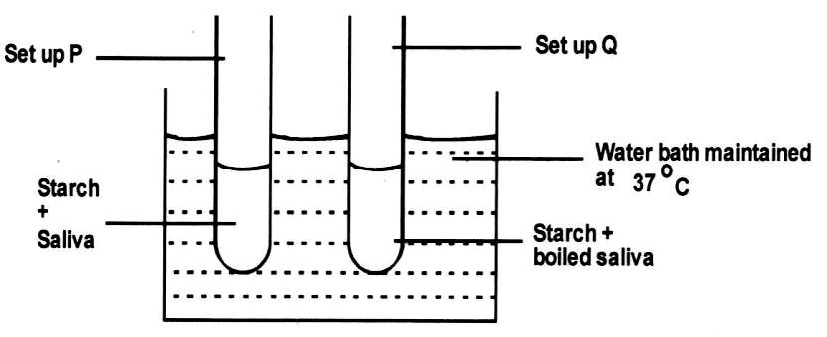
The test tubes were left in the water bath for 30 minutes. The content of each test tube was then tested for starch.
- (i) Name the reagent that was used to test for starch. (1mk)
(ii) What was the aim of the experiment? (1mk)
- What were the expected results in tube P and Q? (2mks)
- Account for the results you have given in (b) in test tube P and Q. (2mks)
- (i) Why was the set-up left at 370C? (1mk)
(ii) In what form is starch stored in animal cells? (1mk)

SECTION B
Answer question 6 (Compulsory) and either question 7 or 8 from this section.
- An experiment was carried out to determine the growth rates of bamboo and a variety of maize plants in two adjacent plots. The average height and average dry weight of plants fromt eh two populations were determined over a period of twenty weeks. The data is as shown in the table below.
Age in weeks | Bamboo |  | Maize
 | Average height (Metres) | Average weight  (Grams) | Average height  (Metres) | Average weight  (Grams)
2 | 1.3 | 52 | 0.3 | 20
4 | 4.0 | 182 | 0.5 | 29
8 | 8.2 | 443 | 0.8 | 57
8 | 12.1 | 682 | 1.2 | 78
10 | 13.9 | 801 | 1.7 | 172
12 | 14.1 | 957 | 1.9 | 420
14 | 14.3 | 1025 | 2.1 | 704
16 | 14.4 | 1062 | 2.1 | 895
18 | 14.6 | 1127 | 2.1 | 926
20 | 14.6 | 1229 | 2.1 | 908
- Between which two weeks did the greatest increase in weight occur in: (2mks)
  - Bamboo plants:
  - Maize plants:
- (i) Which of the two types of plants had a higher productivity by the end of the experiment? (1mk)
(ii) Give a reason for your answer in (b) (i) above. (1mk)
- Between weeks 14 and 18, the average height of the maize plants remained constant while average dry weight increased. Explain this observation. (3mks)
- Suggest how the change in the average dry weight bamboo and maize plants would have been at week 22 if the experiment was continued. (2mks)
- Why was it appropriate for this experiment to use:
  - Dry weight instead of fresh weight. (2mks)
  - Weight and height. (1mk)
- Describe how the average height and weight of the plants were determined in this experiment.
  - Average height. (2mks)
  - Average dry weight. (3mks)
- Give a reason why secondary thickening does not occur in bamboo and maize plants. (1mk)
- Give two characteristics of meristematic cells. (2mks)
- (a) Describe three adaptations of a respiratory surface. (6mks)
(b) Describe the mechanism of gaseous exchange in a mammal. (14mks)
- (a) Describe the mechanism of hearing in man. (16mks)
(b) State four differences between endocrine and hervous systems. (4mks)

NANDI EAST, NANDI SOUTH & TINDERET SUB-COUNTIES JOINT EVALUATION 2016

231/3
BIOLOGY PRACTICAL JULY / AUGUST 2016

CONFIDENTIAL

Reagents
Specimen Q – Tradescantia stem with leaves. Solution S1 - Distilled water
Solution S2 - Saturated salt solution

Each student should be provided with:

- Scalpel
- Ruler (15cm long)
- 8cm3 of solution S1 in a boiling tube.
- 8cm3 of solution S2 in a boiling tube.
- Stickers
- Means of timing

Specimen Q – Tradescantia stem with leaves.

NANDI EAST, NANDI SOUTH & TINDERET SUB-COUNTIES JOINT EVALUATION 2016 231/3
BIOLOGY PAPER 3 (PRACTICAL)
JULY / AUGUST 2016 TIME: 1¾ HOURS

SECTION A (40 MARKS)
Answer all questions in this section in the spaces provided.

- You are provided with a specimen labeled Q. Cut the stem to obtain a 3cm stem piece. Then cut the 3cm stem piece longitudinally to obtain four quarters of equal sizes. Put one piece in solution labeled S, and the other piece in solution S2. Discard the remaining two pieces.
- Draw and label the appearances of the stem pieces put in:
  - Solution S1 (2mks)
  - Solution S2 (2mks)
- Account for the appearances in (a) above.
  - Appearance in S1 (3mks)
  - Appearance S2 (3mks)
  - Explain what would happen if a boiled piece was put in solution S1 (2mks)
  - Give one role of the above physiological process in plants. (1mk)
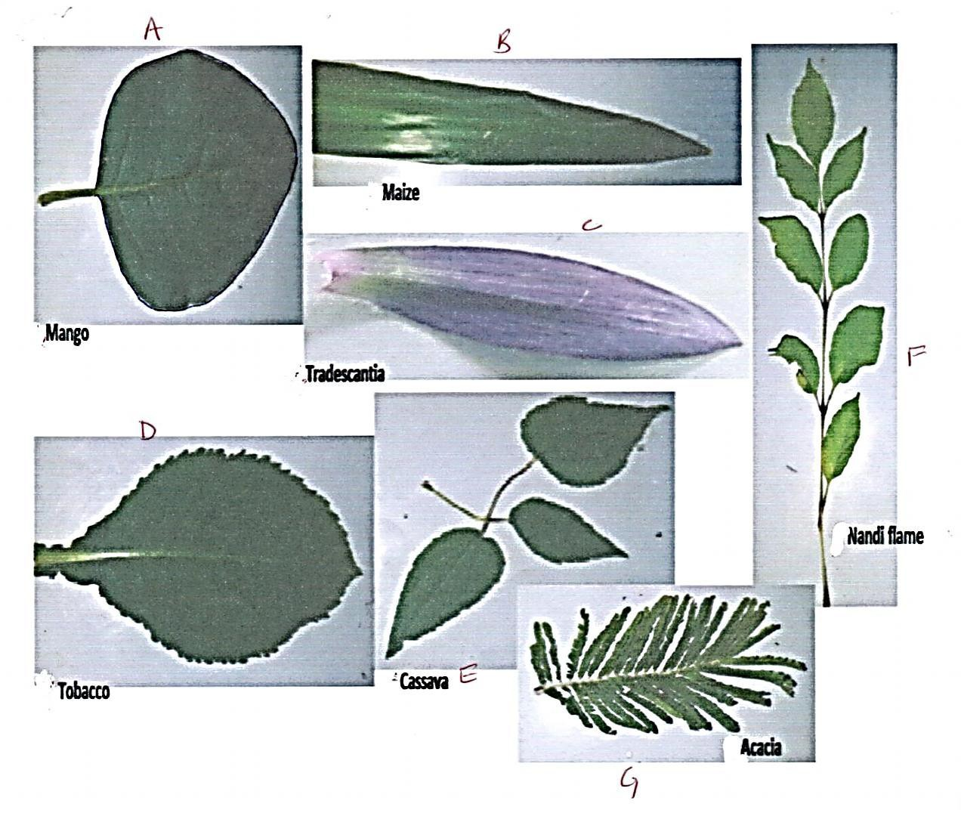
- You are provided with plant specimens below.

(i) | Construct a dichotomous key using the features given below in order.  (i) Leaf type | (10mks)
 | (ii) Leaf venation
 | (iii) Leaf colour
 | (iv) Leaf margin
 | (v) Number of leaflets
 | (vi) Attachment of leaflets
1) | (a) Leaf simple ……………………………………………. | go to 2
 | (b) …………………………………………………………………………….
2) | (a) ……………………………………………………………………………
 | (b) Leaf with network venation …………………………… | go to 4

3) (a) …………………………………………………………………………… (b)…………………………………………………………………………….
4) (a) …………………………………………………………………………… (b)…………………………………………………………………………….
5) (a) …………………………………………………………………………… (b)…………………………………………………………………………….
6) (a) …………………………………………………………………………… (b)…………………………………………………………………………….
(ii) Using the steps followed, identify the plant specimens provided. (3mks)
Specimen | Steps followed | Identity
B
E
G
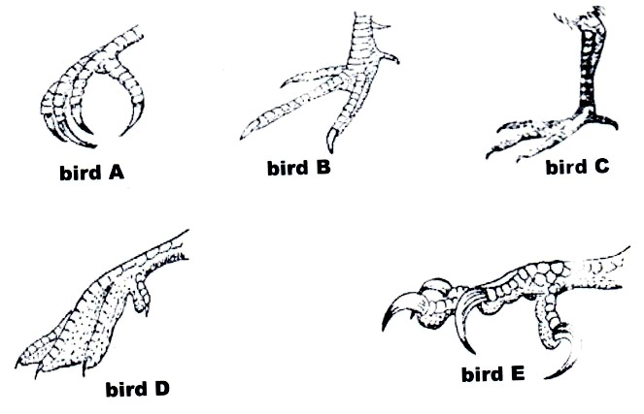
- (a) The figure below shows feet of various birds. Study the diagram and answer the questions that follow.

- Giving a reason, state the type of food eaten by Bird E. (2mks) Food eaten:
Reason:
- Name the habitat of bird D and give a reason for your answer. (2mks) Habitat:
Reason:
- Identify the type of structures shown by the feet above and give a reason for your answer. (2mks) Type of structure:
Reason:
- State the type of evolution shown by the structures. (1mk)
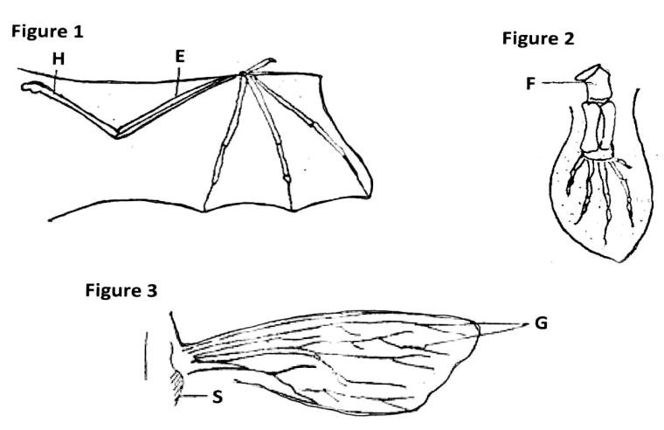
(b) Figure 1 represents a bat wing. Figure 2 a whale paddle and figure 3 an insect wing. Study the diagrams and answer the questions that follow.

- In figure 1, identify bones: H and E
- Name the type of joint formed by bones H and E. (1mk)
- Identify the type of structures shown above and the type of holution. (2mks) Structures:
Type of holution:
- What are vestigial structures? Give one example in man. (2mks)

- (a) Ribosomes√1
(b) Lysosomes √1
- (a) A cross between an organism showing the dominant phenotype but whose genotype is not known with homozygous recessive individual (in order to determine the unknown genotype); (1mk)
(b) Identical pairs of chromosomes that control / have genes for a particular similar traits; (1mk)
- (a) They have perforated cross walls that allow for lateral flow of water; (1mk)
(b) They prevent them from collapsing; (1mk)
- (a) Scientific system of giving living organisms two names; √1
(b) Genus; √1
- (a) Isotonic solution – a solution which has the same concentration as the cell sap; √1
- Hypotonic solution – a solution which is less concentrated than the cell sap; √1
- Hypertonic solution – a solution which is more concentrated than the cell sap; √1
- (a) Lung√1 reject lungs
(b) - Moist surface√1
- Highly supplied with blood capillaries / vasculinised; √1
- Increased surface area; √1 (Mark first 3)
- (a) Autecology is the study of a single species within a community / ecosystem / habitat / environment. √1
(b) Synecology is the study of natural communities / different species with an ecosystem. √1
- (a) The ability of the eye to focus on both far and near objects; (1 mark)
(b) The radial muscle relax; the circular muscles contract; (2 marks)
- (a) Ability of a seed to retain viability while having restricted metabolic activity;
State during which a viable seed cannot germinate when condition are suitable; √1
(b) Abscissic acid; √1 (c)
Epigeal | Hypogeal
- Cotyledons brought above ground level  - Hypocotyl elongates | - Cotyledon remain below ground level  - Epicotyl elongates

- (a) Anaerobic respiration in animals; Rej. anaerobic respiration alone.
(b) - Beer brewing;
- Bread baking / leavening of bread;
- Processing dairy products;
Acc. correct examples
- Biogas production;
- Sewage treatment;
- Manufacture of wines and spirits;
- Production of organic acids; (Mark any first one)
- (i) Sweet net;
- Pair of forceps; (1mk)
- Pooter;
- (a) Homologous – structures arising from same embryonic origin having similar plan but evolved to perform different functions; √1
Analogous structures originate from different embryonic origin but evolved to perform similar function;√1
(b) - Destruction of fossils by geologic activities
- missing links;
- distortion of parts during sedimentation; (mark first mentioned) (1mk)
- (i) Condensation; √1
(ii) Water; √1 (reject chemical formula)
- (a) Femur; √1
(b) Hinge joint; √1
- - Exuddation / Guttation;
  - Transpiration / diffusion;
  - Deposition / leaf fall / abscission. (any two) (2mks)
- (a) Produces progesterone / oestrogen;
(b) Amniotic fluid absorbs shock; prevent dehydration; placenta filter / block pathogens from mother; umbilical cord / placenta attach embryo to mother. (2mks)
- (a) Bryophyta; (1mk)
- K – capsule;
- Anchorage; Absorb water and mineral salts; (1mk)

- (a) AB receives blood from all blood groups; without agglutination since it lacks antibodies that would correspond to donor‟s antibodies;
(b) Blood in undamaged vessels contain anti-clotting factor / heparin.
- (a) Accumulates water in depression thus lowering saturation deficit hence low rate of transpiration;
- Reduce surface area exposed for transpiration hence lowering transpiration rate.
- - Temperature changes
- Changes in humidity
- Wind

- (a) (i) Entamoeba hystolytica
(ii) Schistosoma mansoni or Schistosoma haematobium or Schistosoma Japonicum
- There is decrease in light penetration, the depth of water increases; therefore there is less light for photosynthesis hence process of photosynthesis is reduced.
- Eutrohication is the excessive growth of aquatic plants due to excess nitrates phosphates and sulphates.

- - Expose leaves in position for maximum absorption of light;
- Enables roots to seek water / search for water;
- Enables plants to seek mechanical support especially those without woody stems;
- Roots grow deep for anchorage;
- Pollen tubes grow towards embryo sac to facilitate fertilization; (first two) (2mks)
- (a) Haemophilia; sickle-cell anaemia; Albinism; (2mks)
(b) Early maturity;
Resistance to pests / diseases / drought;
High yield; (2mks)

- (a) Oxyntic cells; (1mk) (1mk)
(b) B – Dentine (1mk)
D – Gum (1mk)
- (a) Pituitary gland; (1mk)
(b) Little ADH secreted; hence little reabsorption of water from kidney tubules; (2mks)
- (a) Wind; (1mk)
(b) Presence of hairs (b) tied to (a) √1 (1mk)
- (a) Cell wall coated with cellulose / pectin. √1
(b) Cell wall thickened with lignin√1
- (a) Movement of particles / ions / molecules from a region of low concentration to a region of high concentration against
 | concentration gradient. |  | (2mks)
(b) | - Excretion of nitrogenous waste
(i) | Reabsorption of glucose and amino acids in nephrone.
(ii) | Absorption of digested food in the ileum. | (1st two) | (2mks)
28. (a) 1mm = 1000 μ m

Areas =

=
π = 22 × (2000)2
7
22
⎜ × 2000 × 2000 ⎟;

⎛ ⎞

⎝ 7 ⎠
= 125714.29 μ m2;

(b) 125714.29
5
= 25142.858 μ m2

29. (a) 45.5 – 7.5 : 38.0√1 +0.5
- Excessive growth of algae / Eutrophication; √1
Depletes dissolved oxygen hence leads to fish suffocating; √1 (2mks)
- Excessive application of inorganic fertilizer / nitrate fertilizer; √1
Sewage; √1 (Mark the first one correct) (1mk)

