NANDI EAST, NANDI SOUTH & TINDERET SUB-COUNTIES JOINT EVALUATION 2016

Kenya Certificate of Secondary Education (KCSE
232 / 1
PHYSICS
PAPER 1
THEORY
JULY / AUGUST 2016
TIME: 2 HOURS
SECTION A (25 MARKS)
Answer ALL questions in this section in the spaces provided
- Figure 1 below shows a section of a micrometer screw gauge used by a student to measure the diameter of a wire. Determine the cross-sectional area of the wire. (2mks)
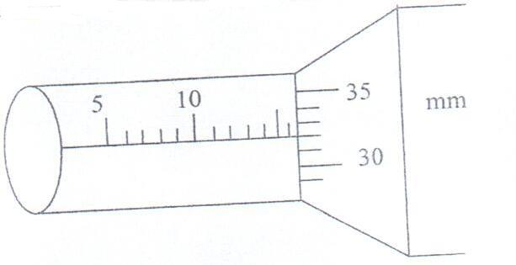

- Figure 2 below shows a capillary tube placed in a trough of mercury.
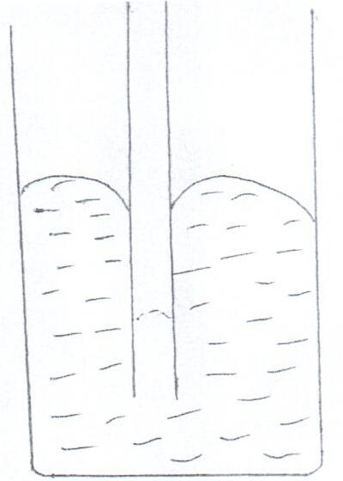

Give a reason why the level of mercury in the tube is lower than in the beaker. (1mk)
- Body scanners and lasers are applications of physics in medicine. State one other application. (1mk)
- A piece of sealing wax, weighs 3N in air and 0.22N when immersed in water. Calculate the density of the wax. (2mks)
- The barometric height in a town is 65cmHg. Given that the standard atmospheric pressure is 76cmHg and the density of mercury is 13600kg/m³, determine the altitude of the town. (Density of air is 1.25kg/m³) (2mks)
- When the temperature of a gas in a closed container is raised, the pressure of the gas increases. Explain in terms of kinetic energy how the molecules of the gas cause an increase in pressure. (2mks)
- A certain mass of hydrogen gas occupies a volume of 1.8m³ at pressure of 2.5 x 10⁵ N/M² and a temperature of 270C. Determine the volume when the temperature 0⁰C at a pressure of 7.5 x 10⁴ N/M². (3mks)
- The figure below shows a uniform metal rod of mass 100g balanced over a pivot using a spring balance and a mass of 300g.
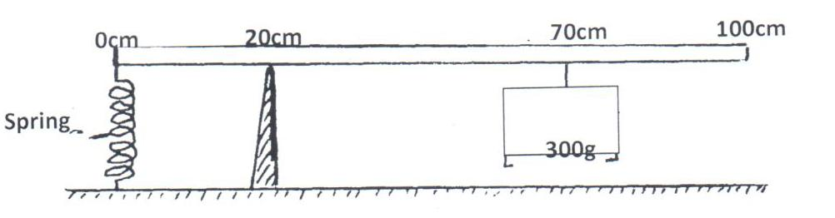

Calculate the tension in the spring. (3mks)
- A student below air into a horizontal straw in the direction shown in the diagram below.

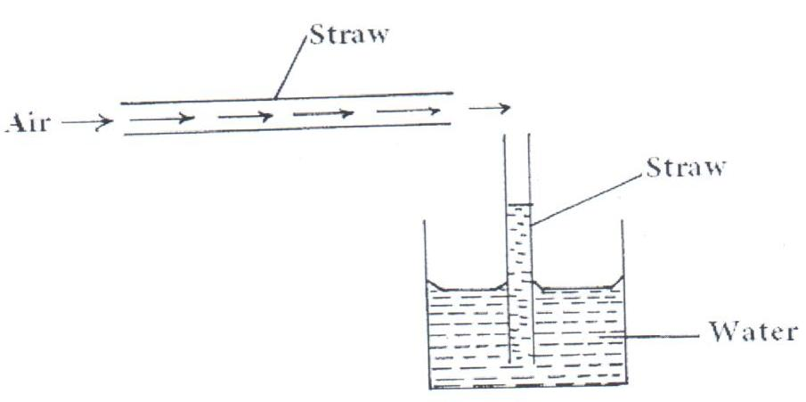

State what was observed in the vertical straw. (1mk)
- The figure below shows a spring balance, its spring constant is 225N/m. The scale spreads a distance of 20cm.
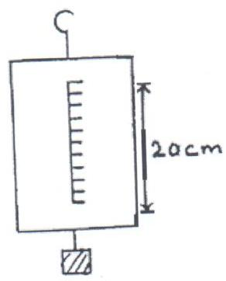

Determine the maximum weight that can be measured using the spring balance. (2mks)
- Give a reason why water is not a suitable liquid for use in a barometer. (2mks)
- An oil drop of radius 0.42mm when placed in water spreads out to form a circular patch of radius 42cm. using this information:
        - Estimate the size of the oil molecule. (2mks)
        - State any one assumption you made in your calculation. (1mk)
- An object is fired vertically upwards from the ground level with a velocity of 50m/s and reaches a maximum height h. It falls back to the ground. Sketch velocity time graph to represent the motion of the object from the time it is fired till it hits the ground.

Velocity, v (m/s)

Time,t (s)

SECTION B (55 MARKS)
Answer ALL questions in this section on the spaces provided.
- (a) State two factors that affects conductivity in metals. (2mks)
- You are provided with a metallic ball, a metallic ring and a source of heat. Describe how you would show that solids expand. (3mks)
- Figure below shows how water expands from lower temperatures.

Volume cm3

0 4 Temperature (⁰C)
On the axes below sketch a graph of density against temperature.
Density gcm-3

Temperature ⁰C
- Explain briefly why concrete walls are reinforced with steel and not other metals. (1mk)
- Figure below shows a wheel and axle of radius R and r respectively.
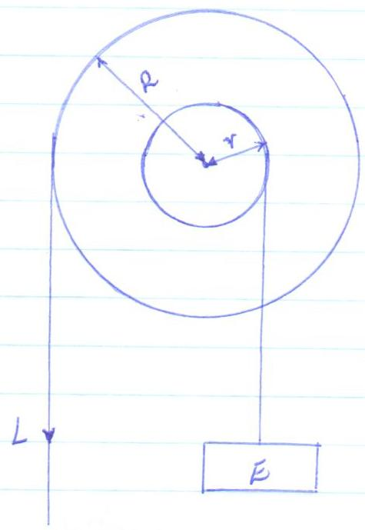
(a) Show that the velocity ratio of the system is given by . (2mks)
- Given that r = 5cm, R = 20cm and an effort of 1200N is used to lift a load of 3000N. Determine:
    - The work done by effort to raise the load through a distance of 2m. (3mks)
    - The efficiency of the system. (3mks)
    - State two ways in which the efficiency in (ii) above can be increased. (2mks)
- A stretched spring with a load attached to one end and fixed at the other is released as shown below.
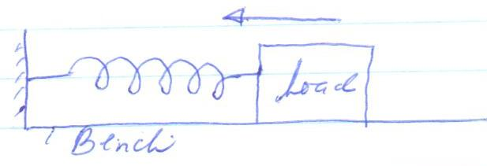

Sketch on the same axis below the graph of potential energy and kinetic energy with time(2mks)
Kinetic Energy

Potential energy
- (a) State any two factors that affect the melting point of a liquid. (2mks)
- 600g of a solid X was heated by an electric heater rated 500W until it melted, temperature readings taken as it heats
from room temperature. The graph shown below shows variation of temperature against time.
Graph of Temperature ⁰C against time (minutes)
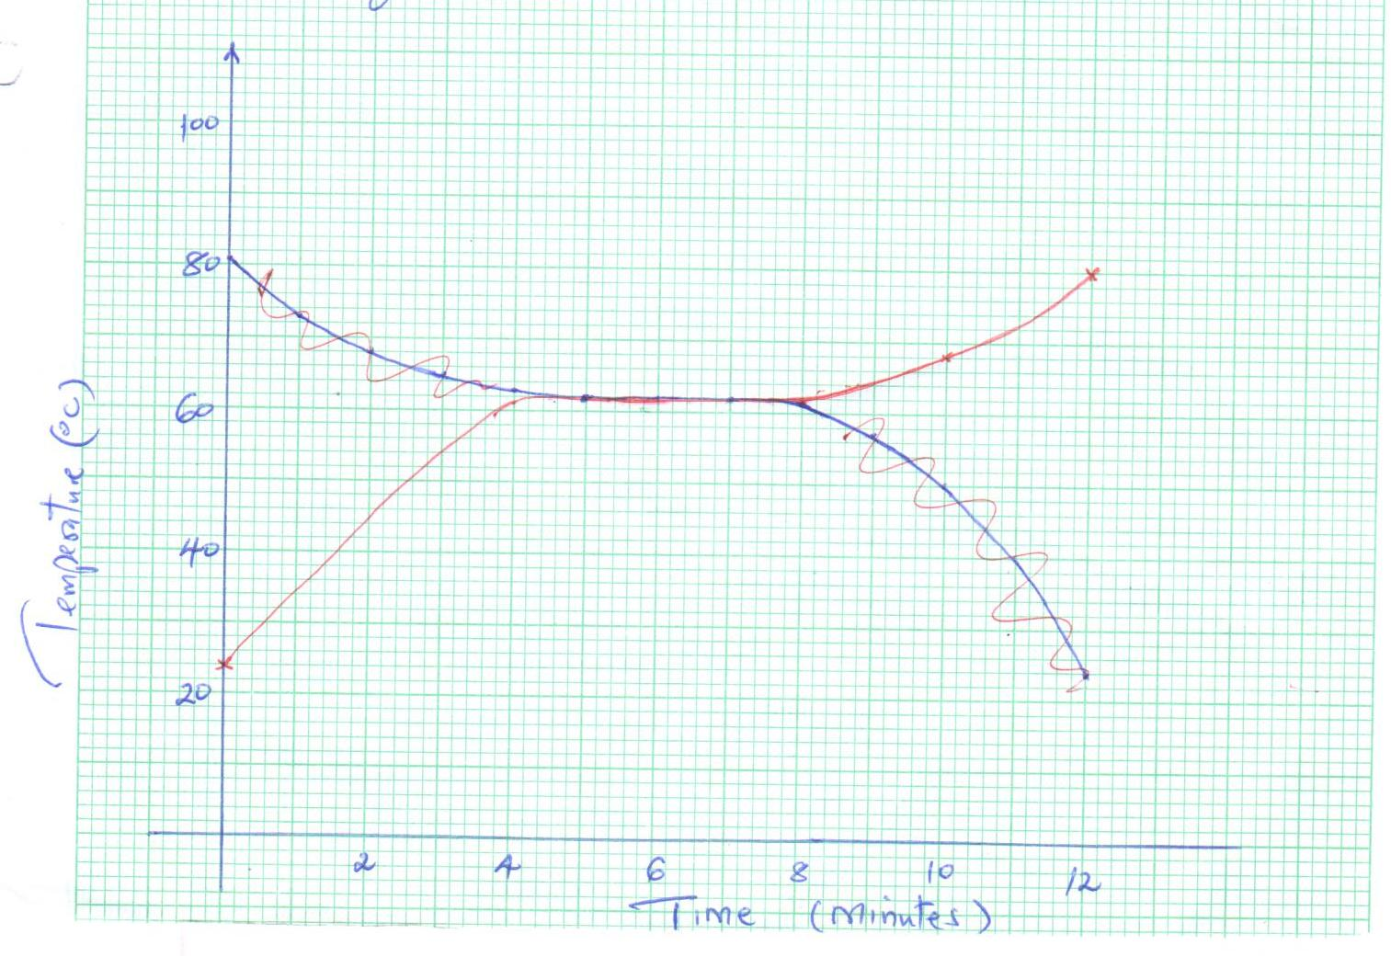
      - From the graph, determine the melting point of the solid X. (1mk)
      - I. Determine the heat supplied by the heater for solid X to melt. (2mks)
II. Hence determine the specific latent heat of fusion for solid X. (2mks)
      - I. State the room temperature. (1mk)
II. From the graph, determine the temperature change between the time t = 0 minutes and t = 4.0 minutes. (2mks)
III. Hence determine the specific heat capacity of the solid X. (3mks)
- (a) State two factors that influence fractional force between two surfaces.
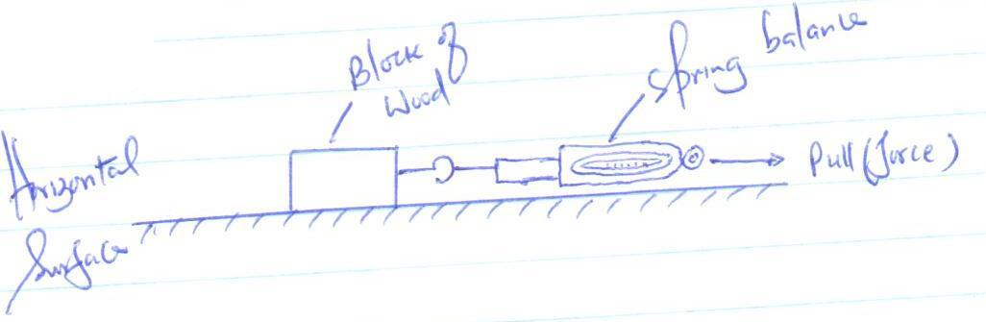
- Figure below shows a rectangular block of wood attached o a spring balance being pulled gently by a pulling force P
at a steady velocity.

    - A graph of pulling force against time was drawn as shown below.

F_{B}
Pulling force

F_{A} _{P} _{Q}

Time
  - State the forces F_{A} and F_{B}.
F_{A} :………………………………………………………………. (1mk)
F_{B} :………………………………………………………………. (1mk)
  - From the graph, state what happens to the block of wood between point P and Q. (1mk)
    - Given that the wooden box has a mass of 2.0kg and requires force of 5N to pull it with uniform speed along a horizontal surface, calculate the coefficient of friction between the surface and the block. Take (g = 10N/kg). (3mks)
- Figure below shows a steel bearing moving through glycerine at a steady velocity.

Steel ball bearing
Glycerin

Tall measuring cylinder

Indicate on the diagram the forces with directions acting on the ball bearing. (2mks)
- (a) A body moving in a circular path with constant speed is said to be accelerating. Explain. (1mk)
- A stone of mass 40g is tied to the end of a string 50cm long such that it is 10m above the ground at its lowest as shown
in the diagram.
The stone is whirled in a vertical circle at 2 rev/s.
I. (i) If the string breaks at point B, what is the velocity at this level? (2mks)
(ii) Determine the maximum horizontal distance it travels after breaking. (3mks)
II. Calculate
    - The tension in the string at point B. (3mks)
    - The tension in the string at point A. (2mks)
- State one application of Uniform Circular motion. (1mk)

NANDI EAST, NANDI SOUTH & TINDERET
SUB-COUNTIES JOINT EVALUATION 2016

Kenya Certificate of Secondary Education (KCSE)
232 / 2
PHYSICS
PAPER 2
THEORY
JULY / AUGUST 2016
TIME: 2 HOURS
SECTION A: 25 MARKS
Answer all questions from this section.
- A plain sheet of paper and a plane mirror both reflect light yet only the plane mirror forms images. Explain why the paper cannot form images. (2mks)
- The element of an electric hot plate has a resistance of 120Ω. What is the energy dissipated when element is kept on for 10 minutes on a 240V supply? (2mks)
- Arrange the following in order of increasing wavelength: Visible light, X-Ray, Ultra Violet Radiation and Radio Waves. (1mk)
- In the circuit shown below, the battery has an e.m.f. of 6.6V and internal resistance of 0.3Ω.
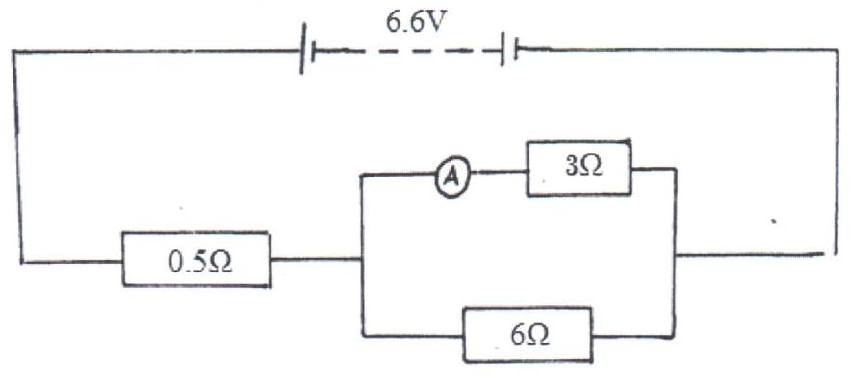

Determine the reading of the ammeter. (3mks)
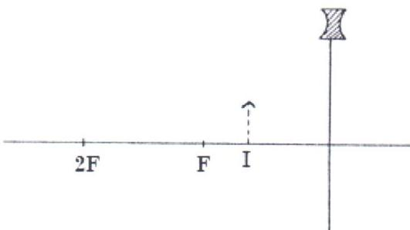
- The figure below shows the image formed when an object is placed in front of a concave lens.

Using suitable rays, locate the position of the object. (3mks)
- State the major difference between a dry cell and a wet cell. (1mk)
- Radium Ra disintegrates into a new stable element lead Pb. How many Alpha and Beta particles are emitted? (2mks)
- The figure below shows an arrangement of three components. If the total capacitance of the capacitors is 5μf, determine the value of X. (3mks)
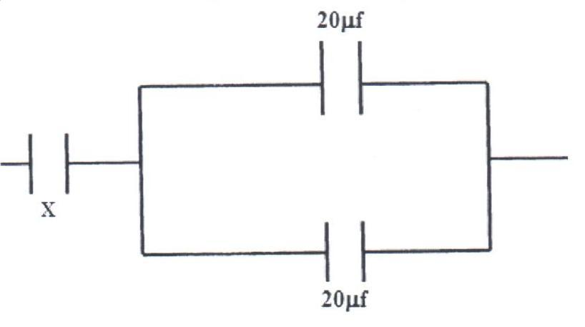

- Explain why a concave mirror is used as a shaving mirror. (1mk)
- A ferromagnetic material was magnetized using single stroking method. Sketch a graph to show how the strength of the magnet being created varies with the number of strokes. (2mks)

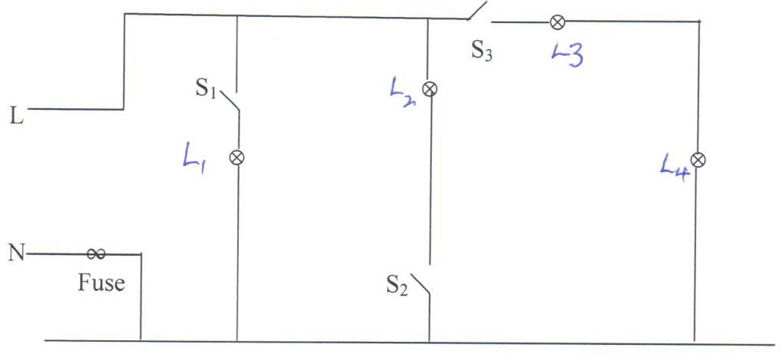
Identify and explain two faults in the light circuit shown in the figure above. (2mks)
- The figure below shows two conducting wires A and B passing through a horizontal piece of cardboard.
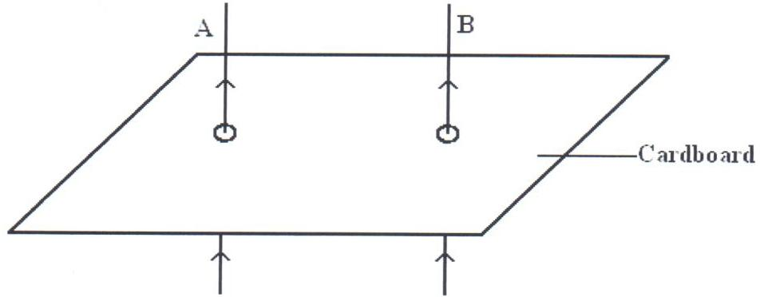

    - Sketch the resultant magnetic field patterns when the currents of the high magnitude are flowing in both wires as
shown. (1mk)
    - What is the resulting effect of the field on the wires at the loose ends? (1mk)
- State one property of high quality X-rays. (1mk)
SECTION B: 55 MARKS
Answer all the questions from this section.
- (a) The figure below shows the cross-section of a ripple tank full of water. a piece of cork floats
on the surface of water and a straight edge vibrator placed at shallow end A to generate waves that travel to deep end B.
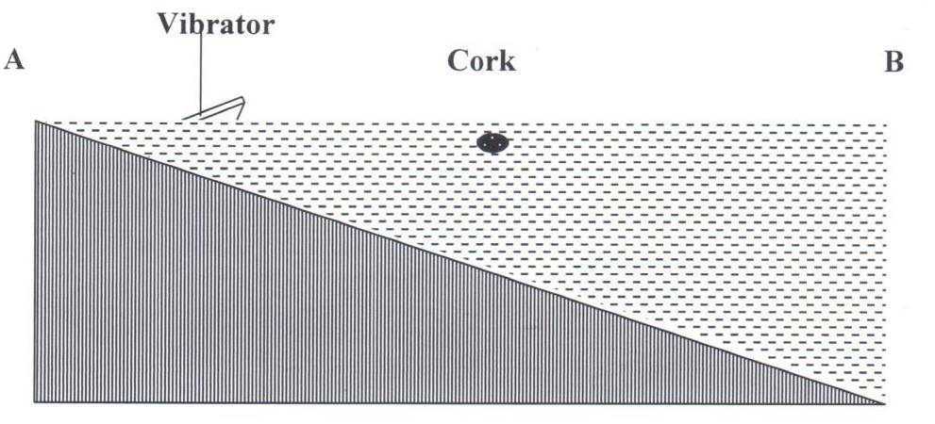
      - Name the type of wave generated on the water surface. (1mk)
      - The cork is observed to stay put despite passing water waves. Explain this observation. (2mks)
      - It was estimated that successive waves pass the cork every 0.25 seconds. If the speed of the waves is 0.28m/s, determine
the frequency and wave length of the waves at that point. (4mks)
      - In the space provided, sketch the wavelength as viewed from a point above the ripple tank. (1mk)

A B

    - A ship sends out an ultrasound whose echo is received after 10 seconds. If the wavelength of the ultrasound in water is
0.05m and the frequency of the transmitter is 50KHz, determine the depth of the ocean.
- (a) The diagram below shows a narrow beam of white light onto a glass prism.
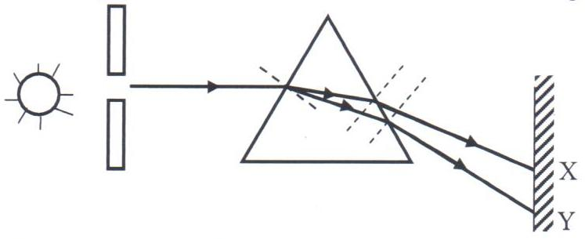

      - What is the name of the phenomenon represented in the diagram? (1mk)
      - Name the colour at X and Y. (2mks)
      - Give a reason for your answer in part (ii) above. (1mk)
      - What is the purpose of the slit? (1mk)
    - The figure below shows the path of a ray of light passing through a rectangular glass block placed in air.
      - Determine the refractive index of glass. (2mks)
      - Given that speed of light in air 3.0 x 10⁸m/s, find the speed of light in the glass. (2mks)
- (a) What do you understand by the term mutual induction? (1mk)
- State two factors that determine the magnitude of e.m.f. induced in a coil. (2mks)
- The diagram below shows an induction coil used to produce sparks.
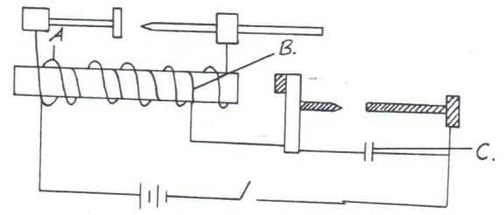

- Name the parts labeled A, B and C. (3mks)
- Explain the purpose of device C. (1mk)
- A transformer is used on a 240V A.C. supply to deliver 12A at 120A to a hating coil. If 20% of energy taken from the
supply is dissipated in the transformer.
  - What is the current in the primary coil? (3mks)
  - Give two causes of 20% energy dissipation in the transformation above. (2mks)

- In an experiment to find the relationship between frequency of radiation and kinetic energy of photoelectrons in a photoelectric device, the following graph was obtained.
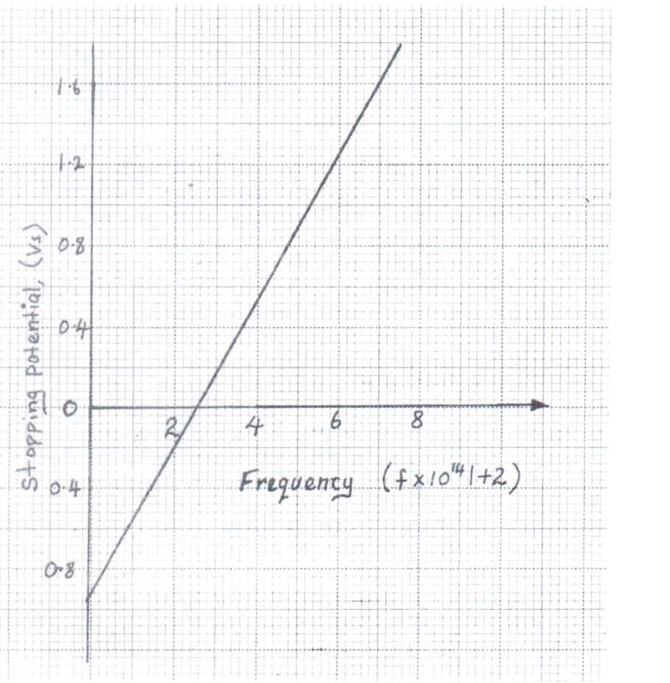
Use the graph to answer the following questions.
    - (i) Determine the threshold frequency. (1mk)
(ii) Find the plank’s constant h. (3mks)
(Take the charge of an electron to be .6 x 10⁻¹⁹C)
(iii) Determine the work function of the metal in joules. (2mks)
    - Determine the threshold wavelength of a metal whose work function is 2.4 x 10⁻¹⁸J. (3mks)
(Take the plank’s constant to be 6.63 x 10⁻³⁴Js)
    - An alternating voltage of peak value 15V and frequency 25Hz is applied to the terminals of a cathode ray oscilloscope. The Y-gain is set at 5v/cm and the time base at 10ms/cm. Draw the trace observed on the screen. (3mks)
1cm
1cm
- (a) What is an extrinsic semi conductor? (1mk)
- The figure below shows a PN junction diode used in a rectifier.
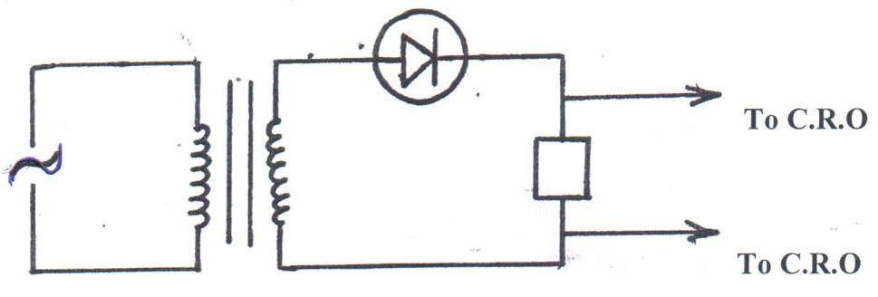
      - What type of rectification is shown? (1mk)
      - Describe how the rectification is achieved. (3mks)
      - State two disadvantages of this rectification. (2mks)
      - In the space provided below, sketch the output signal displayed on the CRO during the rectification process. (2mks)

NANDI EAST, NANDI SOUTH & TINDERET SUB-COUNTIES JOINT EVALUATION 2016

232/3
PHYSICS PRACTICAL
JULY / AUGUST 2016
CONFIDENTIAL INSTRUCTIONS TO SCHOOLS
Each student should be provided with the following apparatus:-
Question 1
- Two dry cells (size D)
- One bulb (1 – 3V)
- Voltmetr (0 – 3V or 0 – 5V)
- Ammeter (0 – 2.5A)
- A mounted nichrome wire (swg) on millimeter scale and labeled X and Y.
- Switch
- Seven connecting wires at least two with crocodile clips.
- Micrometer screw gauge (to be shared)
Question 2
- One metre rule
- Two knife edges each of height 20cm
- One piece of thread of length about 30cm
- An optical pin to act as a pointer
- Some cellotape
- One half metre rule
- One 400g mass or 100g x 4
- One complete stand and clamp
- Vernier calipers (to be shared)
- One concave mirror of focal length 10cm
- One mirror holder
- One white screen

NANDI EAST, NANDI SOUTH & TINDERET
SUB-COUNTIES JOINT EVALUATION 2016

Kenya Certificate of Secondary Education (KCSE)
232 / 3
PHYSICS
PAPER 3
(PRACTICAL)
JULY / AUGUST 2016
TIME: 2 ½ hours
- You are provided with the following:-
- Two dry cells (size D)
- One bulb
- Voltmeter (0 – 3V or 0 – 5V)
- Ammeter (0 – 2.5A)
- A Nichrome wire mounted on a millimeter scale
- Switch
- Seven connecting wire at least two with crocodile clips
- Micrometer screw gauge
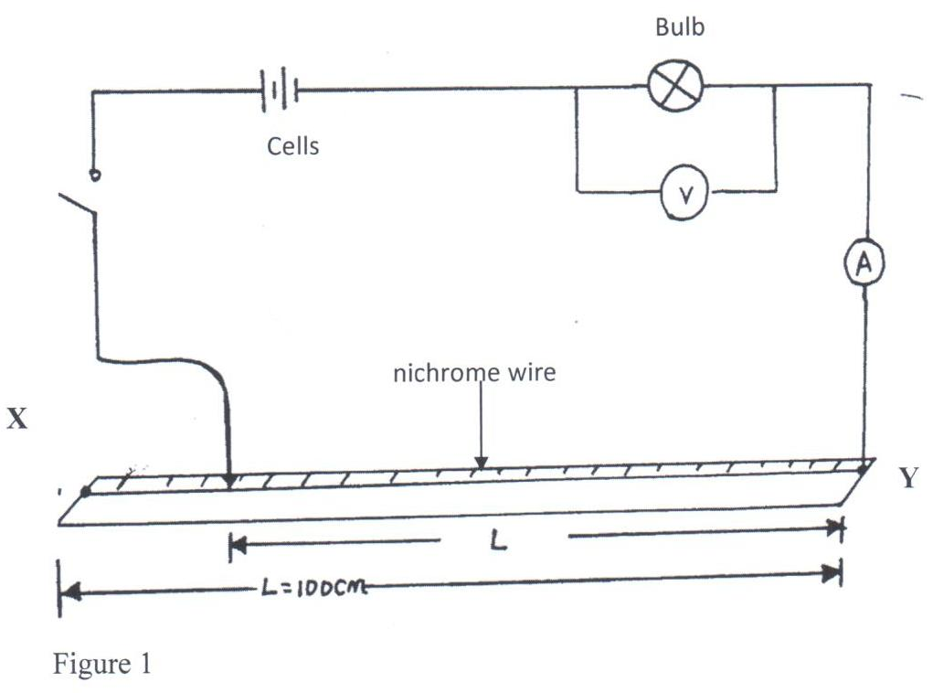
Proceed as follows:
(i) Set up the circuit as shown in figure 1.

- With the crocodile clip at X read and record the voltmeter reading, V and the ammeter reading I in table 1 below. Repeat this procedure for the lengths, L = 80, 60, 40, 20 and 0 respectively.
Table 1
Length, L(cm) | 100 | 80 | 60 | 30 | 40 | 20 | 0
Voltage V(v)
Current, I(A)
Resistance,
(iv) Plot a graph of the ammeter reading (y = axis) against voltmeter reading. (5mks)
(v) Determine the slope of your graph at V = 0.45 volts. (2mks)
(vi) What physical quantity is represented by the slope of the graph at any given point? (1mk)
    - (i) Given the apparatus in a (i) above, draw a diagram of a circuit you would use to determine the current through the resistance wire and the potential difference across it. (2mks)
          - Set up the circuit you have drawn. Record the ammeter reading, I and the voltmeter reading V, when L = 100cm.
V = ………………………………………..v (1mk)
I = …………………………………………A (1mk)

          - Using a micrometer screw gauge, measure the diameter, d, of the nichrome wire. (1mk)
d = …………………………………………m
          - Calculate the quantity, p = 0.785 where L = 100cm. (2mks)
- A. You are provided with the following:-
- A metre rule
- Two knife edges
- Thread
- An optical pin to act as pointer
- Some cellotape
- One half metre rule
- 400g mass or 4 x 100g masses
- Thread 30cm long
- Complete retort stand
- Vernier calipers
Proceed as follows:
        - (i) Measure the width, d and the thickness, t of the metre rule provided using the vernier calipers.
d = ………………………………………….m (1mk)
t = ………………………………………….m (1mk)
(ii) Given that Calculate the value of M.
        - (i) Attach a pointer (optical pin) at the 50cm mark of the metre rule provided using the cellotape
          - Place the metre rule so that it lies horizontal on the two knife edges (wedges) provided.
          - Clamp the half metre rule vertically and place it near the 50cm mark of the metre rule, and adjacent to the pointer as
shown in the diagram 2(a) below.
          - Place the metre rule on the knife edges such that the distance, L, between them is equal to 90cm and is equidistant from
the 50cm mark of the metre rule as shown in figure 2(a).
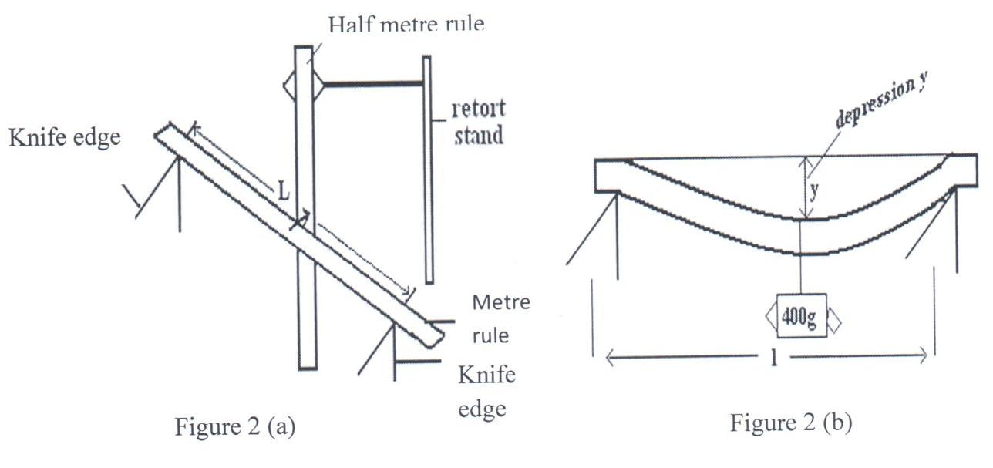

          - Read and record the initial position of the pointer on the half metre rule.
Note: The 0cm mark on the half metre rule should be on top, at the clamped end of the half metre rule and the 50cm mark is below.
        - Suspend a mass of 400g at the 50cm mark of the meter rule using a thread.
        - Read and record the final position of the pointer, L₁, on the half metre rule. Hence find depression, y = L₁ – L₀, of the metre rule as shown in figure 2(b). record the results in table.
        - Remove the mass from the meter rule. Repeat the procedure b(iv) to d above for values of L equal to 80cm, 70cm, 60cm, 50cm and 40cm.
        - Enter your results in table 2 below.
L(cm | 90 | 80 | 300 | 70 | 60 | 50 | 40
Initial pointer reading, L₀(cm)
Final pointer position, L₁(cm)
Depression, y = L₁ – L₀(cm)
Log L
Log y
(6mks)
        - Plot a graph of log y (y-axis) against log L. (4mks)
        - Find the slope S of the graph. (2mks)
        - Given that determine the value of E. (2mks)
2. B
You are provided with the following:-
- A concave mirror
- A mirror holder
- White screen
- A metre rule.
Proceed as follows:-
        - Arrange the concave mirror, mirror holder and the white screen as shown in figure 2(c) below.
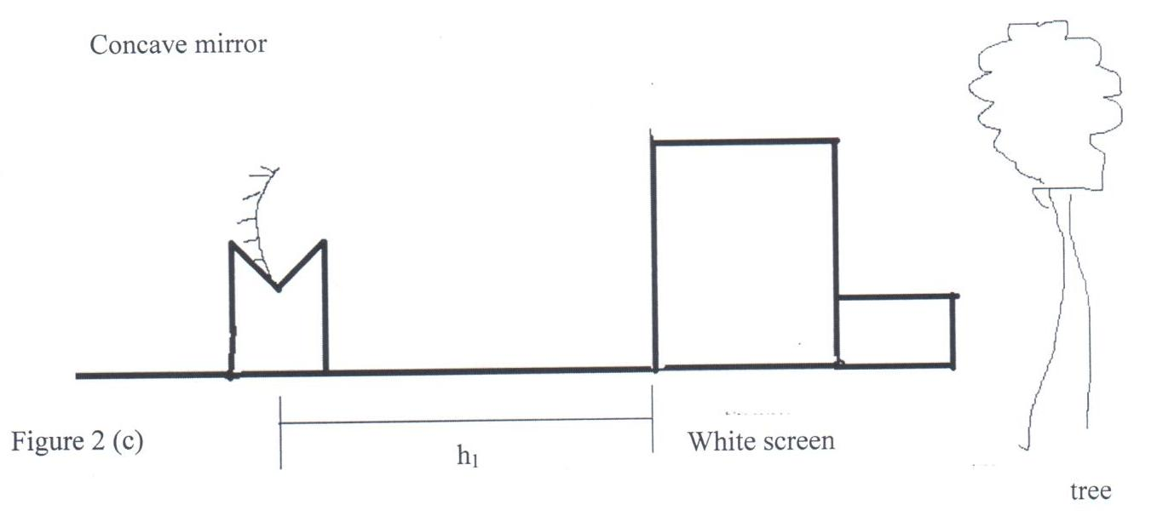

        - Move the concave mirror towards the white screen ………………… clear image of the tree or any far object is seen on the screen.
        - Measure the distance, h₁, between the mirror and the white screen.
h₁ = ………………………….m (½mk)
        - Repeat procedure (b) and (c) to get another value of h₁ and record it as h₂.
h₂ = ………………………….m (½mk)
        - Calculate, h, the average value of h₁ and h₂.
h = …………………………..m (1mk)

