NAME ____________________________________ INDEX NO. _______________
SCHOOL ____________________________________ SIGNATURE _______________
DATE _______________

232/1
PHYSICS
PAPER 1
(THEORY)
JULY, 2017
TIME: 2 HOURS

232/1
PHYSICS
PAPER 1
(THEORY)
TIME: 2 HOURS

INSTRUCTIONS
- Write your name, school and index number in the spaces provided above.
- Sign and write the date of examination in the spaces provided above.
- This paper consists of two sections, section A and B.
- Answer ALL the questions in section A and B in the spaces provided.
- ALL answers and working MUST be clearly shown.
- Non programmable, silent electronic calculators and KNEC Mathematical tables may be used.
- This paper consists of 11 printed pages
- Candidates should check to ensure that all pages are printed as indicated and no questions are missing.
Where necessary take - g = 10 ms^{–2}
- Specific heat capacity of copper = 400 Jkg⁻¹k⁻¹
- Specific heat capacity of oil = 2400 J/kg⁻¹k⁻¹
- Specific latent heat of fusion of ice = 336000 Jkg⁻¹

FOR OFFICIAL USE ONLY
SECTION | question | maximum score | Candidate’s score
A | 1−13 | 25
B | 14 | 12
 | 15 | 12
 | 16 | 11
 | 17 | 11
 | 18 | 09
 | Total | 80

SECTION A (25 MARKS)
Answer ALL the questions in this section in the spaces provided.
- The micrometer screw gauge represented in figure 1 below has a thimble scale of 50 divisions.
Figure 1
What is the reading shown? (1 mark)

- Two identical tubes A and B held horizontally contain air and water respectively. A small quantity of coloured gas is introduced at one end of A while a small quantity of coloured water is introduced to one end of B. State with reasons the tube in which the colour will reach the other end faster. (2 marks)
_________________________________________________________________________________________________________________________________________________________________________________________________________________________________________________________
- In the study of free fall, it is assumed that the force F acting on a given body of mass, m, is gravitational, given by F = ma. State two other forces that act on the same body. (2 marks)
______________________________________________________________________________________________________________________________________________________________________
- Figure 2 below shows a uniform metre rule of weight, 1N with two weights of 0.18N and 0.12N suspended from its ends.
Figure 2
Determine how far from the 0.18N a pivot should be placed in order to balance the metre rule. (3 marks)

- Sketch a velocity time graph for a body moving down a viscous fluid. (1 mark)

- State the reason why banking of a circular part of road is necessary. (1 mark)
______________________________________________________________________________________________________________________________________________________________________
- A lady of mass 80kg walks up a flight of 10 stairs each 20cm high in 5 seconds.
Determine the power she develops. (3 marks)

- Figure 3 shows a fire alarm circuit.
Figure 3
Explain how it works. (3 marks)
____________________________________________________________________________________________________________________________________________________________________________________________________________________________________________________________________________________________________________________________________________
- A light spiral spring extends by 4mm when loaded with a weight W. The spring is connected in series with an identical spring. The combination is loaded with weight W.
Determine the extension of the combination. (2 marks)

- In an experiment to demonstrate atmospheric pressure, a plastic bottle is partially filled with hot water and the bottle is then tightly corked. After some time the bottle starts to get deformed.
- State the purpose of hot water. (1 mark)
______________________________________________________________________________________________________________________________________________________________________
- State the reason why the bottle gets deformed. (1 mark)
______________________________________________________________________________________________________________________________________________________________________
- Explain your answer in (ii) above. (2 marks)
_________________________________________________________________________________________________________________________________________________________________________________________________________________________________________________________
- Define the term angular velocity. (1 mark)
______________________________________________________________________________________________________________________________________________________________________
- Tall buildings are built with lighter materials at the upper part. Explain. (1 mark)
______________________________________________________________________________________________________________________________________________________________________
- State how the pressure in a moving fluid varies with speed of the fluid. (1 mark)
_________________________________________________________________________________________________________________________________________________________________________________________________________________________________________________________

SECTION B (55 MARKS)
Answer ALL questions in this section in the spaces provided.
- a) When a bullet of mass 0.02kg was fired into a block of ballistick pendulum of mass 1.98kg, the block rose through a height of 15cm as in the figure 4 below.
Figure 4
Determine:
- The potential energy of the block and the bullet. (2 marks)

- The velocity of the bullet and block. (2 marks)

b) A trolley of mass 1kg moving at 1 ms⁻¹ collides with a stationary block of wood of mass 2kg.
If the trolley and the block of wood are stuck together and moved a distance of 0.1m before coming to rest. Find the,
- Velocity of the system after collision. (2 marks)

- Kinetic energy after collision. (2 marks)

- The frictional force. (2 marks)

c) In the figure 5 below shows a velocity time graph for an object in a certain motion.
t (s)
V (ms⁻¹)

Figure 5
Describe the motion of the body. (2 marks)
_______________________________________________________________________________________________________________________________________________________________________________________________________________________________________________________________________________________________________________________________________________________________________________________________________________________________

- a) Explain why bodies in circular motion undergo acceleration even when their speed in constant. (1 mark)
_________________________________________________________________________________________________________________________________________________________________________________________________________________________________________________________
b) A particle moving along a circular path of radius 5m describes an arc length 2m every 2 seconds.
Determine:
- Its angular velocity. (2 marks)

- Its periodic time. (2 marks)

c) A stone of mass 40g tied to the end of a string of 50cm and whirled in a vertical circle at 2 revolutions per second. Calculate the maximum tension in the string. (3 marks)

d) Figure 6 below shows a container with small holes at the bottom in which wet clothes have been put.
Figure 6
When the container is whirled at high speed, it is observed that the clothes dry faster.
Explain how the rotation of the container causes the clothes to dry faster. (2 marks)
___________________________________________________________________________________ ___________________________________________________________________________________
______________________________________________________________________________________________________________________________________________________________________
e) State two factors affecting centripetal force. (2 marks)
_________________________________________________________________________________________________________________________________________________________________________________________________________________________________________________________
- a) Distinguish between heat capacity and specific heat capacity. (2 marks)
____________________________________________________________________________________________________________________________________________________________________________________________________________________________________________________________________________________________________________________________________________
b) Figure 7 below shows a set up that may be used to determine specific heat capacity of the liquid.
Figure 7
- Outline the measurements that should be taken in the experiment. (2 marks)
_________________________________________________________________________________________________________________________________________________________________________________________________________________________________________________________

- Explain how the measurements in (i) above are used to determine the specific heat capacity of the liquid. (3 marks)
___________________________________________________________________________________ ___________________________________________________________________________________
______________________________________________________________________________________________________________________________________________________________________
____________________________________________________________________________________________________________________________________________________________________________________________________________________________________________________________________________________________________________________________________________
- State one precaution one would take in modifying the setup for accurate results. (1 mark)
___________________________________________________________________________________
c) An electric heater rated 2kW is used to heat a 400g aluminium container filled with 1kg of water. Assuming no heat is lost to surrounding; calculate the time taken to raise the temperature of the water by 10ºC.
Take specific heat capacity of aluminium as 900Jkg⁻¹k⁻¹ and that of water as 4200Jkg⁻¹k⁻¹. (3 marks)

- a) Define the term work and state its SI units. (2 marks)
_________________________________________________________________________________________________________________________________________________________________________________________________________________________________________________________
b) A crane lifts a load of 500kg through a vertical distance of 4m in 8 seconds. Determine
i) Work done by the crane. (2 marks)

ii) Power developed by the crane. (2 marks)

iii) Efficiency of the crane given that it’s operated by an electric motor rated 2.8kW. (3 marks)

iv) State two factors that contribute to the efficiency being less than 100%. (2 marks)
______________________________________________________________________________________________________________________________________________________________________
- The graph below shows force F applied to a spring and the corresponding length h of the spring.
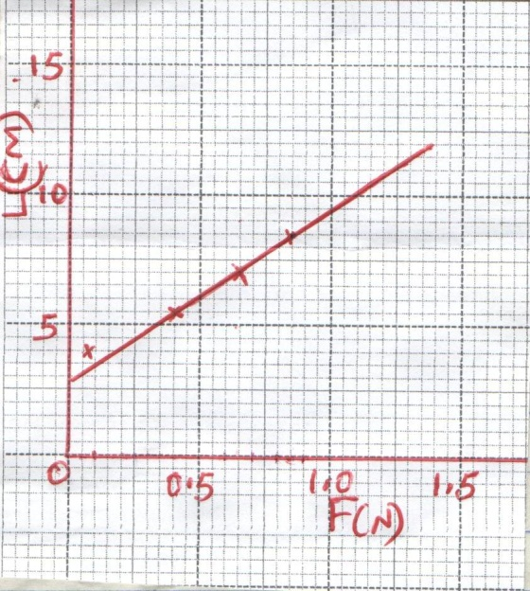
- Use the graph above to find;
- The length of the unloaded spring. (1 mark)

- The gradient of the graph. (2 marks)

- The spring constant in SI unit. (2 marks)

- A body weighing 25N displaces 1.4kg of water when totally immersed in it.
Find the reading of a spring balance supporting the body in water. (2 marks)

- When a stone is placed on water, it sinks. But when the same stone is placed on a block of wood, both are found to float. Explain this observation. (2 marks)
_________________________________________________________________________________________________________________________________________________________________________________________________________________________________________________________

