NAME ____________________________________ INDEX NO. _______________

SCHOOL ____________________________________ SIGNATURE _______________

DATE _______________

232/3

PHYSICS

PAPER 3

(PRACTICAL)

JULY, 2017

TIME: 2½ HOURS

232/3

PHYSICS

PAPER 3

(PRACTICAL)

TIME: 2½ HOURS

INSTRUCTIONS TO CANDIDATES

1. Write your name and index number in the spaces provided above.
2. Sign and write the date of the examination in the spaces provided above.
3. This paper consists of **two** questions.
4. Answer **all** the questions in the spaces provided in the question paper.
5. **All** working must be clearly shown.
6. You are not allowed to start working with the apparatus for the first **¼** hours of the **2½** hours allowed for this paper. This time is to enable you read the question paper and make sure you have all the apparatus you may need.
7. Marks are given for a clear record of the observations actually made, for their suitability and accuracy and the use made of them.
8. Candidates are advised to record their observations as soon as they are made.
9. Mathematical tables and electronic calculators **may be** used in calculations.
10. This paper consists of **7** printed pages.
11. Candidates should check to confirm that all pages are printed as indicated and no questions are missing.

FOR OFFICIAL USE ONLY

|  |  |  |  |  |  |  |  |  |  |
| --- | --- | --- | --- | --- | --- | --- | --- | --- | --- |
| Question 1 | a(i) | (ii) | (iii) | (iv) | (v) | b(i) | (ii) |  | Total |
| Maximum score | 1 | 6 | 5 | 2 | 1 | 2 | 3 |  |  |
| Candidate’s score |  |  |  |  |  |  |  |  |  |

|  |  |  |  |  |  |  |  |  |  |  |  |  |  |  |
| --- | --- | --- | --- | --- | --- | --- | --- | --- | --- | --- | --- | --- | --- | --- |
| Question 2 | a(iv) | b(iii) | c | d(i) | (ii) | e | h(i) | h(ii) | h(iii) | h(iv) |  | Total |  | Grand total |
| Maximum score | 2 | 2 | 6 | 1 | 1 | 2 | 2 | 2 | 1 | 1 |  |  |  |  |
| Candidate’s score |  |  |  |  |  |  |  |  |  |  |  |  |  |  |

1. You are provided with:

* A pendulum bob with a piece of thread attached
* Two wooden blocks
* Clamp, boss and retort stand
* Metre rule
* Half metre rule attached to wooden block
* Cellotape about 10cm long
* Stop watch

**Proceed as follows**

1. Fix the thread between the two wooden blocks and fasten in the clamp. Adjust the thread so that the length L shown below is 50.0cm. Fix the metre rule horizontally to the bench using the cellotape provided. Adjust the clamp so that the pendulum bob is next to the end of the metre rule as shown.

**String**

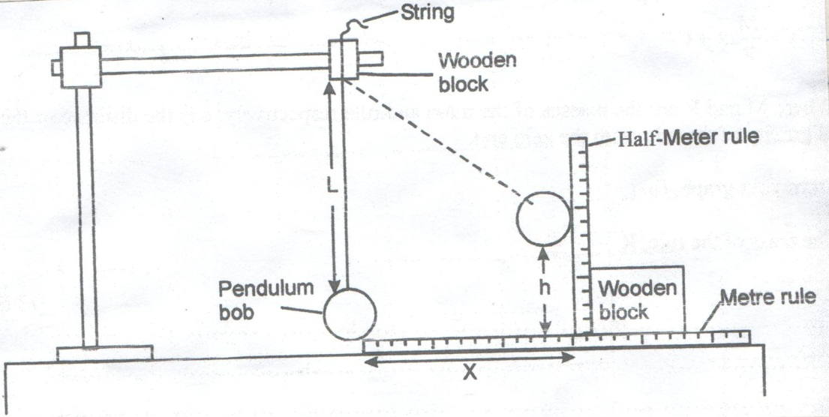

**X**

**Pendulum bob**

**Wooden block**

**h**

**L**

**Half-metre rule**

**Wooden block**

**Metre rule**

1. Displace the marble by a horizontal distance x = 20cm and measure the corresponding vertical displacement h = _____________________cm (1 mark)
2. Repeat the experiment to find h for each of the following values of x : 25cm, 30cm, 35cm, 40cm and 45cm. Complete the table below. (6 marks)

|  |  |  |  |
| --- | --- | --- | --- |
| x (cm) | h (cm) | x2 (cm2) | (cm) |
| 20 |  | 400 |  |
| 25 |  | 625 |  |
| 30 |  | 900 |  |
| 35 |  | 1225 |  |
| 40 |  | 1600 |  |
| 45 |  | 2025 |  |

1. Plot the graph of $\frac{x^{2}}{h}$ (y – axis) against h. (5 marks)
2. Determine the slope of the graph. (2 marks)
3. From the graph, find the value of $\frac{x^{2}}{h}$ when h = 0. (1 mark)
4. Raise the clamp slightly without changing the length L so that the pendulum is free to swing.
5. Determine the period, T, for one oscillation by timing 20 oscillations.

Time for 20 oscillations = _______________________seconds (1 mark)

ii) Period T = _________________________ seconds (1 mark)

iii) Calculate the value of P from the following equation. (3 marks)

T = 2 $π \sqrt{\frac{P}{g}}$ where g = 10ms−2

1. **Part A**

You are provided with:

* A Nichrome wire, 1m long, mounted on mm scale and labelled PQ at the ends.
* A Nichrome wire of length 15cm labelled X
* A 10 ohm resistor labelled Y
* A dry cell (New)
* A switch
* A voltmeter (0 – 2.5V) and
* 8 connecting wires (4 with crocodile clips)

**Proceed as follows**

1. i) Set up your apparatus as shown.

**Cell**

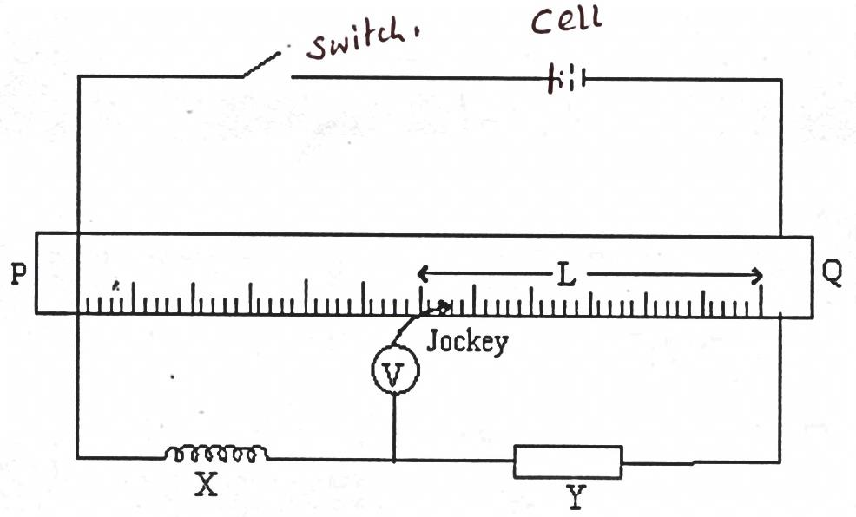

**L**

**Jockey**

**Switch**

**P**

**X**

**Y**

**Q**

i) Close the switch, place the jockey at P and then at Q. (The voltmeter deflects in opposite directions)

iii) Place the contact J, 5cm from Q and record the voltmeter reading.

iv) Repeat this for values of L indicated in table 2. Record the corresponding values of V.

|  |  |  |  |  |  |
| --- | --- | --- | --- | --- | --- |
| Length (cm) | 5 | 15 | 25 | 35 | 45 |
| V (volts) |  |  |  |  |  |

Table 2 (2 marks)

1. i) Interchange the voltmeter terminals. Place jockey at P and make sure the voltmeter pointer deflects to the right.

ii) Place the jockey on the wire 95cm from Q and record the voltmeter reading.

iii) Repeat this for values of L given in table 3.

|  |  |  |  |  |  |
| --- | --- | --- | --- | --- | --- |
| Length (cm) | 95 | 90 | 85 | 80 | 75 |
| V (volts) |  |  |  |  |  |

Table 3 (2 marks)

1. On the same axis plot two graphs of V(y – axis) against L using the values in table 2 and table 3. (6 marks)



1. From your graphs determine.
2. The value of V when L = 0 (1 mark)
3. The value of L where the two graphs intersect. (1 mark)

L = ____________________________________

1. Work out the value of the unknown resistance of wire X, RX using the expression.

Where R**y** is the resistance of resistor **y**. (2 marks)

$\frac{R_{X}}{R_{Y}}= \frac{L}{100-L}$

**Part B**

1. You are provided with the apparatus below.

* Five optical pins and four office pins
* A plain white A4 piece of paper
* Soft board
* Glass slab

Place the glass slab on the white piece of paper and trace its outline. Secure it in place (In its position) by the office pins A, B, C, D as shown in the diagram below.



**(Pin)**

1. i) Fix the pin P firmly at the end of the slab and with your eye E1 at the opposite of the slab fix pin P1 and then P2 in line with the image I of the pin (See diagram)

Remove the pins P1 and P2 and mark their positions P1 and P2 respectively.

ii) Similarly fix P3 and then P4 so that they are in line with the image I of P. Again remove the pins P3 and P4 and mark their positions respectively. Remove the glass slab and pins ABCD

1. Join P1P2 produced with the tracing of the slab outline. Join P3P4 produced to intersect line P1P2.

Label this point of intersection I, the supposed position of the image of pin P.

1. Submit the plain paper used in the experiment. (2 marks)
2. Measure the lengths QP and QI

QP (1 mark)

QI (1 mark)

1. Determine the ratio $\frac{QP}{QI}$ (1 mark)
2. What is the significance of the ratio in (II) above? (1 mark)