NAME ____________________________________ INDEX NO. _______________
SCHOOL ____________________________________ SIGNATURE _______________
DATE _______________

312/1
GEOGRAPHY
PAPER 1
July, 2017
TIME: 2 HOURS 45 MINUTES

312/1
GEOGRAPHY
PAPER 1
TIME: 2 HOURS 45 MINUTES

INSTRUCTIONS TO CANDIDATES
- This paper has two sections, A and B.
- Answer all the questions in section A.
- Answer question 6 and any other two questions from section B.
- All answers must be written in the answer booklet provided.
- This paper consists of 4 printed pages.
- Candidates should check the question paper to ascertain that all pages are printed as indicated and that no questions are missing

SECTION A (25 MARKS)
Answer ALL the questions in this section
1. a) State briefly three ways how air pressure influences the weather of a place. (3 marks)
b) Identify two Global winds that influence the climate of Kenya. (2 marks)

2. a) Give two examples of chemically formed sedimentary rocks. (2 marks)
b) State three conditions necessary for the growth of coral. (3 marks)

3. a) Name the two theories that explain the origin of the earth. (2 marks)
b) Give three proofs that the earth is oblate spheroid. (3 marks)

4. a) Name the categories of lakes formed by earth movement. (2 marks)
b) Give two examples from East Africa of each category named in (a). (2 marks)

5. a) Define of hydrological cycle. (2 marks)
b) State four factors that determine the amount of water that sinks into the ground or flows on the surface. (4 marks)

SECTION B (75 MARKS)
Answer question 6 and any other two questions from this section.
6. Study the map of Kitale 1:50,000 (sheet 75/3) provided and answer the following questions.
a) i) Identify two human made features found at the grid square 2320. (2 marks)
ii) What is the altitude of the highest point in the area covered by the map? (2 marks)
iii) Give three types of natural vegetation found in the area East of Easting 40 and North of Northing 27. (3 marks)
b) i) What is the bearing of air photo principle point at grid square 2931 from the air photo principle point at grid square 3426. (2 marks)
ii) Measure the distance of the dry weather road (C640) from the junction at point M(345142) to the junction at N(416200) give your answer in kilometres. (2 marks)
c) i) Draw a rectangle measuring 3 cm by 4 cm to represent the area in the map extract bounded by Easting’s 28 and 31 and Northing’s 11 and 15. (1 mark)
ii) On the rectangle drawn, mark and name the following;
- Loose surface road (1 mark)
- Air photo principle point (1 mark)
- Swamp (1 mark)
- Pond (1 mark)

d) i) Identify four social services offered in Kitale Municipality. (4 marks)
ii) Describe the drainage of the area covered by the map. (5 marks)

7. Use the map below to answer questions (a) and (b).
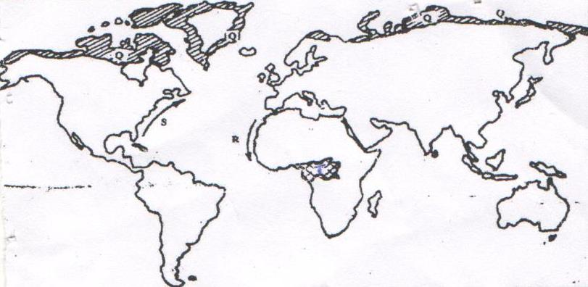
T
Q
Q
Q

Q
R
S

a) Name;
i) The type of climate found in the shaded area marked Q. (1 mark)
ii) The ocean current marked R and S. (2 marks)
b) Describe the characteristics of the type of climate found in the shaded area marked T. (8 marks)
c) Explain how the following factors influence climate.
i) Altitude (4 marks)
ii) Distance from the sea (4 marks)
d) i) Explain two effects of climate change to the physical environment. (4 marks)
ii) State two climatical conditions experienced in the Sahara desert. (2 marks)

8. a) i) Identify two factors that influence glacial erosion. (2 marks)
ii) The diagram below shows the long profile of a glacial trough.
Study it carefully and answer the questions that follow.
Name the parts labeled 1 to 6. (6 marks)
b) Describe the four various ways in which tills are formed at the coast. (8 marks)
c) i) What is an erratic? (2 marks)
ii) Give three examples of areas with erratics. (3 marks)
d) A field study was carried out in an area affected by wind action.
i) List two types of interviews the study would have made use of. (2 marks)
ii) Give two problems the researcher would have experienced. (2 marks)

9. a) What is natural vegetation? (2 marks)
b) i) Give the types of grassland vegetation found in the following countries. (3 marks)
- New Zealand
- Argentina
- South Africa
ii) State two factors why mountain tops have no vegetation. (2 marks)
c) i) Explain four ways in which coniferous forest is adapted to the climatic conditions. (8 marks)
ii) Explain how the following factors influence the distribution of vegetation.
- Altitude (2 marks)
- Human beings (2 marks)
d) You are planning to carry out a fieldstudy on the forest vegetation near your school.
i) State four reasons why it is necessary to have a route map. (4 marks)
ii) Give two reasons why you need a tape measure. (2 marks)

10. a) i) What is soil? (2 marks)
ii) Give three components of soils. (3 marks)
b) The diagram below shows different layers of soil. Use it to answer questions b) i), ii), iii).
i) Name the soil layers marked B, C, and D. (3 marks)
ii) Give two main processes of soil formation which takes place in horizon A. (2 marks)
iii) Name four characteristics of soil in horizon B. (4 marks)
c) Explain how the following helps in the maintenance of soil fertility and quality.
- Crop rotation (2 marks)
- Mixed farming (2 marks)
- Bush fallowing (2 marks)
d) State five significances of soils to human activities. (5 marks)

