NAME ADM NO CLASS
DATE SIGNATURE INDEX NUMBER
BIOLOGY
PAPER 2
TIME: 2 HOURS
TERM TWO 2021
MECS CLUSTER JOINT EXAMINATION
Kenya Certificate of Secondary Education

INSTRUCTIONS TO CANDIDATES
- This paper consists of TWO sections A and B.
- Answer ALL questions in section A in the spaces provided
- In section B answer question 6(compulsory) and either question 7 or 8 in the spaces provided after question 8
- Candidates should check the question paper to ascertain that all the pages are printed and that no questions are missing
SECTION A 40 MARKS
- A potted plant was placed in each of the following conditions for a period of one hour in the order given and transpiration in each hour was measured. The air temperature was 18⁰C throughout the experiment.

CONDITIONS | RELATIVE HUMIDITY | TRANSPIRATION g/hr
- Still air in sunlight and shade | 70 | 1.2
- Moving air only | 70 | 1.6
- Still air in bright sunlight | 70 | 3.75
- Still air in dark chamber | 100 | 0.20

- Account for the rate of transpiration in
- Condition C (3mks)
.
- Condition D (3mks)

- Name the apparatus used to measure the rate of transpiration. (1mark)

- Give one modification in the stomata of xerophytes that reduce the rate of transpiration. (1 marks)

- Sickle cell anaemia is a disease in which people produce abnormal haemoglobin in their red blood cells. Letter H represents the gene for normal haemoglobin while letter S represent the gene for abnormal haemoglobin. Heterozygous individuals are said to have sickle cell trait.
- If both parents have sickle cell trait, work out the proportion of their offspring that have sickle cell anemia. (5marks)

- Explain why sickle cell trait is more prevalent in tropical countries than temperate countries.
(2marks)

(c)Name any other disease caused by gene mutation. (1mk)

- Equal volumes of three different sugar solutions were placed in visking tubings X, Y and Z. The tubings were placed in a beaker containing 5%sugar solution. The set up was left for two hours. The results were as shown in the diagram below.
Z
Z
Y
Y
X
X
End of the experiment
Start of the experiment

- Name the process being investigated (1mark)

- What is the significance of set up X in the experiment? (1mark)

- Account for the observations in set up Y and Z. (4mks)
Y
Z
- Name a structure in cells that can be compared to the visking tubing. (1mark)

- Explain how high temperature above 40⁰C will affect the process being investigated in the cells of organism. (1marks)

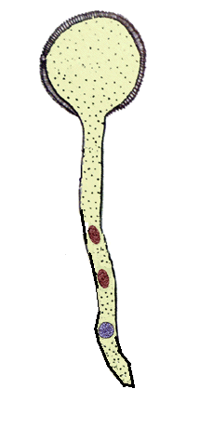
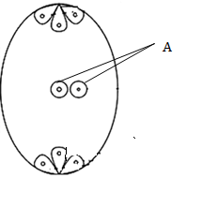
- The diagrams below show changes in the life cycle of a flowering plant.
G
D
B
A

- Name the parts labelled A, B and G. (3marks)

A
B-
G-
- State the function of the part labelled D. (1mark)
- (i) What will part A develop into after fertilization? (1mark)

(ii) Define the term parthenocarpy. (1mark)

- Name two features in flowering plants that prevent self-fertilization (2marks)

- The diagram below represents one of the joints in the mammalian body.
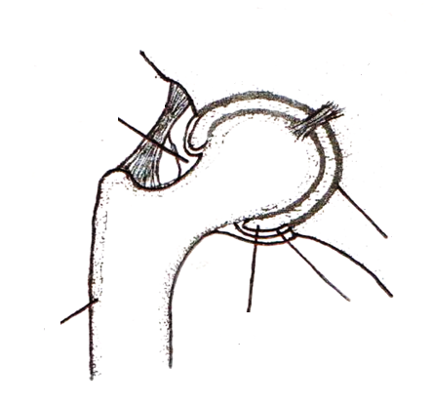
U
Z
W
Pelvis
Capsule
Synovial membrane

- Name the type of joint shown in the diagram. (1mark)

- Name each of the parts labeled Z and U. (2marks)
Z-
U-
- State two functions of the fluid found in W. (2marks)

- Identify the type of muscle found attached to bone Z. (1mark)

- State two differences between the muscle identified in (d) above and those found in the gut. (2marks)

SECTION B (40MARKS)
Answer question 6 (compulsory) and either question 7 or 8 in the spaces provided after question 8.
- In an experiment to investigate a certain process in a given plant species, the rate of carbon (IV) oxide consumption and the rate of carbon (IV) oxide released were measured over a period of time of the day. The results of the investigation are shown in the table below.
Time of day | 6am | 8am | 10am | 12pm | 2pm | 4pm | 6pm | 8pm | 10pm | 12am
CO₂ consumption (mm³/min) | 0 | 43 | 69 | 91 | 91 | 50 | 18 | 0 | 0 | 0
CO₂ release (mm³/min) | 38 | 22 | 10 | 3 | 3 | 6 | 31 | 48 | 48 | 48
- On the same axis, plot graphs of volume carbon (IV) oxide against time (7mk

- Name the biochemical process represented by:
- Carbon (IV) oxide consumption (1 mark)

- Carbon (IV) oxide released (1 mark)

- Account for the shape of the curve for:
- Carbon (IV) oxide consumption (3 marks)

- Carbon (IV) oxide released (3marks)

- (i) What is meant by the term compensation point? (1marks)

(ii) From the graph state the time of the day when the plant attains compensation point (2 mark)

- Explain how temperature affects the rate of CO₂ consumption in a plant. (2 marks)

- a) Explain how the villi in the small intestines are adapted to their functions. (10 marks)
b) Describe the photosynthetic theory as a mechanism of opening and closing of the stomata. (10marks)
- a) Explain how ultrafiltration occurs within the kidneys. (5marks)
- Describe water pollution under the following headings:
- Causes (5marks)
- Effects (5marks)
- Control measures. (5marks)

