NAME…………………………………………………..INDEX NO………………………..

ADM NO……………CLASS…………DATE……………..SIGNATURE…………….
231/3
BIOLOGY
PAPER 3
PRACTICAL
TIME: 1¾ HOURS

MECS CLUSTER JOINT EXAMINATION TERM 2 2021
Kenya Certificate of Secondary Education

Instructions to Candidates
- Write your name, Index number and your other details in the spaces provided above.
- Spend the first 15 minutes of the time allocated to read through the question paper.
- Answer all the questions in the spaces provided only.
- Wrong spelling especially of biological terms will be penalized.
FOR EXAMINER’S USE ONLY
QUESTION | MAXIMUM SCORE | CANDIDATE’S SCORE
1 | 18
2 | 10
3 | 12
TOTAL | 40

This paper consists of 6 printed pages

Candidates should check the question paper to ascertain that all the pages are printed as indicated and that no questions are missing.

- (a) You are provided with solution Q, Solution W, Visiking tubing and a thread. Divide solution Q and W into two halves in separate beakers. Use one half for Procedure 1 and second half for Procedure II.
Procedure 1
- Using reagents provided and one half of solution Q, carry out tests to determine the food substance present in solution Q.
- Record the procedure, observations and conclusions in the table below.
- Repeat the same procedure using the half of solution W. (10mks)

Test | Food Solution | Procedure | Observation | Conclusion
Starch | Q
 | W
Reducing  sugars | Q
 | W

Procedure II
(Clean and rinse properly any of the beakers that contained Solution W or Solution Q for use in this procedure)
- Tie one end of visking tubing provided with a thread tightly.
- Measure about 5ml of solution Q into the visking tubing (Stir the solution thoroughly before use).
- Tie the other end tightly to ensure that there is no leakage.
- Immerse the visking tubing and its content into a beaker containing solution W.
- Allow it to stand for 20 minutes.
- After 20 minutes empty the content of the visking tubing into a clean empty beaker.

b) Use the solution that was in the visking tube to test for starch and reducing sugars. Record the observations and conclusions in the table below:

Test | Observations | Conclusions
Starch test

Reducing sugars test

(4mks)
  - Name the physiological process being investigated in the experiment. (1mark)
……………………………………………………………………………………………

  - Which structure in the living organism is represented by the visking tubing? (1mark)
………………………………………………………………………………………………

  - Account for the observation made in the table (b) above. (2marks)
………………………………………………………………………………………………………………………………………………………………………………………………………………………………………………………………………………………………………………………………………………………………………………………………………………………………
2 a) Study the photograph below. The specimen had been placed in adequate light at a horizontal
position for one week.
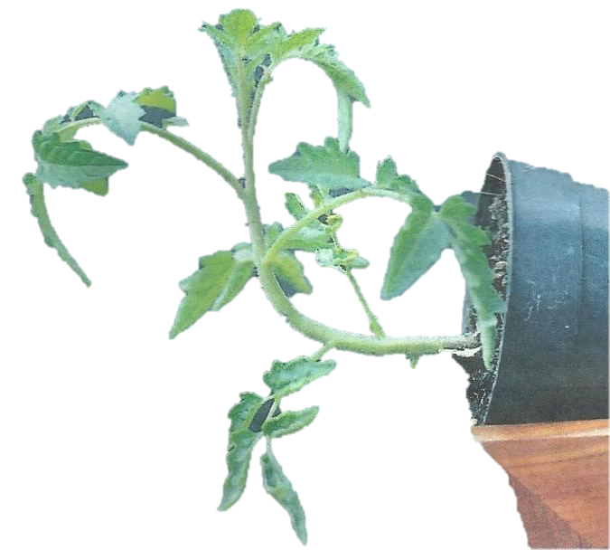

- What was the aim of this experiment? (1 mark)
……………………………………………………………………………………………………………………………………………………………………………………………………………………

- What would be the result if seedling is placed on a working klinostat? (1 mark)
………………………………………………………………………………………………………………………………………………………………………………………………………………………………………………………………………………………………………………………
- Explain how the growth curvature occurred. (3 marks)
……………………………………………………………………………………………………………………………………………………………………………………………………………………………………………………………………………………………………………………………………………………………………………………………………………………………………………………………………………………………………………………………………………………………………………………………………………………………………………………………………………………………………………………………………………………………………………………………………………………………………………………………
- Study the Photographs below and answer the questions that follows :

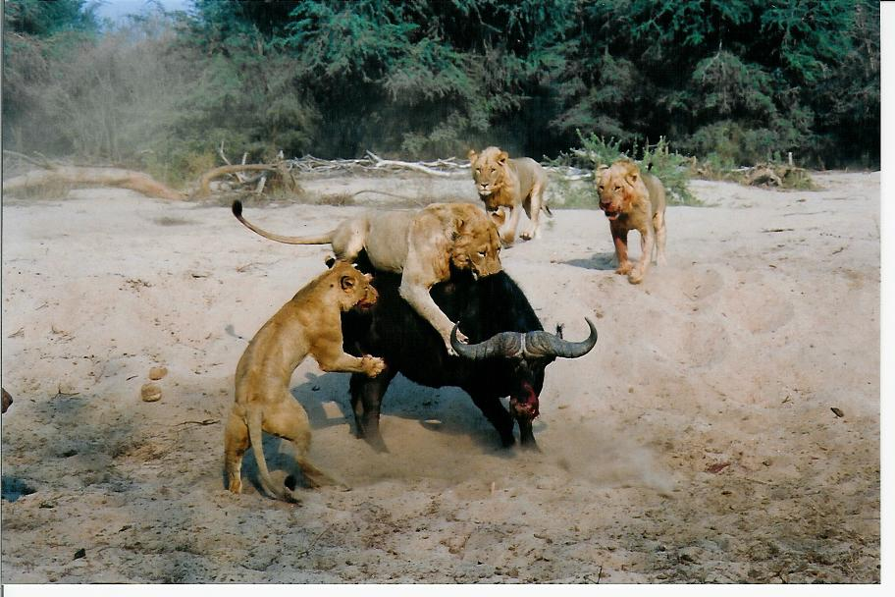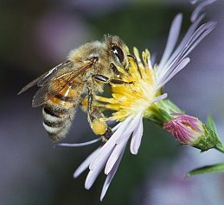
Photo F
Photo E
i) Name the type of relationship in Photograph E and F:
Photograph E ……………………………………………………………………….(1mk)

Photograph F ………………………………………………………………………(1mk)
ii)What is the importance of the relationship taking place in Photograph E.(1mk)
………………………………………………………………………………………………………………………………………………………………………………………………………………………………………………………………………………………………………………………
iii) Using observable features only explain two ways in which the flower is adapted for the activity
taking place in Photograph F. (2mks)
…………………………………………………………………………………………………………………………………………………………………………………………………………………………………………………………………………………………………………………………………………………………………………………………………………………………
3. The photographs below shows bones obtained from different regions of a mammalian body. The
photographs are in different views.
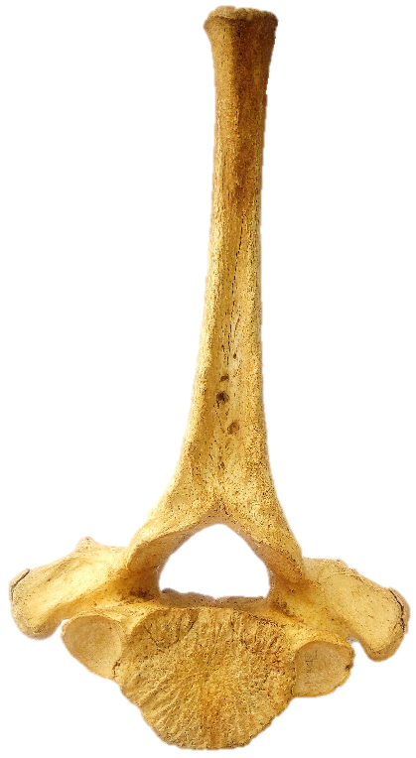
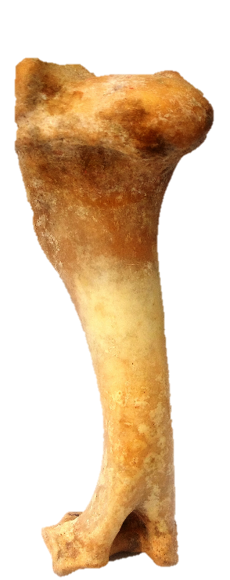
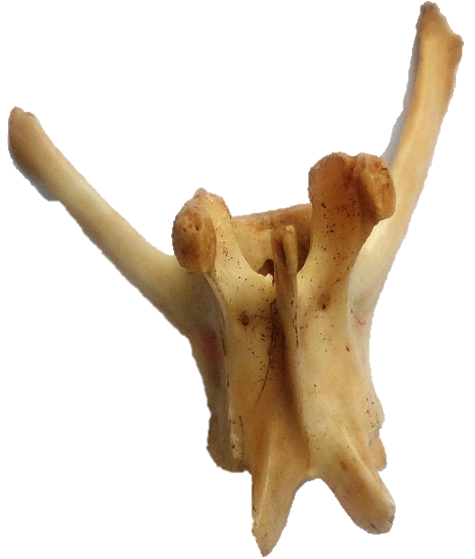
Anterior view of bone A
Anterior view of bone C
Dorsal lateral view of Bone B
T

- Identify the bones. (3 marks)
A……………………………………………………………
B……………………………………………………………
C……………………………………………………………

- Name the regions from which bone B was obtained from. (1 marks)
………………………………………………………………………………………………
………………………………………………………………………………………………
- State two distinguishing features of the bone in photograph labeled B. (2 marks)
……………………………………………………………………………………………………………………………………………………………………………………………………………………………………………………………………………………………………………………………………………………………………………………………………………………………………………………………………………………………….

- State the significance of the part labeled T in the photograph of bone A. (1 mark)
……………………………………………………………………………………………………………………………………………………………………………………………….

- With reason state the type of joint formed at the distal and proximal ends of specimen C.
( 4 marks)
- Distal end ……………………..……………………………………………………….
Reason ……………………………………………………………………………………………………………………………………………………………………………………………………
- Proximal end. ……………………..………………………………………………………
Reason ……………………………………………………………………………………………………………………………………………………………………………………………………..
- Name the bone that articulates with the proximal end of the bone in photograph labelled C. ………………………………………………………………………………(1 mark)

