NAME ADMN NO.

DATE SIGNATURE
232/1
PHYSICS
PAPER 1
TIME: 2 HOURS.
DECEMBER 2021

MURANG’A EXTRA COUNTY SCHOOLS (MECS) EXAM -2021
INSTRUCTIONS TO CANDIDATES
- Write your name and admission number in the spaces provided above.
- Sign and write the date of examination in the spaces provided above
- This paper consists of TWO sections A and B.
- Answer ALL the questions in section A and B in the spaces provided.
- All working MUST be clearly shown.
- Non programmable silent calculators may be used.
- ALL numerical answers must be expressed in decimal notation.
- This paper has 12 pages. It is the responsibility of the candidate to ascertain that all the pages are printed as indicated and that no questions are missing.
- Candidates should answer the questions in English.
Constant: g=10N/kg or 10m/s²
FOR OFFICIAL USE
Section | Question | Max. Score | Candidate’s score
A | 1-13 | 25
B | 14 | 12
 | 15 | 14
 | 16 | 09
 | 17 | 08
 | 18 | 12
TOTAL SCORE |  | 80
SECTION A: 25 MARKS
- The figure below shows a part of micrometer screw gauge with a zero error of -0.04mm. Write down the exact length measured. (2 marks)
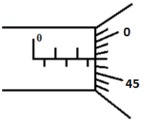
- The following figure shows a rod made of wood on one end and metal on the other end suspended freely with a piece of thread so that it is in equilibrium.
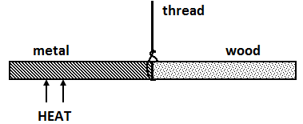
The side made of metal is now heated with a Bunsen flame. State and explain the observation that will be made after some time. (2marks)

- Estimate the size of an oil molecule if a drop of oil of volume 6.0 × ${10}^{-10}$ m³ forms a patch of diameter 32 cm on a water surface. (2marks)

- An immersion heater rated at 180W is placed in a liquid of mass 2kg. When the heater is switched on for 7.5 minutes the temperature of the liquid rises by 40ºC. Determine the specific heat capacity of the liquid. (3marks)

- Other than increase in temperature state one other way of lowering the surface tension of a liquid. (1mark)

- The figure below shows a uniform bar pivoted at its centre and is at equilibrium.
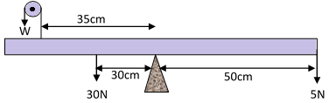
Determine the value of W. (3marks)

7.(i) Sketch a velocity – time graph on the axes provided for an object thrown vertically upwards with initial velocity $20 {ms}^{-1}$ and takes 2 seconds to reach maximum height. (1 mark )

Velocity
Ms⁻¹

0 1 2 3 4 5 6
time(s)
(ii) Calculate the maximum height attained by the object in 7 (i) above ( 2 marks)

8. In an experiment to demonstrate Brownian motion, smoke was placed in a smoke cell and observed under a microscope. State and explain the observation. (2marks)

9. State a reason why a burn from steam at 1000C is more severe than a burn from boiling water at the same temperature (1 mark)

10. Explain why the rate of heat flow in a conductor increases with increase in cross-section area.
( 1 mark )

11.A piece of paper is held in front of the mouth and air blown horizontally over the paper, it is observed that the paper get lifted up. Give reason for the observation. (1mark)

12. In the study of free fall, it is assumed that the gravitational force F acting on a given body of mass, m is given by F = mg. State two other forces that act on the same body. (2marks)

13.A girl in a school in Nakuru plans to make a barometer using a liquid of density 1.25gcm⁻³. If the atmospheric pressure in the school is 93750Nm⁻². Determine the minimum length of the tube that she will require? ( 2 marks)

SECTION B (55MARKS)
ANSWER ALL QUESTIONS IN THIS SECTION

- a) (i) State Archimedes’ Principle. (1mk)

(ii) A metal block weighs 1.04N in air, 0.64N when fully immersed in water and 0.72N when fully immersed in a liquid. If the density of water is 1000 kg m⁻³, find:

I) the density of the liquid. (2mks)

II) The density of the metal block. (2mks)

b) A crane lifts a load of 2000Kg through a vertical distance of 3.0m in 6 seconds.
Determine the;
i) Work done by the crane. (2mks)

ii) Power developed by the crane. (2mks)

iii) Efficiency of the crane given that it is operated by an electric motor rated 12.5kW. (2mks)

15. (A) The figure below shows a hydraulic brake system.
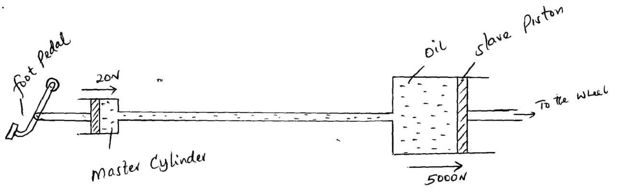

A force of 20 N is applied on the foot pedal connected to a master cylinder piston of area 500cm². This causes a stopping force of 5,000N on one wheel. Calculate.

- Pressure on the master cylinder (2 marks)

- Area of the slave cylinder piston. ( 2 marks)

- Velocity ratio of the system. ( 2 marks)

B) I) State the reason why a body in uniform circular motion is said to be accelerating. (1 mark)

II) A particle moving along a circular path of radius 5cm describes an arc of length 2cm every second. Determine:
- Its angular velocity. (1mark)

- Its periodic time. (2marks)

c) A stone of mass 150g is tied to the end of a string 80cm long and whirled in a vertical circle at 2rev/s. Determine the maximum tension in the string. (3marks)

(d) State one factor affecting centripetal force (1mark)

- a) Define “specific heat capacity” of a substance (1mark)

b) In an experiment, an aluminum block of mass 2kg was heated using an immersion heater as shown in figure below.
A
(+)
(-)
V
Thermometer
Aluminium block
Insulating cover

The temperature of the block was recorded every minute for exactly five minutes and then the heater was switched off. A graph of temperature in ºC against time in minutes for the experiment is shown below.
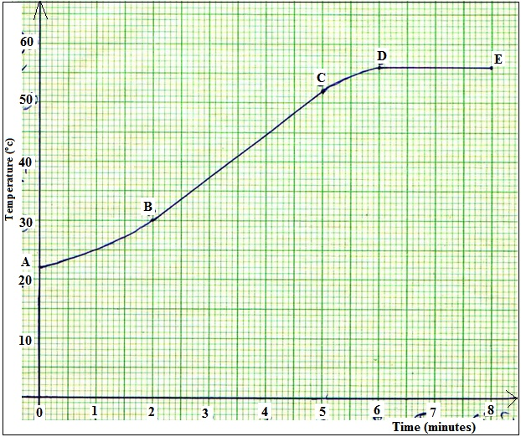

Using the graph, Suggest why;
- The reading in the thermometer rose relatively slowly between point A and B. (1mark)

- The temperature continued to rise after the heater was switched off (1mark)

- Use the straight portion of the graph (B to C) to calculate the specific heat capacity of the aluminum given that the voltmeter reads 22.0 V and ammeter 10.0 A throughout the experiment. (3 marks)

- Giving a reason explain why the value calculated in b) (iii) will not be accurate. (1 mark)

- A faulty thermometer reads 40⁰Cwhen dipped in pure melting ice and 240⁰C when in contact with steam above pure boiling water. What would the same thermometer read when put in water at 50⁰C? ( 2 marks)

- (a) A stone is thrown horizontally with a velocity of 45m/s from the top of a vertical tower 50m high. Determine:
- The time taken by the bullet to reach the bottom of the ground (2 marks)

- The maximum horizontal distance covered by the bullet (2marks)

b) i) Distinguish between elastic and inelastic collision. (1mark)

ii) A car of mass 800 kg collides heads on with a truck of mass 5000kg travelling at 40 m/s. The car is thrown to the bonnet of the truck which continues to move after impact at 10 m/s in the original direction. How fast was the car moving? (3marks)

18. Figure below shows the apparatus that a student used to investigate the relationship between temperature and pressure of a fixed mass of a gas at constant volume.
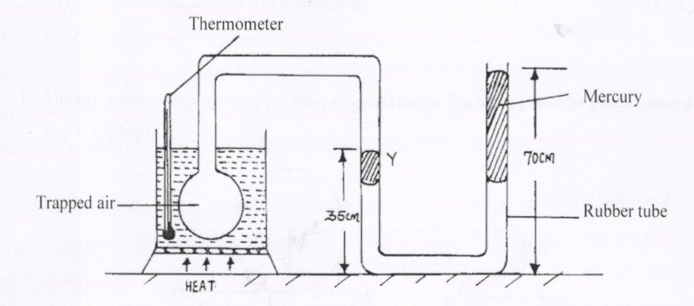

a) i) Describe how the student should ensure that all air trapped has the same temperature as indicated by the thermometer. (2 marks)

ii) Give a reason why it is necessary to ensure that before taking any reading on pressure, the liquid level should reach the level marked Y. (1 mark)

(b) The pressure P of a fixed mass of a gas at a constant temperature of T = 200K is varied continuously and values of corresponding volume recorded. A graph P against $\frac{1 }{V }$is shown on grid below.

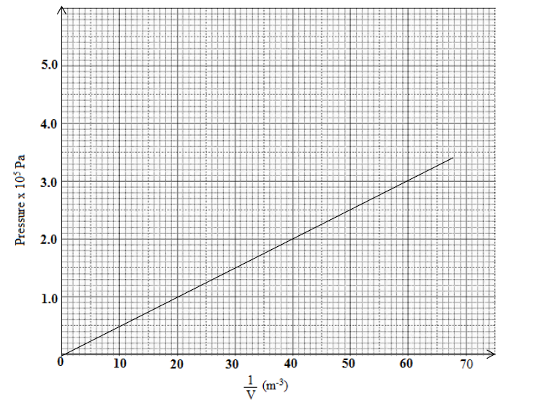
- determine the volume of the gas when the pressure reads 2.8 x 10⁵pa (2 marks)

- find the value of R given that the pressure P and volume V of the gas are related by the equation$T=\frac{PV}{2R}$ , where R is a constant (4 marks)

(c) The pressure of the air inside a car tyre increases if the car stands out in the sun for some time on a hot day. Explain the pressure increase in terms of the kinetic theory of gases. (2 marks)

(d) A gas is put into a container of fixed volume at a pressure of 3.6 x 10⁵ Nm⁻² and temperature 27°C. The gas is then heated to a temperature of 177°C. Determine the new pressure (3 marks)

THIS IS THE LAST PRINTED PAGE.

