NAME: ADM NO: - CLASS:
PHYSICS PAPER 2 TIME: 2 HOURS
M.E.C.S CLUSTER EXAMINATION
FORM FOUR END OF TERM 2, DECEMBER 2021
INSTRUCTIONS TO CANDIDATES
- This paper consists of two sections A and B.
- Answer all the questions in sections A and B in the spaces provided.
- Non programmable silent electronic calculators may be used.
- Candidates should check the questions to ascertain that all the pages are printed as indicated and that no question is missing.
SECTION A 25MARKS.
Answer all questions in the space provided
- What is meant by virtual image? (1mk)

……………………………………………………………………………………………..

- i) Arrange the following electromagnetic waves in order of their increasing wavelength visible light, X-rays, Microwaves, infrared radiation. (1 mk).

………………………………………………………………………………………………………

………………………………………………………………………………………………………

ii) Name one device that can be used to detect infrared radiation. (1mk)

………………………………………………………………………………………………………

- Indicate the direction of the magnetic field in the conductor carrying current shown below. (1mk)
XX

- i) Define the term ‘doping’. (1mk)

………………………………………………………………………………………………………

………………………………………………………………………………………………………

ii) The diagram below shows a p – n junction diode.

p n

Complete the diagram above to show how the diode can be connected in reverse bias mode. (1mk)

- Given that the refractive index of glass is 3/2 and that of water is 4/3. Determine the value of angle in the figure below. (3mks)

50º
θ
Water
Glass

………………………………………………………………………………………………………

………………………………………………………………………………………………………

………………………………………………………………………………………………………

………………………………………………………………………………………………………

- State two factors that determine how far X- rays penetrate a given material. (2mks)

………………………………………………………………………………………………………

………………………………………………………………………………………………………

- i) Uranium ²³⁸ U emits an alpha particle to become another element X as shown in the
₉₂
equation below.

$238$ a
U X + alpha particle
92 b

Determine the values of a and b. (2mks)

………………………………………………………………………………………………………

………………………………………………………………………………………………………

ii) State two sources of background radiation. (2mks)

………………………………………………………………………………………………………

……………………………………………………………………………………………………
- i) Explain why Nichrome wire is used as a heating element rather than copper. (1mk)

………………………………………………………………………………………………………

………………………………………………………………………………………………………

ii) An electric bulb is rated 240V, 100W. Calculate the amount of current through its filament.
(2mks)
………………………………………………………………………………………………………
………………………………………………………………………………………………………
………………………………………………………………………………………………………
iii) If ten such bulbs were used in a house for lighting, determine the most suitable fuse value. (1mk)
………………………………………………………………………………………………………
………………………………………………………………………………………………………
- State two conditions for the formation of a stationary wave. (2mks)

………………………………………………………………………………………………………
………………………………………………………………………………………………………
- A gun is fired and an echo heard at the same place 0.6s later. How far is the barrier which reflected the sound from the gun? (Speed of sound in air = 330m/s). (3mks)

………………………………………………………………………………………………………
………………………………………………………………………………………………………
………………………………………………………………………………………………………
………………………………………………………………………………………………………
- State how polarization is reduced in a dry cell. (1mk)
………………………………………………………………………………………………………
- A negatively charged rod is brought near the cap of lightly charged electroscope. The leaf divergence first reduces but as the rod comes nearer, it diverges more. State the charge of the electroscope. (1 mk)

………………………………………………………………………………………………
SECTION B (55 MARKS).
Answer all the questions in the spaces provided
- a) State one condition under which ohm’s law is obeyed in a metal conductor. (1mk)

………………………………………………………………………………………………………
b) You are provided with three resistors R₁, R₂ and R₃ connected in parallel. If the p.d across them is V, show that an expression for the effective resistance of the three resistors is given by. 1 = 1 + 1 + 1 (3mks)
R_{T} R₁ R₂ R₃

………………………………………………………………………………………………………
………………………………………………………………………………………………………
………………………………………………………………………………………………………
………………………………………………………………………………………………………
c) The diagram below shows the resistors connected in a circuit.

3V
4Ω
6Ω

3Ω

Calculate:
i) The total resistance in the circuit. (2mks)

………………………………………………………………………………………………………
………………………………………………………………………………………………………
………………………………………………………………………………………………………
ii) Total current flowing in the circuit. (2mks)
………………………………………………………………………………………………………
……………………………………………………………………………………………………

d. i) State one way of increasing the capacitance of a parallel plate capacitor. (1mk)
………………………………………………………………………………………………………
ii) The diagram below shows a simple network of capacitor.

3µF
6µF
2µF
X
Y

If the potential difference between X and Y is 12V, calculate the total charge stored by the capacitors. (3mks)

………………………………………………………………………………………………………
………………………………………………………………………………………………………
………………………………………………………………………………………………………
……………………………………………………………………………………………………
- a) Define Principal focus of a biconcave lens

………………………………………………………………………………………………………
…………………………………………………………………………………………………
b)The diagram below shows a virtual image of an object placed in front of a biconvex lens
F
2F
F
2F

Draw appropriate rays to locate the objects. (3mks)
c). A convex lens forms a real image five times the size of the object on a screen. If the distance between the object and screen is 120cm.

Determine:
- Image distance (1mk)

………………………………………………………………………………………………………
………………………………………………………………………………………………………
- Focal length. (2mks)

………………………………………………………………………………………………………
……………………………………………………………………………………………………
d) The diagram below shows a defect in human eye.

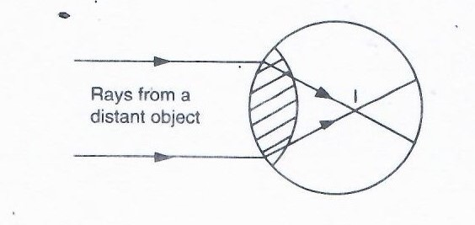
(i) Name the defect. (1mk)

………………………………………………………………………………………………………
ii) State one cause of the defect. (1mk)

………………………………………………………………………………………………………
iii) How can the defect be corrected? (1mk)

…………………………………………………………………………………………………….
- a) State Lenz’s law of electromagnetic induction. (1mk)

………………………………………………………………………………………………………
………………………………………………………………………………………………………
b) The figure below shows a bar magnet being moved into a coil connected to a galvanometer in the direction indicated.

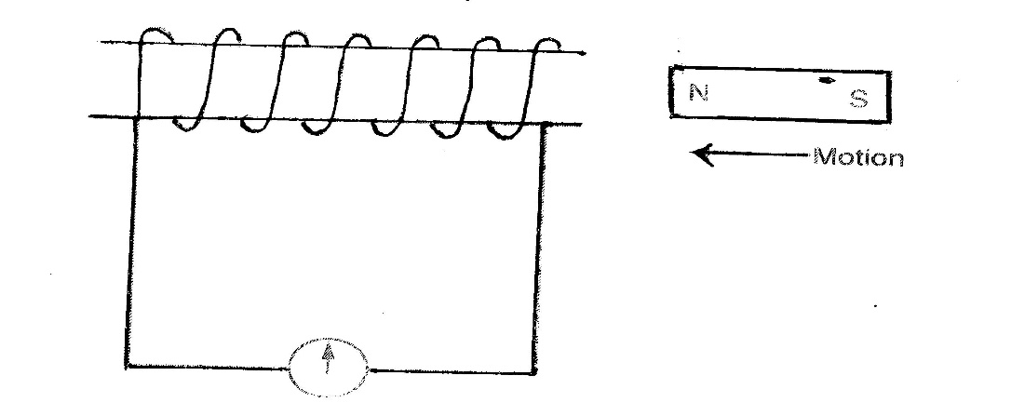
State the observation made on the galvanometer when:
- The magnet is moved into the coil at a steady speed. (1mk)

………………………………………………………………………………………………………
- The magnet is held stationary inside the coil. (1mk)

……………………………………………………………………………………………………
c) How is a transformer designed to minimize energy losses through flux leakage? (1mk)
………………………………………………………………………………………………………
………………………………………………………………………………………………………
d) The primary coil of a transformer has 2000 turns and is connected to a 240V a.c supply. The secondary coil has 400 turns.

- State with a reason the type of the transformer. (1mk)

………………………………………………………………………………………………………
………………………………………………………………………………………………………
- Determine the voltage in the secondary coil. (2mks)

………………………………………………………………………………………………………
………………………………………………………………………………………………………
………………………………………………………………………………………………………
- If the current flowing in the primary coil is 0.5A and in the secondary coil is
2.0 A determine the efficiency of the transformer. (2mks)
………………………………………………………………………………………………………
………………………………………………………………………………………………………
………………………………………………………………………………………………………
e) Electrical energy is transmitted at very high voltage and low current.
- State how the high voltages are attained. (1mk)

………………………………………………………………………………………………………
- State two reasons why aluminum wires are preferred to copper wires for transmission over long distances. (2mks)

………………………………………………………………………………………………………
………………………………………………………………………………………………………
- a) What is thermionic emission? (1mk)

………………………………………………………………………………………………………
………………………………………………………………………………………………………
b) Explain why a cathode ray tube is evacuated. (1mk)
………………………………………………………………………………………………………
………………………………………………………………………………………………………
c) Heated cathodes are coated with oxides of such metal as barium, Strontium or thorium. Explain. (1mk)
………………………………………………………………………………………………………
………………………………………………………………………………………………………
d) State one property of cathode rays. (1mk)

………………………………………………………………………………………………………
………………………………………………………………………………………………………
e) The figure below shows the waveform displayed on C.R.O screen when an alternating voltage is applied on the Y – input. The time – base is at 1ms/cm and the Y- gain at 10v/cm.
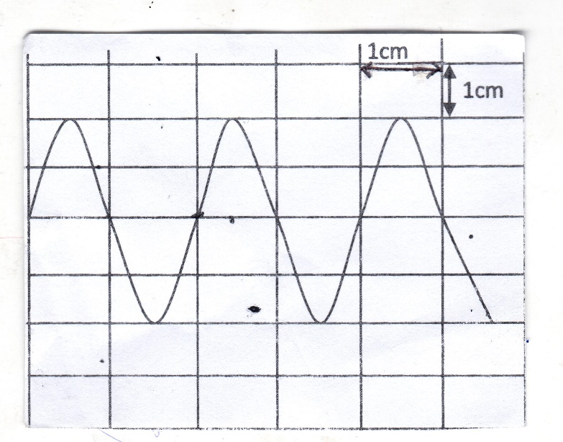

Calculate :
- The pick voltage of the input signal. (2mks)

………………………………………………………………………………………………………
………………………………………………………………………………………………………
- The frequency of the a.c signal. (2mks)

………………………………………………………………………………………………………
………………………………………………………………………………………………………
………………………………………………………………………………………………………
………………………………………………………………………………………………………
f) In a certain X- ray tube, the electrons are accelerated by p.d of 12kv. Assuming that all the energy goes to produce X-rays, determine the frequency of the X rays produced.
(take planck’s constant h = 6.62 x10 ⁻³⁴ Js, and the charge of an electron e = 1.6 x 10 ⁻¹⁹ C) (3mks)

………………………………………………………………………………………………………
………………………………………………………………………………………………………
………………………………………………………………………………………………………
………………………………………………………………………………………………………
- a) It is observed that when ultra – violet radiation is directed onto a clean Zinc plate connected to the cap of a negatively charged leaf electroscope, the leaf falls.
- Explain this observation. (1mk)

………………………………………………………………………………………………………
………………………………………………………………………………………………………
- Explain why the leaf of the electroscope does not fall when infrared radiation is directed onto the zinc plate. (1mk)

………………………………………………………………………………………………………
………………………………………………………………………………………………………
b) State the effect on the electrons emitted by the photoelectric effect when the intensity of incident radiation is increased. (1mk)
………………………………………………………………………………………………………
………………………………………………………………………………………………………
c) The maximum wavelength required to cause photoelectric emission on a metal surface
is 8.0 x 10 ⁻⁷ m. The metal surface is irradiated with light of frequency 8.5 x 10 ¹⁴ Hz.
(Take lev = 1.6 x 10 ⁻¹⁹ J , c = 3.0 x 10 ⁸ m/s , h= 6.63 x 10 ⁻³⁴ Js)

Determine:
i). The threshold frequency. (2mks)

………………………………………………………………………………………………………
………………………………………………………………………………………………………
……………………………………………………………………………………………………..
ii) .The work function of the metals in electron volts. (2mks)

………………………………………………………………………………………………………
………………………………………………………………………………………………………
………………………………………………………………………………………………………
iii) .The maximum Kinetic energy of the electrons. (3mks)

………………………………………………………………………………………………………
………………………………………………………………………………………………………
………………………………………………………………………………………………………
………………………………………………………………………………………………………
………………………………………………………………………………………………………
………………………………………………………………………………………………………
………………………………………………………………………………………………………
………………………………………………………………………………………………………
………………………………………………………………………………………………………
………………………………………………………………………………………………………
………………………………………………………………………………………………………

