**C NAME ADMN NO CLASS**

**233/1**

**CHEMISTRY**

**PAPER 1**

**(THEORY)**

**TERM TWO DECEMBER 2021**

**TIME: 2 Hours**

**MURANG’A EXTRA COUNTY SCHOOLS EXAMINATION (MECS)**

**Instructions to Candidates**

1. Write your name, admission number in the spaces provided above
2. Answer all the questions in the spaces provided
3. KNEC Mathematical tables and silent electronic calculator may be used.
4. All the working must be shown clearly where necessary
5. Candidates should answer questions in English.
6. this exam consists of 11 printed pages

**For Examiner’s Use Only**

|  |  |  |
| --- | --- | --- |
| **Question** | **Maximum Score** | **Candidate’s Score** |
| **1-27** | **80** |  |

1. The set up below was used to separate a mixture of two substances.

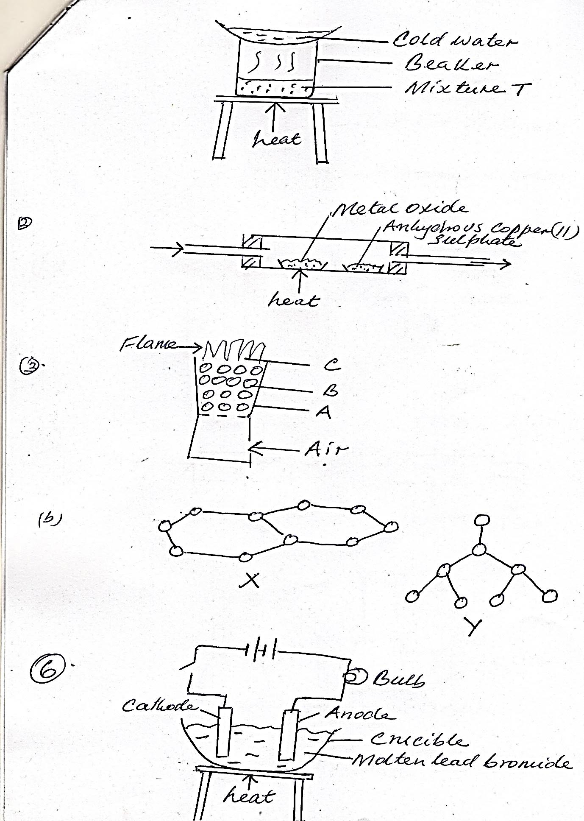

One of the components in the mixture T was sodium chloride.

(i). Name the other component (1mk)

……………………………………………………………………………………………………………………………………………………………

……………………………………………………………………………………………………………………………………………………………

(ii). Name the method of separation (1mk)

……………………………………………………………………………………………………………………………………………………………

……………………………………………………………………………………………………………………………………………………………

2. Dry hydrogen gas was passed through a hot metal oxide as shown in the diagram below.

Dry Hydrogen

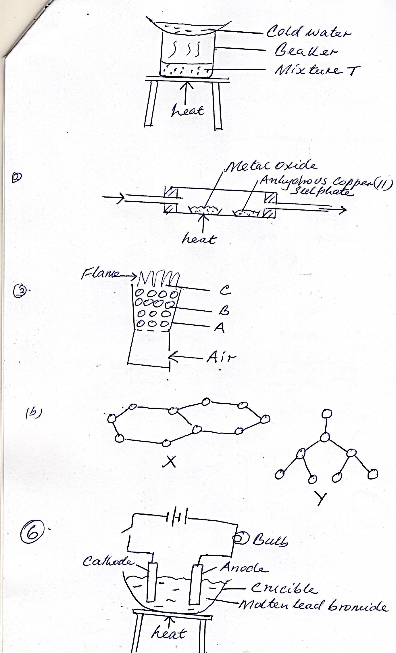

The metal oxide turned from black to brown.

a). Identify the metal oxide (1mk)

……………………………………………………………………………………………………………………………………………………………

b). State one other observation in the combustion tube. (1mk)

……………………………………………………………………………………………………………………………………………………………

c). Write a chemical equation for one of the reaction taking place in the combustion tube. (1mk)

……………………………………………………………………………………………………………………………………………………………

……………………………………………………………………………………………………………………………………………………………

3.The diagram below shows regions of a burning charcoal stove.



a). Write an equation for the reaction taking place at

(i). B (1mk)

……………………………………………………………………………………………………………………………………………………………

(ii). C (1mk)

……………………………………………………………………………………………………………………………………………………………

b. Name the allotropes of carbon represented by the diagram below (2mks)



4. Student are advised to use a non- luminous flame when heating during laboratory experiments.

a). Why is the non-luminous flame preferred. (1mk)

……………………………………………………………………………………………………………………………………………………………

……………………………………………………………………………………………………………………………………………………………

b). How does a Bunsen Burner produce a non-luminous flame. (1mk)

……………………………………………………………………………………………………………………………………………………………

……………………………………………………………………………………………………………………………………………………………

5a. State Boyles Law (1mk)

……………………………………………………………………………………………………………………………………………………………

……………………………………………………………………………………………………………………………………………………………

b). A balloon contains 250dm3 of helium at 25˚c and 100kPa pressure. Calculate the temperature when its volume reaches 400dm3and 80kpa pressure (2mks)

……………………………………………………………………………………………………………………………………………………………

……………………………………………………………………………………………………………………………………………………………

……………………………………………………………………………………………………………………………………………………………

……………………………………………………………………………………………………………………………………………………………

6. Below is a diagram of a set up of apparatus used to investigate the effect of electric current on a binary electrolyte, lead (II) bromide.

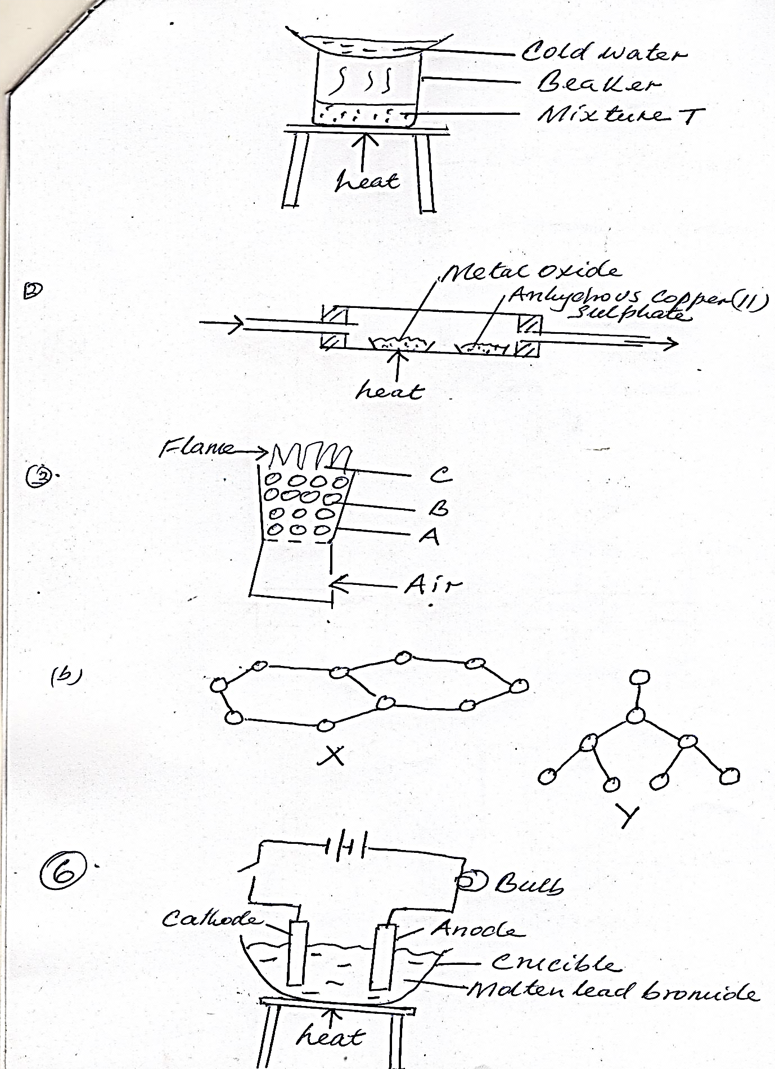

(i). What is a binary electrolyte. (1mk)

……………………………………………………………………………………………………………………………………………………………

……………………………………………………………………………………………………………………………………………………………

(ii). What is the importance of heating in the above experiment? (1mk)

……………………………………………………………………………………………………………………………………………………………

……………………………………………………………………………………………………………………………………………………………

(iii). Write the ionic equation for the reaction taking place at the anode (1mk)

……………………………………………………………………………………………………………………………………………………………

……………………………………………………………………………………………………………………………………………………………

7. Explain how the following factors affect the rate of a chemical reaction

(a). Temperature (2mks)

……………………………………………………………………………………………………………………………………………………………

……………………………………………………………………………………………………………………………………………………………

(b). Concentration (2mks)

……………………………………………………………………………………………………………………………………………………………

……………………………………………………………………………………………………………………………………………………………

8.Study the reaction below and answer the questions that follows

2NO2g N2O4(g) H = -ve

Brown Pale yellow

a). State the observation made when a mixture of NO2 (g) and N2O4 (g) at equilibrium is subjected to

(i). High pressure (½mk)

……………………………………………………………………………………………………………………………………………………………

……………………………………………………………………………………………………………………………………………………………

(ii). High temperatures (½mk)

……………………………………………………………………………………………………………………………………………………………

……………………………………………………………………………………………………………………………………………………………

Explain the observations in a(i) and a(ii) (1mk)

……………………………………………………………………………………………………………………………………………………………

……………………………………………………………………………………………………………………………………………………………

……………………………………………………………………………………………………………………………………………………………

9. The set up below shows the catalytic oxidation of ammonia in the laboratory.

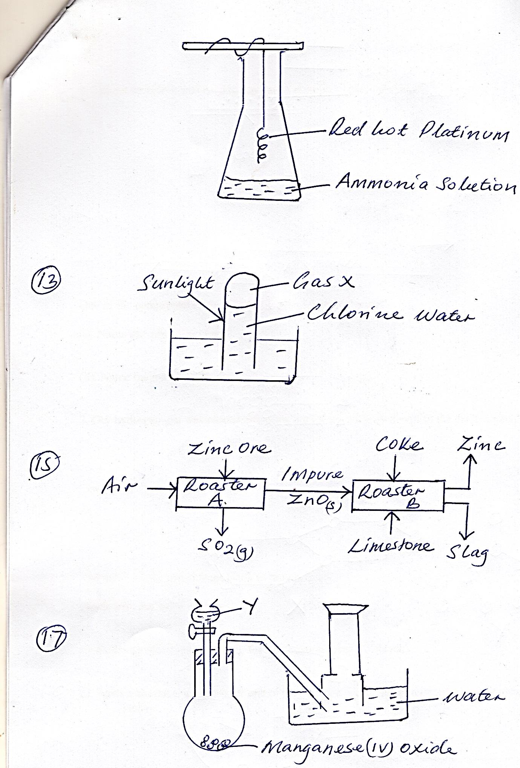

One of the observations made in the flask is that the platinum wire glows even though it is no longer heated.

(a). Explain this observation (1mk)

……………………………………………………………………………………………………………………………………………………………

……………………………………………………………………………………………………………………………………………………………

(b). State another observation made in the conical flask (1mk)

……………………………………………………………………………………………………………………………………………………………

……………………………………………………………………………………………………………………………………………………………

c). Write an equation to explain the second observation (1mk)

……………………………………………………………………………………………………………………………………………………………

……………………………………………………………………………………………………………………………………………………………

10. Distinguish between a dative and covalent bond (2mks)

……………………………………………………………………………………………………………………………………………………………

……………………………………………………………………………………………………………………………………………………………

……………………………………………………………………………………………………………………………………………………………

b). Draw a diagram to show bonding in hydroxonium ion (H3O+) (H=1, O = 8) (2mks)

11.The information below gives pH value of solution V, W, X, Y, Z

|  |  |
| --- | --- |
| **SOLUTION** | **pH Values** |
| V | 2 |
| W | 6.5 |
| X | 11 |
| Y | 14 |
| Z | 4.5 |

(a). Which solution is likely to be

--

(i). Calcium hydroxide? (1mk)

……………………………………………………………………………………………………………………………………………………………

(ii). Rain Water (1mk)

……………………………………………………………………………………………………………………………………………………………

b. Explain the pH value of rain water (1mk)

……………………………………………………………………………………………………………………………………………………………

12. 20cm3 of a dibasic acid required 25cm3 of 0.1M sodium hydroxide for complete neutralisation.

(a). How many moles of sodium hydroxide reacted with the dibasic acid ? (1mk)

……………………………………………………………………………………………………………………………………………………………

……………………………………………………………………………………………………………………………………………………………

……………………………………………………………………………………………………………………………………………………………

b). Calculate the concentration of the dibasic acid in moles per litre (2mks)

……………………………………………………………………………………………………………………………………………………………

……………………………………………………………………………………………………………………………………………………………

……………………………………………………………………………………………………………………………………………………………

13. Chloride water was exposed to sunlight as shown in the set up below x

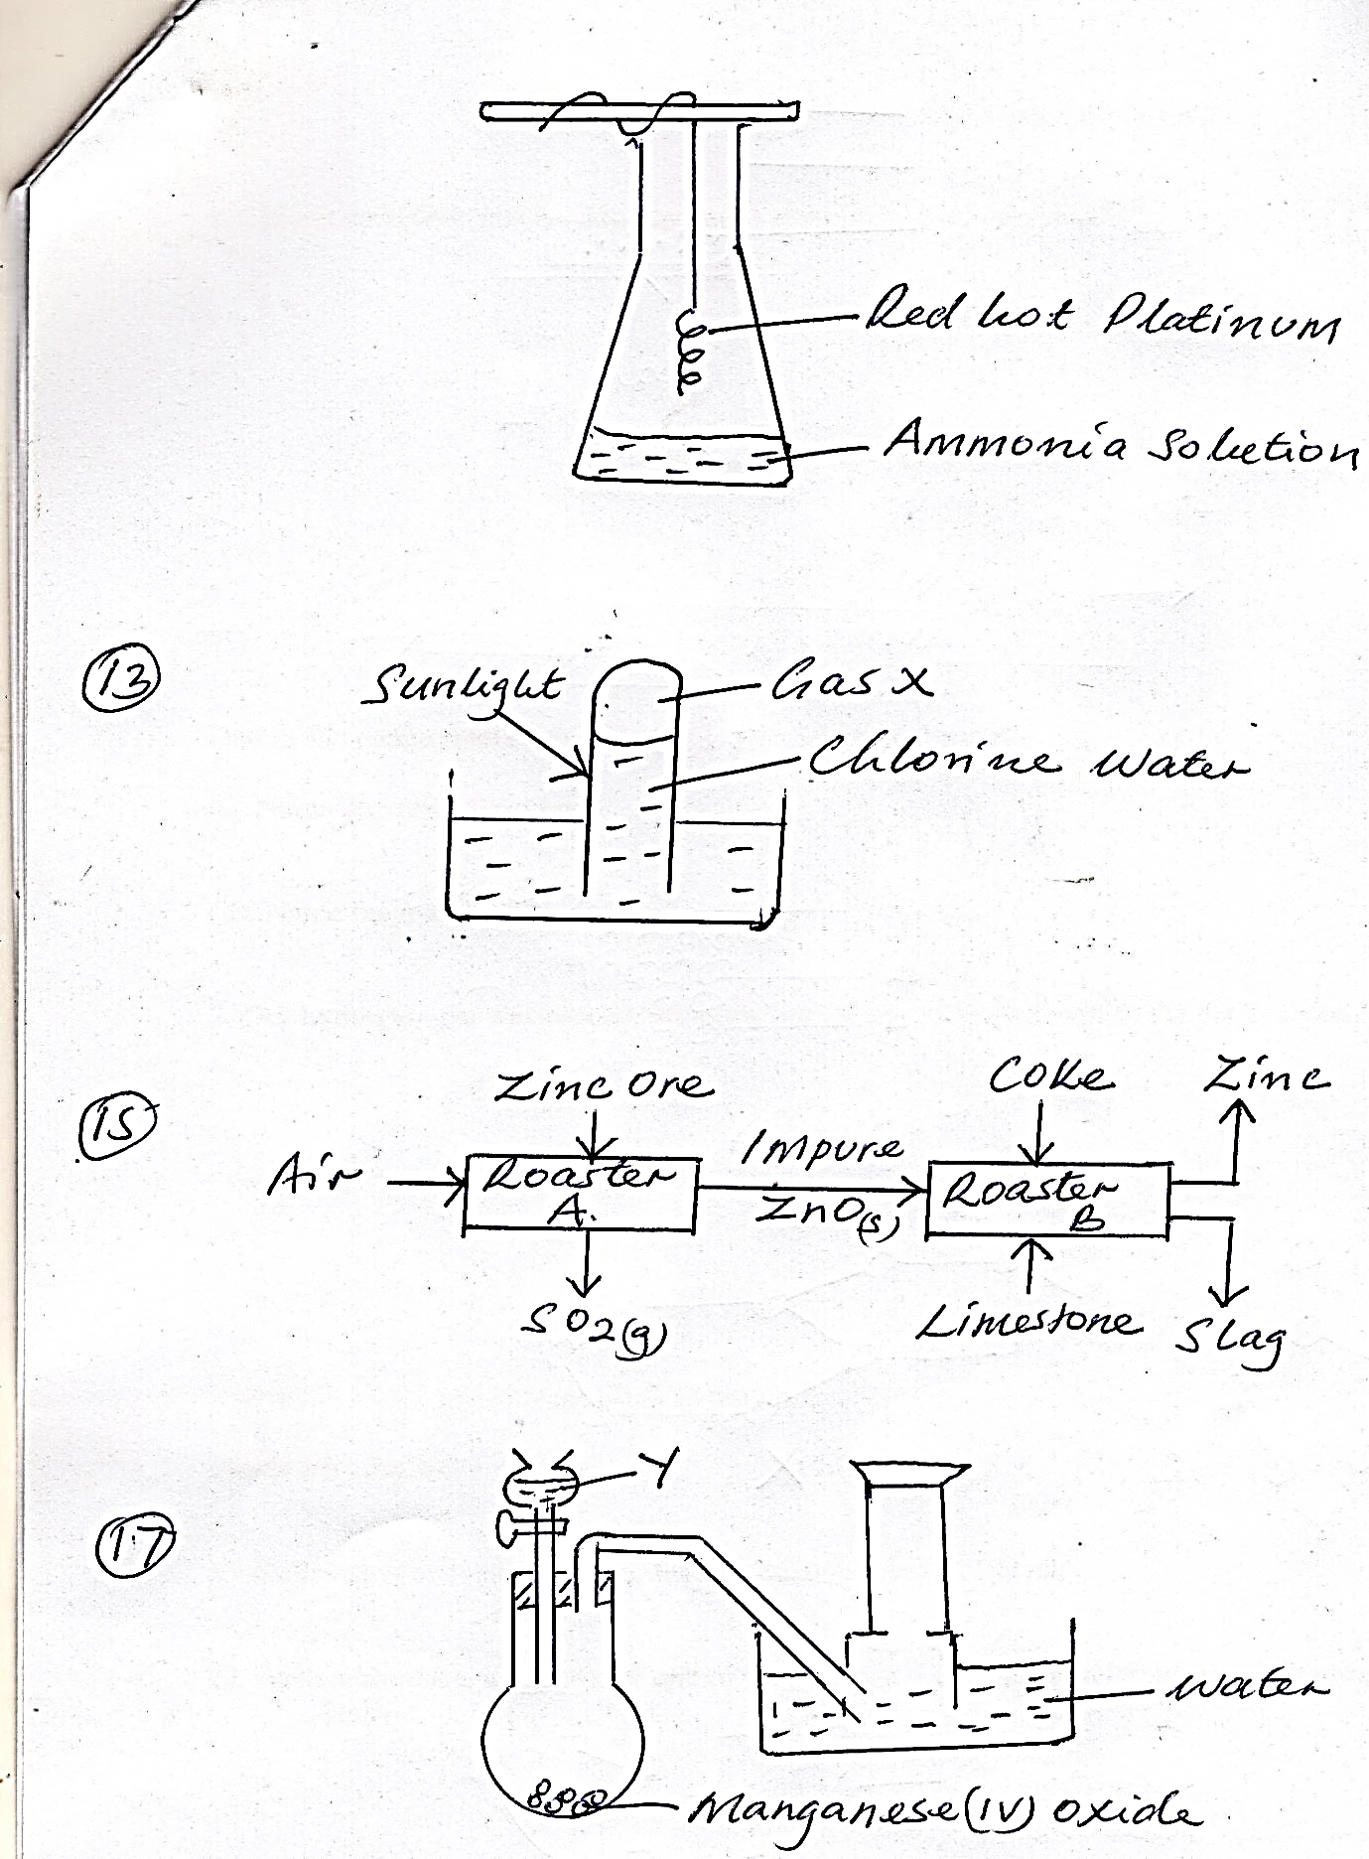

a). Write an equation for the reaction that produce gas X. (1mk)

……………………………………………………………………………………………………………………………………………………………

……………………………………………………………………………………………………………………………………………………………

b). Explain the observation made if a red flower petal is immersed in chlorine water. ……………………………………………………………………………………………………………………………………………………………

……………………………………………………………………………………………………………………………………………………………

(1mk)

14. The table below shows the solubility of a substance at various temperatures. Study it and answer the questions that follows.

|  |  |
| --- | --- |
| Temperature ˚c | Solubility in g/100g water |
| 0 | 36 |
| 40 | 30 |
| 80 | 25 |
| 110 | 20 |

a). What is the meaning of solubility (1mk)

……………………………………………………………………………………………………………………………………………………………

……………………………………………………………………………………………………………………………………………………………

……………………………………………………………………………………………………………………………………………………………

b. State and explain what would happen if a sample of a saturated solution of the substance at 40˚c was heated to 110˚c (1mk)

……………………………………………………………………………………………………………………………………………………………

……………………………………………………………………………………………………………………………………………………………

……………………………………………………………………………………………………………………………………………………………

15. The flow chart below shows the processes involved in extraction of Zinc metal. Study it and answer the questions that follow.

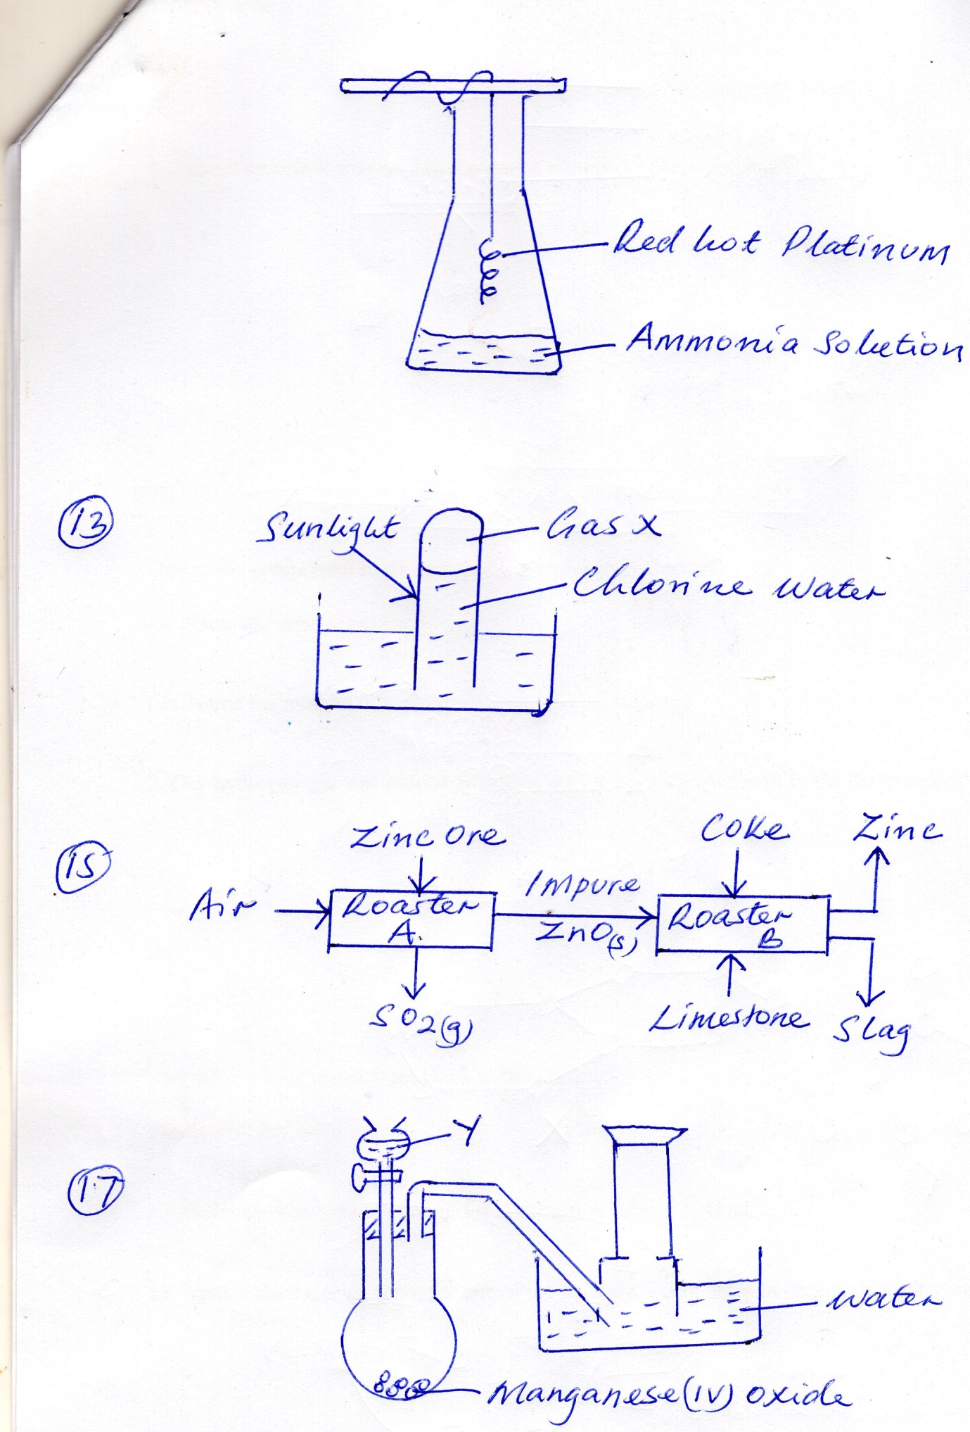

(a). Name the main ore used in the extraction of Zinc. (1mk)

……………………………………………………………………………………………………………………………………………………………

……………………………………………………………………………………………………………………………………………………………

……………………………………………………………………………………………………………………………………………………………

b). What is the function of limestone in roaster B (1mk)

……………………………………………………………………………………………………………………………………………………………

……………………………………………………………………………………………………………………………………………………………

……………………………………………………………………………………………………………………………………………………………

c). State one use of Zinc (1mk)

……………………………………………………………………………………………………………………………………………………………

……………………………………………………………………………………………………………………………………………………………

16. The products formed by action of heat on nitrates of elements P,Q,R are shown in the table below.

|  |  |
| --- | --- |
| **Nitrate of element** | **Products formed** |
| P  Q  R | Metal oxide + Nitrogen (iv) Oxide +Oxygen  Metal + oxygen + nitrogen (iv)Oxide  Metal Nitrite + Oxygen |

a). Arrange the metal elements in order of increasing reactivity (1mk)

……………………………………………………………………………………………………………………………………………………………

……………………………………………………………………………………………………………………………………………………………

b). Which element forms a soluble carbonate (1mk)

……………………………………………………………………………………………………………………………………………………………

……………………………………………………………………………………………………………………………………………………………

c). Give an example of element Q (1mk)

……………………………………………………………………………………………………………………………………………………………

……………………………………………………………………………………………………………………………………………………………

17. A student set up the apparatus shown below to prepare and collect oxygen gas.

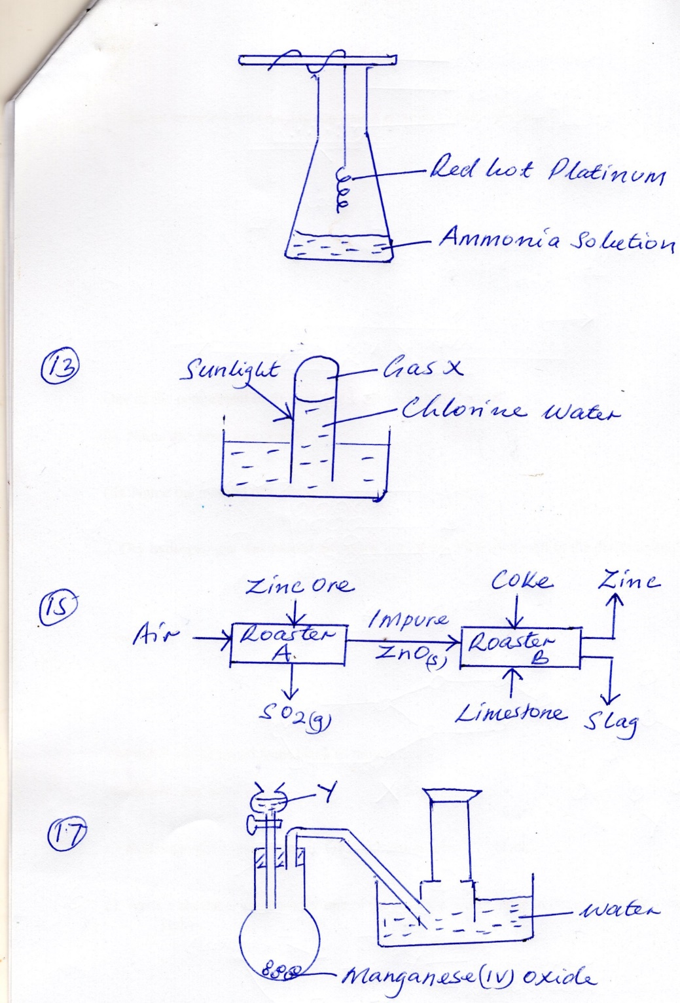

He made a mistake in the set and could not collect the gas.

(i). What was the mistake (1mk)

……………………………………………………………………………………………………………………………………………………………

……………………………………………………………………………………………………………………………………………………………

(ii). Identify substances Y (1mk)

……………………………………………………………………………………………………………………………………………………………

(iii). Write an equation for the reaction in the flask (1mk)

……………………………………………………………………………………………………………………………………………………………

……………………………………………………………………………………………………………………………………………………………

18a). A radioactive element weighed 384g. After 270days, its mass fell to 48g. Calculate the half -life of the element. (2mks)

……………………………………………………………………………………………………………………………………………………………

……………………………………………………………………………………………………………………………………………………………

……………………………………………………………………………………………………………………………………………………………

b). State one application of radioisotopes in industry. (1mk)

……………………………………………………………………………………………………………………………………………………………

……………………………………………………………………………………………………………………………………………………………

19. Three portions of a solution of B(NO3)2 (B is not the actual symbol of the element) where tested as follows.

(i). When 2cm3 portions of dilute hydrochloric acid is added to the first portion, a white precipitate was formed which dissolve on warming.

(ii). When two drops of 2M sodium hydroxide solution were added to the second portion, a white precipitate is formed which dissolved in excess sodium hydroxide to form a colourless solution.

(iii). When a solution of potassium iodide was added to the third portion, a yellow precipitate was formed.

(a). Identify the

White precipitate formed in step 1 (1mk)

……………………………………………………………………………………………………………………………………………………………

Element B (1mk)

……………………………………………………………………………………………………………………………………………………………

b). Write an ionic equation for the reaction that occurs in step (iii) (1mk)

……………………………………………………………………………………………………………………………………………………………

20. The following table gives standard electrode potentials for a number of half cell reactions.

Zn2+(aq) + 2e-  Zn(s) -0.70

Fe2+ (aq) + 2e- Fe (s) -0.44

I2 + 2e- 2I-(aq) +0.54

(i).Which of the substances listed above is the strongest oxidising agent. Explain (2mks)

……………………………………………………………………………………………………………………………………………………………

……………………………………………………………………………………………………………………………………………………………

(ii). Write the cell representation that would give the highest e.m.f value (1mk)

……………………………………………………………………………………………………………………………………………………………

……………………………………………………………………………………………………………………………………………………………

21. 0.6g of element K (not actual symbol) were completely burnt in oxygen to heat 500cm3of water. Given that the RAM of X is 12.06, determine the final temperature of the water heated if the initial temperature was 21˚c. Specific heat capacity of water = 4.2Jk-1g-1

Density of water = 1.0gcm³

Molar heat of combustion of K is 380kJ mol (3mks)

……………………………………………………………………………………………………………………………………………………………

……………………………………………………………………………………………………………………………………………………………

……………………………………………………………………………………………………………………………………………………………

……………………………………………………………………………………………………………………………………………………………

……………………………………………………………………………………………………………………………………………………………

22a. Name two reagent that can be used to prepare sulphur (iv) oxide gas in the laboratory. (2mks)

……………………………………………………………………………………………………………………………………………………………

……………………………………………………………………………………………………………………………………………………………

b). When a tube containing moist sulphur (iv) oxide gas is inverted over one containing hydrogen sulphide gas a yellow deposit forms on the sides of both tubes. Explain (2mks)

……………………………………………………………………………………………………………………………………………………………

……………………………………………………………………………………………………………………………………………………………

c). State one use of sulphur (iv) oxide gas (1mk)

……………………………………………………………………………………………………………………………………………………………

……………………………………………………………………………………………………………………………………………………………

23. A container in the lab has the label CH3CH2COOCH3.

(i). Name the process of formation of the above substance (1mk)

……………………………………………………………………………………………………………………………………………………………

(ii). Identify the two substances from which the substance is made (2mks)

……………………………………………………………………………………………………………………………………………………………

……………………………………………………………………………………………………………………………………………………………

(iii). Name the condition necessary for the formation of CH3CH2COOCH3- (1mk)

……………………………………………………………………………………………………………………………………………………………

……………………………………………………………………………………………………………………………………………………………

24. In an electrolytic process a current of 200A was passed through molten oxide of a metal Q for 58 minutes and 64.8g of the metal deposited. Determine

(i). Charge on metal Q (R.M.M of Q =27) (1mk)

……………………………………………………………………………………………………………………………………………………………

……………………………………………………………………………………………………………………………………………………………

……………………………………………………………………………………………………………………………………………………………

(ii). The volume of oxygen produced at standard temperature and pressure (IF= 96500c, Molar gas volume at StP = 22.4dm³) (2mks)

……………………………………………………………………………………………………………………………………………………………

……………………………………………………………………………………………………………………………………………………………

……………………………………………………………………………………………………………………………………………………………

……………………………………………………………………………………………………………………………………………………………

25. Describe how a student can distinguish between Calcium and Lead ions in solution using aqueous sodium chloride. (2mks)

……………………………………………………………………………………………………………………………………………………………

……………………………………………………………………………………………………………………………………………………………

……………………………………………………………………………………………………………………………………………………………

26. The table below shows the 1st and 2nd ionization energies of three elements in the same family of the periodic table.

|  |  |  |
| --- | --- | --- |
| Element | 1st ionisation energy kJ/mol | 2nd Ionisation energy kJ/mol |
| K | 900 | 1880 |
| L | 736 | 1450 |
| M | 590 | 1150 |

(a). Arrange the above element in order of decreasing reactivity (1mk)

……………………………………………………………………………………………………………………………………………………………

b). Explain why the 1st ionization energy is higher than the second ionization energy (2mks)

……………………………………………………………………………………………………………………………………………………………

……………………………………………………………………………………………………………………………………………………………

27. Draw and name two isomers of C4H6 (3mks)

……………………………………………………………………………………………………………………………………………………………

……………………………………………………………………………………………………………………………………………………………

……………………………………………………………………………………………………………………………………………………………

……………………………………………………………………………………………………………………………………………………………

**This is the last printed page**