NAME ADMN NO CLASS
233/2
CHEMISTRY
PAPER 2
(THEORY)
TERM TWO DECEMBER 2021
TIME: 2 Hours
MURANG’A EXTRA COUNTY SCHOOLS EXAMINATION (MECS)
Instructions to Candidates
- Write your name and index number in the spaces provided above
- Sign and write the date of examination in the spaces provided.
- KNEC Mathematical tables and silent electronic calculator may be used.
- All the working must be shown clearly where necessary
- Candidates should answer questions in English.
For Examiner’s Use Only
- The flow diagram below shows some reactions starting with propanol. Study it and use it to answer the questions that follow.

CO₂ + H₂O

Step I Reagent T
Step III Step II
Ethane
Propanoic acid
Substance M
Propene
Propanol
Methanoic acid H₂SO₄(l)
Step IV Reagent B

Step V Sodium hydroxide
Step VI
Sodium propanoate
Reagent N
- Name the process in step; (3 marks)
I …………………………………………………………………………………………….
III …………………………………………………………………………………………...
IV …………………………………………………………………………………………..
- Write an equation for the reaction in step (2 marks)
I …………………………………………………………………………………………….
V ……………………………………………………………………………………………

- Give the name and structural formula of substance M (2 marks)
Name ………………………………………………………………………………………
Structural formula ………………………………………………………………………………………………………………………………………………………………………………………………
- Name the reagent; (2 marks)
B ……………………………………………………………………………………………
N ……………………………………………………………………………………………
- State the condition necessary for reaction in step II (1 mark)
………………………………………………………………………………………………
- The diagram below shows the structure of a detergent.

- Identify the detergent (1 mark)
………………………………………………………………………………………….
- A sample of water was found to contain magnesium ions. Explain why the detergent above is a suitable reagent to be used in the water. (1 mark)
…………………………………………………………………………………………………………………………………………………………………………………………………………………………………………………………………………
- a.The table below shows properties of four substances. Study it and use it to answer the questions that follow.
Substance | Melting point  (⁰C) | Electrical conductivity
 |  | Solid | Molten
A | – 33 | Poor | Poor
B | 801 | Poor | Good
C | 1083 | Good | Good
D | 1417 | Poor | Poor

- Identify the structure in the following: (2 marks)
A ………………………………………………………………………………….
C ………………………………………………………………………………….
- Explain the conductivity in substance B (2 marks)
…………………………………………………………………………………………………………………………………………………………………………………………………………………………………………………………………………
……………………………………………………………………………………………………………………………………
- Give a reason why substance D has a h-igh melting point. (1 mark)
…………………………………………………………………………………………………………………………………………………………………………………………………………………………………………………………………………
b.Draw dot and cross diagram showing bonding in the following; (2 marks)
- Ammonia gas (N=7, H=1)

- Sodium sulphide ( Na=11, S=16)

c. Explain the following; (3 marks)
- Magnesium and sulphur are in the same period of the periodic table. However, magnesium oxide is a solid while sulphur (IV) oxide is a gas at room temperature (Mg = 12, S=16, O=8)
………………………………………………………………………………………………………………………………………………………………………………………………………………………………………………………………………………………………………………………………………………………………………………………………………………………………
- Ethanol is molecular but it dissolves in water
………………………………………………………………………………………………………………………………………………………………………………………………………………………………………………………………………………………………………………………………………………………………………………………………………………………………
- Solid copper metal is a better electrical conductor than molten copper
………………………………………………………………………………………………………………………………………………………………………………………………………………………………………………………………………………………………………………………………………………………………………………………………………………………………
- a.The diagram below shows the set-up used to test a property of carbon in the laboratory. Study it and use it to answer the questions that follow.
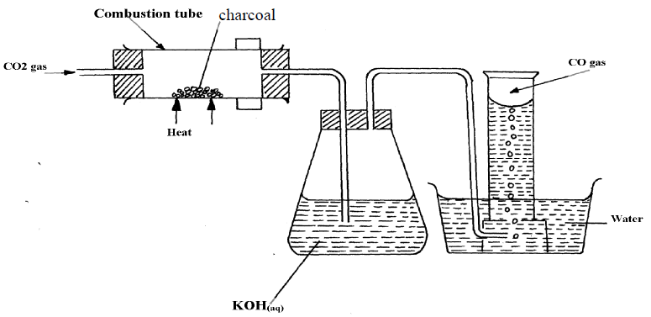
- State the role of potassium hydroxide solution (1 mark)
……………………………………………………………………………………………………………………………………………………………………………………………………………………………………………………
- Write an equation for the reaction in the combustion tube (1 mark)
……………………………………………………………………………………………………………………………………………………………………………………………………………………………………………………
- State the property of carbon being investigated. (1 mark)
……………………………………………………………………………………………………………………………………………………………………………………………………………………………………………………
b.Sodium carbonate is prepared industrially using Solvay process. The flow diagram below shows some of the reactions in the process. Study it and use it to answer the questions that follow.
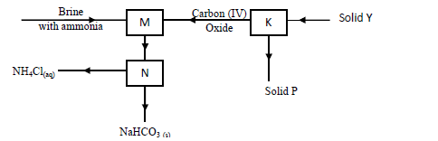
- Identify; (2 marks)

Solid Y …………………………………………………………………………

Solid P ………………………………………………………………………….

- Write an equation for the reaction taking place in chamber M (1 mark)
……………………………………………………………………………………………………………………………………………………………………………………………………………………………………………………

- Name the process taking place in chamber N. (1 mark)
……………………………………………………………………………………………………………………………………………………………………………………………………………………………………………………
- State two uses of sodium carbonate (2 marks)
……………………………………………………………………………………………………………………………………………………………………………………………………………………………………………………
…………………………………………………………………………………………………………………………………………
c. The set-up below was used to prepare carbon (IV) oxide gas in the laboratory. Study it and answer the questions that follow.
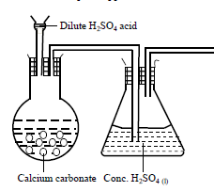
- Identify the mistake in the set-up and suggest a possible correction. (2 marks)
…………………………………………………………………………………………………………………………………………………………………………………………………………………………………………………………………………
…………………………………………………………………………………………

- Complete the diagram showing how the gas can be collected (1 mark)
- The list below shows reduction potentials of element M, N, P and Q

- Identify the element that is strongest reducing agent (1 mark)
………………………………………………………………………………………………………………………………………………………………………………………………
- Which elements would form an electrochemical cell with the highest e.m.f. (1 mark)
………………………………………………………………………………………………………………………………………………………………………………………………
- The half cells of M and P were combined to form an electrochemical cell.
- Draw the electrochemical cell formed (3 marks)

- Calculate the e. m. f of the cell formed (1 mark)
…………………………………………………………………………………………………………………………………………………………………………………….

- The set-up below was used during the electrolysis of a solution of Magnesium sulphate using inert electrodes.
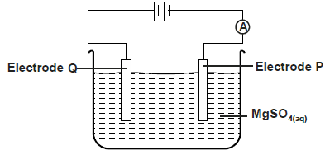
- State the observation made in electrode Q. Explain (2 marks)
………………………………………………………………………………………………………………………………………………………………………………………………………………………………………………………Write an equation for the reaction in electrode P (1mark)
……………………………………………………………………………………………………………………………………………………………………
- A current of 0.5 Amperes was passed through the cell for 16 minutes and 5 seconds. Calculate the volume of product at the anode at RTP (1M= 24l ,I F=96500C)
…………………………………………………………………… (3 marks) ……………………………………………………………………………………………………………………………………………………………………………………
- Give one application of electrolysis (1 mark)
……………………………………………………………………………………………………………………………………………………………………………………

- a) Define molar heat of neutralization (1mark)
……………………………………………………………………………………………………………………………………………………………………………………
……………………………………………………………………………………………………………………………………………………………………………………
b) The table below shows temperature reached when equal volumes of an alkaline solution of 1.5M concentration was reacted with 0.95M sulphuric (VI) acid.
Total volume of Sulphuric VI acid added | 0 | 5 | 10 | 15 | 20 | 25 | 30 | 35 | 40
Volume of alkaline solution | 30 | 30 | 30 | 30 | 30 | 30 | 30 | 30 | 30
Highest temperature reached | 23 | 24 | 25 | 26 | 27 | 28 | 28 | 27 | 26

Plot a graph of temperature against volume of acid used (3mks)
c. From the graph determine

  - the volume of sulphuric VI acid needed to completely neutralize 30cm³ of the alkali solution ( 1mk)
……………………………………………………………………………………………………………………………………………………………………………………
the temperature change (1mk)
……………………………………………………………………………………………………………………………………………………………………………………
d. Calculate the heat change for the above reaction density of solution 1g/cm³, Specific Heat Capacity 4.2g/J/K (2mks)
……………………………………………………………………………………………………………………………………………………………………………………
……………………………………………………………………………………………………………………………………………………………………………………
……………………………………………………………………………………………………………………………………………………………………………………
e. Calculate the molar heat of neutralization for the reaction (2mks)
……………………………………………………………………………………………………………………………………………………………………………………
……………………………………………………………………………………………………………………………………………………………………………………
……………………………………………………………………………………………………………………………………………………………………………………
- The diagram below shows the set-up used to extract sodium metal.
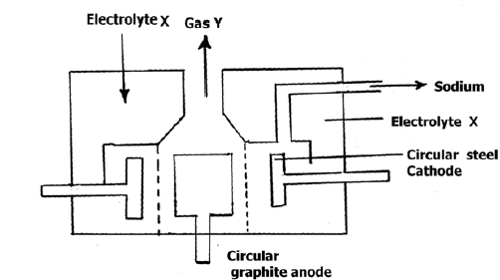
- Identify; (2 marks)
- Electrolyte X
………………………………………………………………………………………………………………………………………………………………………………
- Gas Y
………………………………………………………………………………………………………………………………………………………………………………
- During extraction of sodium using the down's process, calcium chloride is added to the ore. Give a reason for the addition of calcium chloride. (1 mark)
………………………………………………………………………………………………………………………………………………………………………………………………
- State two uses of sodium (2 marks)
………………………………………………………………………………………………………………………………………………………………………………………………

- Give a reason why sodium is extracted using electrolysis (1 mark)
………………………………………………………………………………………………………………………………………………………………………………………………
- Why is the anode made of graphite and not steel? (1 mark)
………………………………………………………………………………………………………………………………………………………………………………………………
- On the diagram, label the steel diaphragm. (1 mark)

- State the role of the steel diaphragm (1 mark)
……………………………………………………………………………………………………………………………………………………………………………………………
- State and explain two observations made when sodium metal is placed in a trough of cold water. (3 marks)
………………………………………………………………………………………………………………………………………………………………………………………………………………………………………………………………………………………………………………………………………………………………………………………………
………………………………………………………………………………………………………………………………………………………………………………………………
- a. The figure below shows some properties and reactions starting with solid S. Study it and answer the questions that follow.

White solid S

Add dilute nitric (V) acid Step 1

Colourless solution F
Gas K that forms a white precipitate with lime water

Step 2 Step 3 Step 4
Sodium hydroxide in excess Aqueous In excess Sodium sulphate solution
Ammonia
Colourless solution
White precipitate
White precipitate
- Identify; (2 marks)
Solid S
………………………………………………………………………………………………………………………………………………………………………………
Gas K
………………………………………………………………………………………………………………………………………………………………………………
- Write an equation for the reaction in step 1 (1 mark)
………………………………………………………………………………………………………………………………………………………………………………
- State the property of solution F that makes the reaction in step 2 possible. (1mark)
………………………………………………………………………………………………………………………………………………………………………………
- Write an ionic equation for the reaction in step 2 (1 mark)
………………………………………………………………………………………………………………………………………………………………………………
b. Starting with Zinc oxide, describe how a dray sample of zinc carbonate can be prepared in the laboratory (3 marks)
……………………………………………………………………………………………………………………………………………………………………………………………………………………………………………………………………………………………………………………………………………………………………………………………………………………………………………………………………………………………………………………………………………………………………………………………
c. Name the process taking place when the following reactions take place (3 marks)

- Calcium chloride placed on a watch glass overnight forms a solution
………………………………………………………………………………………………………………………………………………………………………………………………

- Sodium hydroxide reacts with sulphuric (VI) acid to form a colourless solution
………………………………………………………………………………………………………………………………………………………………………………………………

- Silver nitrate and potassium chloride react to form a white solid
………………………………………………………………………………………………………………………………………………………………………………………………

