SECTION A.

NAME………………………………………………ADM NO…………………..Class………

SCHOOL…………………………………… DATE………………… SIGN…………..
312/2
GEOGRAPHY
PAPER 2
2021
TIME 2 ¾ HOURS

M.E.C.S CLUSTER EXAMINATION
__________________________________________

INSTRUCTIONS TO CANDIDATES
- Write your name, Admission Number and Class
- The paper consists of two section A and B
- Answer all question in section A
- In section B answer question 6 and any other 2 questions
- Candidates should check to ascertain that all pages are printed and that no question is missing

Answer all the questions in this section
- (a) Name two breeds of dairy cattle reared in Kenya. (2mks)
(b) State three factors which favour dairy farming in Denmark. (3mks)

2. (a) State three physical factors which influence the location of settlements. (3mks)
(b) Use the sketch map below to answer questions (i) and (ii)
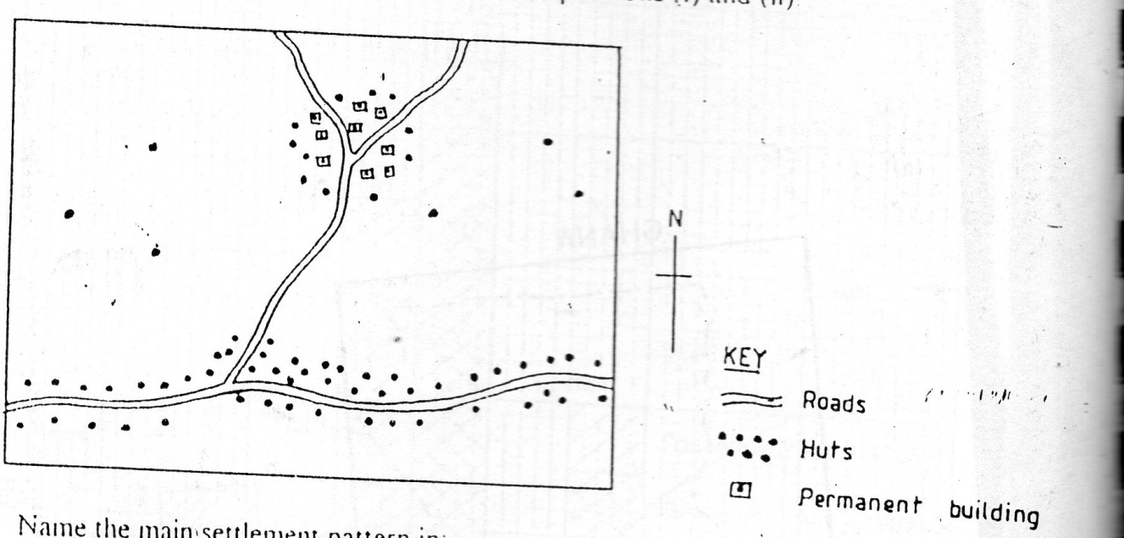
Name the main settlement pattern in
- the northern part of the area represented by the map. (lmk)
- the southern part of the area represented by the map. (1mk)

3(a) State three reasons why marine fisheries in Kenya are underdeveloped. (3mks)
(b) State three ways through which fish farming contributes to the economy of Kenya.
(3mks)

4(a) Name two conditions that are necessary for the formation of petroleum. (2mks)
(b) List three ways in which open-cast mining affects the environment. (3mks)

5. State four factors that have influence the development of industries in Eldoret town (4mks)

SECTION B
Answer question 6 and any other two questions in this section
6. The table below shows the various modes of transport used by tourists visiting Kenya between the years 2006 and 2009. Use it to answer the following questions.
Mode of transport | YEARS
 | 2006 | 2007 | 2008 | 2009
Road | 100,000 | 50,000 | 150,000 | 200,000
Air | 600,000 | 650,000 | 700,000 | 800,000
Water | 200,000 | 150,000 | 100,000 | 50,0000
- i) Calculate the percentage increase in the number of tourists between year 2008 and 2009. (3mks)
ii) Draw a compound bar graph to represent the data use the scale 1cm rep. 100,000 tonnes. (8mks)
- (i) Explain any four roles played by transport in the economy of Kenya. (8mks)
(ii) State two problems that face the construction of trans-continental highway in Africa. (2mks)
- Students from your class visited Kisumu airport for a field study
- Identify two methods they used to record their data (2mks)
- Give two follow up activities they engaged in (2mks)
7. (i) What is industrialisation. (2mks)

(ii) Name a town in Kenya where each one of the following industries are located
- Oil refining. (1mk)
- Paper manufacturing. (lmk)
- Motor vehicle assembly. (lmk)

(b) Explain four factors which influenced location of iron and steel industry in the Ruhr region of Germany. (8mks)

C(i) Give five reasons why development of Jua kali industry is encouraged in Kenya (5mks)
ii) Apart from Jua Kali industry give three other categories of manufacturing industries in Kenya. (3mks)

d) State four negative effect of industrialisation to a country. (4mks)

8(a) Name four sources of electric power apart from water.
(4mks)
(b) (i) State four factors that favoured location of hydro-electric power plants along river Tana. (4mks)

- Explain four ways in which Kenya has benefited from development of seven folks hydroelectric power scheme. (8mks)

C(i) Give three disadvantages of coal as a source of power. (3mks)
ii) Explain three problems Kenya face as a result of overdependence on petroleum. (6mks)

9(a) What is meant by overpopulation. (2mks)

(b) How does Kenya population differ from Sweden’s. (4mks)

c) Explain four factors that influence population distribution in Kenya. (8mk)

d(i) Apart from rural rural migration, list three other types of migrations in Kenya. (3mks)

(ii) Explain four causes of rural-rural migration. (8mk)

10(a) (i) State four physical factors favouring beef farming in Argentina. (4mks)
(ii) Give four characteristic features of beef farming in Argentina. (4mks)
(b) A form 3 class carried out a field study on a beef farm in Narok:
(i) Give three ways in which they prepared for the study. (3mk)
(ii) Name three types of beef breeds they identified. (3mks)
(iii) Give three benefits derived from studying beef farming in a field study. (3mks)
c. Explain four problems facing beef farming in Kenya. (8mks).

