Name:…………………………………….....................ADM No:………......Class:……....
488/1
ELECTRICITY
PAPER 1
DECEMBER 2021
$2\frac{1}{2}hours$
MECS CLUSTER JOINT EXAMINATION
FORM FOUR END OF THE TERM TWO EXAMINATION 2021
ELECTRICITY
INSTRUCTIONS TO CANDIDATES
- Write your name, index number and class in the spaces provided above.
- The paper contains two sections: Section A and Section B
- Section A carries 52 marks while section B carries 48 marks
- The paper contains 13 PRINTED pages make sure all PAGES ARE PRINTED and NON IS MISSING
- Answer ALL the questions in section A and ANY FOUR questions in section B
- All the answers and working must be written on the question paper in the spaces provided below each question.
- Non-programmable silent electronic calculators are allowed for use
For examiner use only
Section A
1 | 2 | 3 | 4 | 5 | 6 | 7 | 8 | 9 | 10 | 11 | 12 | 13 | 14 | 15 | Total
Section B
15 | 17 | 15 | 19 | 28
GRAND TOT

SECTION A (52 Marks)
- (a). Name four prime movers used in the process of generation electricity in Kenya
(2 marks)

(b). State two responsibilities of the following job groups (2 marks)
- Artisan

- Technician

- (a). State four main components of a business plan (2 marks)

(b). State four causes of electric shock in a workshop (2 marks)

- (a). State two safety precaution that needs to be put in place to avoid accidents from overhead power lines (2 marks)

(b). Draw a common base transistor configuration circuit (1 mark)

- The figure 1 shows a logic gate

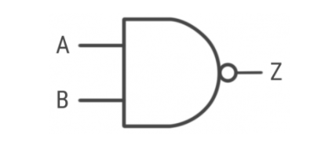

Figure 1

- Give the name of the logic gate (1 mark)

- Draw the truth table for the logic gate shown (2 marks)

- (a). Differentiate between a conductor and a semi-conductor. (1 mark)

(b). State one area of application for each of the above materials (2 marks)

- State four uses of ohmmeter function of a multimeter in trouble shooting circuits
(2 marks)

- (a). Using a schematic diagram, show how a lamp can be controlled from two different position (2 marks)

(b). Find the resistance of a resistor whose color code is:
- marks)
i). Grey, Red, Gold, Gold

ii). Green, White, Black, Gold

- With aid of a diagram, differentiate between repulsion and attraction type moving iron meter (4 marks)

- A single phase step-down transformer has a ratio of 8:1, a primary voltage of 3.3kV and a load of 6.6kVA. Ignoring losses, calculate; (6 marks)
- Secondary voltage

- Secondary current

- Sketch the symbol for the following circuit symbol (2 marks)
- Zener diode

- Incandescent lamp

- (a). State the meaning of capacitance (1 mark)

(b). State three factors that affect the capacitance of a capacitor (3 marks)

- (a). What is an autotransformer (1 mark)

(b). An autotransformer has 1200 turns connected to 250V a,c to supply a 60V load. Calculate the number of turns in the secondary section (2 marks)

- (a). Three inductors of 60mH, 120mH and 75mH respectively, are connected together in a parallel combination. Calculate the total inductance of the parallel combination (1 mark)

(b). Find the total energy in the circuit given that the total current is 2.5A.
(2 marks)

- (a). State three parts of a machine ($1\frac{1}{2}$marks)

(b). An alternating current completes ten cycles in 0.1 seconds. Calculate the period and frequency of the current. ($1\frac{1}{2} marks$)

- In a 12V dc system a 40W solar panel is exposed to the sun for six hours daily. Calculate the number of days it will take to fully charge a 60 ampere-hour battery (4 marks)

SECTION B (48 Marks)
- Figure 2 shows and RLC circuit. (12 marks)
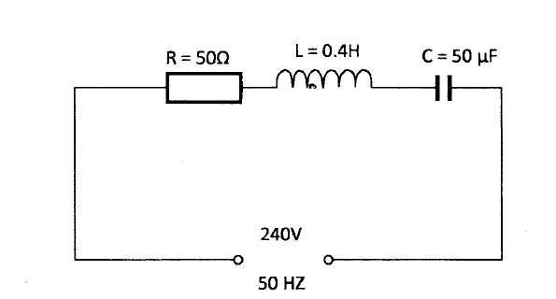

Figure 2
Calculate the:
- Inductive reactance

- Capacitive reactance

- Circuit impedance

- Circuit current

- Power dissipated in the circuit

- (a). With aid of a labelled diagram, explain the principle of operation of a trembler bell.
(9 marks)

(b). With aid of a diagram, differentiate between shunt generator and series d.c generator
(3 marks)

- Figure 3 shows the isometric view of a towing hook.
Draw, full size, in third angle projection: (12 Marks)
(a). front elevation in the direction of arrow A;
(b). end elevation in the direction of arrow B

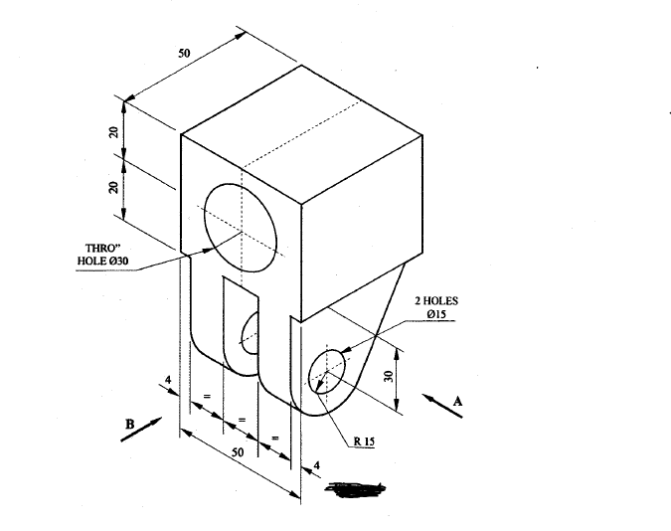
Figure 3

- (a). With reference to Sinusoidal waveforms, explain each of the following terms
(3 marks)
- Amplitude

- Period

- Frequency

(b). A Sinusoidal voltage trace displayed on an oscilloscope has peak voltage of 48V and a period of 80 ms. (9 marks)
Draw the waveform and calculate:

- Frequency

- Average value

- RMS value

- (a) Explain why a series motor develops high torque when subjected to a heavier load
(5 marks)

(b) A 240V/120V, 1.2kVA transformer delivers power to a load. Calculate the:
- Transformation ratio

- Rated secondary current

- Primary impedance at the rated load

- Number of turns in secondary winding if the primary winding induces 0.2V per turn (7 marks)

