Name:…………………………………….....................ADM No:………......Class:……....
488/2
ELECTRICITY
PAPER 2
DECEMBER 2021
$2\frac{1}{2}hours$
MECS CLUSTER JOINT EXAMINATION
FORM FOUR END OF THE TERM TWO EXAMINATION 2021
ELECTRICITY
INSTRUCTIONS TO CANDIDATES
- Write your name, index number and class in the spaces provided above.
- The paper contains 7 PRINTED pages make sure all PAGES ARE PRINTED and NON IS MISSING
- Non-programmable silent electronic calculators are allowed for use
- This paper consists of 5 EXERCISES
- Each exercise should be done in 30 MINUTES
For examiner use only
EXERCISE 1 | EXERCISE 2 | EXERCISE 3 | EXERCISE 4 | EXERCISE 5

GRAND TOTAL

EXERCISE 1

Using the components, materials and equipment provided, perform the following tasks
- Connect the figure as shown below. Let the examiner check your work (6 marks)
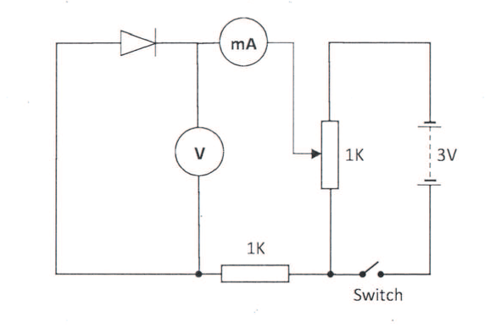
- Close the switch. Adjust the potentiometer to obtain voltage reading shown in the table below. For each voltage obtained, measure and record the corresponding current values
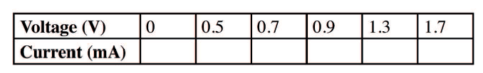
(5 marks)
- Plot a graph of current against voltage. (6 marks)

- From the graph:
- Determine the resistance when the voltage is 1.3V

- Give a reason for the shape of the graph
(3 marks)

EXERCISE 2
Using the components, materials and equipment provided, carry out the following tasks:
- Connect the circuit as shown in the figure below
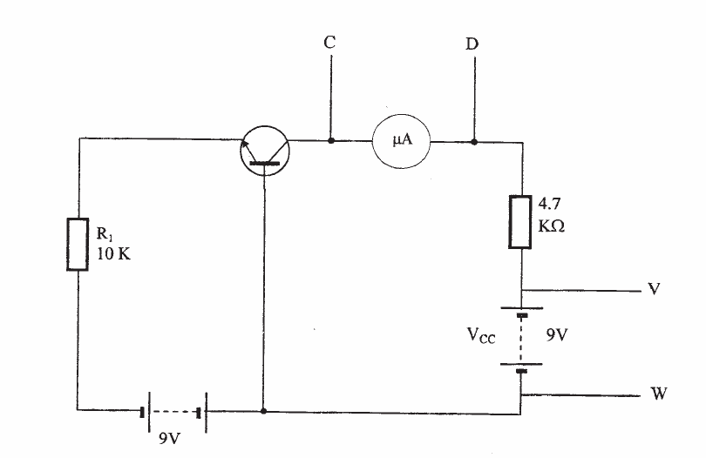

Let the examiner check your work. (5 marks)
- Adjust V_{cc} to the values shown in the table below and for each voltage value measure and record the corresponding value of the collector current, Ic
(6 marks)
V_{cc} | 9 | 7 | 5 | 3 | 1 | 0.5
I_{c} (mA)

- Repeat step in (b) above for the values shown in the table below and complete the table
V_{cc} (V) | 10 | 8 | 6 | 4 | 2 | 0.5
I_{c} (mA)

- From the results obtained in (b) and (c) above, make two comments about the collector current I_{c.} (4 marks)

- State two factors that determine the value of collector current (2 marks)

EXERCISE 3
Using the tools, materials and equipment provided, carry out the following tasks:
- Terminate the three-core flexible cable to the top plug and iron box (15 marks)
- Turn the thermostat switch to ON position, measure and record the values of resistance between;
- Live and Neutral at plug………Ohms

- Live and earth at plug………...Ohms

- Earth at plug and iron box body……..Ohms

- Neutral at plug and at iron box……….Ohms
(5 marks)

EXERCISE 4

Using the tools, material and equipment provided, fabricate the stand as shown in the figure below. (20 marks)
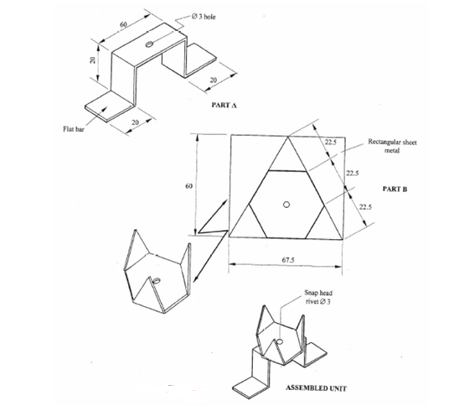

EXERCISE 5
The figure below shows the layout of a final circuit. Using PVC sheathed cables, install the lamps to controlled by one-way switch (20 marks)
