NAME__________________________________________________________
CLASS_________________INDEX NO_____________________
511/3
MUSIC
Paper 3
TERM 2 2021
2 Hrs. 30 min

MOCK
Murang’a Extra- County Secondary Schools
MUSIC
Paper 3
2½ hours
Instructions to Candidates
- Write your name and index number in the space provided
- Answer all the questions in this paper.
- In question 4 choose any two questions in (a), (b). (c) and (d)
- All answers must be written in the space provided

For Official UseOnly
SECTION | QUESTION | MAXIMUMSCORE | STUDENT’S SCORE
A | 1a | 07
 | 1b | 08
 | 2 | 15
B | 3 | 14
 | 4 | 14
 | 5 | 10
 | 6 | 10
 | 7 | 6
C | 8 | 16
TOTAL |  | 100

SECTION A: BASIC SKILLS.(30 marks)
Answer questions from all sections
- a) Continue the following opening to make a melody of 16 bars for voice introducing sequence and triplet Modulate to Relative minor key before returning to the tonic .( 7 marks)

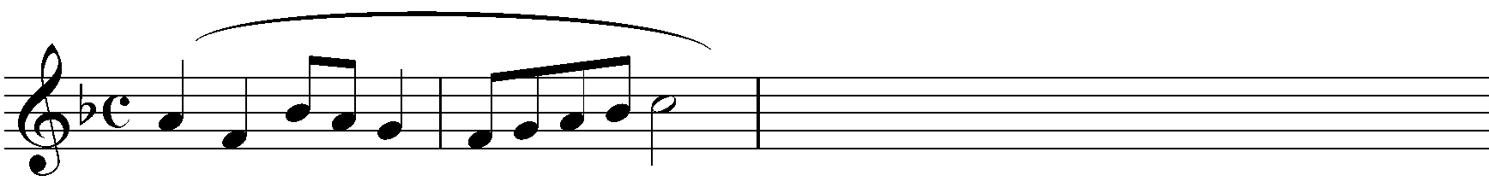

b) Use the text below to compose a melody in staff notation. Add phrase marks (8 marks) .

Kwa Afya nguvu na chakula
Twakushukuru ewe Bwana

- Harmonize the following melody for Soprano, Alto, Tenor and Bass (SATB). Choose appropriate chords from the following: I,ii,IV, V and iv.Incoporate Dominant Seventh
.(15 marks)

SECTION B: HISTORY AND ANALYSIS (54 marks)
3. AFRICAN MUSIC
a)i) State three most common vocal ornaments used during the performance of African traditional Music (3 marks)
________________________________________________________________________________________________________________________________________________________________________________________________________________________________________________________________________________________________________________________
ii) State three functions of Music in a dance. (3 marks)
________________________________________________________________________________________________________________________________________________________________________________________________________________________________________________________________________________________________________________________
b) Describe how a Ketubet both percussive and melodic effect in the course of his performance. (4 marks)
_________________________________________________________________________________________________________________________________________________________________________________________________________________________________________
c) Outline four aspects of socio-cultural traditions which are always reflected in an African traditional dance performance. (4 marks)
____________________________________________________________________________________________________________________________________________________________________________________________________________________________________________________________________________________________________________________________________________________________________________________________________________________________________________________________________________________

SECTION B: HISTORY AND ANALYSIS (54 Marks)
- WESTERN MUSIC
Answer any two of the following questions (a), (b), (c) and (d)
- William Byrd
i) State the nationality of William Byrd (1 mark)
__________________________________________________________________
ii). State the rights that Byrd and Tallis were given by Queen Elizabet (3 marks)
__________________________________________________________________
__________________________________________________________________
__________________________________________________________________
__________________________________________________________________
__________________________________________________________________
__________________________________________________________________

iii) Outline three sources that influenced Byrd’s style of Music. (3 marks)
_______________________________________________________________________
_______________________________________________________________________
______________________________________________________________________
_______________________________________________________________________
b) Bella Bartok
i) State the period which he lived. (1 mark)
__________________________________________________________________
ii). What is the importance of folk music to Bartok (3 marks)
__________________________________________________________________
__________________________________________________________________
__________________________________________________________________
__________________________________________________________________
__________________________________________________________________
__________________________________________________________________

iii) Outline any three characterics features of Bartok’s style. (3 marks)
_______________________________________________________________________
_______________________________________________________________________
______________________________________________________________________
_______________________________________________________________________

c) Joseph Haydn
i) State Haydn’s Nationality___________________________________ (1 Mark)
ii) State any 4 of his contemporaries_________________ (2 Marks)
iii) Explain Haydn‘s contribution to instrumental music (2mks)

iii) Describe Haydn‘s service of esterhazy (2 Marks)
________________________________________________________________________
________________________________________________________________________
- Franz Liszt
i) During which era did Liszt live? _________________________________ (1 mark)
ii) What is a symphonic poem?
______________________________________________________________ (2 marks)

iii) Name twosymphonic poemsLiszt wrote.
________________________________________________________________________
________________________________________________________________________
_____________________________________________________________ (2 marks)
- Give examples of Liszt‘s piano works (2 mark)
________________________________________________________________________
________________________________________________________________________
________________________________________________________________________
________________________________________________________________________

5. PRESCRIBED TRADITIONAL AFRICAN MUSIC
CHIVOTI BY DIWANI FROM YOU TUBE
- Classify the instruments in this recording, giving names of the used instruments in each classification (3 marks)
________________________________________________________________________________________________________________________________________________________________________________________________________________________________________________________________________________________________

- Describe the relationship between instruments in the recording( 3 marks)
_______________________________________________________________________________________________________________________________________________________________________________________________________________
- State two ways through which contrast has been achieved in the recording. (2 marks)
_______________________________________________________________________________________________________________________________________________________________________________________________________________
- State the features of African Music in the performance (2 marks)
_______________________________________________________________________________________________________________________________________________________________________________________________________________

- PRESCRIBED WESTERN MUSIC-Too much I once lamented by Thomas Tomkins
- For what medium is the work scored? (2 mark)
_____________________________________________________________________
- Describe how voices enter at the beginning of this recording. (2 marks)
____________________________________________________________________________________________________________________________________________________________________________________________________________________________________________________________________________________
- Identify two devices the composer has used to decorate the melody (2 marks)
_______________________________________________________________________________________________________________________________________________________________________________________________________________
- Describe the dynamic range of this music. (1 marks)
__________________________________________________________________________________________________________________________________________
- Describe three ways through which the composer varies the expression in Singing.
(3 Marks)

- ANALYSIS OF UNPREPARED WORK
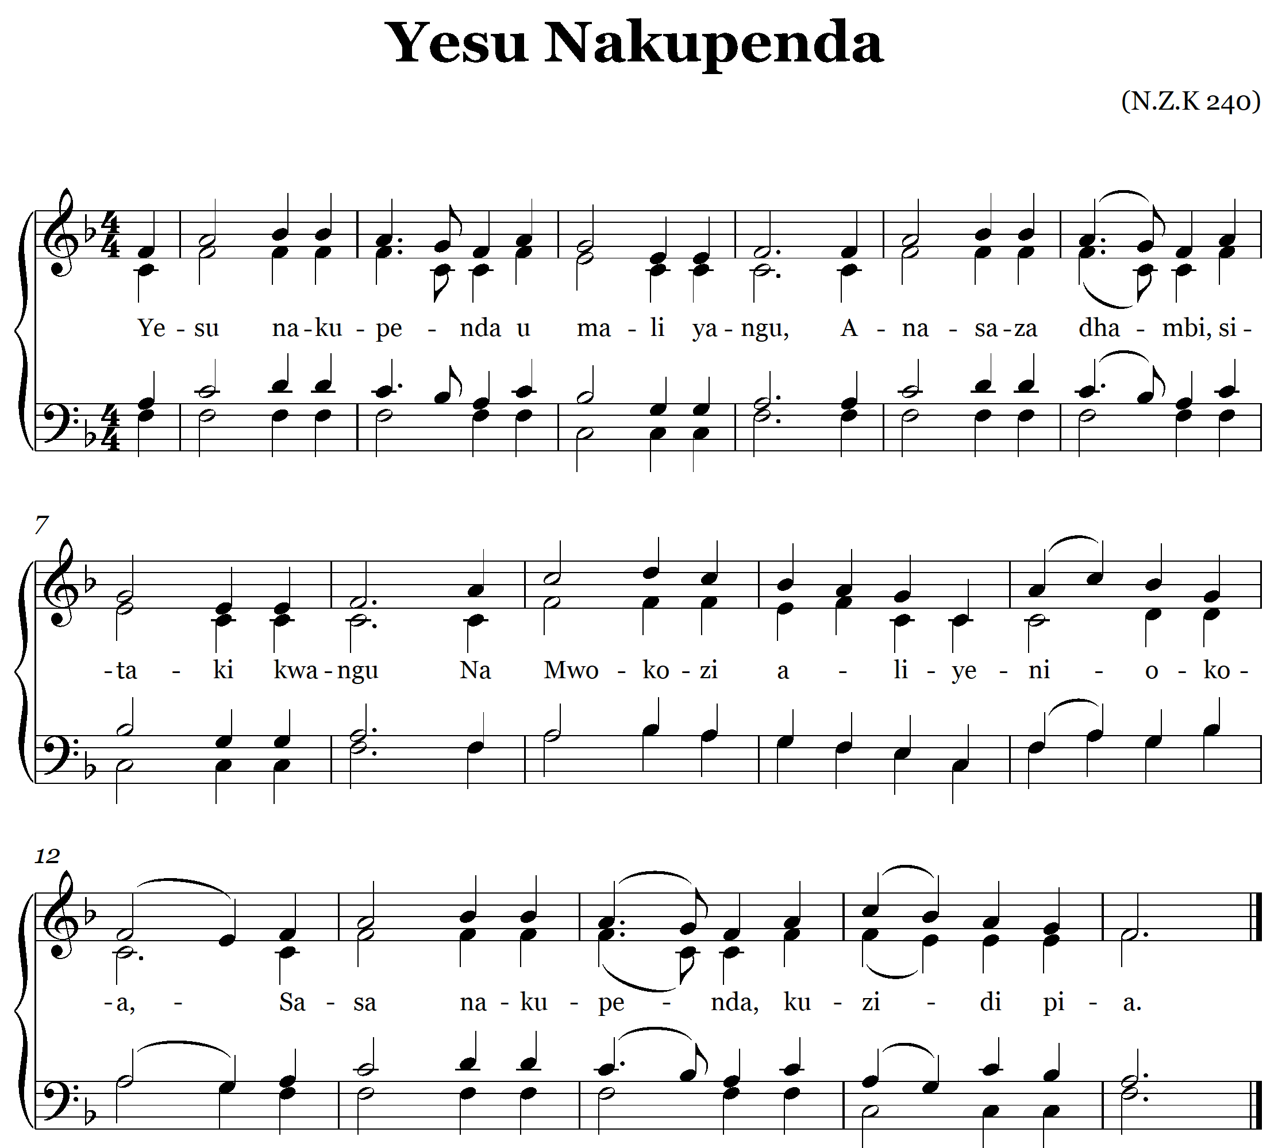
- State the main type of text setting in the above piece of music. (1 marks)
_______________________________________________________________________
- Which bar is identical with bar 6? __________________________ (1 Marks)
- Name the cadence in bar 7-8. ____________________________ (1 marks)
- What is the texture of the Music?_________________________________ ( 1 mark)
- Using phrases as sections, identify the general form of the piece of music. ( 2 marks)
________________________________________________________________________
SECTION C: GENERAL MUSIC KNOWLEDGE (16 MARKS)
- a) Write out the following using open score using Treble, Alto, Tenor and Bass Clefs
(6 marks)
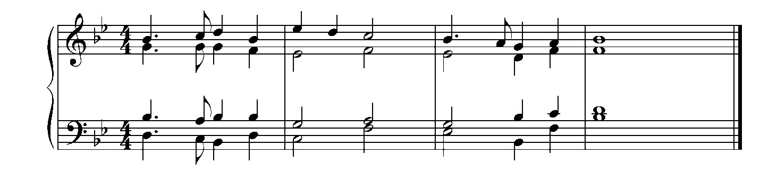

- Describe the following terms as used in music. (5 marks)
- Tetra chord
________________________________________________________________________________________________________________________
- Ostinato
________________________________________________________________________________________________________________________
- Dissonance
________________________________________________________________________________________________________________________
- Motif
________________________________________________________________________________________________________________________
- Ululation
_______________________________________________________________________________________________________________________
- State two relationships between Music and language (2 marks)
________________________________________________________________________________________________________________________________________________________________________________________________________________________________________________________________________________________________
- Give examples of each of the following African traditional Instruments( 3 marks)
- Plucked idiophone__________________________________________________
- Struck____________________________________________________________
- Double stringed fiddle_______________________________________________

