**NAME………………………………………………………………………………………………………ADM…….. ….CLASS………..**

**SCHOO.L…………………………………………………………………………………………………..SIGNATURE…………………**

ASUMBI GIRLS HIGH SCHOOL

PRE-MOCK

MAY-JUNE

2022

*KENYA CERTIFICATE OF SECONDARY EDUCATION (KCSE)*

**BIOLOGYPAPER 2 231/2.TIME: 2 HOURS.**

**INSTRUCTIONS TO CANDIDATES.**

* 1. Write your **Name** and **Admission Number** in the spaces provided.
  2. Sign and write the **date** of examination in the spaces provided above.
  3. This paper has **Two** SECTIONS; **A** and **B**.
  4. Answer all questions in section **A** in the spaces provided.
  5. In Section **B** answer question **6(Compulsory)** and either question **7** or **8** in the space provided after question **8**
  6. Ensure all the pages are printed as indicated below and no question is missing

For Examiner’s Use only

|  |  |  |  |
| --- | --- | --- | --- |
| Section | Question | Maximum Score | Candidate’s  Score |
|  |  |  |  |
| A | 1 | 8 |  |
| 2 | 8 |  |
| 3 | 8 |  |
| 4 | 8 |  |
| 5 | 8 |  |
| B | 6 | 20 |  |
| 7 | 20 |  |
| 8 | 20 |  |
| Total score | | 80 |  |

**SECTION A (40 MARKS)**

**Answer ALL the questions in this section in the spaces provided.**

1. The diagram illustrates a bone found in a mammal

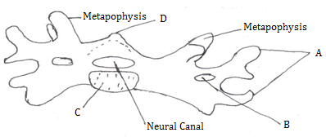

i) Label the Parts A, B, C and D (4mks)

A------------------------------------------------------

B-----------------------------------------------------

C----------------------------------------------------

D---------------------------------------------------

ii) Identify the bone (1mk)

---------------------------------------------------------------------------------------------------------

iii) Give one reason for your answer in (ii) above (1mk)

---------------------------------------------------------------------------------------------------------

iv) State the function of the part labeled B (1mk)

-----------------------------------------------------------------------------------------------------------------

v) Name the part of the skeleton where the above bone can be found (1mk)

--------------------------------------------------------------------------------------------------

1. A set up was done as shown below

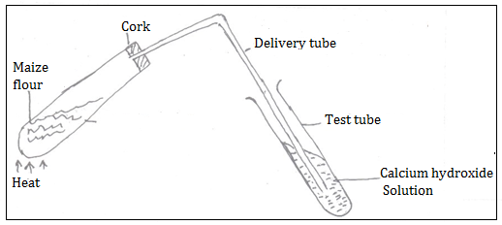

Boiling tube

1. What was the aim of the experiment? (1mk)

------------------------------------------------------------------------------------------------

1. State two observations in the test tube (2mks)

---------------------------------------------------------------------------------------------------------------------------------------------------------------------------------------------------------------------------------------------------------------------------------------------------------------------

1. State an observation in the boiling tube 1mk)

--------------------------------------------------------------------------------------------------------------------------------------------------------------------------------------------------------------

1. List two conclusions made at the end of the experiment (2mks)

---------------------------------------------------------------------------------------------------------------------------------------------------------------------------------------------------------------------------------------------------------------------------------------------------------------------

1. A man weighing 90kg requires 200KJ per gram of body weight while a rat weighing 50g requires 2500KJ per gram of body weight. Explain (2mks)

------------------------------------------------------------------------------------------------------------------------------------------------------------------------------------------------------------

1. Study the diagram below and answer the questions that follows

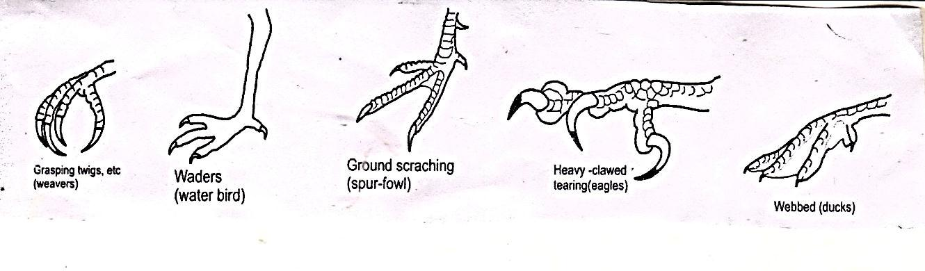

1. What type of evolution is illustrated by the limbs (1mk)

……………………………………………………………………………………………………..

1. What does the origin of the limbs suggest about the ancestry of these animals (1mk)

-----------------------------------------------------------------------------------------------------------------

(c) (i.) What are vestigial structures? (1mk) ………………………………………………………………………………………………………………………………………………………………………………………………………………………………………………………………………………………………………………………………………………………………………………………………………………………………………………………………………………………

(ii). State an example of vestigial structure in humans (1mk

……………………………………………………………………………………………………………………………………………………………………………………………………………………

1. (i) What is natural selection? (2mks) …………………………………………………………………………………………………………………………………………………………………………………………………………………………………………………………………………………………………………………………………………………………………………………………………………………………………………………………………………………….

(ii) Give one example of nature selection in action (1mk)

………………………………………………………………………………………………………………………………………………………………………………………………………………………………………………………………………………………………………………………..

(e) Explain comparative serology as evidence of evolution. 1mk

……………………………………………………………………………………………………………………………………………………………………………………………………………….

4. The diagram below represents the lower jaw of mammals.

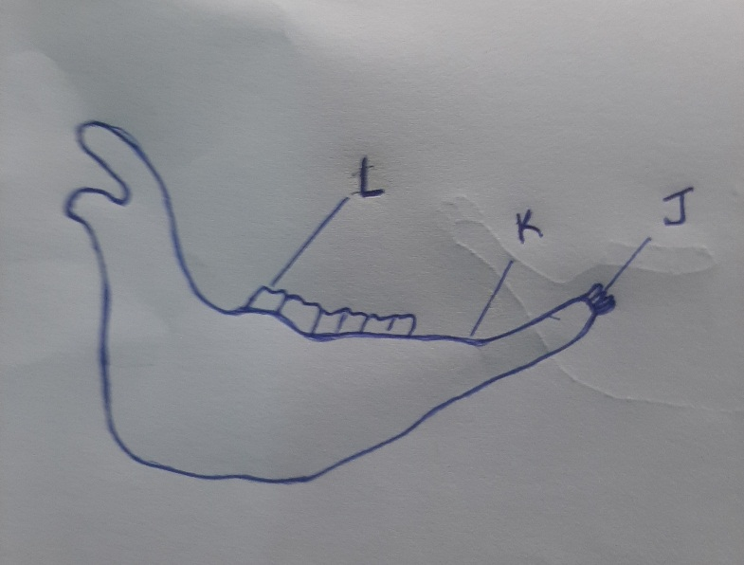

(a) Name the mode of nutrition of the mammal whose jaw is shown. (1 mark)

…………………………………………………………………………………………………………………………….

(b) State one structural and one functional difference between the teeth labeled J and L. (2marks)

. . . . . . . . . . . . . . . . . . . . . . . . . . . . . . . . . . . . . . . . . . . . . . . . . . . . . . . . . . . . . . . . . . . . . . . . . .

. . . . . . . . . . . . . . . . . . . . . . . . . . . . . . . . . . . . . . . . . . . . . . . . . . . . . . . . . . . . . . . . . . . . . . . . . .

. . . . . . . . . . . . . . . . . . . . . . . . . . . . . . . . . . . . . . . . . . . . . . . . . . . . . . . . . . . . . . . . . . . . . . . . . .

(c) i) Name the toothless gap labelled K. (1 mark)

. . . . . . . . . . . . . . . . . . . . . . . . . . . . . . . . . . . . . . . . . . . . . . . . . . . . . . . . . . . . . . . . . . . . . . . . . .

. . . . . . . . . . . . . . . . . . . . . . . . . . . . . . . . . . . . . . . . . . . . . . . . . . . . . . . . . . . . . . . . . . . . . . . . . .

ii) State the function of the gap. (1 mark)

. . . . . . . . . . . . . . . . . . . . . . . . . . . . . . . . . . . . . . . . . . . . . . . . . . . . . . . . . . . . . . . . . . . . . . .

(d) Name the substance that is responsible for hardening of teeth. (1 m

(e) Distinguish between the terms homodont and heterodont. (1 mark)

. . . . . . . . . . . . . . . . . . . . . . . . . . . . . . . . . . . . . . . . . . . . . . . . . . . . . . . . . . . . . . . . . . . . . .

5. In a population of guinea pigs a certain mutant gene (b) was discovered. It causes the Beta cells

in the pancreas fail to release insulin in order to control blood sugar level. In Homozygous

condition the victims are born dead. In heterozygous condition the animals grow to maturity and

reproduce. In a certain season 390 still births were counted.

1. Write down the genotypes of parents who some of their offspring were born dead. (2 marks)

. . . . . . . . . . . . . . . . . . . . . . . . . . . . . . . . . . . . . . . . . . . . . . . . . . . . . . . . . . . . . . . . . . . . . . . . . .

. . . . . . . . . . . . . . . . . . . . . . . . . . . . . . . . . . . . . . . . . . . . . . . . . . . . . . . . . . . . . . . . . . . . . .

1. Carry out a cross using a punnet square to show the occurrence of the still birth. (4 marks)
2. Work out the total number of the offspring that grew to maturity. (2 marks)

**SECTION B (40 MARKS).Answer question 6 (Compulsory and either question 7 or 8.)**

6. An experiment was carried out to investigate haemolysis of human red blood cells.

The red blood cells were place in different concentrations of sodium chloride solution. The

percentage of haemolysed cells was determined. The results were as shown in the table below.

|  |  |  |  |  |  |  |  |
| --- | --- | --- | --- | --- | --- | --- | --- |
| Salt concentration (g/100cm) (%) | 0.33 | 0.36 | 0.38 | 0.39 | 0.42 | 0.44 | 0.48 |
| Red blood cells (Haemolysed) (%) | 100 | 91 | 82 | 69 | 30 | 15 | 0 |

1. (i) On the grid provided, plot a graph of haemolysed red blood cells against salt concentration.

(6



(ii) At what concentration of salt solution was the proportion of haemolysed cells equal of non-

Haemolysed cells? (1 mark)

. . . . . . . . . . . . . . . . . . . . . . . . . . . . . . . . . . . . . . . . . . . . . . . . . . . . . . . . . . . . . . . . . . . . . . . . . .

(iii) State the percentage of cells haemolysed at salt concentration of 0.45% (1 marks)

…………………………………………………………………………………………………………………………………..

1. Account for the results obtained at:
2. 0.33 percent salt concentration. (3 marks)

. . . . . . . . . . . . . . . . . . . . . . . . . . . . . . . . . . . . . . . . . . . . . . . . . . . . . . . . . . . . . . . . . . . . . . . . . .

. . . . . . . . . . . . . . . . . . . . . . . . . . . . . . . . . . . . . . . . . . . . . . . . . . . . . . . . . . . . . . . . . . . . . . . . . .

. . . . . . . . . . . . . . . . . . . . . . . . . . . . . . . . . . . . . . . . . . . . . . . . . . . . . . . . . . . . . . . . . . . . . . . . . .

. . . . . . . . . . . . . . . . . . . . . . . . . . . . . . . . . . . . . . . . . . . . . . . . . . . . . . . . . . . . . . . . . . . . . .

1. 0.48 percent salt concentration. (3 marks)

. . . . . . . . . . . . . . . . . . . . . . . . . . . . . . . . . . . . . . . . . . . . . . . . . . . . . . . . . . . . . . . . . . . . . . . . . .

. . . . . . . . . . . . . . . . . . . . . . . . . . . . . . . . . . . . . . . . . . . . . . . . . . . . . . . . . . . . . . . . . . . . . . . . . .

. . . . . . . . . . . . . . . . . . . . . . . . . . . . . . . . . . . . . . . . . . . . . . . . . . . . . . . . . . . . . . . . . . . . . . . . . .

. . . . . . . . . . . . . . . . . . . . . . . . . . . . . . . . . . . . . . . . . . . . . . . . . . . . . . . . . . . . . . . . . . . . .

1. What would happen to the red blood cells if they were placed in 0.50 percent salt solution?

(3 marks)

. . . . . . . . . . . . . . . . . . . . . . . . . . . . . . . . . . . . . . . . . . . . . . . . . . . . . . . . . . . . . . . . . . . . . . . . . .

. . . . . . . . . . . . . . . . . . . . . . . . . . . . . . . . . . . . . . . . . . . . . . . . . . . . . . . . . . . . . . . . . . . . . . . . . .

. . . . . . . . . . . . . . . . . . . . . . . . . . . . . . . . . . . . . . . . . . . . . . . . . . . . . . . . . . . . . . . . . . . . . . . .

1. Explain what would happen to onion epidermal cells if they were place in distilled water.

(3marks)

………………………………………………………………………………………………………………………………………..

……………………………………………………………………………………………………………………………………….

………………………………………………………………………………………………………………………………………….

………………………………………………………………………………………………………………………………………

7 Describe how human kidneys function. (20 marks)

8. Describe secondary growth in Dicotyledonous plants. (20 marks)

. . . . . . . . . . . . . . . . . . . . . . . . . . . . . . . . . . . . . . . . . . . . . . . . . . . . . . . . . . . . . . . . . . . . . . . . . .

. . . . . . . . . . . . . . . . . . . . . . . . . . . . . . . . . . . . . . . . . . . . . . . . . . . . . . . . . . . . . . . . . . . . . . . . . .

. . . . . . . . . . . . . . . . . . . . . . . . . . . . . . . . . . . . . . . . . . . . . . . . . . . . . . . . . . . . . . . . . . . . . . . . . .

. . . . . . . . . . . . . . . . . . . . . . . . . . . . . . . . . . . . . . . . . . . . . . . . . . . . . . . . . . . . . . . . . . . . . . . . . .

. . . . . . . . . . . . . . . . . . . . . . . . . . . . . . . . . . . . . . . . . . . . . . . . . . . . . . . . . . . . . . . . . . . . . . . . . .

. . . . . . . . . . . . . . . . . . . . . . . . . . . . . . . . . . . . . . . . . . . . . . . . . . . . . . . . . . . . . . . . . . . . . . . . . .

. . . . . . . . . . . . . . . . . . . . . . . . . . . . . . . . . . . . . . . . . . . . . . . . . . . . . . . . . . . . . . . . . . . . . . . . . .

. . . . . . . . . . . . . . . . . . . . . . . . . . . . . . . . . . . . . . . . . . . . . . . . . . . . . . . . . . . . . . . . . . . . . . . . . .

. . . . . . . . . . . . . . . . . . . . . . . . . . . . . . . . . . . . . . . . . . . . . . . . . . . . . . . . . . . . . . . . . . . . . . . . . .

. . . . . . . . . . . . . . . . . . . . . . . . . . . . . . . . . . . . . . . . . . . . . . . . . . . . . . . . . . . . . . . . . . . . . . . . . .

. . . . . . . . . . . . . . . . . . . . . . . . . . . . . . . . . . . . . . . . . . . . . . . . . . . . . . . . . . . . . . . . . . . . . . . . . .

. . . . . . . . . . . . . . . . . . . . . . . . . . . . . . . . . . . . . . . . . . . . . . . . . . . . . . . . . . . . . . . . . . . . . . . . . .

. . . . . . . . . . . . . . . . . . . . . . . . . . . . . . . . . . . . . . . . . . . . . . . . . . . . . . . . . . . . . . . . . . . . . . . . . .

. . . . . . . . . . . . . . . . . . . . . . . . . . . . . . . . . . . . . . . . . . . . . . . . . . . . . . . . . . . . . . . . . . . . . . . . . .

. . . . . . . . . . . . . . . . . . . . . . . . . . . . . . . . . . . . . . . . . . . . . . . . . . . . . . . . . . . . . . . . . . . . . . . . . .

. . . . . . . . . . . . . . . . . . . . . . . . . . . . . . . . . . . . . . . . . . . . . . . . . . . . . . . . . . . . . . . . . . . . . . . . . .

. . . . . . . . . . . . . . . . . . . . . . . . . . . . . . . . . . . . . . . . . . . . . . . . . . . . . . . . . . . . . . . . . . . . . . . . . .

. . . . . . . . . . . . . . . . . . . . . . . . . . . . . . . . . . . . . . . . . . . . . . . . . . . . . . . . . . . . . . . . . . . . . . . . . .

. . . . . . . . . . . . . . . . . . . . . . . . . . . . . . . . . . . . . . . . . . . . . . . . . . . . . . . . . . . . . . . . . . . . . . . . . .

. . . . . . . . . . . . . . . . . . . . . . . . . . . . . . . . . . . . . . . . . . . . . . . . . . . . . . . . . . . . . . . . . . . . . . . . . .

. . . . . . . . . . . . . . . . . . . . . . . . . . . . . . . . . . . . . . . . . . . . . . . . . . . . . . . . . . . . . . . . . . . . . . . . . .

. . . . . . . . . . . . . . . . . . . . . . . . . . . . . . . . . . . . . . . . . . . . . . . . . . . . . . . . . . . . . . . . . . . . . . . . . .

. . . . . . . . . . . . . . . . . . . . . . . . . . . . . . . . . . . . . . . . . . . . . . . . . . . . . . . . . . . . . . . . . . . . . . . . . .

. . . . . . . . . . . . . . . . . . . . . . . . . . . . . . . . . . . . . . . . . . . . . . . . . . . . . . . . . . . . . . . . . . . . . . . . . .

. . . . . . . . . . . . . . . . . . . . . . . . . . . . . . . . . . . . . . . . . . . . . . . . . . . . . . . . . . . . . . . . . . . . . . . . . .

. . . . . . . . . . . . . . . . . . . . . . . . . . . . . . . . . . . . . . . . . . . . . . . . . . . . . . . . . . ……………………………..

. . . . . . . . . . . . . . . . . . . . . . . . . . . . . . . . . . . . . . . . . . . . . . . . . . . . . . . . . . . . . . . . . . . . . . . . . .

. . . . . . . . . . . . . . . . . . . . . . . . . . . . . . . . . . . . . . . . . . . . . . . . . . . . . . . . . . . . . . . . . . . . . . . . . .

. . . . . . . . . . . . . . . . . . . . . . . . . . . . . . . . . . . . . . . . . . . . . . . . . . . . . . . . . . . . . . . . . . . . .

……………………………………………………………………………………………………………………………………………………………………………………………………………………………………………………………………………………………………………………………………………………………………………………………………………………………………………………………………………………………………………………………………………………………………………………………………………………………………………………………………………………………………………………………………………………………………………………………………………………………………………………………………………………………………………………………………………………………………………………………………………………………………………………………………………………………………………………………………………………………………………………………………………………………………………………………………………………………………………………………………………………………………………………………………………………………………………………………………………………………………………………………………………………………………………………………………………………………………………………………………………………………………………………………………………………………………………………………………………………………………………………………………………………………………………………………………………………………………………………………………………………………………………………………………………………………………………………………………………………………………………………………………………………………………………………………………………………………………………………………………………………………………………………………………………………………………………………………………………………………………………………………………………