NAME………………………………………………………ADM NO…………CLASS………..

DATE………………SIGN.............………

443/1

PAPER 1

TIME: 2 HOURS
ASUMBI GIRLS HIGH SCHOOL
PRE-MOCK
2022
AGRICULTURE
PAPER ONE
TIME: 2 HOURS
INSTRUCTIONS TO CANDIADATES
- Write your name, admission number and class
- This paper contains three sections
- Answer all question in section A and B
- In section C answer any two questions
- Candidates should check the question paper to ascertain that all pages are printed as indicated and that no questions are missing
- This paper has 15 printed page
- Candidates must answer all the questions in English

For examiner’s use only
Section | Questions | Maximum score | Candidate score
A | 1 -18 | 30
B | 19 -22 | 20
C |  | 20
 |  | 20
Total score |  | 90

SECTION A(30MARKS)
Answer ALL questions in this section
1) Name a chemical used to achieve the following during water treatment.
(a) Coagulation of solid particles (½mark)

………………………………………………………………………………………………………......
(b) Softening of water (½mark)

…………………………………………………………………………………………………………

(c) Killing pathogens (½mark)
.……………………………………………………………………………........................................
2) State two causes of forking in carrots (1mark)
……………………………………………………………………………………………………………
……………………………………………………………………………………………………………
3) Name four books of account kept by a farmer (2 mark)
……………………………………………………………………………………………………………
……………………………………………………………………………………………………………
……………………………………………………………………………………………………………
……………………………………………………………………………………………………………
4) Give the element whose deficiency in plants is characterized by the following
(a) Interveinal chlorosis of the leaves ...................................................................................... (½ mark)
(b Blossom end rot in tomatoes ................................................................................................ (1/2mark)
(c) Scorched edges of a leaf ....................................................................................................... (½ mark)
5) Give two roles of agriculture in industrial growth. (1 mark)
………………………………………………………………………………………………………….
………………………………………………………………………………………………………….
6) Difference between olericulture and pomoculture ( 1 mark)
…………………………………………………………………………………………………………..
…………………………………………………………………………………………………………..
7 a) Give two disadvantages of hydram pumps (1 mark)
………………………………………………………………………………………………………….

………………………………………………………………………………………………………….
(b) State two methods of harvesting Maize (1 mark)
………………………………………………………………………………………………………….
…………………………………………………………………………………………………………..
8) a) What is Agro forestry. (1mark)
…………………………………………………………………………………………………………..
b) State four ways in which Agro forestry is important. (2marks)

…………………………………………………………………………………………………………..
…………………………………………………………………………………………………………..

9) Give four farming practices that may help in achieving minimum tillage. (2 marks)
………………………………………………………………………………………………………….
……………………………………………………………………………………..................................
………………………………………………………………………………………………………….
…………………………………………………………………………………………………………..
10) Define the term “Economic Injury Level” of a crop. (1 mark)
…………………………………………………………………………………………………………..
…………………………………………………………………………………………………………..
11) State two conditions when opportunity costs are zero (1 mark)
……………………………………………………………………………………………………………
…………………………………………………………………………………………………………..
12) State four factors that influence solifluction (2 marks)
…………………………………………………………………………………………………………...
…………………………………………………………………………………………...........................
……………………………………………………………………………………………………………
……………………………………………………………………………………………………………

13) Give four conditions that necessitate clearing of land. (2 marks)
……………………………………………………………………………………………………………………………………………………………………………………………………………………………………………………………………………………………………………………………………………………………………………………………………………………………………………………

14) Give four reasons for keeping health records (2 marks)
……………………………………………………………………………………………………………………………………………………………………………………………………………………………………………………………………………………………………………………………………………………………………………………………………………………………………………………
15) Name any two diseases that affect bean production in the field. (1 mark)
…………………………………………………………………………………………………………………………………………………………………………………………………………………………
16) State four benefits of crop rotation (2 marks)
……………………………………………………………………………………………………………………………………………………………………………………………………………………………………………………………………………………………………………………………………………………………………………………………………………………………………………………
17) State four management practices in a vegetable nursery (2 marks)
...............................................................................................................................................................................................................................................................................................................................................................................................................................................................................................................................................................................................................................................................................
18) Give four methods of land reform practiced in Kenya (2mks)
………………………………………………………………………………………………………………………………………………………………………………………………………………………………………………………………………………………………………………………………………………………………………………………………………………………………

SECTION B ( 20 MARKS)

Answer ALL the questions in this section in the spaces provided.
19. Study the methods of crop propagation illustrated below and answer the questions that follow
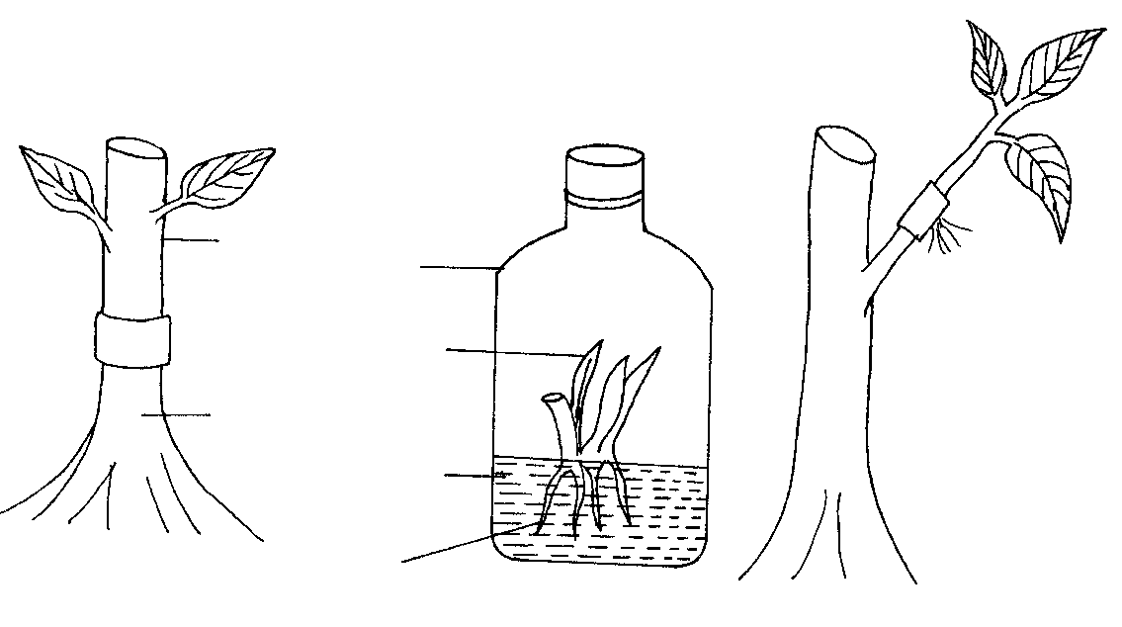
3
1
2
Banana plantlet
Root stock
Glass container
scion
Culture medium
roots
Developing roots
- Identify the methods of crop propagation illustrated above.

1………………………………………………………………………. (½ mark)

2 ……………………………………………………………………… (½ mark)

3……………………………………………………………………… (.½ mark)

b) Give one condition under which method (1) above is carried out. (½ mark)
………………………………………………………………………………………………..

c) State two disadvantages of using stem cuttings for planting. (2marks)
. ……………………………………………………………………………………………….
………………………………………………………………………………............................

20.(a) Form two student put some soil sample in a measuring cylinder, added some water and sodium carbonate and then covered the cylinder with the hand and shook the cylinder for about two minutes. He left the cylinder on the bench for one hour. The result was as shown below.
a
b

c

d

d
(i). Name the layers marked a,b,c and d. (4x ½ =2 mark)
a) ……………………………………………………………………………………….
b) ……………………………………………………………………………………….
c)……………………………………………………………………………………….
d)……………………………………….........................................................................

(ii) What was the function of sodium carbonate in this experiment? (Imark)

.…………………………………………………………………………………………
(iii) What was the aim of this experiment? (lmark)

. ……………………………………………………………………………………….

21.The diagrams below illustrate both field and storage pests
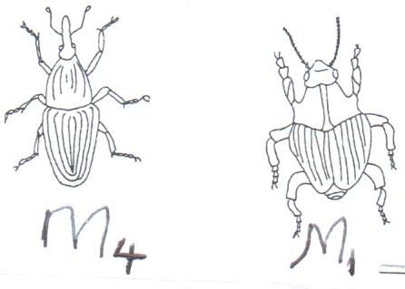
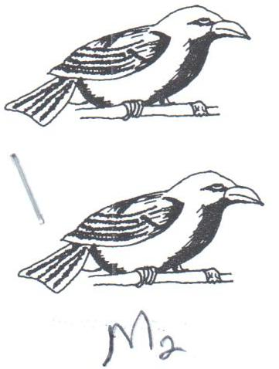
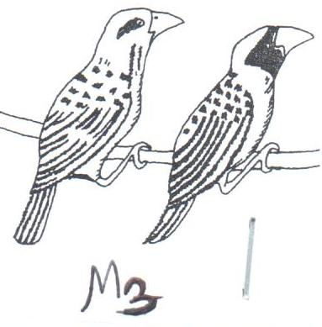

a) Identify the pests in the illustration. (4marks)
M₁………………………………

M₂……………………………….

M₃: ………………………………

M_{4:} ……………………………….

b) State two ways by which pest labelled M₂ causes loss in cereal crops. (1marks)
…………………………………………………………………………………………………………………………………………………………………………………………………………………………

c) State two methods which are used to control the pest labeled M_{2.} (2marks)
…………………………………………………………………………………………………………………………………………………………………………………………………………………………

22.Study the diagram on silage making shown below and answer the questions that follow.

Ground level
Polythene sheet
Soil layer
Silage material
Drainage
a) Identify the silage preparation method shown above. (1mark)
………………………………………………………………………………………………
b) Give two precautions taken when ensiling to ensure high quality silage. (2marks)
………………………………………………………………………………………………..
…………………………………………………………………………………………. ……
c) State two advantages of this method of forage conservation over other methods. (2marks)
……………………………………………………………………………………………………
……………………………………………………………………………………………………

SECTION C ( 40 marks)
Answer TWO questions from this section in the spaces provided
23. a) State and explain five agricultural services offered to farmers. (10marks)
b) Give ways in which labour efficiency can be increased in the farm (5marks)
c) State five the functions of co-operatives. (5marks)
24.a) Give one reason in each case why it is difficult to control the following weeds.
  - Oxalis
  - Nut grass
  - Couch grass (3marks)
b) State two main factors which contributes to competitive ability of weeds. (2marks)
c) State five safety measures that a farmer must consider to prevent danger to other
people and environment when using herbicides. (5marks)
d) Describe any five cultural methods of controlling weeds. (10marks)
25. a) The table gives information on the supply of potatoes in a local market.

Price /bag in Kshs. 1000 | Quantity Demanded (in bags) | Quantity supplied (in bags)
1 | 20 | 2
2 | 15 | 8
3 | 12 | 12
4 | 10 | 16
5 | 9 | 19

- using a suitable scale and on the same axis, draw and label supply and demand curves using the data given. (8marks)
- From the curves drawn, what is the price per bag when 15 bags of potatoes were supplied? (1mark)
- How many bags of potatoes were supplied at Equilibrium price. (1mark)
- Outline the harvesting of coffee under following subheadings
  - Stage of harvesting (2marks)
  - Procedure of harvesting (5marks)
  - Precautions when harvesting (3marks)

………………………………………………………………………………………………………………………………………………………………………………………………………………………………………………………………………………………………………………………………………………………………………………………………………………………………………………………………………………………………………………………………………………………………………………………………………………………………………………………………………………………………………………………………………………………………………………………………………………………………………………………………………………………………………………………………………………………………………………………………………………………………………………………………………………………………………………………………………………………………………………………………………………………………………………………………………………………………………………………………………………………………………………………………………………………………………………………………………………………………………………………………………………………………………………………………………………………………………………………………………………………………………………………………………………………………………………………………………………………………………………………………………………………………………………………………………………………………………………………………………………………………………………………………………………………………………………………………………………………………………………………………………………………………………………………………………………………………………………………………………………………………………………………………………………………………………………………………………………………………………………………………………………………………………………………………………………………………………………………………………………………………………………………………………………………………………………………………………………………………………………………………………………………………………………………………………………………………………………………………………………………………………………………………………………………………………………………………………………………………………………………………………………………………………………………………………………………………………………………………………………………………………………………………………………………………………………………………………………………………………………………………………………………………………………………………………………………………………………………………………………………………………………………………………………………………………………………………………………………………………………
……………………………………………………………………………………………………………………………………………………………………………………………………………………………………………………………………………………………………………………………………………………………………………………………………………………………………………………………………………………………………………………………………………………………………………………………………………………………………………………………………………………………………………………………………………………………………………………………………………………………………………………………………………………………………………………………………………………………………………………………………………………………………………………………………………………………………………………………………………………………………………………………………………………………………………………………………………………………………………………………………………………………………………………………………………………………………………………………………………………………………………………………………………………………………………………………………………………………………………………………………………………………………………………………………………………………………………………………………………………………………………………………………………………………………………………………………………………………………………………………………………………………………………………………………………………………………………………………………………………………………………………………………………………………………………………………………..
……………………………………………………………………………………………………………………………………………………………………………………………………………………………………………………………………………………………………………………………………………………………………………………………………………………………………………………………………………………………………………………………………………………………………………………………………………………………………………………………………………………………………………………………………………………………………………………………………………………………………………………………………..………………………………………………………………………………………………………………………………………………………………………………………………………………………………………………………………………………………………………………………………………………………………………………………………………………………………………………………………………………………………………………………………………………………………………………………………………………………………………………………………………………………………………………………………………………………………………………………………………………………………………………………………………………………………………………………………………………………………………………………………………………………………………………………………………………………………………………………………………………………………………………………………………………………………………………………………………………………………………………………………………………………………………………………………………………………………………………………………………………………………………………………………………………………………………………………………………………………………………………………………………………………………………………………………………………………………………………………………………………………………………………………………………………………………………………………………………………………………………………………………………………………………………………………………………………………………………………………………………………………………………………………………………………………………………………………………………………………………………………………………………………………………………………………………………………………………………………………………………………………………………………………………………………………………………………………………………………………………………………………………………………………………………………………………………………………………………………………………………………………………………………………………………………………………………………………………………………………………………………………………………………………………………………………………………………………………………………………………………………………………………………………………………………………………………………………………………………………………………………………………………………………………………………………………………………………………………………………………………………………………………………………………………………………………………………………………………………………………………………………………………………………………………………………………………………………………………………………………………………………………………………………………………………………………………………………………………………………………………………………………………………………………………………………………………………………………………………………………………………………………………………………………………………………………………………………………………………………………………………………………………………………………………………………………………………………………………………………………………………………………………………………………………………………………………………………………………………………………………………………………………………………………………………………………………………………………………………………………………………………………………………………………………………………………………………………………………………………………………………………………………………………………………………………………………………………………………………………………………………………………………………………………………………………………………………………………………………………………………………………………………………………………………………………………………………………………………………………………………………………………………………………………………………………………………………………………

……………………………………………………………………………………………………………………………………………………………………………………………………………………………………………………………………………………………………………………………………………..
………………………………………………………………………………………………………………………………………………………………………………………………………………………………………………………………………………………………………………………………………………………………………………………………………………………………………………………………………………………………………………………………………………………………………………………………………………………………………………………………………………………………………………………………………………………………………………………………………………………………………………………………………………………………………………………………………………………………………………………………………………………………………………………………………………………………………………………………………………………………………………………………………………………………………………………………………………………………………………………………………………………………………………………………………………………………………………………………………………………………………………………………………………………………………………………………………………………………………………………………………………………………………………………………………………………………………………………………………………………………………………………………………………………………………………….……………………………………………………………………………………………………………………………………………………………………………………………………………………………………………………………………………………………………………………………………………………………………………………………………………………………………………………………………………………………………………………………………………………………………………………………………………………………………………………………………………………………………………………………………………………………………………………………………………………………………………………………………………………………………………………………………………………………………………………………………………………………………………………………………………………………………………………………………………………………………………………………………………………………………………………………………………………………………………………………………………………………………………………………………………………………………………………………………………………………………………………………………………………………………………………………………………………………………………………………………………………………………………………………………………………………………………………………………………………………………………………………………………………………………………………………………………………………………………………………………………………………………………………………………………………………………………………………………………………………………………………………………………………………………………………………………………………………………………………………………………………………………………………………………………………………………………………………………………………………………………………………………………………………………………………………………………………………………………………………………………………………………………………………………………………………………………………………………………………………………………………………………………………………………………………………………………………………………………………………………………………………………………………………………………………………………………………………………………………………………………………………………………………………………………………………………………………………………………………………………………………………………………………………………………………………………………………………………………………………………………………………………………………………………………………………………………………………………………………………………………………………………………………………………………………………………………………………………………………………………………..

……………………………………………………………………………………………………………………………………………………………………………………………………………………………………………………………………………………………………………………………………………..
………………………………………………………………………………………………………………………………………………………………………………………………………………………………………………………………………………………………………………………………………………………………………………………………………………………………………………………………………………………………………………………………………………………………………………………………………………………………………………………………………………………………………………………………………………………………………………………………………………………………………………………………………………………………………………………………………………………………………………………………………………………………………………………………………………………………………………………………………………………………………………………………………………………………………………………………………………………………………………………………………………………………………………………………………………………………………………………………………………………………………………………………………………………………………………………………………………………………………………………………………………………………………………………………………………………………………………………………………………………………………………………………………………………………………………….……………………………………………………………………………………………………………………………………………………………………………………………………………………………………………………………………………………………………………………………………………………………………………………………………………………………………………………………………………………………………………………………………………………………………………………………………………………………………………………………………………………………………………………………………………………………………………………………………………………………………………………………………………………………………………………………………………………………………………………………………………………………………………………………………………………………………………………………………………………………………………………………………………………………………………………………………………………………………………………………………………………………………………………………………………………………………………………………………………………………………………………………………………………………………………………………………………………………………………………………………………………………………………………………………………………………………………………………………………………………………………………………………………………………………………………………………………………………………………………………………………………………………………………………………………………………………………………………………………………………………………………………………………………………………………………………………………………………………………………………………………………………………………………………………………………………………………………………………………………………………………………………………………………………………………………………………………………………………………………………………………………………………………………………………………………………………………………………………………………………………………………………………………………………………………………………………………………………………………………………………………………………………………………………………………………………………………………………………………………………………………………………………………………………………………………………………………………………………………………………………………………………………………………………………………………………………………………………………………………………………………………………………………………………………………………………………………………………………………………………………………………………………………………………………………………………………………………………………………………………………………..

