END TERM ONE EXAM
AGRICULTURE FORM ONE
DURATION-1HR 30 MIN (70 Marks)
Instructions: Answer all questions in the spaces provided
NAME ……………………………………………………………….ADM……………CLASS…………

1. Define the following (6mks)
A) Agriculture ………………………………………………………………………………………………………………………………………
……………………………………………………………………………………………………………………………………………………………b)Floriculture……………………………………………………………………………………………………………………………………………………………………………………………………………………………………………………………………………………………………c)Apiculture………………………………………………………………………………………………………………………………………………………………………………………………………………………………………………………………………………………………………
2. Giving examples, explain why agriculture is both an art and science (6mks)
…………………………………………………………………………………………………………………………………………………………………………………………………………………………………………………………………………………………………………………………………………………………………………………………………………………………………………………………………………………………………………………………………………………………………………………………………………………………………………………………………………………………………………………………………………………………………………………………………………………………………………………………………………………………………………………………………………………………………………………………………………………………………………………………………………………………………………………………………………….
…………………………………………………………………………………………………………………………………………………………………………………………………………………………………………………………………………………………………………………………………………………………………………………………………………………………………………………………………………………………………………………………………………………………………………………………………………………………………………………….
3. Why is agriculture very important to the economic development of Kenya (5mk)
……………………………………………………………………………………………………………………………………………………………………………………………………………………………………………………………………………………………………………………………………………………………………………………………………………………………………………………………………………………………………………………………………………………………………………………………………………………………………………………………………………………………………………………………………………………………………………………………………………………………………………………………………………………………………………………………………………………………………………….
……………………………………………………………………………………………………………………………………………………………
4. Name and explain three methods of farming (6mks)
…………………………………………………………………………………………………………………………………………………………………………………………………………………………………………………………………………………………………………………………………………………………………………………………………………………………………………………………………………………………………………………………………………………………………………………………………………………………………………………………………………………………………………………………………………………………………………………………………………………………………………………………………………………………………………………………………………………………………………………………………………………………………………………………………………………………………………………………………………………………………………………………………………………………………………………………………………………………………………………………………………………………………………………………………………………………………………………………………………………………………………………………………………………………………………………………………………………………………….
5. Give the difference between the following
a) Olericulture and pomology (2mks)
…………………………………………………………………………………………………………………………………………………………………………………………………………………………………………………………………………………………………………………………b)Intensive farming and extensive farming (2mks)
…………………………………………………………………………………………………………………………………………………………………………………………………………………………………………………………………………………………………………………………c)Pastoralism and aquaculture (2mks)
…………………………………………………………………………………………………………………………………………………………….
……………………………………………………………………………………………………………………………………………………………
d)Plantation farming and ranching (2mks)
……………………………………………………………………………………………………………………………………………………………………………………………………………… …………………………………………………………………………………………………………
e)Small scale and large scale farming (2mks)
…………………………………………………………………………………………………………………………………………………………………………………………………………………………………………………………………………………………………………………………6.What are the advantages of shifting cultivation (3mks)
………………………………………………………………………………………………………………………………………………………………………………………………………………………………………………………………………………………………………………………………………………………………………………………………………………………………………………………………………………………

7a)What is soil profile? (2mks)
…………………………………………………………………………………………………………………………………………………………………………………………………………………………………………………………………………………………………………………………b)Below is a diagram of soil profile, label the parts A to E (5mks)
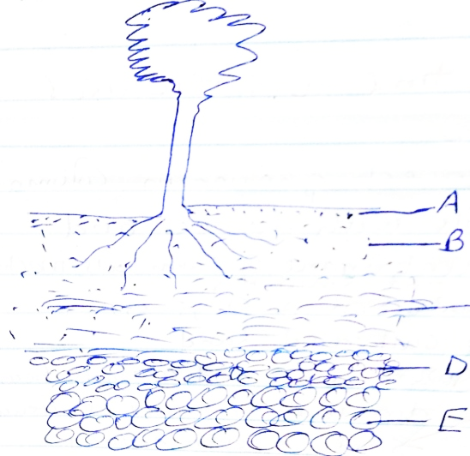
C
8.Name four aspects of rainfall that influence agriculture (4mks)
……………………………………………………………………………………………………………………………………………………………………………………………………………………………………………………………………………………………………………………………………………………………………………………………………………………………………………………………………………………………………………………………………………………………………………………………………………………………………………………
9.Name four factors that influence soil formation (4mks)
……………………………………………………………………………………………………………………………………………………………………………………………………………………………………………………………………………………………………………………………………………………………………………………………………………………………………………………………………………………………………………………………………………………………………………………………………………………………………………………
b)Name the three agents of weathering (3mks)
…………………………………………………………………………………………………………………………………………………………………………………………………………………………………………………………………………………………………………………………
…………………………………………………………………………………………………………………………………………………………………………………………………………………………………………………………………………………………………………………………
10.Name the biotic factors that influence agriculture (4mks)
……………………………………………………………………………………………………………………………………………………………………………………………………………………………………………………………………………………………………………………………………………………………………………………………………………………………………………………………………………………………………………………………………………………………………………………………………………………………………………………
11.State the effects of HIV/ AIDS on agriculture (4mks)
……………………………………………………………………………………………………………………………………………………………………………………………………………………………………………………………………………………………………………………………………………………………………………………………………………………………………………………………………………………………………………………………………………………………………………………………………………………………………………………
12.Match column A to the correct answer in column B (4mks)
A | B
1)Domestication | Deals with the use and maintenance of farm tools machinery and structures
2)Crop pathology | Production of crops on cultivated land
3)Crop farming | When crops and animals become dependent to man for existence
4)Agricultural engineering | Study of crop diseases

b)Name the constituents of soil (4mks)
……………………………………………………………………………………………………………………………………………………………………………………………………………………………………………………………………………………………………………………………………………………………………………………………………………………………………………………………………………………………………………………………………………………………………………………………………………………………………………………………………………………………………………………………………………………………………………………………………………………………………………………………………………………………………………………………………………………………………………………………………………………………………………………………………………………………………………………………………………

