NAME…………………………………………………….ADM……………..CLASS…………
END OF TERM 1 2022 EXAM
443/1
AGRICULTURE
PAPER 1
TIME: 2 HOURS
SECTION A (30 MARKS)
Answer all questions in this section
- Give two disadvantages of intensive system of farming. (1mk)

- List four methods of farming. (2mks)

- Give the meaning of the following terms:
a) Nitrogen fixation into the soil; (1mk)

b) Phosphorus fixation in loss of soil fertility. (1mk)

4. Give four reasons for keeping livestock health records on the farm. (2mks)

5. Explain the relationship between scarcity and choice as used in agricultural economics. (2mks)

6. Sate two reasons for land fragmentation in Kenya. (1mk)

7. Give four advantages of individual owner operator tenure system as practiced in Kenya. (2mks)

8. State four features that should be considered when choosing water pipes for use on the farm. (2mks)

9. Give four reasons for treating water for use on the farm. (2mks)

10. Give two reasons for carrying out each of the following operations in land preparation:
a) Rolling; (1mk)

b) Leveling. (1mk)

11. List two aspects of light that affect agricultural production (1mk)

12. State four factors considered when determining the time of planting (2mks)

13. List four advantages of the title deed to a farmer (2mks)

14. Name the plant part used for vegetative propagation of each of the following plants: (2mks)
(a) Cassava
(b) Sisal
(c)Pyrethrum
(d)Sweet potatoes.
15. Name four settlement schemes that the Kenyan government started as a result of the success of the Million Acre Scheme. (2mks)

16. What is the meaning of seed dressing (1mk)

17. What four factors would you advise a farmer to consider when siting a tomato nursery (2mks)

SECTION B (20 MARKS)
Answer all questions in this section
18. The following is a list of plant nutrients; Copper, Calcium, Nitrogen, Molybdenum, Zinc,
Phosphorus, Carbon, Sulphur, Iron and Magnesium.
Which of the above plant nutrients are:
(a) Macro-nutrients (1mk)

(b) Micro-nutrients (1mk)

(c) Fertilizer elements (1mk)

(d) Liming elements. (1mk)

(e) Mineral whose deficiency causes blossom end rot in tomatoes (1mk)
19. a). A farmer was advised to apply 150 kg CAN (21%N) per hectare while topdressing his maize crop. Calculate the amount of nitrogen applied for two hectares (3mks)

b) Give two forms in which Nitrogen is absorbed by plants (2mks)

20. Below are illustrations of types of weeds. Study them and answer the questions that follow.
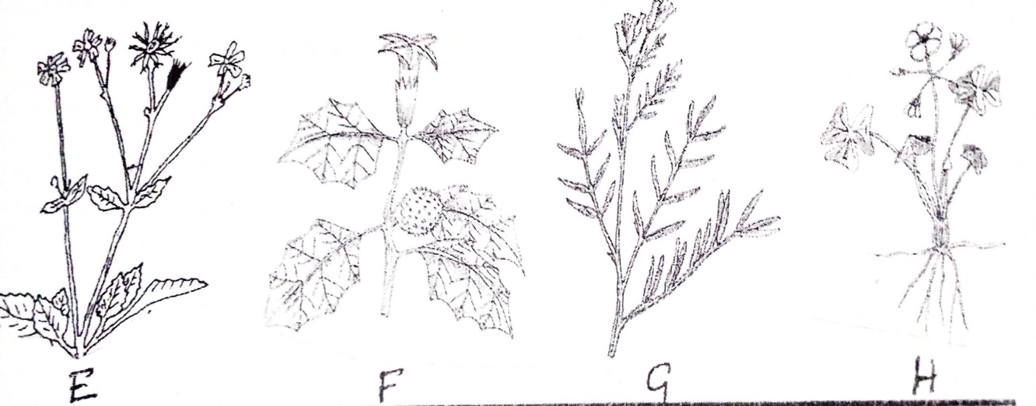
- Identify the weeds labelled E, F, G and H. (4mks)
E-
F-
G-
H-
b) Why is it difficult to control weed H (1mk)

21. Below shows an experiment set up and observations made after 24 hours. Study it and answer the questions below
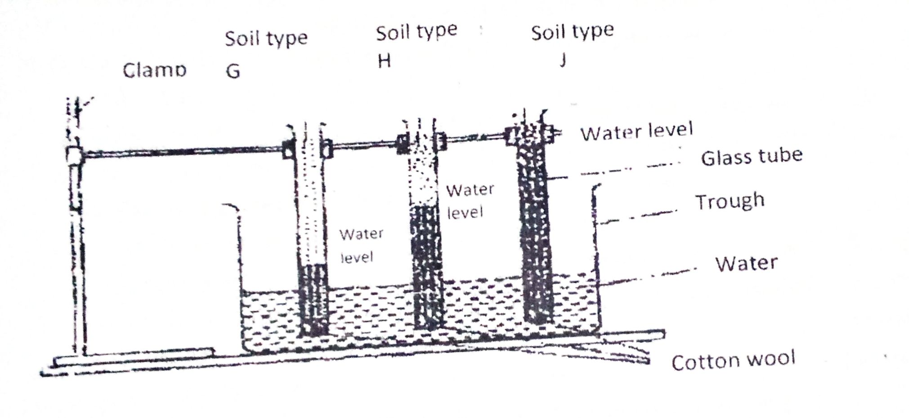
- What is the experiment below designed to study (1mk)

- Names soil types G, H and J (3mks)

- How can a farmer improve the structure of soil type G (1mk)

SECTION C (40 MARKS)
Answer any TWO questions from this section
22. (a) Explain seven physical methods of pest control. (7mks)
(b) Explain eight factors that contribute to the competitive ability of weeds. (8mks)
(c) Describe the harvesting of coffee. (5mks)
23 a) Explain eight factors that can encourage soil erosion. (8mks)
b) Describe the seven management practices that should be carried out on a vegetable nursery after sowing seeds until the seedlings are ready for transplanting. (7mks)
c) Outline five ways in which high temperature affects agricultural production in Kenya. (5mks)
24. a) Describe the production of cabbages under the following sub-headings:
(i) Seedbed preparation; (3mks)
(ii)Transplanting of seedlings. (7mks)
b) State biotic factors and explain how they influence crop production in agriculture. (5mks)
c) Explain five ways in which HIV/AIDS limits agricultural production (5mks)

