NAME…………………………………………………………ADM…………………..CLASS……………
END OF TERM 1 2022 EXAM
231/1 (THEORY)
BIOLOGY PAPER 1
TIME: 2 HOURS
Answer all the questions in the spaces provided (80 Marks)
1. Give two reasons why a cell must undergo interphase before mitosis starts. (2mks)

2. a) State three limitations of quadrat method used in estimation of population of organisms in a given ecosystem.
(3mks)

b) Apart from quadrat method, name any other two methods of estimating populations of organisms (2mks)

3. The diagram below represents the sporophyte generation of a fern plant. Study it and answer the questions that follow.

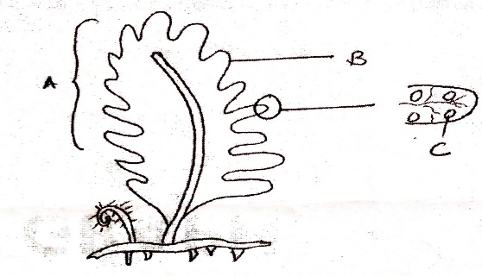
- Name the parts labelled A and B (2mks)
A…………………………….
B…………………………….
- Suggest the significance of the structure labelled C (1mk)

4. State two importance of aerobic respiration. (2mks)

5. Name two sites of respiration in a cell. (2mks)

6. a) Differentiate between sickle-cell anaemia and sickle- cell trait. (2mks)

- Name the type of gene mutation that brings about the sickle cell anaemia. (1mk)

7. Through which blood vessels does the blood from the alimentary canal return to the heart? (2mks)

8. Name two examples of polysaccharides in plants. (2mks)

9. The diagram below is a specialized mammalian cell
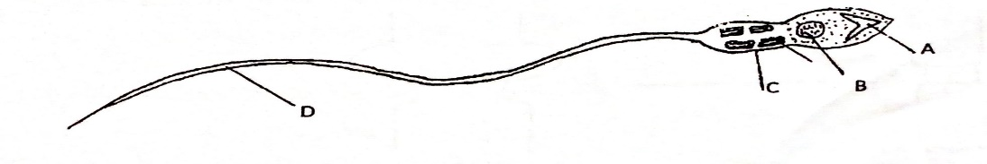
a) Name the parts labelled B and D (2mks)
B………
D………..
b) State how the following parts are adapted to their functions (2mks)
i) Part labelled A

ii) Part marked C

10. What is the name given to the pregnancy that occurs in the fallopian tube? (1mk)

11. List the causative agent of the following sexually transmitted infections (STls): (2mks)
(a) Gonorrhoea.

(b) Syphilis

12. (a) How would you destarch the leaves of a potted plant? (1mk)

(b) Which chemical would you use to test for presence of vitamin C in a food substance? (1mk)
13. Name the two types of chemical compounds which combine to form a lipid. (2mks)

14. Name the processes by which the following enter the root hair cell. (2mks)
(a) Oxygen.
(b) Water.
15. Give two structural differences between mature white blood cells and red blood cells. (4mks)

16. Give two examples of genetic engineering that are intended to improve crop plants. (2mks)

17. An animal has 36 chromosomes in each of its body cells. How many of these chromosomes came from its male parent? (1mk)

18. Study the diagram below:
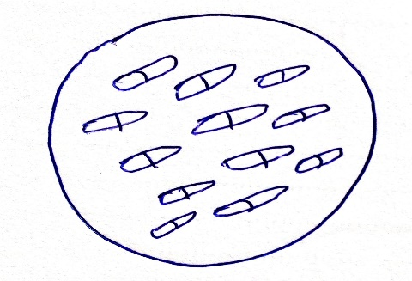
(a) From which type of plant is the section representing? (1mk)

(b) Give two reasons for your answer in (a) above. (2mks)

19. (a) Name the organelle involved in formation of cilia and flagella. (1mk)

(b) Give two strengthening materials of cell wall of plant. (2mks)

20. State two homeostatic functions of mammalian kidney. (2mks)

21. a) What type of gene mutations are represented by the following messages? (2mks)
i) Intended message: Lions have pointed claws.
Actual message: Lions have pointed laws.

ii) Intended message: The strong wind caused severe damage.
Actual message: The strong wind paused severe damage.

b) At what stage of cell division does exchange of genetic material occur ? (1mk)

22. The diagram below shows an embryo sac of a flowering plant
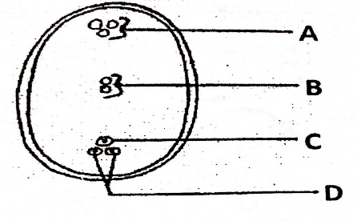
a) Name the parts labelled A and D (2mks)
A………………
D……………
b) What is the function of structure labelled B (1mk)

c) Why is cross pollination more advantageous to a plant species than self-pollination (1mk)

d) What name is given to the type of fertilization exhibited in plants (1mk)

23. a) What is divergent evolution (1mk)

b) Distinguish between divergent and convergent evolution (2mks)

24. Name two mechanisms that hinder fertilization in flowering plants (2mks).
25.The diagram below represents an experiment that was set up to investigate a certain process
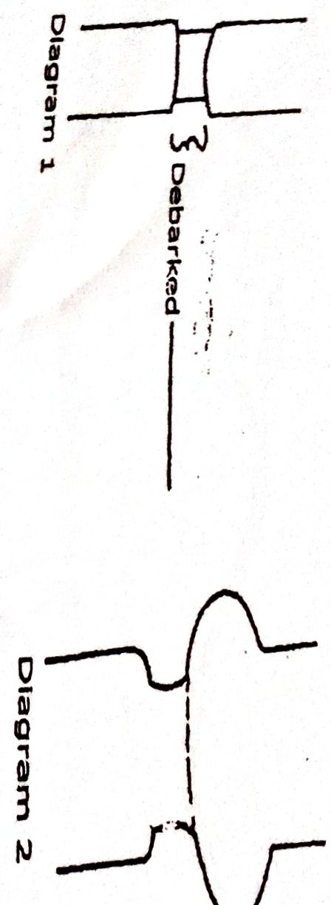
- Name the process that was being investigated (1mk)

- Account for the swelling in diagram 2 (2mks)

c) Give a reason why the plant did not dry up during the investigation (1mk)

26. a) Name one hormone that is involved in insect metamorphosis (1mk)

b) State the site where the above named hormone is produced (1mk)

c) State two roles of metamorphosis to the life of insects (2mks)

27. Explain why swallowing and breathing cannot take place at the same time (2mks)

28. State three properties of a cell membrane (3mks)

29. Give a reason why it is only mutation in genes of gametes that influence evolution (1mk)

30. State three structural differences between Ribonucleic acid (RNA) and Deoxyribonucleic acid (DNA) (3mks)

31. Define the term homeostasis (1mk)
32. a) What was the function of the following apparatus. (3mks)
- Pooter

- Sweep net

- Chloroform

- Other than observation, give other two scientific skills developed by studying biology. (2mks)

33. (a) What is peristalsis? (1 mk)

- Explain how the process above is brought about.
(2mks)

- What are the two functions of bile salts during the process of digestion. (2mks)

