ASUMBI GIRLS HIGH SCHOOL
PRE-MOCK
MAY-JUNE
2022

233/2 CHEMISTRY
MARKING SCHEME
FORM 4

1 a)
- V
- S
- Q Neither gain nor lose electrons’ hence only give more room for bond formation
- Alkali metals
- On the grid
- It ionizes by receiving an electron , hence the gained electrons repelled by the already existing electrons
b)i) SICl₄, PCl₅, SCl₂,
Melting below room temperature and boiling point above room temperature
ii) AlCl₃ has simple molecular structure with weak van der waal forces , while MgCl₂ has giant ionic
structure with strong ionic bond

2. (a) M- Vanadium (V) oxide√
N- Concentrated sulphuric (VI) acid
(b) To dry the gases SO₂ and air√1
(c)Forward reaction is exorthermic
- 197KJ energy is produced when 2 moles of SO₃ are formed
- 98.5 KJ are produced when 1 mole of SO3 in addition to keeping the boiling tube dry
(d) Deposition/solidification
(e) CaO reads with the escaping SO₃ in addition to keeping the boiling tube dry.

(II) (a)(i) –Sulphur (IV) oxide gas √ ½
- - Oxygen gas (air) √ ½
(ii) reduces environmental pollution √ ½
Reduces costs √ ½
(b) (i) –Is the removal of acidic gases by reacting it with a base e.g SO2 reacted with Ca(OH)₂
(ii) SO_{2(g)} + Ca(OH)_{2(s)} CaSO_{3(s)} + H₂O_{(l)}
(c) SO₃ reacts with water producing a lot of heat which causes acid mists or sprays which are corrosive √1
(III) C1V1=C2V2
1.82 x V1= 2x1000√1
V1= √1
= 109.8901cm³√1

3 a) (i) D⁺ ⁴
( iii) A _{(s)}

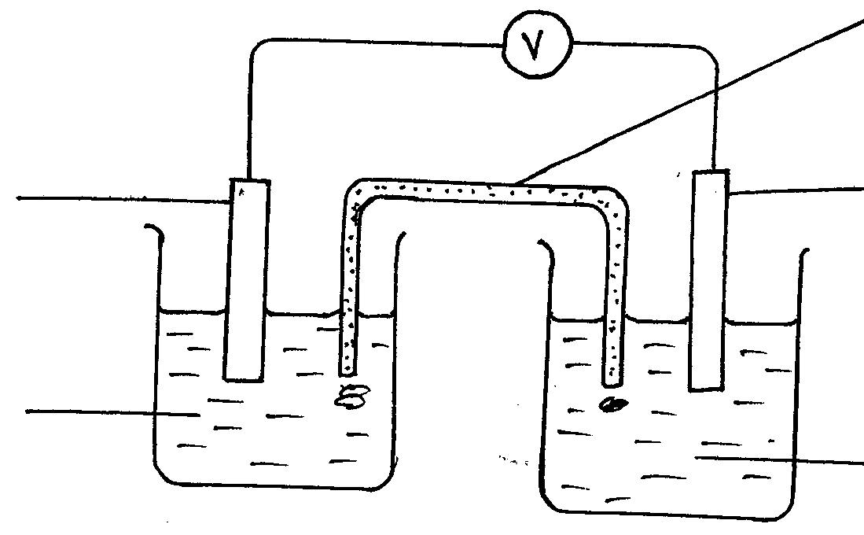
1MA²⁺
1MB²⁺
B _{(s)}
Salt bridge
b i)
A _{(s)}

ii) emf + E red - E ox
- .44 ---0.776 = 0.32v

iii) D⁴⁺ /D³ and A_{s} /A²⁺
fe³⁺( ag ) + 3 e fe_{(s)}
1 mole 3mole 1 mole
- o.1 mole of fe 3+ + 0.1 * 3= 0.3 feraday
d i) to prevent steel from rusting
- to prevent steel from reacting with chromium at higher temperature since copper or nickel are uncreative
- Fe²⁴ (ag) + CV _{(S) -} Cv2+ (ag) + F₄ (s)
IV) Q = It = 4.5 x 20 x60 x 60 = 324 ,000c
Mass deposited = 52 x 3240000/ 96500/2 = 87.295 g
4a) propane
H HH
H - | | | - H
C - C- C
| | |
H HH

b) Reagent – concentrated sulphuric (vi) acid
Condition: 160 - 180^{0 c}
ii) condition:uv light /sunlight

c) (i) carbon(iv) oxide
(ii). hydrogen
(iii) propane-I-oic acid
- Bromo-propan – 2-01
2 bromopropane -1 -01
d) 2 C₃H₇ ,OH_{(I)} + 90₂ (g) - 6Co ₂ (g) + 8 H2O _{(g)}
e) Addition polymerization /polymerization

f) 3x12x 1x 6 = 42
N = 2100/ 42 = 500

5a) phosphonessmolders
Itsreaction with air is exothermic
II) phosphorous (iii)oxide formed is an acidic oxide which dissolves in water to form phosphoric oxide.
phosphoric(iii) acid
iii) volume of air used = 30.65 – 24. 28 = 637 cm
percentage volume = 6.37/30.65 * 100 = 20.78%
b)black powder changes to red brown bead
brownbeed Mg reduces Cv0 to copper metal
White ash formed : Mg is oxidized to Mg0
C) carbon 9ii0 oxide
Sulphuric (iv) oxide
Nitrogen (iv) oxide

6) mass of magnesium = 20.36 – 19.52= 0.849
Mass of oxygen = 20.92= 20.36=0.56g
Mass of Mg0 = 20.92 – 19.52 = 1.40g
% of magnesium = 0.84/ 1.40* 100 =60%
% of mass of oxygen Mg0= 0.56/1.40*100= 40%

II)elements present Mg 0
Mass 0.84 0.56
molespresent 0.84/24 0.56/16
0.035 0.035
Simple ratio
Formula Mg0

b) 2 Na0H (ag) + H2 So₄ - Na₂S0₄ (ag) = 2 H₂0
ii) I : moles ratio of Na0H ;H₂SO₄ = 2:1
Moles of Na0H = 2 x 0.005 = 0.01
ii) if 50 cm³of Na0H = 0.01
1000 cm³ of Na0H = 1000 x 0.01/50 8 0.02moles
OR Ans in (i) x 1000 /50 = Ans

iii) molar mass of Na0H = 23 +1 =16 = 40 G
Mass of Na0h reacted = 40 x 0.2 = 8g
Mass of NaCL = 0.8/8.8 x 100 = 9.0909%

7a) H HHH
| | | |

H- C - C- H + Bv - Bv H- C- C - Bv + H -Bv
| |
H H | |
H H
Bond breaking energy = 413 +193 = 606kj
Bond function energy = 280 +365 = 645 kj
H for the reaction = 606- 645
= 39 kj

Temp 80

b )

-10ºC
Time

c) C s = 5 H₂ g Δ H₂ c4 H₁₀ (g)
4CO₂ g + 5/2H₂O13/2 O(g)

4CO₂ g + 5H₂O∆ H3

∆H2 = ∆ H1 -∆H3
= ( 4 x -343 +-286)-(-2877)
= -1572 – 1430 +2877
= -125 kHz /mol

d) ∆H +∆Hhyd
= 690 + 322 + 364
= 690- 686
= + 4 kJ / mol

