NAME: …………………………………. ADM NO: ………….… CLASS: ………
FORM 1 BIOLOGY
END TERM 1 2022
TIME: 2 HOURS

Answer all the questions in the spaces provided.

1. With reference to the term Biology, state the meaning of the following:- (2 mks)
(i) bios –

(ii) logos –

2. State the two major branches of Biology and give their meaning. (4 mks)

3. Complete the table below by giving the meaning of the terms: (5 mks)
Branch of Biology | Meaning
Microbiology
Anatomy
Physiology
Entomology
Cytology

4. Outline four benefits of study of biology. (4 mks)

5. With reference to characteristics of living organisms complete the table below. (8 mks)

Characteristic | Definition/Meaning
Reproduction
Movement
Excretion
Nutrition
Respiration
Growth and development
Gaseous exchanges
Irritability (Responsiveness)

6. State the importance of the following in living organisms. (6 mks)
(i) Reproduction –

(ii) Movement –

(iii) Excretion –

7. Explain how plants and animals differ with reference to the following characteristics. (10 mks)
NB: Marks are linked in each characteristic.

(i) Nutrition | Plants | Animals
(ii) Irritability
(iii) Growth
(iv) Excretion
(v) Movement

8. Explain how the following apparatus are used in collection and observation of specimens.
(6 mks)
(i) A pooter –

(ii) A bait trap –

(iii) A pit fall trap –

(iv) A fish net –

(v) A sweep net –

(vi) Pair of forceps –

9. (a) Define the following terms: (2 mks)
(i) Taxonomy –

(ii) Taxonomic units –

(iii) Outline the seven taxonomic units of classification from the largest to the smallest.
(7 mks)

(b) Complete the table below kingdoms should be in the order of simplest to most complex
organisms. (10 mks)
 | Kingdom | Example of organism
(i)
(ii)
(iii)
(iv)
(v)

10. (a) Identify the organisms shown in the photographs. (3 mks)

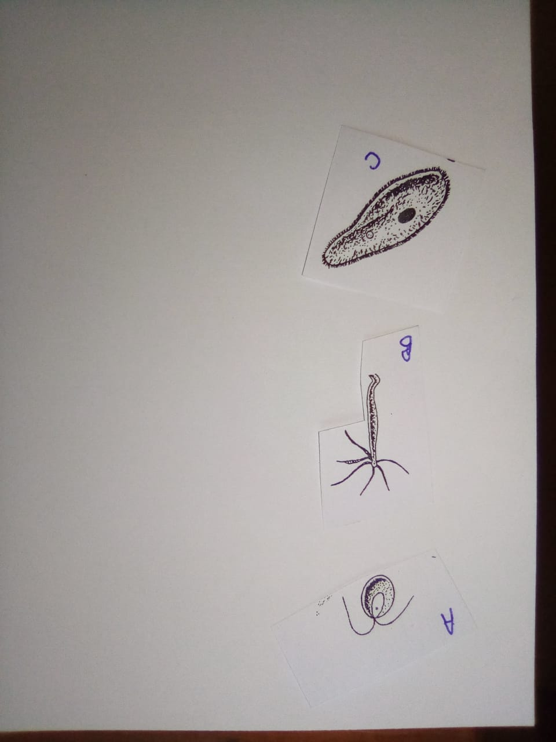

A –

B –

C –

(b) If fish in diagram A is the drawing of object B, calculate the drawing magnification. (3 mks)

