NAME…………………………………………………………..ADM………CLASS………
GEOGRAPHY
FORM THREE
END TERM 1 2022
TIME:2 ¾ HOURS
INSTRUCTION TO STUDENTS
- Answer all Questions
- This paper contain two sections
- Check the question paper to ascertain no question is missing
- Student should answer the question in English.
SECTION A
- (a)Give four areas that are of great interest in physical geography. (4mks)

(b)Outline three ways in which a student benefits from learning Geography. (3mks)

- (a)The diagram below shows the internal structure of the earth.
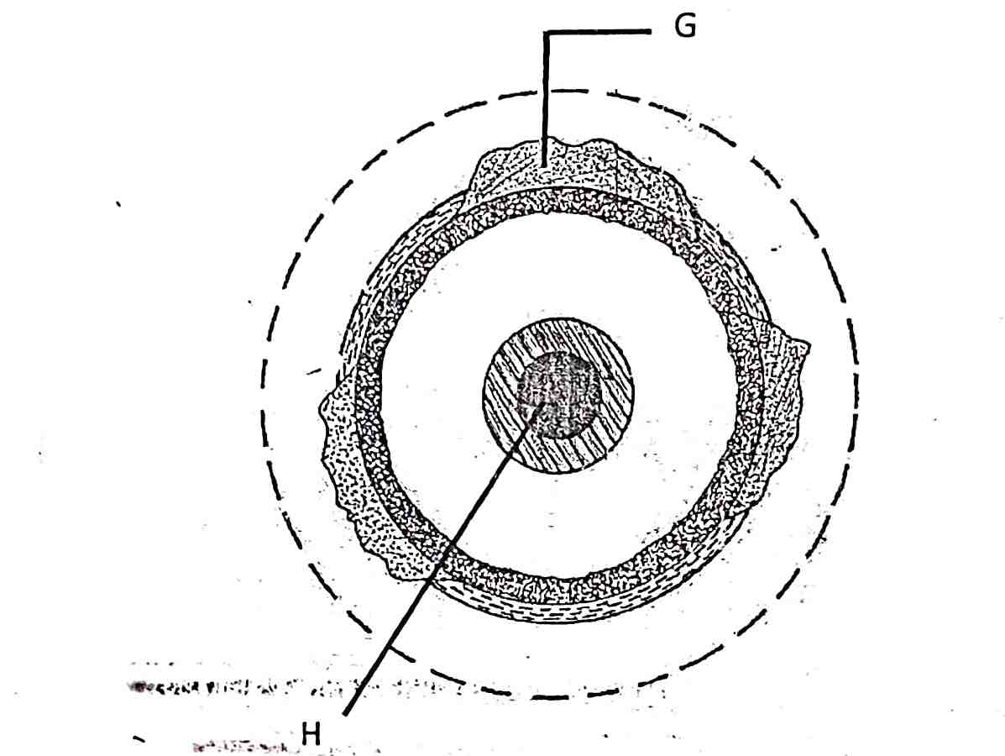

- Name the parts marked G and H. (2mks)

- Name the dorminant mineral in the mantle. (1mk)

- (a) Differentiate between absolute and relative humidity. (2mks)

(b)State the significance of humidity in the atmosphere. (3mks)

- The diagram below shows some features formed by faulting

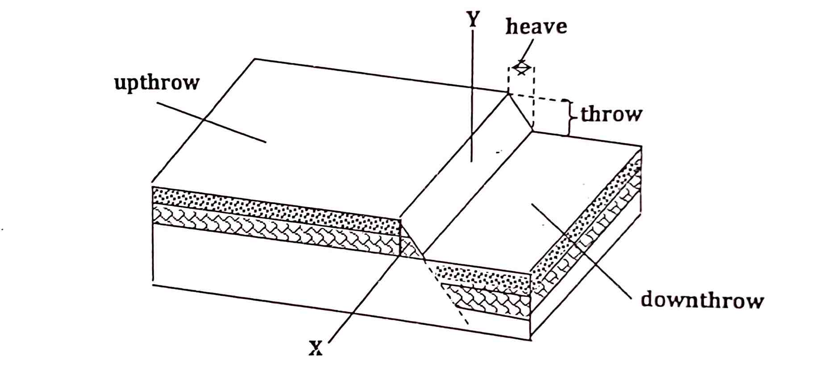

(a)Name the parts marked X and Y. (2mks)

(b)State three effects of faulting on drainage of an area. (3mks)

- (a)What is weathering. (2mks)

(b)State three agents of weathering. (3mks)

SECTION B
Answer all Question in this section.

- The table below shows hypothetical figure of major crops exported from Kenya in tonnes.

YEAR | COFFEE | TEA | MAIZE | WHEAT
1990 | 4500 | 1300 | 800 | 600
1991 | 5000 | 1100 | 900 | 500
1992 | 5200 | 2500 | 500 | 600
1993 | 6000 | 2100 | 400 | 700
1994 | 5900 | 2200 | 400 | 500

- Using scale 1cm represent 1000tonnes draw a compound bar graph showing major crops exported from Kenya in tonnes. (13mks)

- Give four possible analyses one could be deduce from the graph you have drawn. (4mks)
- Give four advantages of compound bar graphs. (4mks)
- State four disadvantages of compound bar graph. (4mks)

- (i)Distinguish between minerals and rocks. (2mks)

(ii)State three characteristics of minerals. (3mks)

(iii)Name three types of minerals. (3mks)

- (i)Describe how intrusive Igneous rocks are formed. (5mks)

(ii)State three characteristic of intrusive rocks. (3mks)

- (i)What is rock metamorphism. (2mks)

(ii)State three factors that influence rock metamorphism. (3mks)

- Explain two economic benefits of coral limestone rocks. (4mks)

- Describe how block disintegration occur in weathering. (5mks)

- Explains how the following factors influence weathering.
(i)Time. (2mks)

(ii)Nature of the rocks. (4mks)

(iii)Action of plants. (3mks)

- Your class carried out a field study on the effects of weathering along the school compound.
(i)State two objective for your study. (2mks)

(ii)State two effects of weathering on the physical environment you are likely to identify. (2mks)

- (i)Define the term mass wasting. (2mks)

(ii)State three storage processes of water on the earth surface. (3mks)

(iii)Define the term river. (2mks)

9. (a)(i) Name two types of earth movements. (2 marks)
(ii) State three causes of earth movement. (2 marks)
(iii) Describe the plate tectonics theory. (5 marks)
(b) (i) Define faulting. (2 marks)
(ii) State three factors that may influence faulting processes. (3 marks)
(iii) Name four types of faults. (4 marks)
(d) With the aid of well-labelled diagrams, describe the formation of rift Valley by compressional forces. (7 marks)

10. (a) (i) What is river rejuvenation (2mks)
(ii) Study the diagram below and answer the questions that follow.

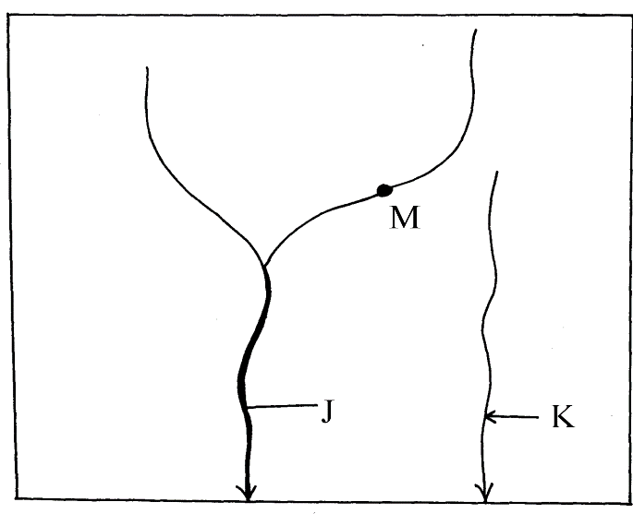
(a) Identify the process represented by the diagram above (1mk)
(b) Label the parts marked J and K (2mks)

(c) Identify the type of erosion that take place at the point marked M (2mks)
(iii) Describe three ways in which a river transport its load (6mks)
(iv) With the aid of a well – labeled diagram, illustrate the hydrological cycle (6mks)
(v) Give the significance of river to human Activities. (6mks)

