NAME: …………………………………. ADM NO: ………….. CLASS: ………….
443/2
AGRICULTURE
PAPER 2
FORM FOUR
ENDTERM 1 EXAM
JUNE/JULY 2022
TIME: 2 HOURS

INSTRUCTIONS TO CANDIDATES:
(a) This paper consists of three sections A, B and C.
(b) Answer all the questions in section A and B.
(c) Answer any two questions in section C.
(d) Answers should be written in the spaces provided.

SECTION A: (30 MARKS)
1. Name two exotic breeds of dairy goats. (1 mk)
(i)

(ii)

2. State four advantages of natural method of rearing calves. (2 mks)

(i)

(ii)

(iii)

(iv)

3. (a) Name livestock commonly attacked by keds. (½ mk)

(b) Give three signs of attack by keds on livestock named in 3(a) above. (1½ mk

(i)

(ii)

(iii)

4. State four disadvantages of a hedge in a farm. (2 mks)

(i)

(ii)

(iii)

(iv)

5. (a) Name a tool used in carrying out each of the following practices:
(i) Cutting galvanized iron sheet - (½ mk)

(ii) Cutting wood along the grains - (½ mk)

(iii) Marking lines parallel to the edge of stock - (½ mk)

(iv) Placing mortar between construction stones - (½ mk)

6. State four maintenance practices carried out on a jack plane. (2 mks)
(i)

(ii)

(iii)

(iv)

7. State four signs of parturition in a cow. (2 mks)

(i)
(ii)
(iii)
(iv)

8. Explain how the following methods help in controlling livestock diseases:
(i) Mass slaughter ½ mk)

(ii) Proper feeding - ½ mk)

(iii) Quarantine - ½ mk)

(iv) Vaccination - ½ mk)

9. Give two uses of litter in a brooder. (1 mk)
(i)

(ii)

10. State two reasons for dehorning in cattle. (2 mks)
(i)

(ii)

(iii)

(iv)
11. Give four essentials of clean milk production in a herd. (2 mks) (i)

(ii)

(iii)

(iv)

12. Give four predisposing factor of pneumonia in cattle. (2 mks)
(i)

(ii)

(iii)

(iv)

13. State four factors that determine digestibility of a feed. (2 mks)
(i)

(ii)

(iii)

(iv)

14. Give four methods of preserving fish. (2 mks)
(i)
(ii)
(iii)
(iv)

15. Give four disadvantages of using thatch in construction of farm buildings. (2 mks)

(i)

(ii)

(iii)

(iv)

16. State four reasons for swarming in bees. (2 mks)

(i)
(ii)
(iii)
(iv)

SECTION B: (20 MARKS)
17. (a) A farmer was advised to prepare 180kg of calf ration containing 20% DCP. Using pearsons
square method, calculate the amount of maize containing 10% DCP and sunflower
containing 40% DCP the farmer needs to use. Show your working. (4 mks)

(b) State two factors considered when formulating a livestock ration. (2 mks)
(i)

(ii)

18. Study the diagram below and answer the questions that follow.
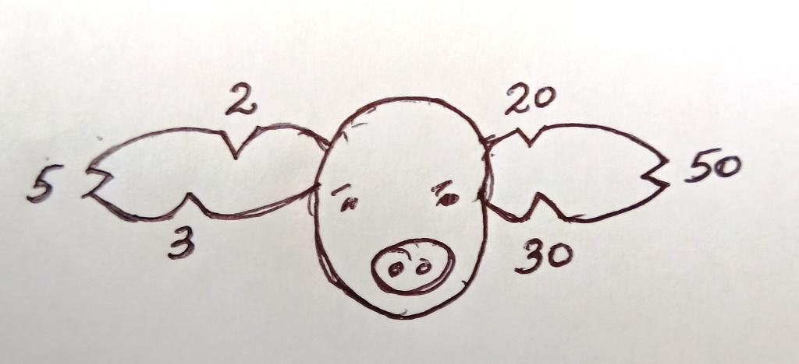
(a) Name the type of identification illustrated above. (1 mk)

(b) Give the identification number of the pig illustrated above. (1 mk)

(c) Using a diagram, illustrate how animal number 83 can be identified using the above method. (2 mks)

(d) What is the use of metal rails in a farrowing pen. (1 mk)

19. The diagrams below shows the behaviour of chicks in a brooder in response to heat.

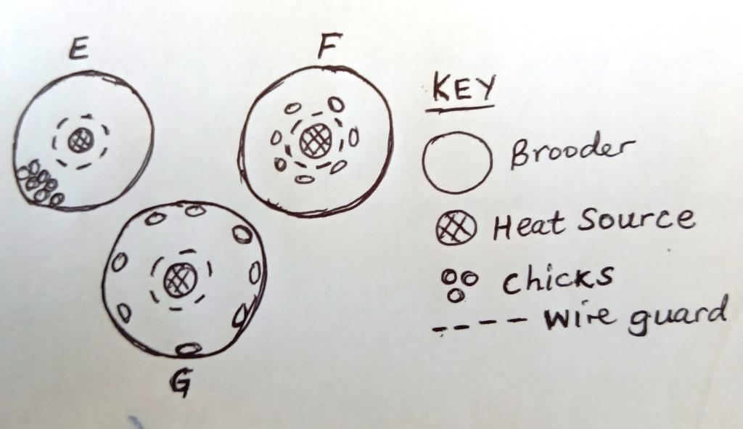
(a) Explain the behaviour of chicks in brooder;
E – (1 mk)

F – (1 mk)

G – (1 mk)

(b) Explain why the brooder is rounded. (1 mk)

20. The diagram below shows the structure of the udder of a cow. Study it then answer the
questions that follow.
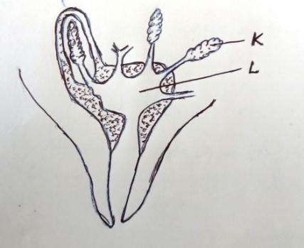
(a) Identify parts labeled K and L. (2 mks)
K –

L –

(b) Name two hormones that control milk let-down in a dairy cow. (2 mks)
(i)

(ii)

(c) Name one disease that attacks part labeled L. (1 mk)

SECTION C: (40 MARKS)

21. (a) Describe the physical characteristics of a good dairy cow for breeding. (10 mks)

(b) (i) State five functions of water in the body of livestock. (5 mks)

(ii) Explain the advantages of a four stroke cycle engine. (5 mks)

22. (a) Explain five factors that affect milk composition in dairy cattle. (5 mks)

(b) Describe five factors that may lead to failure of a cow to conceive after service. (5 mks)

(c) Explain the factors that a farmer should consider when selecting materials to construct a
zero grazing unit. (10 mks)

23. (a) Describe milk fever under the following sub-headings:
(i) Animal affected. (1 mk)

(ii) Cause of disease. (1 mk)

(iii) Symptoms. (5 mks)

(iv) Control measures. (3 mks)

(b) Outline the advantages of artificial insemination in cattle. (10 mks)

