NAME........................................................ Index number..................................ADM NO............
Candidate’s signature.................................................. Date..................................
121/2
FORM 4
MATHEMATICS
PAPER 2

2¹/₂ HOURS
ASUMBI GIRLS HIGH SCHOOL
PRE-MOCK
MAY-JUNE
2022
Instructions to candidates
- Write your name and index number in the spaces provided above.
- Sign and write the date of examination in the spaces provided above.
- This paper consists of two sections I, II.
- Answer all the questions in section 1 and any five questions from section II.
- All working and answers must be written on the question paper in the spaces provided below each question.
- Show all steps in your calculations, giving answers at each stage in the spaces provided below each question.
- Marks may be given for correct working even if the answer is wrong.
- Non-programmable silent electronic calculators and KNEC mathematical tables may be used.
- This paper consists of 13 printed pages.
- Candidates should check the question paper to ascertain that all the pages are printed as indicated and that no questions are missing.
For Examiner’s Use Only.
SECTION I
Questions | 1 | 2 | 3 | 4 | 5 | 6 | 7 | 8 | 9 | 10 | 11 | 12 | 13 | 14 | 15 | 16 | Total
marks
SECTION II

Grand
Questions | 17 | 18 | 19 | 20 | 21 | 22 | 23 | 24 | Total
Marks 17

SECTION 1 (50MARKS)
- Use logarithms to evaluate (4mks)
$\frac{\left(0.8932\right)2 ×\left(582.3\right)1/3}{\left(69.35\right)}$
4

- A rectangular card measures 5.3cm by 2.5cm. find
- The absolute error in the area of the card. (2mks)

- The relative error in the area of the card (2mks)

- Solve the equation (4mks)
Sin (2x +10)⁰=-0.5 for 0⁰$≤$x$≤$ 360 ⁰

- In a transformation, an object with an area of 52cm² is mapped onto an image whose area is 30cm². Given that the matrix of the transformation is $\begin{matrix}x & x-1 \\ 2 & 4\end{matrix}$ find the value of x (3mks)

- Simplify $\sqrt{48 }$leaving your answer in the form of a$\sqrt{b}$ + c where a, b and c are integers. (3mks)
$\sqrt{5}$ + $\sqrt{3}$

- A customer deposited sh 14000 in a saving account. Find the accumulated amount after one year if interest was paid at 12% p.a compounded quarterly (3mks)

- Expand (1+x)⁵, hence use the expansion to estimate (1.04)⁵ correct to 4 decimal place (3mks)

- Find the centre and the radius of circle whose equation is (3mks)
x²+4x+y²-5=0

- Make d the subject of the formula (3mks)
P=¹/₂mn²-gd²
n

- In what proportion should grades of sugar costing sh 45 and sh 50 per kg be mixed in order to produce a blend worth sh 48 per kg (3mks)

- Simplify the expression (3mks)
16m² $–$ qn²
4m²$-$ mn $-$3n²

- Find the equation of the tangent to the curve (3mks)
y=2x² at (2, 3)

- Use matrix method to solve the given simultaneous equation (3mks)
3x+y=7
5x+2y=12

- The sum of n terms of the sequence 3, 9, 15, 21 ... is 7500. Determine the value of n (3mks)

- The figure below (not drawn to scale) shows a triangle ABC in which AB=6cm, BC=9cm, AC=10cm. calculate the radius of the circle touching the three vertices of the triangle. (3mks)
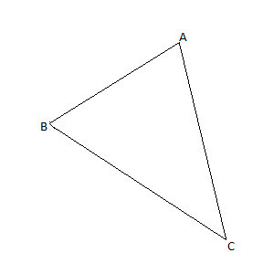

- The point p (40⁰S, 45⁰E) and point Q (40⁰S, 60⁰W) are on the surface of the earth. Calculate the shortest distance along a circle of latitude between the two points. (3mks)

SECTION B (ANSWER ANY FIVE QUESTION (50 MARKS)
- The table below shows monthly income tax rates.
Monthly taxable pay  K$£$ | Rate of tax sh per K£
1-342  343-684  685-1026  1027-1368  1369-1710  Over 1710 | 2  3  4  5  6  7

A civil servant earns a monthly salary of sh 20 000 and is provided with a house at a normal rent of sh 700 per month.
- calculate the civil servant taxable pay in K£ (4mks)

- Calculate the total tax (4mks)

- If the employee is entitled to a tax relief of sh 600 per month. What is the net tax paid? 2mks)

- In an agricultural research centre, the length of a sample of 50 maize cobs were measured and recorded as shown in the frequency distribution table below.
Length in cm | Number of cobs
8-10  11-13  14-16  17-19  20-22  23-25 | 4  7  11  15  8  5

Calculate
- The mean (2mks)

- (i) the variance (5mks)

(ii) The standard deviation (3mks)

- In the diagram shown below O is the centre of the circle, angle RTV=150⁰,and angle RST=50^{0,}
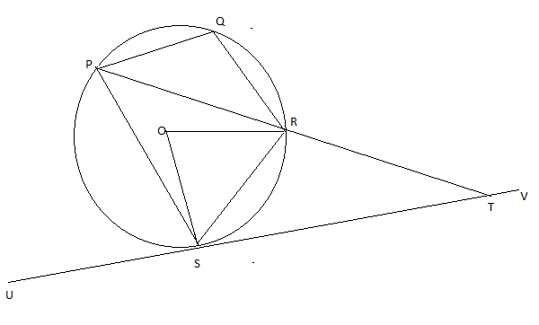

- Calculate the size of
- $<$ORS (2mks)

- $<$USP (1mk)

- $<$PQR (2mks)

- Given that RT =7cm and ST=9cm, calculate to 3.s.f
- The length of line PR (2mks)

- The radius of the circle (3mks)
- The position of two towns A and B on the earth surface are (36⁰N, 49⁰E) and (36⁰N, 131⁰W) respectively
a) Find the difference in longitude between town A and town B (2mks)

b) Given that the radius of the earth is 6370km calculate the distance between town A and B (4mks)

(c) Another town C is 840km east of town B and on the same latitude as towns A and B. find the longitude of town C (4mks)

- The distance sm from a fixed point O, covered by a particle after ts is given by the equation
S=t³-6t²+9t+5
a) Calculate the gradient to the curve at t=0.5s (3mks)

b) Determine the values of s at the maximum and minimum turning points of the curve. (4mks)

c) On the space provided sketch the curve of s=t³-6t²+9t+5 (3mks)

- In the figure below OQ =a and OB=b. m is the midpoint of OA and AN:NB =2:1
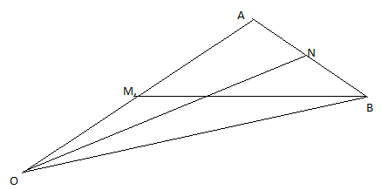

a) Express in terms of a and b
- BA (1mk)

- BN (1mk)

- ON (2mks)

b) Given that BX=hBM and OX=KON determine the values of h and k (6mks)

- (a) Complete the table below, giving the values correct to 1 d.p (2mks)

 |  | X⁰ | 0 | 40 | 80 | 120 | 160 | 200 | 240
2sin (x+20)⁰ |  | 0.7 |  |  | 2.0 |  | 0.0 |  | -2.0
$\sqrt{3}$ cos x |  | 1.7 | 1.3 |  |  | -0.9 |  | -1.6
(b) On the grid provided, using the same scale and axes, draw the graphs of y=2sin (x+20)⁰ and y=$\sqrt{3}$ cos x for 0$≤$x$≤$ 240⁰ (5mks)
(c) Use the graphs drawn in (b) above to determine:
- The values of x for which 2 sin (x+20)⁰ =$\sqrt{3}$ cos x (2mks)
- The difference in the amplitudes of y=2sin(x+20) and y=$\sqrt{3}$ cox x (1mk)

- The probabilities that a husband and wife will be a live 25 years from now are 0.7 and 0.9 respectively. Find the probability that in 25 years time;
a) Both will be a live (2mks)

b) Neither will be a live (3mks)

c) One will be a live (2mks)

d) At least one will be a live (3mks)

