NAME: …………………………………………………….CLASS: …….. ADM.NO. : ………..
PHYSICS FORM ONE
END OF TERM 1 EXAM - 2022
TIME:
Take g=10N/kg
Answer All questions in the spaces provided.
- List 3 branches of physics. (3mks)

- Explain the relationship between physics and Geography. (2mks)

- Explain how you would estimate the circumference of a curved object using a thread and a ruler. (4mks)

- (a) The mass of a density bottle of 50cm³ is 10.0g when empty. Aluminium turning are poured into the bottle and the total mass is 60.0g. Water is then added into the turnings till the bottle is full. If the total mass of the bottle and its contents is 90g, calculate the density of Aluminium. (4mks)

(b) State three characteristics of a solid whose volume is to be determined by displacement method 3mks

- (a) Name the three different types of forces that act on a block of wood when placed on a table. (3mks)

(b) State and explain the factors that affect surface tension. (2mks)

- (a) Give five differences between mass and weight. (5mks)

MASS | WEIGHT

(b) A mass of 7.5 kg has weight of 30N on a certain planet. Calculate the acceleration due to gravity on this planet. (2mks)

- (a) Define the term pressure and state its SI unit. (2mks)

(b) Explain why a camel is able to walk on deserts and cannot sink in sand. (2mks)

(c) A brick 30cm long 20cm and 5cm thick has a mass of 500g. Determine the;

- Greatest pressure that can be exerted by the brick on the flat surface. (2mks)

- Least pressure exerted by the brick. (2mks)

- Calculate the weight of the following masses

- 2kg 1mk

- 300000mg 2 mk

- (i) State the Pascal’s principle. (1mk)

(ii) Calculate the pressure at the bottom of a jar 30cm tall and filled with kerosene of density 0.8g/cm³. 3mks

(b) Explain how a Hydraulic brake system below works. (5mks)

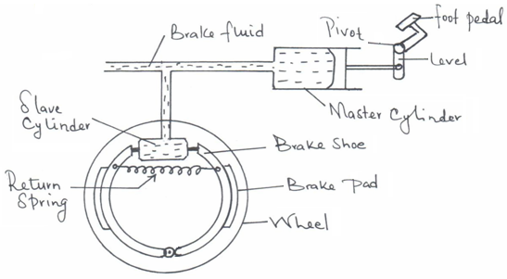

(c) A small force of 100N is applied on a small piston of area 0.25m² produces a bigger force on a larger piston of 10m². Calculate F₂. (3mks)

(d) Explain why water storage tanks in houses are erected as high as possible.
(2mks)

- (a) Differentiate between cohesive forces and adhesive forces. (2mks)

(b) A body weighs 200N in air and 170N when submerged in water. Calculate the upthrust acting on the body. (2mks)

(c) When a glass window is wiped with a dry cloth on a dry day dust particles tend to stick on the window, identify the force responsible for this. (1 mk)

- Water level in a burette is 30cm³. If 55 drops of water fall from the burette and the average volume of drop is 0.12cm³, what is the final water level in the burette? (3mks)

- A block of glass of mass 187.5g is 5.0cm long, 2.0cm thick and 7.5cm high. Calculate the density of the glass kg/m³. (3mks)

- Express the following volumes in the units in brackets in:
- 9000 cm³ to (m³) 2mks

- 27mm³ to (cm³) 2mks

- State two effects of a force on a moving object 2mks

