Name............................................................................................. Index Number................................

232/2
PHYSICS
July/August 2011
(Theory)

2 Hours

NAKURU NORTH JOINT EVALUATION

Instructions to Candidates

- Write your name and index number in the spaces provided above
- Sign and write the date of examination in the spaces provided above.
- This paper consists of TWO sections A and B.
- Answer ALL QUESTIONS in section A and B in the spaces provide
- All working MUST be clearly shown.
- Non-programmable silent electronic calculators and KNEC Mathematical tables may be used.

For Examiner’s Use Only

SECTION | Question | Maximum Score | Candidate’s Score
A | 1 – 13 | 25
B | 14 | 13
 | 15 | 10
 | 16 | 9
 | 17 | 13
 | 18 | 10
Total Score |  | 80

SECTION A (25 MARKS)
- Figure 1 shows a pinhole camera.
Figure 1
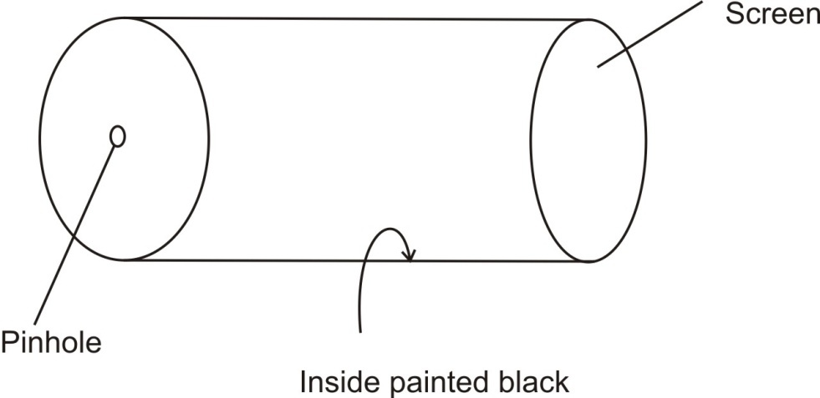
- Name the type of material that is suitable for use as screen. (1mrk)
........................................................................................................................................................................
- State one disadvantage of a small pinhole. (1mrk)
................................................................................................................................................................................................................................................................................................................................................
- Explain why the electromotive force of a dry cell drops if large current is drawn for a short time and then recovers if allowed to rest. (1mrk)
................................................................................................................................................................................................................................................................................................................................................ ........................................................................................................................................................................

- Figure 2 shows a negatively charged leaf electroscope. A steel pin was placed on the cap of the electroscope for sometime.
Figure 2

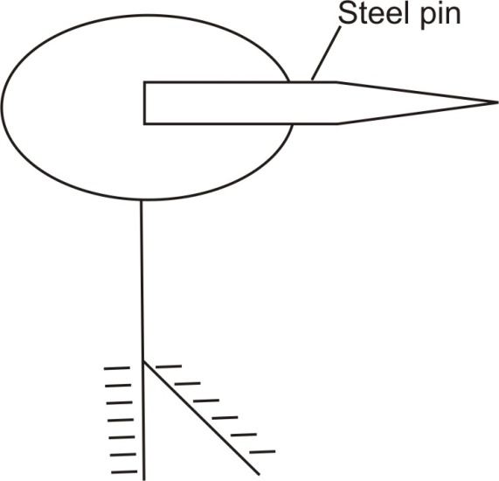
State and explain the observation made. (2mrks)
................................................................................................................................................................................................................................................................................................................................................
................................................................................................................................................................................................................................................................................................................................................
- In order to make a magnet by electrical method a student placed a steel rod into a solenoid as shown in figure 3. He then held a soft iron rod at one end of the steel rod.
Figure 3
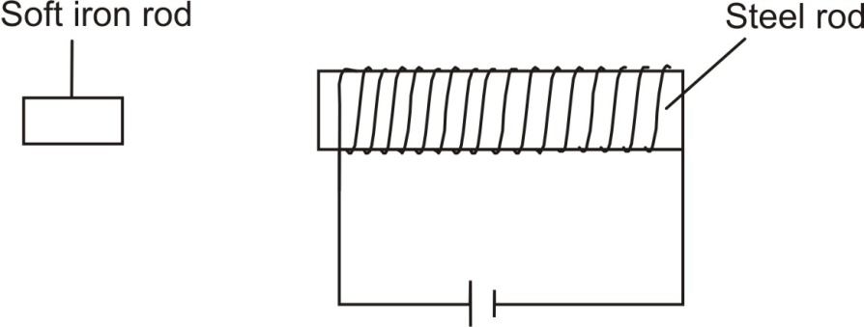
Draw the magnetic field pattern around the end of the steel rod near the soft iron. (2mrks)

- Figure 4 shows how the displacement varies with distance for a wave whose velocity is 340m/s.
Figure 4
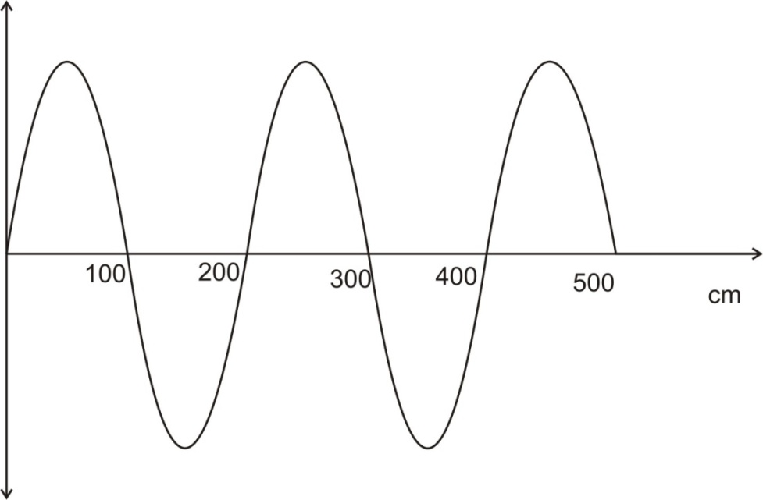
Determine the periodic time of the wave. (3mrks)
................................................................................................................................................................................................................................................................................................................................................
................................................................................................................................................................................................................................................................................................................................................
........................................................................................................................................................................ ................................................................................................................................................................................................................................................................................................................................................
- Figure 5 shows a set-up where A and B are two loudspeakers connected to the same oscillator that produces a note of same frequency. The loudspeakers produce waves which are in phase. An observer walked along the line PQRS.
Figure 5
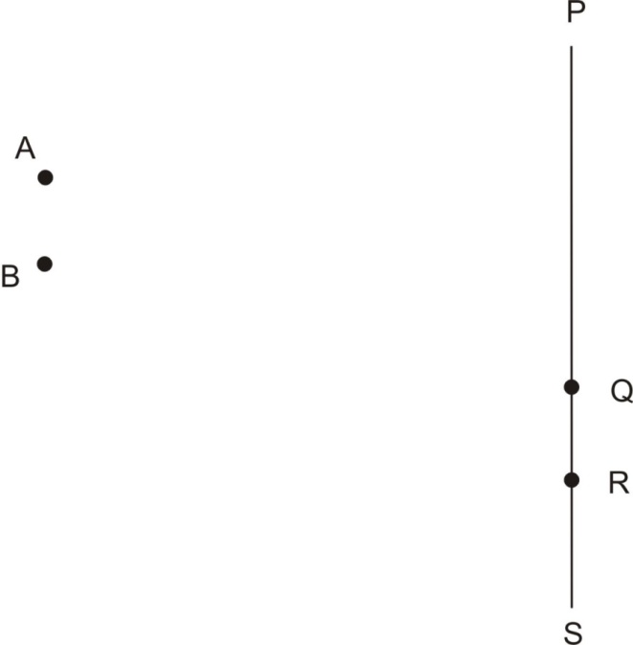

A loud note was heard at Q and a faint note at R. Explain this observation in terms of the distances AR and BR. (2mrks)
................................................................................................................................................................................................................................................................................................................................................
................................................................................................................................................................................................................................................................................................................................................
- The diagram in figure 6 shows a ray of light incident on a curved transparent plastic tube.
Figure 6

Explain why the light will stay in the tube and come out at the other end. (2mrks)
................................................................................................................................................................................................................................................................................................................................................
................................................................................................................................................................................................................................................................................................................................................
- The ammeter in figure 7(a) and voltmeter in figure 7(b) read 0.8A and 1.5V respectively.
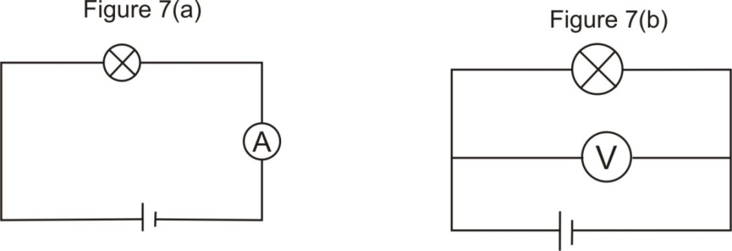
Determine the ammeter and voltmeter readings in figure 7(a)i and figure 7(b)I given that the bulbs and cells are similar (2mrks)
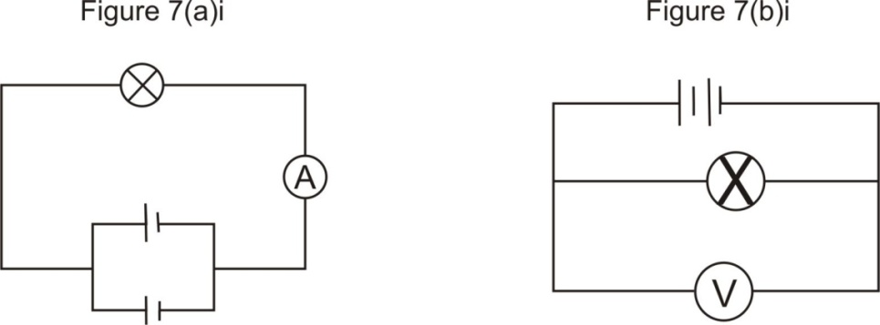
................................................................................................................................................................................................................................................................................................................................................
- Figure 8 shows a convex lens L, an object O and a ray, R passing through the lens and the possible path of the ray after passing through the lens.
Complete the diagram and locate the position of the image, I. (2mrks)

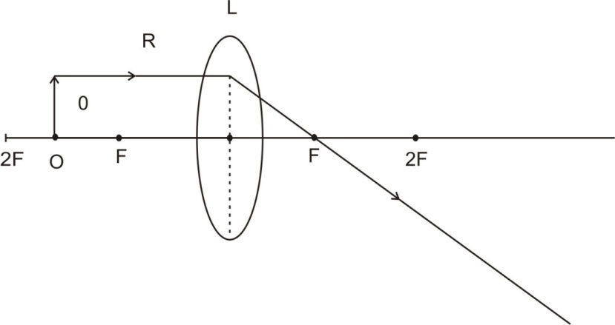
- Figure 9 shows a p-n junction connected in series with an alternating current power supply and a resistor R.

Figure 9
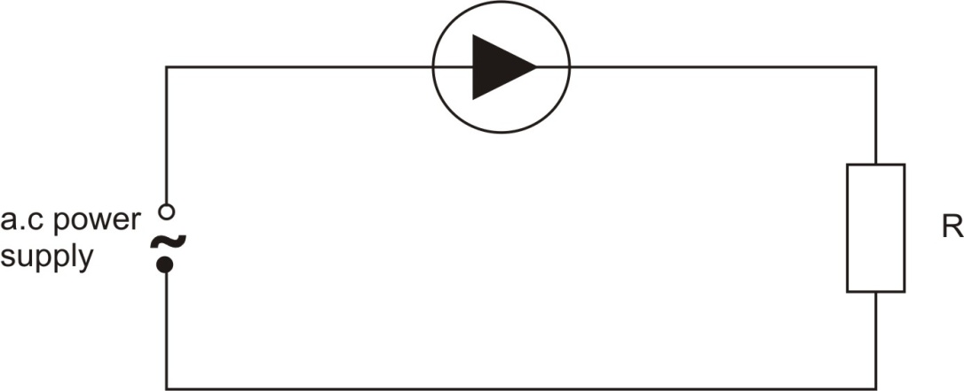

On the axis provided, sketch the graph of the p.d across the resistor R against time. (1mrk)

- Figure 10 is a graph of the kinetic energy (K.E) against frequency (f) for a Caesium metal.

Figure 10
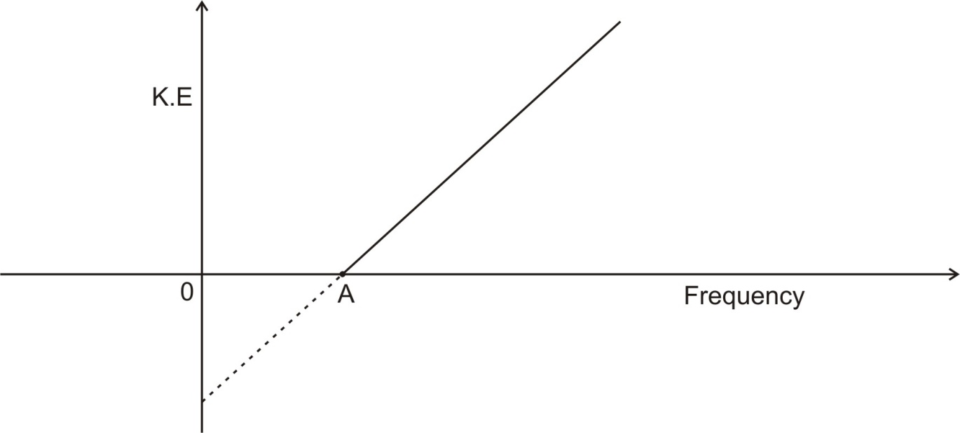

- What is the SI unit of the slope? (1mrk)
................................................................................................................................................................................................................................................................................................................................................
- What physical quantity is represented by point A? (1mrk)
................................................................................................................................................................................................................................................................................................................................................
- A sound is sent out from the hull of a ship and the reflection from the bottom of the ocean returns 1.0s later. The velocity of sound in water is 1500m/s. Determine the depth of the ocean. (2mrks)
................................................................................................................................................................................................................................................................................................................................................
................................................................................................................................................................................................................................................................................................................................................
- Figure 11 show a waveform displayed on the screen of cathode ray oscilloscope is connected across the Y-plates. The Y-gain is set at 2v/cm.
Figure 11
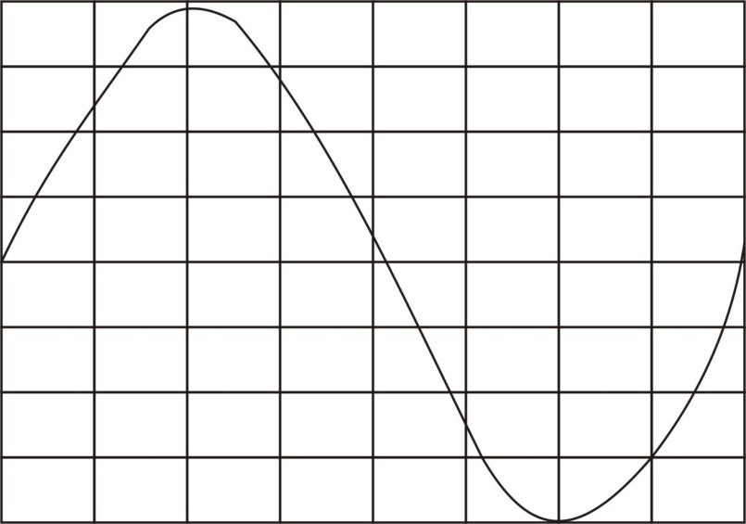
Determine the peak voltage of the waveform. (2mrks)
................................................................................................................................................................................................................................................................................................................................................ ................................................................................................................................................................................................................................................................................................................................................

SECTION B (55MARKS)

- (a) State Ohm’s law. (1mrk)
........................................................................................................................................................................................................................................................................................................................................................................................................................................................................................................................
- Figure 12 shows a battery of 24V in a circuit having two resistors of 3Ω and 6Ω in series with an 8Ω resistor.
Figure 12
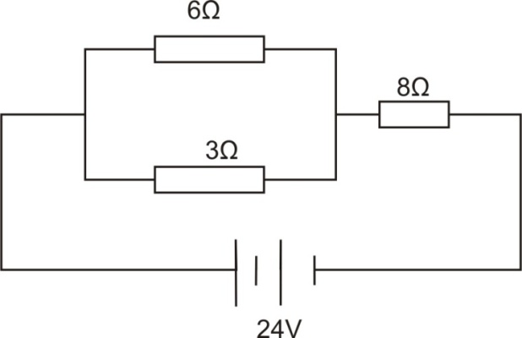
Calculate the current through the 3Ω resistor. (3mrks)

- In an experiment to determine the internal resistance of a cell the voltage across the cell and the current in the circuit were varied using a variable resistor. The results of the experiment are given in the table below.

Current (A) | 0.5 | 1.0 | 1.5 | 2.0 | 2.5
Voltage (V) | 1.54 | 1.28 | 1.03 | 0.78 | 0.52

- Draw a diagram of the circuit used in performing the experiment. (2mrks)

- Use the result to plot a graph of voltage (V) against current (A). On the grid provided. (5mrks)
- Use the graph to determine the internal resistance, r, of the cell. (2mrks)
................................................................................................................................................................................................................................................................................................................................................ ................................................................................................................................................................................................................................................................................................................................................
- (a) Figure 13 shows a pair of parallel plates of a capacitor connected to a battery.
Figure 13
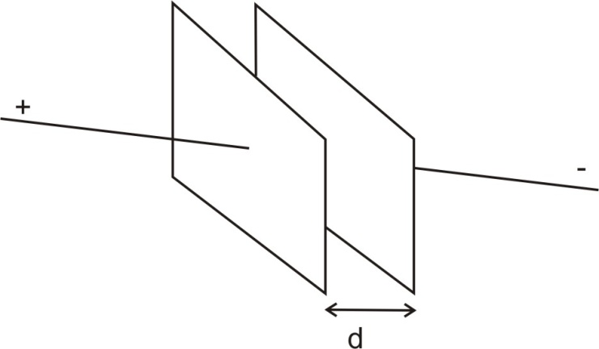
State with reason the effect of reducing the distanced, d. (2mrks)
................................................................................................................................................................................................................................................................................................................................................ ................................................................................................................................................................................................................................................................................................................................................
- A 10µF capacitor is charged to a potential of 100V and isolated. It is then connected in parallel to uncharged 20 µF capacitor. Find ;
- The final potential difference across the combination. (3mrks)
................................................................................................................................................................................................................................................................................................................................................ ................................................................................................................................................................................................................................................................................................................................................ ................................................................................................................................................................................................................................................................................................................................................ ................................................................................................................................................................................................................................................................................................................................................
- The energy stored before connection. (1mrk)
................................................................................................................................................................................................................................................................................................................................................ ................................................................................................................................................................................................................................................................................................................................................
- The energy stored in the two capacitors after connection. (2mrks)
................................................................................................................................................................................................................................................................................................................................................ ................................................................................................................................................................................................................................................................................................................................................

- Is the energy conserved? Explain your answers. (2mrks)
................................................................................................................................................................................................................................................................................................................................................ ........................................................................................................................................................................
- (a) ( i) Figure 14(a) and 14(b) shows a bar magnet M, with its S-pole at the bottom dropping vertically through a coil C of copper wire.
Indicate the direction of the induced current in figure 14(a) just before M passes through and in figure 14 (b) after M have passed completely. (1mrk)
................................................................................................................................................................................................................................................................................................................................................
- State two factors that would affect the magnitude of the induced current in 16(a) above. (2mrks)
................................................................................................................................................................................................................................................................................................................................................ ........................................................................................................................................................................

- Figure 15 shows a generator.

Figure 15
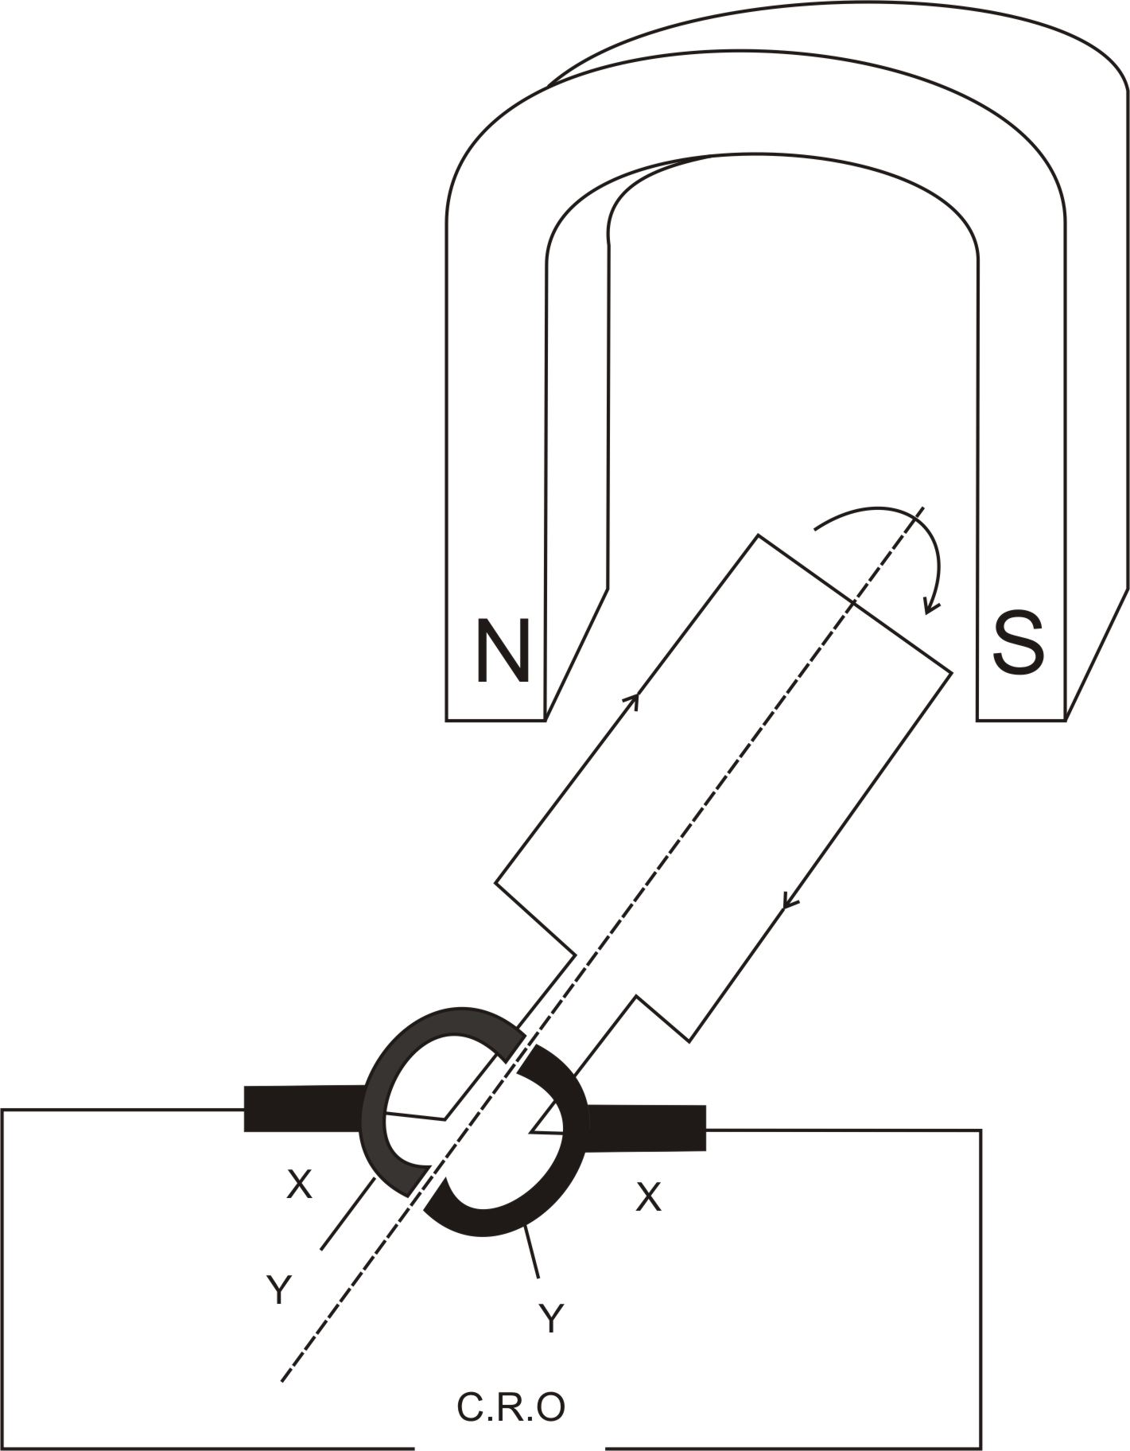

- Name the parts labelled X and Y. (2mrks)
................................................................................................................................................................................................................................................................................................................................................

- Indicate using an arrow on the figure the direction of the induced current in the coil as it passes the position shown. (1mrk)
................................................................................................................................................................................................................................................................................................................................................ ........................................................................................................................................................................ ........................................................................................................................................................................

- Draw the display on the C.R.O screen produced as the coil rotate.
0V
C.R.O

- State the energy changes that takes place as the coil rotates. (2mrks)
................................................................................................................................................................................................................................................................................................................................................
........................................................................................................................................................................ ................................................................................................................................................................................................................................................................................................................................................

- In an experiment with radioactive source, the following observation were made;
- A charged electroscope was discharged slowly
- Few sparks were observed on the spark counter
- The emission penetrated Perspex
- The emission gave a count rate with both thin window and a thick window Geiger Muller, G-M tube.
- i) State the type of emission given off by the source. (1mrk)
........................................................................................................................................................................ ................................................................................................................................................................................................................................................................................................................................................

- Explain how this emission discharges an electroscope. (2mrks)
................................................................................................................................................................................................................................................................................................................................................ ................................................................................................................................................................................................................................................................................................................................................

- Name a radiation detector not mentioned in the observation I to IV. (1mrk)
.................................................................................................................................................................. ................................................................................................................................................................................................................................................................................................................................................ ........................................................................................................................................................................

- Figure 16 shows a diagram of a Geiger Muller tube.
Figure 16
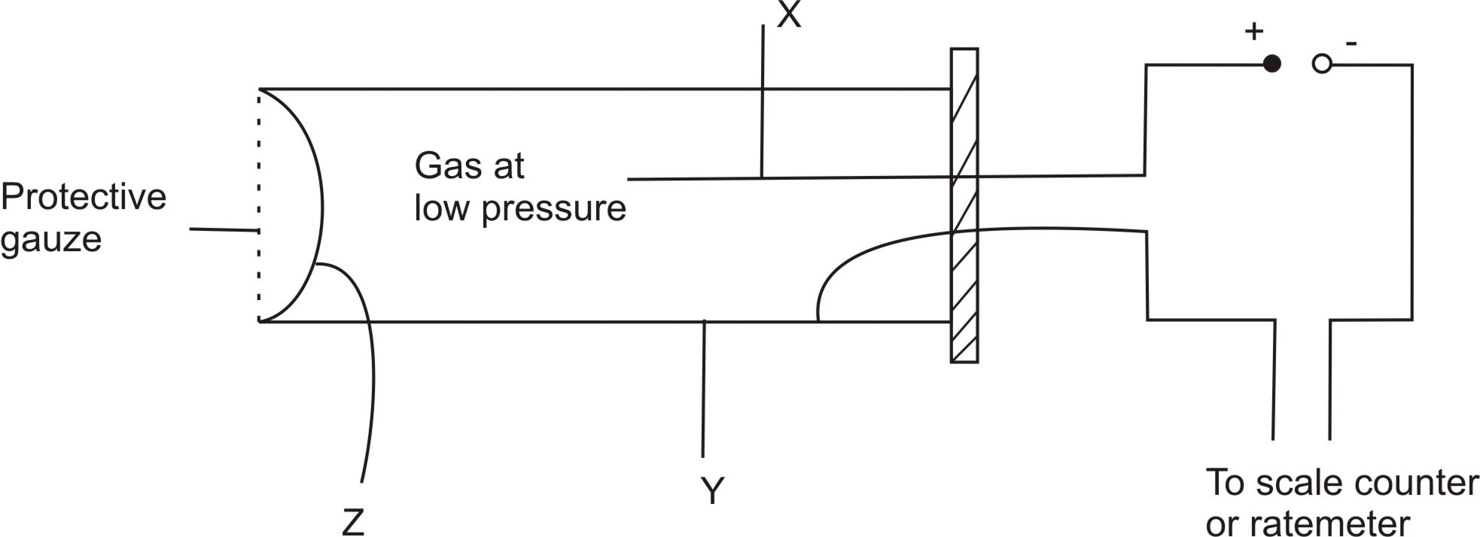

- Name the parts labelled X and Y. (2mrks)
........................................................................................................................................................................ ................................................................................................................................................................................................................................................................................................................................................
................................................................................................................................................................................................................................................................................................................................................

- Explain why Z is a very thin mica. (2mrks)
................................................................................................................................................................................................................................................................................................................................................ ................................................................................................................................................................................................................................................................................................................................................

- The table below shows readings of a counter connected to a Geiger-Muller tube placed infront of a radioactive source. Counter readings are taken at intervals of 20s.

Time(S) | 0 | 20 | 40 | 60 | 80 | 100 | 120
Corrected counts | 120 | 74 | 48 | 30 | 20 | 12 | 8

- Plot a graph of corrected counts against time on the grid provided. (3mrks)

- Show on the graph how the half-life of the radioactive material is obtained. (2mrks)
................................................................................................................................................................................................................................................................................................................................................
- (a) Explain why the cathode rays are deflected toward the positive plate of an electric field. (2mrks)
........................................................................................................................................................................ ................................................................................................................................................................................................................................................................................................................................................
- Figure 17 represent an X – ray tube.
Figure 17
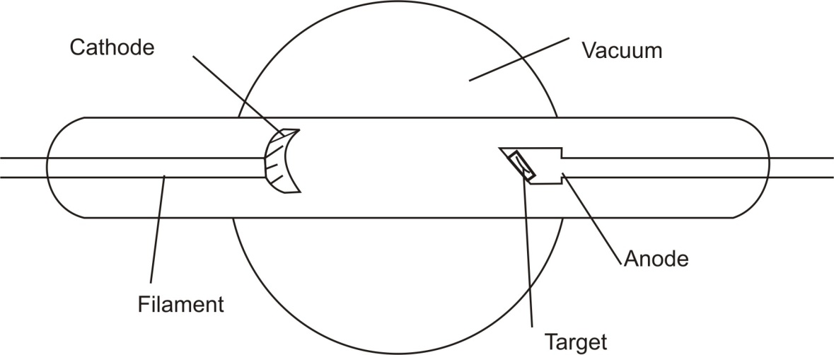
- State the energy changes that occur when the accelerated electrons hit the target. (3mrks)
................................................................................................................................................................................................................................................................................................................................................
- Name a suitable material used as the target. (1mrk)
........................................................................................................................................................................
- What is the function of the filament? (1mrk)
................................................................................................................................................................................................................................................................................................................................................
- What effects will the increase in the potential difference between the cathode and the anode have on the X-rays produced? Explain. (2mrks)
................................................................................................................................................................................................................................................................................................................................................

- State one use of X-rays. (1mrk)
................................................................................................................................................................................................................................................................................................................................................ ................................................................................................................................................................................................................................................................................................................................................

