Name:……….............................................Index Number ……………………Date ......................
Candidate’s Signature:……........................

443/1
AGRICULTURE
PAPER 1
MOCK JULY- 2015
TIME 2 HOURS

STAREHE GIRLS’ CENTRE MOCK EXAMINATIONS- 2015
Kenya Certificate of Secondary Education

443/1
AGRICUITURE
PAPER 1
JULY - 2015

INSTRUCTIONS TO CANDIDATES
- Write your name and Adm. Number in the spaces provided above.
- Sign and write the date of examination in the spaces provided above.
- This paper consists of THREE sections A, B and C.
- Answer All the Question in section A and B and TWO questions in section C.
- This paper consists of 11 printed pages.
- Candidates should check the question paper to ascertain that all the pages are printed as
indicated and that no questions are missing.

For Examiner’s Use Only.
Section | Questions | Maximum Marks | Candidate’s Score
A | 1-17 | 30
B | 18-20 | 20
C | 21-23 | 40
 | GRAND TOTAL | 90

This paper consists of 11 printed pages. Students should check the question paper to ensure that all pages are
Printed as indicated and that no questions are missing.
SECTION A (30 Marks)
Answer all the questions in this section in the spaces provided.

1. Give four characteristics of plantation farming. (2 marks) ................................................................................................................................................................................................................................................................................................................................................................................................................................................................................................................................................................................................................................................................................................................
2. Name one biotic factor that affects agriculture both positively and negatively. ( ½ mark)

........................................................................................................................................................................................................................................................................................................................................................
3. Describe two effects of liming soil. (1 mark)
........................................................................................................................................................................................................................................................................................................................................................
- State two ways in which good transport and communication system influence agriculture production. ( 1 mark)
........................................................................................................................................................................................................................................................................................................................................................
............................................................................................................................................................................
- Give three reasons why platy soil structure may not favour crop production. ( 1 ½ marks)

........................................................................................................................................................................................................................................................................................................................................................
............................................................................................................................................................................
- Name two crop nutrients that are not available in low soil PH (1 mark)

........................................................................................................................................................................................................................................................................................................................................................
- State four reasons why its important to drain water logged soils (2 marks)
........................................................................................................................................................................................................................................................................................................................................................
............................................................................................................................................................................
............................................................................................................................................................................
............................................................................................................................................................................

- Give reasons why the following field practices are carried out in crop production. (3 marks)
- Rogueing
........................................................................................................................................................................................................................................................................................................................................................
- Pricking out
........................................................................................................................................................................................................................................................................................................................................................
- Gapping
........................................................................................................................................................................................................................................................................................................................................................
- List six Agricultural support services available to the farmers. (3 marks)

........................................................................................................................................................................................................................................................................................................................................................
............................................................................................................................................................................
........................................................................................................................................................................................................................................................................................................................................................
............................................................................................................................................................................
- Give three ways in which pruning helps in control of diseases in crops. ( 1 ½ marks)
........................................................................................................................................................................................................................................................................................................................................................
............................................................................................................................................................................
............................................................................................................................................................................
- List two types of weeds that cause the following effects.
- Lower the quality of agricultural products. ( 1 mark)
............................................................................................................................................................................
............................................................................................................................................................................

- Irritate the workers hence lowering their efficiency. (1 mark)
............................................................................................................................................................................
............................................................................................................................................................................
- Poisonous to livestock (1 mark)
............................................................................................................................................................................
............................................................................................................................................................................

12. State four qualities of a good farm manager. (2 marks)

........................................................................................................................................................................................................................................................................................................................................................
............................................................................................................................................................................
............................................................................................................................................................................
- Distinguish between liquid capital and working capital. (2 marks)
........................................................................................................................................................................................................................................................................................................................................................
............................................................................................................................................................................
- List two factors that influence carrying capacity of a pasture. ( 1 mark)

........................................................................................................................................................................................................................................................................................................................................................
............................................................................................................................................................................
15. State four advantages of raising tea seedlings in polythene sleeves. (2 marks)
........................................................................................................................................................................................................................................................................................................................................................
............................................................................................................................................................................
............................................................................................................................................................................
............................................................................................................................................................................
16. List three aspects of light which have influence on crop production. ( 1 ½ marks)
........................................................................................................................................................................................................................................................................................................................................................
............................................................................................................................................................................
............................................................................................................................................................................

17. Outline three ways in which amount of Light harnessed by crops can be increased. (1 ½ marks)
........................................................................................................................................................................................................................................................................................................................................................
............................................................................................................................................................................
............................................................................................................................................................................

SECTION B - ( 20 Marks)

Answer all the questions in this section in the spaces provided.

18. The diagram below shows a type of a silo. Use it to answer the questions that follow.

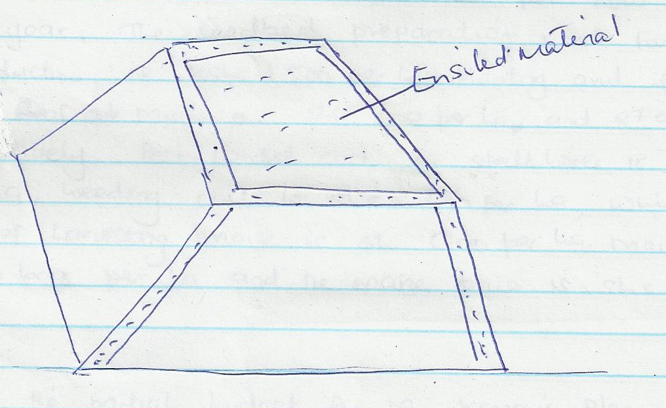

- Identify the type of the silo drawn above. (1 mark)
........................................................................................................................................................................................................................................................................................................................................................
- Give two ways in which temperature can be reduced in the above structure during silage making. (2 marks)
........................................................................................................................................................................................................................................................................................................................................................
............................................................................................................................................................................
- State the roles of additives in silage making. (2 marks)
............................................................................................................................................................................
............................................................................................................................................................................

19. Mr. Kamau intends to increase his dairy herd from 4 to 6. He intends to change 1 hactare of land from
maize production to keep his two extra cows. Each cow requires the purchase of a replacement heifer
each year at 3000 ksh milk yield for each cow is 3000 kg per year, price of milk is 20 ksh per kg. Each
cow gives birth to a calf worth 500 ksh every year. Veterinary service charge per cow is 600 ksh per
year while the cost of concentrate and minerals per cow is 360 ksh per year. The seeded preparation cost
for maize production is kshs 1,500 per ha. Planting and fertilizer cost maize are shs 500 per ha ad 2700
per ha respectively. Pest control cost for stalkborer is shs 300 per ha, weeding cost is shs 600 per ha,
while the cost of harvesting maize is sh 600 per ha. Maize yield is 40 bags per ha, and the maize price is
shs 800 per bag.

- Prepare the partial budget for Mr. Kamau’s plan. (Show your working) (8 marks)

- State whether the change is worth while (2 marks)
........................................................................................................................................................................................................................................................................................................................................................
............................................................................................................................................................................

20. Study the diagrams and answer the questions that follow.
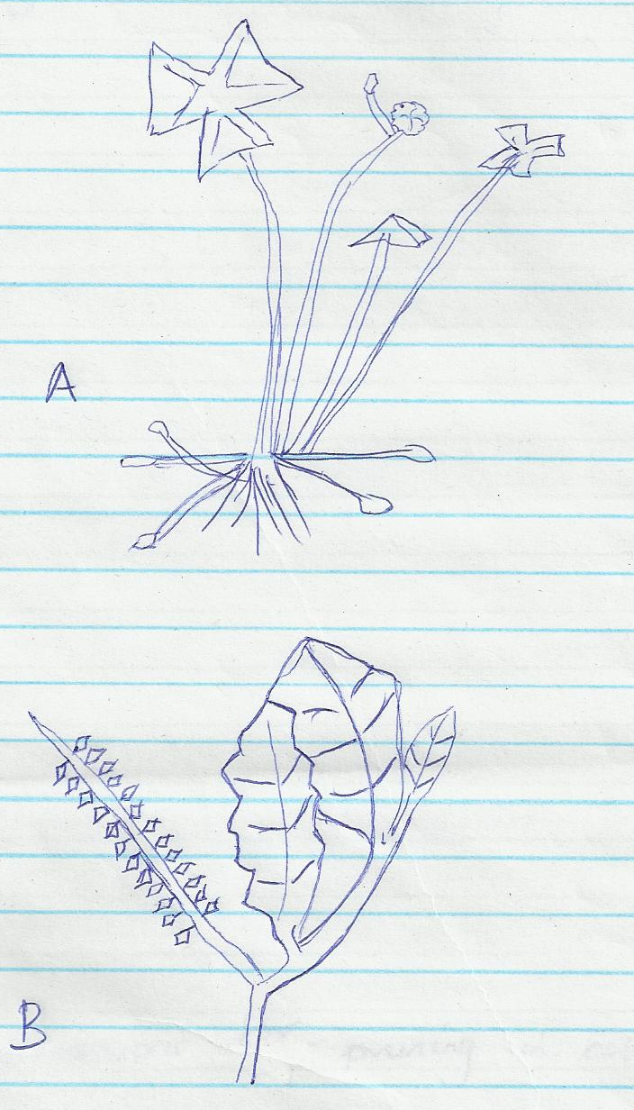

  - Identify weeds A and B. (2 marks)
A _____________________________________

B ______________________________________

  - Classify weed A according to lifecycle. (1 mark)
............................................................................................................................................................................
............................................................................................................................................................................
  - Describe one economic importance of weed B. (1 mark)
........................................................................................................................................................................................................................................................................................................................................................
............................................................................................................................................................................

  - Give a reason why weed A is difficult to control. (1 mark)
........................................................................................................................................................................................................................................................................................................................................................
............................................................................................................................................................................

SECTION C - (40 Marks)
Answer Two questions only

21.a) Explain ten precautions that a farmer should observe when using farm chemicals. (10 marks)
b) Give five reasons for pruning in coffee production. (5 marks)

c) Describe five factors that influence soil formation. (5 marks)

22.a) Describe five methods used in water harvesting. (5 marks)

b) Explain five importance of agro forestry in soil and water conservation. (5 marks)

c) Explain ten effects of strong wind on crop production. (10 marks)

23.a) Describe five factors that determines time of harvesting. (5 marks)

b) Explain five post harvest practices carried out in the production of cereal crops. (5 marks)

c) Explain five effects of liberalization of farming in Kenya. (5 marks)

d) Explain five factors considered when designing crop rotation programme. (5 marks)

……………………………………………………………………………………………………………………………………………………………………………………………………………………………………………………………………………………………………………………………………………………………………………………………………………………………………………………………………………………………………………………………………………………………………………………………………………………………………………………………………………………………………………………………………………………………………………………………………………………………………………………………………………………………………………………………………………………………………………………………………………………………………………………………………………………………………………………………………………………………………………………………………………………………………………………………………………………………………………………………………………………………………………………………………………………………………………………………………………………………………………………………………………………………………………………………………………………………………………………………………………………………………………………………………………………………………………………………………………………………………………………………………………………………………………………………………………………………………………………………………………………………………………………………………………………………………………………………………………………………………………………………………………………………………………………………………………………………………………………………………………………………………………………………………………………………………………………………………………………………………………………………………………………………………………………………………………………………………………………………………………………………………………………………………………………………………………………………………………………………………………………………………………………………………………………………………………………………………………………………………………………………………………………………………………………………………
…………………………………………………………………………………………………………………………………………………………………………………………………………………………………………………………………………………………………………………………………......................……
…………………………………………………………………………………………………………………………………………………………………………………………………………………………………………………………………………………………………………………………………….....................…
………………………………………………………………………………………………………………………………………………………………………………………………………………………………………………………………………………………………………………………………………………………………………………………………………………………………………………………………………………………………………………………………………………………………………………………………………………………………………………………………………………………………………………………………………………………………………………………………………………………………………………………………………………………………………………………………………………………………………………………………………………………………………………………………………………………………………………………………………………………………………………………………………………………………………………………………………………………………………………………………………………………………………………………………………………………………………………………………………………………………………………………………………………………………………………………………………………………………………………………………………………………………………………………………………………………………………………………………………………………………………………………………………………………………………………………………………………………………………………………………………………………………………………………………………………………………………………………………………………………………………………………………………………………………………………………………………………………………………………………………………………………………………………………………………………………………………………………………………………………………………………………………………………………………………………………………………………………………………………………………………………………………………………………………………………………………………………………………………………………………………………………………………………………………………………………………………………………………………………………………………………………………………………………………………………………………………………………………………………………………………..................................................……………
……………………………………………………………………………………………………………………………………………………………………………………………………………………………………………………………………………………………………………………….......................………………
………………………………………………………………………………………………………………………………………………………………………………………………………………………………………………………………………………………………………………………………......................………
………………………………………………………………………………………………………………………………………………………………………………………………………………………………………………………………………………………………………………………………………………………………………………………………………………………………………………………………………………………………………………………………………………………………………………………………………………………………………………………………………………………………………………………………………………………………………………………………………………………………………………………………………………………………………………………………………………………………………………………………………………………………………………………………………………………………………………………………………………………………………………………………………………………………………………………………………………………………………………………………………………………………………………………………………………………………
………………………………………………………………………………………………………………………………………………………………………………………………………………………………………………………………………………………………………………………………………………………………………………………………………………………………………………………………………………………………………………………………………………………………………………………………………………………………………………………………………………………………………………………………………………………………………………………………………………………………………………………………………………………………………………………………………………………………………………………………………………………………………………………………………………………………………………………………………………………………………………………………………………………………………………………………………………………………………………………………………………………………………………………………………………………………
………………………………………………………………………………………………………………………………………………………………………………………………………………………………………………………………………………………………………………………………………………………………………………………………………………………………………………………………………………………………………………………………………………………………………………………………………………………………………………………………………………………………………………………………………………………………………………………………………………………………………………………………………………………………………………………………………………………………………………………………………………………………………………………………………………………………………………………………………………………………………………………………………………………………………………………………………………………………………………………………………………………………………………………………………………………………

