STAREHE GIRLS’ CENTRE

NAME……………………………………………………INDEX NO…………………ADM……….…CLASS…
CANDIDATE’S SIGNATURE………………………… DATE……………………………………………………

Kenya Certificate of Secondary Education
AGRICULTURE
Paper 2
July - 2015
Time: 2 hours

INSTRUCTIONS TO CANDIDATES
INSTRUCTIONS TO CANDIDATES
- Write your name and Adm. Number in the spaces provided above.
- Sign and write the date of examination in the spaces provided above.
- This paper consists of THREE sections A, B and C.
- Answer All the Question in section A and B and TWO questions in section C.
- This paper consists of 12 printed pages.
- Candidates should check the question paper to ascertain that all the pages are printed as
indicated and that no questions are missing.

For examiner’s use only
Section | Question | Maximum score | Candidates Score
A | 1-18 | 30
B | 19-23 | 20
C | 24-26 | 20  20
Total Score |  | 90

SECTION A (30 marks)
Answer all the questions in this section in the spaces provided.
1 State four maintenance practices for a disc plough. (2 marks)
………………………………………………………………………………………………………………………………………………………………………………………………………………………………………………………………………………………………………………………………………………………………………………………………………………………………………………………………………………………………………………………………………………………………………………
.........................................................................................................................................................................
2 Name three methods that are used in selection of breeding stock in livestock production. (1 mark)
………………………………………………………………………………………………………………………………………………………………………………………………………………………………………………………………………………………………………………………………………………………………………………………………………………………………………………………………………………………………………………………………………………………………………………………………………………………………………………………………………………………………
3 State four advantages of using animals instead of tractors as a source of power on the farm.(2 marks)
………………………………………………………………………………………………………………………………………………………………………………………………………………………………………………………………………………………………………………………………………………………………………………………………………………………………………………………………………………………………………………………………………………………………………………………………………………………………………………………………………………………………
4 Name one livestock disease that is transmitted by each of the following parasites:
(a) blue ticks; (1 mark)
………………………………………………………………………………………………………………
(b) brown ear ticks; (1 mark)
………………………………………………………………………………………………………………
5. State four methods of controlling round worms (Ascaris sp) in livestock. (2 marks)
………………………………………………………………………………………………………………………………………………………………………………………………………………………………………………………………………………………………………………………………………………………………………………………………………………………………………………………………………………………………………………………………………………………………………………………………………………………………………………………………………………………………

6 Give the meaning of the following terms as used in livestock health:
(a) disease; (1 mark)
………………………………………………………………………………………………………………………………………………………………………………………………………………………………
(b) vaccination (1 mark)
………………………………………………………………………………………………………………………………………………………………………………………………………………………………
7 State three maintenance practices for a tractor battery (1 marks)

………………………………………………………………………………………………………………………………………………………………………………………………………………………………
………………………………………………………………………………………………………………………………………………………………………………………………………………………………
8 Name the type of breed into which each of the following breeds of cattle are classified:
(a) Aberdeen Angus; (1 mark)
………………………………………………………………………………………………………………………………………………………………………………………………………………………………
(b) Guernsey; (1 mark)
………………………………………………………………………………………………………………………………………………………………………………………………………………………………
(c) Sahiwal; (1 mark)
………………………………………………………………………………………………………………………………………………………………………………………………………………………………
………………………………………………………………………………………………………………………………………………………………………………………………………………………………
(d) Redpoll. (1 mark)

9 Give two ways in which proper nutrition helps to control livestock diseases. (1 mark)
………………………………………………………………………………………………………………………………………………………………………………………………………………………………………………………………………………………………………………………………………………………………………………………………………………………………………………………………
10 List four categories of livestock diseases. (2 marks)
………………………………………………………………………………………………………………………………………………………………………………………………………………………………………………………………………………………………………………………………………………………………………………………………………………………………………………………………………………………………………………………………………………………………………………………………………………………………………………………………………………………………
11 Name two breeding systems that can increase the frequency of high milk production genes in
indigenous cattle. (1 mark)
………………………………………………………………………………………………………………………………………………………………………………………………………………………………………………………………………………………………………………………………………………………………………………………………………………………………………………………………
12 Name two bloodless methods of castration in lambs. (1 mark)
………………………………………………………………………………………………………………………………………………………………………………………………………………………………………………………………………………………………………………………………………………………………………………………………………………………………………………………………………………………………………………………………………………………………………………………………………………………………………………………………………………………………

13 Give the meaning of the following terms as used in livestock breeding:
(a) recessive gene; (1 mark)

………………………………………………………………………………………………………………………………………………………………………………………………………………………………………………………………………………………………………………………

(b) epistasis.

……………………………………………………………………………………………………………………………………………………………………………………………………………………………………………………………………………………………………………………………………………
14. State four signs that indicate that a doe is about to kindle. (2 marks)

………………………………………………………………………………………………………………………………………………………………………………………………………………………………………………………………………………………………………………………………………………………………………………………………………………………………………………………………………………………………………………………………………………………………………………………………………………………………………………………………………………………………

15 Name two developmental stages of a liverfluke (Fasciola sp.) which occur in the fresh water
snail (Limnaea sp).
(1 mark)
……………………………………………………………………………………………………………………………………………………………………………………………………………………………………………………………………………………………………………………………………………………………………………………………………………………………………………………

16 Name the strokes in a four stroke cycle engine. (2 marks)
……………………………………………………………………………………………………………………………………………………………………………………………………………………………………………………………………………………………………………………………………………………………………………………………………………………………………………………
17 State four signs of mite attack in poultry. (2 marks)
……………………………………………………………………………………………………………………………………………………………………………………………………………………………………………………………………………………………………………………………………………………………………………………………………………………………………………………………………………………………………………………………………………………………………………………………………………………………………………………………………………………………………………………………………………………………………………………………

18 State three advantages of natural feeding in calf rearing. (1marks)

……………………………………………………………………………………………………………………………………………………………………………………………………………………………………………………………………………………………………………………………………………………………………………………………………………………………………………………

SECTION B (20 marks)
Answer all the questions in this section in the spaces provided.
19 A dairy farmer is required to prepare 100 kg of dairy meal containing 20% Digestible Crude
Protein (D.C.P.). Using the Pearson's Square Method, calculate the quantity of soya bean (40% D.C.P.) and rice (16% D.C.P.) the farmer requires for the dairy meal. (4 marks)

20 Below is an illustration of a camel. Study it and answer the questions that follow.
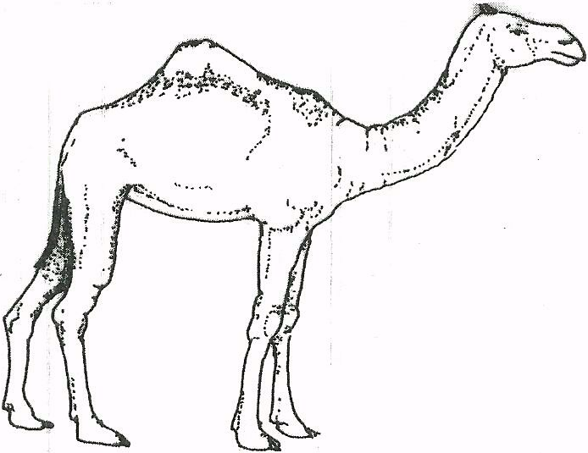

(a) Identify the'camel species illustrated above.

………………………………………………………………………………………………………

(b) Name three products that farmers obtain from the camel species illustrated above. (1 marks)

……………………………………………………………………………………………………………………………………………………………………………………………………………………………………………………………………………………………………………………………..........…………

(c) Give two reasons why the camel species illustrated above is able to survive in its natural habitat. (2 marks)

………………………………………………………………………………………………………………………………………………………………………………………………………………………………………………………..........………………………………………………………………………………
.....................................................................................................................................................................
21 The diagram below represents farm tools and equipment. Study them and answer the questions that follow.

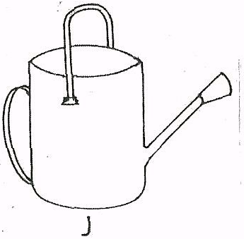
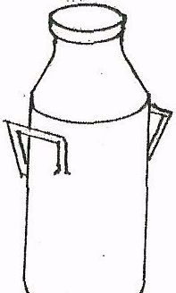

K

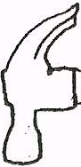
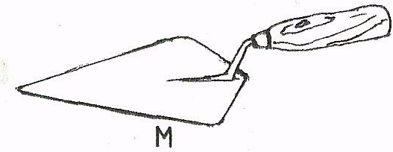
J
L

(a) Identify the tool equipment labelled J, K and M.

J………………………………………………………………………..........…………
K……………………………………………………………………..........…………
L……………………………………………………………………..........…………
(b) State one use for each of the tool / equipment labelled K and L.
……………………………………………………………………..........…………
(c) Give two maintenance practices for the equipment labelled K. (1 mark)

………………………………………………………………………………………………………………………………………………………………………………………………………………………………………………………..........………………………………………………………………………
.....................................................................................................................................................................

22 The illustration below shows a practice carried out to prevent mastitis infection in a dairy cow.

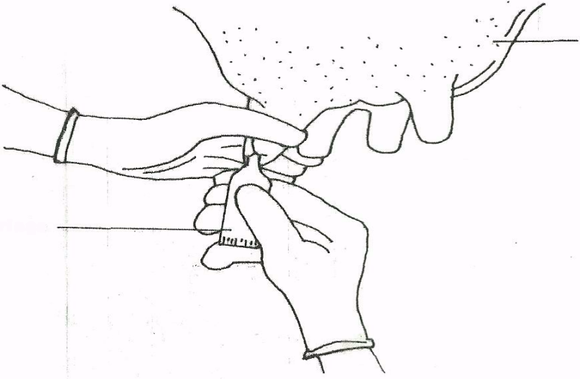

(a) Identify the practice. (1 mark)
…………………………………………………………………………………………………………………………………………..........…………………………………………………………………………
(b) At what stage is the practice carried out? (1 mark)
…………………………………………………………………………………………………………………………………………..........…………………………………………………………………………
(c) State two other practices that are carried out on the udder to prevent mastitis infection.
(2 marks)

…………………………………………………………………………………………………………………………………………..........…………………………………………………………………………

23 The diagram below shows the digestive system of cattle. Study it and answer the questions that follow.

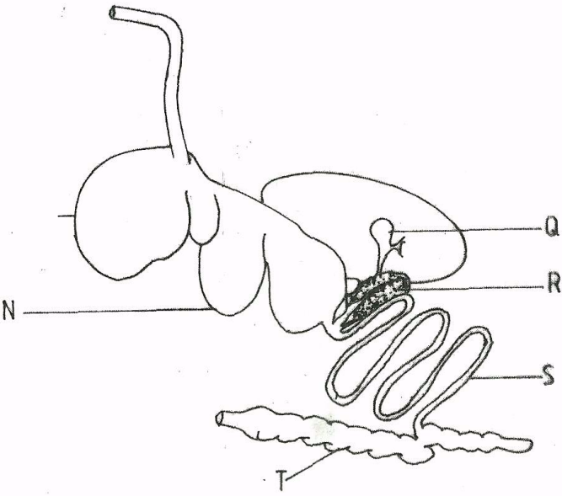

(a) Name the parts labelled N, I and Q. (3 marks)
N.............................................................................................................................
I.............................................................................................................................
Q.........................................................................................................................

(b) State one function for each of the parts labelled S and T. : (1 mark)
…………………………………………………………………………………………………………………………………………..........…………………………………………………………………………
(c) Give one enzyme produced by each of the parts labelled R and S. (1 mark)

…………………………………………………………………………………………………………………………………………..........…………………………………………………………………………
…………………………………………………………………………………………………………………………………………..........…………………………………………………………………………

SECTION C (40 marks)
Answer any two questions from this section in the spaces provided after question 26.
24 (a) Explain the factors considered when culling livestock. (5 marks)
(b) Describe poultry management under the following sub-headings: (8 marks)
(i) causes of stress
(ii) control measures for cannibalism.
25 (a) Describe the feeding practices in artificial rearing of a dairy calf. (7 marks)
(b) Describe Newcastle disease under the following sub-headings: (10 marks)
(i) causal organism; (1 mark)
(ii) signs of infection; (7 marks)
(iii) control measures. (2 marks)
26. (a) Describe the uses of fences on the farm. (10 marks)
(b) Give five harmful effects of liver flukes in sheep rearing. ( 5 marks)
(c) State the differences between a diesel engine and a petrol engine. (5 marks)

………………………………………………………………………………………………………………………………………………………………………………………………………………………………………………………………………………………………………………………………………………………………………………………………………………………………………………………………………………………………………………………………………………………………………………………………………………………………………………………………………………………………………………………………………………………………………………………………………………………………………………………………………………………………………………………………………………………………………………………………………………………………………………………………………………………………………………………………………………………………………………………………………………………………………………………………………………………………………………………………………………………………………………………………………………………………………………………………………………………………………………………………………………………………………………………………………………………………………………………………………………………………………………………………………………………………………………………………………………………………………………………………………………………………………………………………………………………………………………………………………………………………………………………………………………………………………………………………………………………………………………………………………………………………………………………………………………………………………………………………………………………………………………………………………………………………………………………………………………………………………………………………………………………………………………………………………………………………………………………………………………………………………………………………………………………………………………………………………………………………………………………………………………………………………………………………………………………………………………………………………………………………………………………………………………………………………………………………………
………………………………………………………………………………………………………………………………………………………………………………………………………………………………………………………………………………………………………………………
………………………………………………………………………………………………………………………………………………………………………………………………………………
………………………………………………………………………………………………………………………………………………………………………………………………………………………………………………………………………………………………………………………………………………………………………………………………………………………………………………………………………………………………………………………………………………………………………………………………………………………………………………………………………………………………………………………………………………………………………………………………………………………………………………………………………………………………………………………………………………………………………………………………………………………………………………………………………………………………………………………………………………………………………………………………………………………………………………………………………………………………………………………………………………………………………………………………………………………………………………………………………………………………………………………………………………………………………………………………………………………………………………………………………………………………………………………………………………………………………………………………………………………………………………………………………………………………………………………………………………………………………………………………………………………………………………………………………………………………………………………………………………………………………………………………………………………………………………………………………………………………………………………………………………………………………………………………………………………………………………………………………………………………………………………………………………………………………………………………………………………………………………………………………………………………………………………………………………………………………………………………………………………………………………………………………………………………………………………………………………………………………………………………………………………………………………………………………………………………………………………………………
………………………………………………………………………………………………………………………………………………………………………………………………………………………………………………………………………………………………………………………
………………………………………………………………………………………………………………………………………………………………………………………………………………
………………………………………………………………………………………………………………………………………………………………………………………………………………
………………………………………………………………………………………………………………………………………………………………………………………………………………………………………………………………………………………………………………………………………………………………………………………………………………………………………………………………………………………………………………………………………………………………………………………………………………………………………………………………………………………………………………………………………………………

