KASSU JOINT EXAMINATION TEST
Kenya Certificate of Secondary Education (K.C.S.E)

231/1
BIOLOGY
PAPER 1
JUNE 2015
TIME: 2 HOURS

Name……………………………………………………………. Index No…………………..

School…………………………Candidate’s Sign…………………..Date………………………

INSTRUCTIONS TO CANDIDATES

1. Answer ALL the questions.
2. This paper consists of 23 questions

FOR EXAMINERS USE ONLY

QUESTION | MAX SCORE | CANDIDATE’S SCORE
1 – 23 | 80

This paper consists of 11 printed pages. Candidates should check the question paper to ensure that all pages are printed as indicated and no questions are missing.

- In what two ways does excretion differ between plants and animals? (2marks)
………………………………………………………………………………………………………………………………………………………………………………………………………………………………………………………………………………………………………………………………………………………………………………………………………………………………………………………………………………………………...................
- (a) Give two contributions made by Carolus Linneus to classification (2marks)
……………………………………………………………………………………………………………………………………………………………………………………………………………………………………………………………………………………………………………...........................................................................................................................................
b) Classify Human being based on the Order and Family it belongs to? (2marks)
Order…………………………………………………………………………………………… Family …………………………………………………………………………………………
- (a)State two functions of the plasma membrane? (2marks)
…………………………………………………………………………………………………………………………………………………………………………………………………………………………………………………………………………………………………………………………………………………………………………………………………………..
(b) Give the synthesis role of smooth endoplasmic reticulum. (1mark)
…………………………………………………………………………………………………………………………………………………………………………………………………
- (a) Distinguish between Plasmolysis and turgidity (2marks)
………………………………………………………………………………………………………………………………………………………………………………………………………………………………………………………………………………………………………
…………………………………………………………………………………………………

(b) Explain how the following factors affect active transport (4marks)
Oxygen concentration
………………………………………………………………………………………………………………………………………………………………………………………………………………………………………………………………………………………………………………………………………………………………………………………………
Metabolic poisons
…………………………………………………………………………………………………………………………………………………………………………………………………………………………………………………………………………………………………………………………………………………………………..…………………………..
- How is a palisade cell suited to carry out photosynthesis? ( 3marks)
……………………………………………………………………………………………………………………………………………………………………………………………………………………………………………………………………………………………………………………………………………………………………………………………………………………………………………………………………………………………………………
- (a) What is anaphylaxis (1mark)
…………………………………………………………………………………………………………………………………………………………………………………………………………………………………………………………………………………………………………………………………………………………………………………………………………
(b) State the difference between active artificial acquired and active natural acquired immunity (2marks)
……………………………………………………………………………………………………………………………………………………………………………………………………………………………………………………………………………………………………………………………………………………………………………………………………………………………………………………………………………………………………………
…………………………………………………………………………………………………

- State how the following structural features affect transpiration (3marks)
Leaf fall
…………………………………………………………………………………………………………………………………………………………………………………………………………………………………………………………………………………………………………………………………………………………………………………………………………..
Sunken stomata
………………………………………………………………………………………………………………………………………………………………………………………………………………………………………………………………………………………………………………………………………………………………………………..........................................
Thin cuticle
…………………………………………………………………………………………………………………………………………………………………………………………………………………………………………………………………………………………………………………………………………………………………………………………………………
- The diagram below represents a specialized plant structure
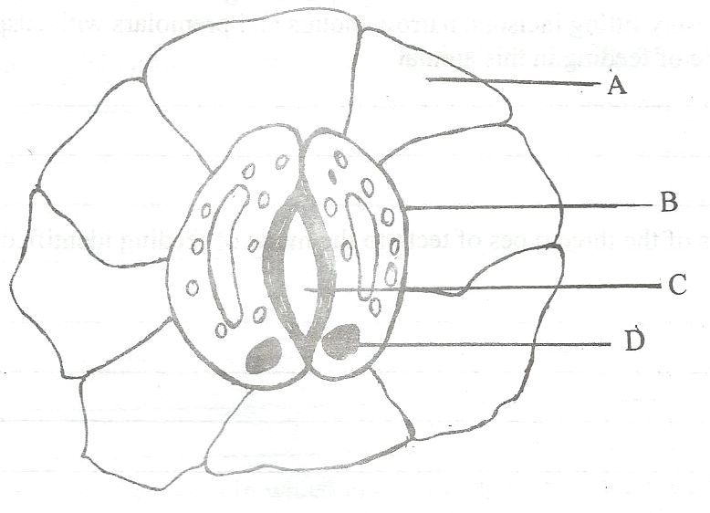

(a) Name the cells labelled A and B (2marks)
A ………………………………………………………………………………………
B……………………………………………………………………………………….

(b) Describe the mechanism of closing of aperture C (4marks)
…………………………………………………………………………………………………………………………………………………………………………………………………………………………………………………………………………………………………………………………………………………………………………………………………………………………………………………………………………………………………………………………………………………………………………………………………………………………………………………………………………………………………………………………………………………………………………………………………………………………………………………………………………………………………………………………………………………………………………………………………………………………………………………………………………………………………………………………………………………………………………………………………………………………………………………………………………………………………………………………………
- Name the causative agent of whooping cough (1mark)
…………………………………………………………………………………………………
- State the economic importance of the following excretory products in plants (2marks)
Nicotine …………………………………………………………………………………………………
Quinine
…………………………………………………………………………………………………
11. Give three distinguishing features of class Aves (3marks)
…………………………………………………………………………………………………
……………………………………………………………………………………………………………………………………………………………………………………………………………………………………………………………………………………………………………………………………………………………………………………………………………………………………………………………………………………………………………
…………………………………………………………………………………………………

- State two differences in the roots of Monocotyledonae and Dicotyledonae? (2marks)

Monocotyledonae | Dicotyledonae

- A student set up an experiment as shown in the diagram below.
Cotton wool
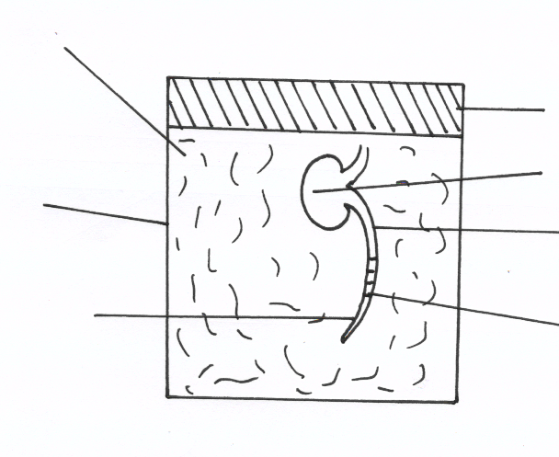
Cork
Cotyledons
Glass Container
Bean seedlings
Radicle
Marking

a) (i) What was being investigated in the experiment? (1mark)
……………………………………………………………………………………………..
(ii) Draw a diagram to indicate the expected results of the experiment after three days.
(2mks)

(iii) Why was it necessary to have wet cotton wool in the container (1mark)
…………………………………………………………………………………………………
b) What is the role of the following in a germinating seed (2 marks)
(i) Oxygen

.............................................................................................................................................................
(ii) Cotyledons
………………………………………………………………………………………………

- The following set up was used in an experiment
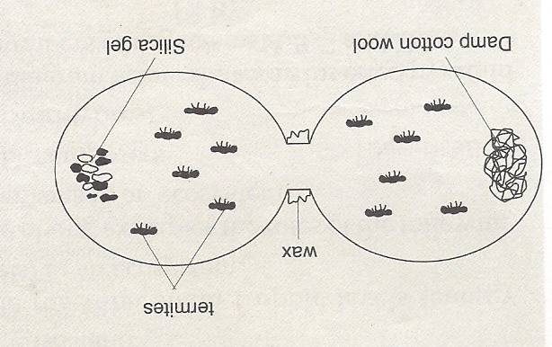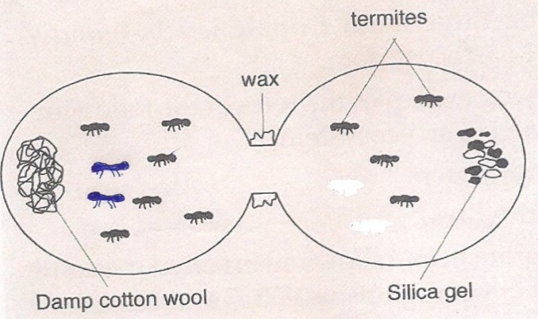
At the start of experiment at the end of experiment
(a) State the function of the following in the set –up (3 marks)
i). damp cotton wool
………………………………………………………………………………………
ii) Silica gel.
………………………………………………………………………………………
iii) Wax
……………………………………………………………………………………
b) Deduce the condition that must be present in a termite habitat (2 marks)
……………………………………………………………………………………………………………………………………………………………………………………………………………………………………………………………………………………………………………………………………………………………………………………………………………………………………………………………………………………………………………

- (a) Give the importance of nitrogen cycle. (1mark)
………………………………………………………………………………………………………………………………………………………………………………………………
(b)What are the roles of the following organisms in an ecosystem? (2 marks)
Decomposers
………………………………………………………………………………………………………………………………………………………………………………………………………………………………………………………………………………………………
Detrivores
………………………………………………………………………………………………………………………………………………………………………………………………………………………………………………………………………………………………
- Define the term:
Greenhouse effect (1mark)
………………………………………………………………………………………………………………………………………………………………………………………………………………………………………………………….……………………………………………………………………………………………………………………………………………………………………………………………………………………………………………..……
Global warming (1mark)
……………………………………………………………………………………………………………………………………………………………………………………….……………………………………………………………………………………………………………………………………………………………………………………………………………………………………………………………………………………………………………………
- (a)What is organic evolution? ( 1mark)
………………………………………………………………………………………………………………………………………………………………………………………………………………………………………………………………………………………………………………………

(b)Briefly explain how the peppered moth (Bistonbetularia) shows natural selection
(3marks)
………………………………………………………………………………………………………………………………………………………………………………………………………………………………………………………………………………………………………………………………………………………………………………………………………………………………………………………………………………………………………………………………………………………………………………………………………………………………………………
c) Distinguish between convergent and divergent evolution (2 marks)
……………………………………………………………………………………………………………………………………………………………………………………………………………………………………………………………………………………………………………………………………………………………………………………………………………………………………………………………………………………………………………………………………..
- Study the diagram and answer the questions that follow
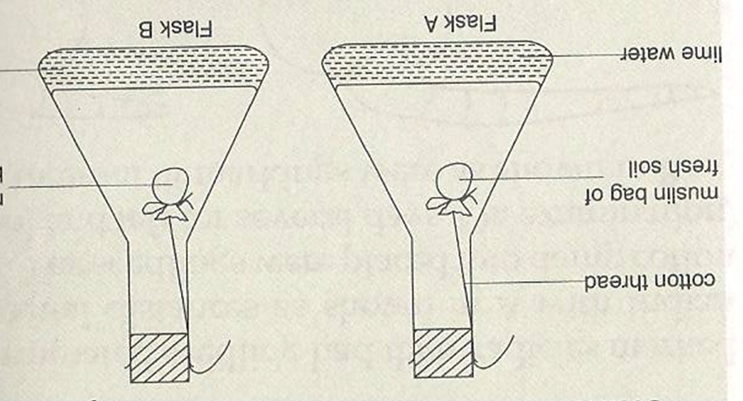

Muslin bag of baked soil
(a) In which set-up did the lime water become turbid? ( 1 mark)
............................................................................................................................................................

(b) Explain your answer in (a) above ( 2 marks)
………………………………………………………………………………………………………………………………………………………………………………………………………………………………………………………………………………………………………………………………………………………………………………………………………………………………
- State the three structural adaptations of the lungs in mammals ( 3marks)
……………………………………………………………………………………………………………………………………………………………………………………………………………………………………………………………………………………………………………………………………………………………………………………………………………………………
- What are the roles of each of the following on transmission of impulses:( 2 marks)
- Nodes of Ranvier
………………………………………………………………………………………………………………………………………………………………………………………………
ii) Myelin Sheath
………………………………………………………………………………………………………………………………………………………………………………………………
- (a) Give three effects of over secretion of adrenaline? ( 3 marks)
………………………………………………………………………………………………………………………………………………………………………………………………………………………………………………………………………………………………………………………………………………………………………………………………………………………………………………………………………………………………………………………………………………………………………………………………………………
…………………………………………………………………………………………………
21. (a) Define non disjunction? (1 mark)
…………………………………………………………………………………………………………………………………………………………………………………………………………………………………………………………………………………………………………………………………………………………………………………………………………

(b) Name two genetic disorders of the blood. (2marks)
……………………………………………………………………………………………………………………………………………………………………………………………………
…………………………………………………………………………………………………
22. (a) How are female parts of wind pollinated flowers adapted to perform their function?
(2marks)
………………………………………………………………………………………………………………………………………………………………………………………………………………………………………………………………………………………………………………………………………………………………………………………………………………………………………………………………………………………………………………………………………23. State how herbaceous plants obtain their support? (3marks)
- …………………………………………………………………………………………
- ………………………………………………………………………………………
- …………………………………………………………………………………………

