Name……………………………………………………….Cl………………Adm…………………

Date……. …………………….

Sign……. …………………….
231/3
BIOLOGY PRACTICAL
PAPER 3
JUNE 2015
Time: 1 ¾ Hours

KASSU JET EXAMINATION 2015
(Kenya Certificate of Secondary Education)

INSTRUCTIONS TO CANDIDATES
- Answer all the questions in the spaces provided.
- You are required to spend the first 15 minutes of 1 ¾ hours allowed for this paper reading the whole paper carefully before commencing your work.
- Candidates may be penalized for recording irrelevant information and for incorrect spelling especially of technical terms.

FOR EXAMINER’S USE ONLY
Question | Max Score | Candidate’s Score
1 | 12
2 | 16
3 | 12
TOTAL | 40

This paper consists of 5 printed pages. Candidates should check the question paper to ensure that all pages are printed as indicated and no questions are missing.
1. You are provided with specimen S. Study the specimen carefully then answer questions that follow.
a) Make a drawing of specimen S and label midrib, leaf lamina, leaf margin, and leaf petiole. (3mk)

b) Name the class to which the specimen belongs. (1mk)
…………………………………………………………………………………………………………c) Identify two features of the specimen S that may have been used to place it in the class named in (b) above. (2mk)
…………………………………………………………………………………………………………………………………………………………………………………………………………………………………………………………………………………………………………………………………………………………………………………………………………………………………………d) Using observable features only, explain how the specimen S is adapted to its photosynthetic function. (6mk)
………………………………………………………………………………………………………………………………………………………………………………………………………………………………………………………………………………………………………………………………………………………………………………………………………………………………………………………………………………………………………………………………………………………………………………………………………………………………………………………………………………………………………………………………………………………………………………………………………………………………………………………………………………………………………………………………………………………………………………………………
2. Use the photographs provided to answer the questions that follow:
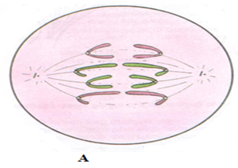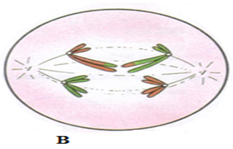
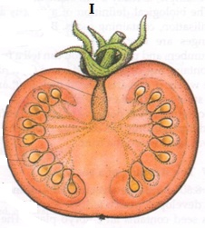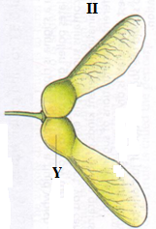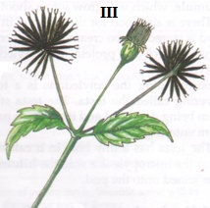

a) (i) Identify the type of cell division represented in the photographs A and B. (2mk)
A ……………………………………………………………………………………………………..
B ……………………………………………………………………………………………………..
(ii) With a reason, name the stage of cell division represented in each case. (4mk)
A …………………………………………………………………………………………………….
Reason ………………………………………………………………………………………….........
………………………………………………………………………………………………………..
B ………………………………………………………………………………………………………
Reason ………………………………………………………………………………………………...
…………………………………………………………………………………………………………
(iii) Name the parts of human body where the process B represented above occur. (2mk)
……………………………………………………………………………………………………………………………………………………………………………………………………………………
b) (i) What type of fruit is represented by photograph I? Give two reasons. (3mk)
Type ………………………………………………………………………………………………..
Reasons……………………………………………………………………………………………….
………………………………………………………………………………………………………..
(ii) Name the agent of dispersal for fruits II and III. (2mk)
II ………………………………………………………………………………………………………
III ……………………………………………………………………………………………………..
(iii) How are the fruits adapted for the mode of dispersal stated in (b)( ii) above? (2mk)
II ……………………………………………………………………………………………………..
……………………………………………………………………………………………………….
III ……………………………………………………………………………………………………..
…………………………………………………………………………………………………………
(iv) Identify the type of placentation shown by photograph I. (1mk)
…………………………………………………………………………………………………………
3. You are provided with specimens labeled L and M. Study them then answer questions that follow:
a) Identify the specimens. (2mk)
L …………………………………………………………………………………………………….
M ……………………………………………………………………………………………………...
b) Name the part of the body where each is found. (2mk)
L ……………………………………………………………………………………………………..
M …………………………………………………………………………………………………….
c) With which bone does the vertebra L articulate, other than those of the vertebral column? (1mk)
…………………………………………………………………………………………………………
d) Using observable features only, state two adaptations of the specimen M to its functions. (2mk)
…………………………………………………………………………………………………………………………………………………………………………………………………………………………………………………………………………………………………………………………………………………………………………………………………………………………………………
e) Observe the specimen L from the anterior view. Name the parts of the vertebra that are most pronounced. (3mk)
…………………………………………………………………………………………………………………………………………………………………………………………………………………………………………………………………………………………………………………………………………………………………………………………………………………………………………
f) Name the cartilaginous pad found between two adjacent vertebrae and state its function. (2mk)
Name ……………………………………………………………………………………………….
Function ……………………………………………………………………………………………
……………………………………………………………………………………………………..

