NAME...................................................................................................................... INDEX NO:...................
Candidate’s signature............................
Date.......................................................

GATUNDU SUB COUNTY DISTRICT FORM FOUR 2015 EVALUTION EXAMINATION

231/1
BIOLOGY
PAPER I
(Theory)
JULY/AUGUST 2015

GATUNDU DISTRICT SECONDARY SCHOOLS EVALUATION TEST
KENYA CERTIFICATE OF SECONDARY EDUCATION

BIOLOGY
PAPER 1
TIME: 2 HOURS

INSTRUCTIONS TO CANDIDATES
- Write your name and index number in the spaces provided
- Answer all questions in the spaces provided.

FOR EXAMINER’S USE ONLY

QUESTIONS | MAXIMUM SCORE | CANDIDATE’S SCORE
1-30 | 80

- State the importance of each of the following in living organisms. (2 marks)

  - Respiration ........................................................................................................................................................................................................................................................................................
  - Reproduction
................................................................................................................................................................................................................................................................................................................
- State function of the following in seed. Germination. (3 marks)

  - Water
................................................................................................................................................................................................................................................................................................................
  - Enzymes
................................................................................................................................................................................................................................................................................................................
  - Oxygen
................................................................................................................................................................................................................................................................................................................
- Distinguish between identical twins and fraternal twins. (2 marks)

........................................................................................................................................................................................................................................................................................................................................................................................................................................................................
........................................................................................................................................................

- The diagram below represents a stage during cell division.

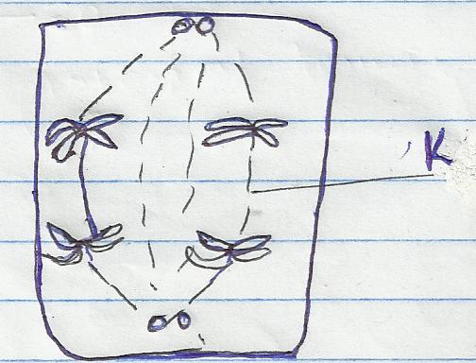

  - Identify the stage of cell division. (1 mark)
................................................................................................................................................................................................................................................................................................................
  - Give two reasons for your answer (a) above. (2 marks)
................................................................................................................................................................................................................................................................................................................
................................................................................................................................................................................................................................................................................................................
  - Name the structures labeled K. (1 mark)
........................................................................................................................................................................................................................................................................................................................................................................................................................................................................
- State three roles of Gibberellins hormone in plant. (3 marks)
........................................................................................................................................................................................................................................................................................................................................................................................................................................................................
........................................................................................................................................................
- (i) The diameter field of view of a light microscopic is 6.5mm. Plant cells lying across the diameter are 12. Determine the size of one cell in micrometers. (2 marks)
........................................................................................................................................................................................................................................................................................................................................................................................................................................................................
........................................................................................................................................................
........................................................................................................................................................
........................................................................................................................................................

(ii) Explain how drooping of leaves on a hot sunny day is advantageous to a plant. (1 marks)

........................................................................................................................................................................................................................................................................................................................................................................................................................................................................

- Distinguish between diffusion and osmosis. (2 marks)

........................................................................................................................................................................................................................................................................................................................................................................................................................................................................

- State the changes that occur in a nerve axon to produce an action potential. (3 marks)
........................................................................................................................................................................................................................................................................................................................................................................................................................................................................
........................................................................................................................................................................................................................................................................................................................................................................................................................................................................
- (i) Name the gaseous exchange surface in insects. (1 mark)
........................................................................................................................................................................................................................................................................................................................................................................................................................................................................

(ii) State two ways the surface named in (a) above is suited to its function. (2 marks)
........................................................................................................................................................................................................................................................................................................................................................................................................................................................................
........................................................................................................................................................
10. 5C₅₁ H₉₈ 0₆ + 145 O₂ 102 CO₂ + 98 H₂O

The above equation shows an oxidation reaction of food substances.

- What do you understand by the term respiratory quotient? (1 mrk)
........................................................................................................................................................................................................................................................................................................................................................................................................................................................................

- Determine respiratory quotient of the oxidation of food substances. (1 mark)
........................................................................................................................................................................................................................................................................................................................................................................................................................................................................

- Identify the food substances. (1 mark)
........................................................................................................................................................................................................................................................................................................................................................................................................................................................................
  - State one function of each of the following parts of a mammalian ear.

    - Pinna (1 mark)
........................................................................................................................................................................................................................................................................................................................................................................................................................................................................
    - Tympanic membrane (1 mark)
........................................................................................................................................................................................................................................................................................................................................................................................................................................................................
    - Vestibule (1 mark)
........................................................................................................................................................................................................................................................................................................................................................................................................................................................................
  - State one structural and one functional difference between motor and sensory neurones. (2 marks)
    - Structural difference –
........................................................................................................................................................................................................................................................................................................................................................................................................................................................................
    - Functional difference –
........................................................................................................................................................................................................................................................................................................................................................................................................................................................................
  - i) Distinguish between a community and a population (2 marks)
................................................................................................................................................................................................................................................................................................................
................................................................................................................................................................................................................................................................................................................

ii) State two measures that can be taken to control infection of man by protozoan parasites. (2 marks)
................................................................................................................................................................................................................................................................................................................
........................................................................................................................................................................................................................................................................................................................................................................................................................................................................
  - i) Pregnancy continues if the ovary of an expectant mother is removed after 4 months. Explain. (2 marks)
................................................................................................................................................................................................................................................................................................................................................................................................................................................................................................................................................................................................................................
ii) What is the role of testes in the mammalian reproductive system? (2 marks)
........................................................................................................................................................
........................................................................................................................................................................................................................................................................................................................................................................................................................................................................
  - i) State two ways in which skeletal muscles fibres are adapted to their function.
(2 marks)
........................................................................................................................................................................................................................................................................................................................................................................................................................................................................
ii) State two structural differences between biceps muscles & muscles of the gut.
(2 marks)
................................................................................................................................................................................................................................................................................................................................................................................................................................................................................................................................................................................................................................
  - a) Explain why Lamarck’s theory of evolution is not accepted by biologists today.
(2 marks)
........................................................................................................................................................................................................................................................................................................................................................................................................................................................................
........................................................................................................................................................
b) State two pieces of evidence that support the theory of evolution. (2 marks)
........................................................................................................................................................................................................................................................................................................................................................................................................................................................................
  - The diagram below shows a section through plant organ.
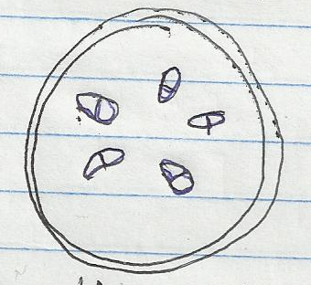

- (i) Name the class of the section was obtained.(1 mark)
........................................................................................................................................................................................................................................................................................................................................................................................................................................................................
(ii) Give a reason for your answer in (a) above (1 mk)
........................................................................................................................................................................................................................................................................................................................................................................................................................................................................
- What is the role of vascular bundles in plant nutrition? (2 marks)
........................................................................................................................................................
........................................................................................................................................................................................................................................................................................................................................................................................................................................................................
  - The following is a dental formula of a dog and rabbit, state two differences between them. (2 marks)

Dog: I 3 C 1 PM 4 M 2
3 1 4 3
Rabbit: I 2 C 0 PM 3 M 3
1 0 2 3

........................................................................................................................................................................................................................................................................................................................................................................................................................................................................

- The figure below illustrates a portion of a chromosome with genes named A, B, C, S, Q and R

A | B | C | S | Q | R

Use the diagrams similar to the one above to illustrate the changes if the above
chromosome undergoes the following mutations affecting only gene C and S.

- Deletion (1 mark)
........................................................................................................................................................................................................................................................................................................................................................................................................................................................................

- Inversion (1 mark)
........................................................................................................................................................................................................................................................................................................................................................................................................................................................................
- Name the disease characterized by
Glycosuria (2 marks)
........................................................................................................................................................................................................................................................................................................................................................................................................................................................................
Diuresis (1 mark)
........................................................................................................................................................................................................................................................................................................................................................................................................................................................................
- State the importance of each of the following features in animals; (2 marks)

  - Solid food being broken down into small pieces.
........................................................................................................................................................................................................................................................................................................................................................................................................................................................................
  - Presence of caecum in herbivorous mammals.
........................................................................................................................................................................................................................................................................................................................................................................................................................................................................
- Name the substance that accumulates in muscles when respiration occurs with insufficient oxygen. (1 mark)
.......................................................................................................................................................................................................................................................................................................................................................................................................................................................................
- The diagram below represents gaseous exchange in the alveolus

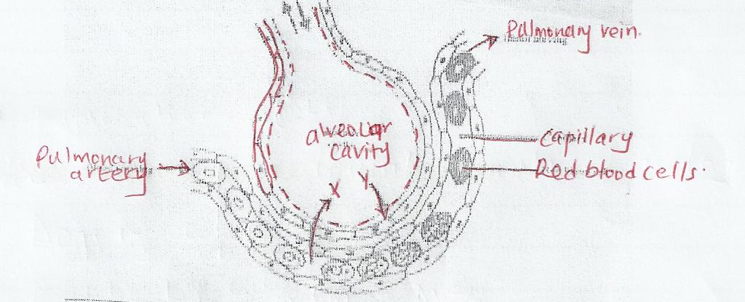

  - Mention the path followed by gas y from alveolar space until it reaches the red blood cells.
........................................................................................................................................................................................................................................................................................................................................................................................................................................................................
- Explain how water from the soil is gained by root hair in plants. (2 marks)
........................................................................................................................................................................................................................................................................................................................................................................................................................................................................
- In what form is carbon IV oxide transported in blood. (1 mark)
........................................................................................................................................................................................................................................................................................................................................................................................................................................................................
- The diagram below shows a section of a dicotyledonous stem.
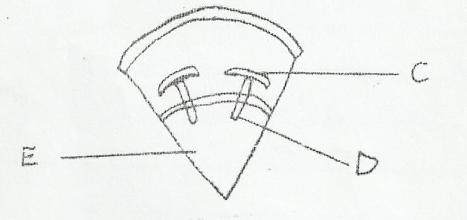

Name the type of cells found in part labeled E. (1 mark)
........................................................................................................................................................................................................................................................................................................................................................................................................................................................................
- State three features that a grasshopper, a crab, a spider and a millipede have in common. (3 mark)
........................................................................................................................................................................................................................................................................................................................................................................................................................................................................
........................................................................................................................................................................................................................................................................................................................................................................................................................................................................
- State two characteristics of Eukaryotes. (2 marks)
................................................................................................................................................................................................................................................................................................................................................................................................................................................................................................................................................................................................................................
- A cell organelle can be thought of as a “bag” full of “liquid”, the “liquid” being the “background” substance that holds other structures within the “bag”. Distinguish between the “background” substance of a mitochondria and that of a chloroplast.
(2 marks)
........................................................................................................................................................................................................................................................................................................................................................................................................................................................................................................................................................................................................................................................................................................................................................................................
- The figure below shows a stem of a plant growing round a tree trunk

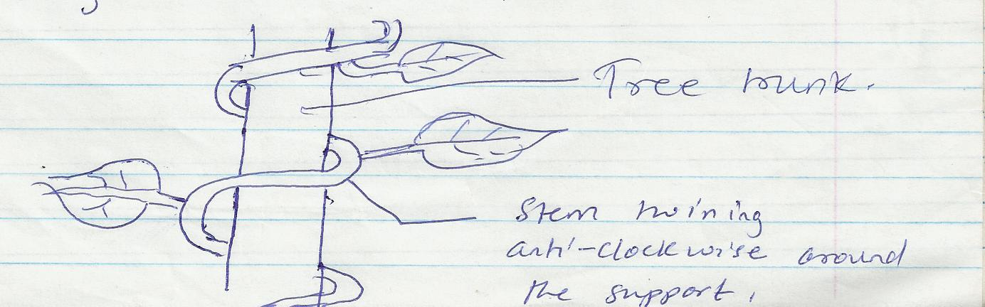

  - What is the name of the response which causes such a twisted growth? (1 mark)
........................................................................................................................................................................................................................................................................................................................................................................................................................................................................
  - Explain how twisting process is accomplished (2 marks)

..................................................................................................................................................................................................................................................................................................................................................................................................................................................................
........................................................................................................................................................................................................................................................................................................................................................................................................................................................................

