NAME:.............................................................................................................. INDEX NO:.........................

GATUNDU SOUTH FORM FOUR 2015 EVALUATION EXAM

565/1
BUSINESS STUDIES
PAPER 1
JULY/AUGUST 2015
TIME: 2 HOURS

INSTRUCTIONS TO CANDIDATES

- Write your name and index number in the spaces provided.
- Answer all questions in the spaces provided.
- All answers should be written in the spaces provided in this booklet.

Qs | 1 | 2 | 3 | 4 | 5 | 6 | 7 | 8 | 9 | 10 | 11 | 12 | 13
mrks

Qs | 14 | 15 | 16 | 17 | 18 | 19 | 20 | 21 | 22 | 23 | 24 | 25

TOTAL
MARKS

- Identify the terms given to each of the following statements. (4 marks)

 | Statement | Term
a. | Transport goods from producers to consumers
b. | Activities carried out with a view of making profit.
c. | A person who uses a good or service.
d. | Increasing the usefulness of a good or services

- Outline four business resources that business can use to enhance its operation. (4 marks)

.....................................................................................................................................................................................................................................................................................................................................................................................................................................................................................................................................................................................................................................................................................................................................................................................................................
- Outline four characteristics of basic wants. (4 marks)

.....................................................................................................................................................................................................................................................................................................................................................................................................................................................................................................................................................................................................................................................................................................................................................................................................................

- Outline four gaps in the market that may give rise to a business opportunity. (4 marks)

.....................................................................................................................................................................................................................................................................................................................................................................................................................................................................................................................................................................................................................................................................................................................................................................................................................

- Indicate in the table below the office machine used to perform the following functions. (4 marks)

 | Function | Machine
a. | Folding documents, placing them in envelopes and sealing the envelopes.
b. | Making short hand dictations and recording information on tapes.
c. | Posting information to ledgers and preparation of pay rolls.
d. | For trimming documents into required shapes and sizes.

6. Highlight four features of subsistence production. (4 marks)

.....................................................................................................................................................................................................................................................................................................................................................................................................................................................................................................................................................................................................................................................................................................................................................................................................................
7. Highlight four circumstances under which deffered payment may be appropriate. (4 marks)

.....................................................................................................................................................................................................................................................................................................................................................................................................................................................................................................................................................................................................................................................................................................................................................................................................................
8. Outline four advantages of consumer co-operatives. (4 marks)

.....................................................................................................................................................................................................................................................................................................................................................................................................................................................................................................................................................................................................................................................................................................................................................................................................................
9. Outline four disadvantages of using a train as a means of transport. (4 marks)

.....................................................................................................................................................................................................................................................................................................................................................................................................................................................................................................................................................................................................................................................................................................................................................................................................................
10. Highlight four functions of advertising agencies. (4 marks)

.....................................................................................................................................................................................................................................................................................................................................................................................................................................................................................................................................................................................................................................................................................................................................................................................................................

11. The figure below shows a shift in supply curve from SS to S₁S₁.

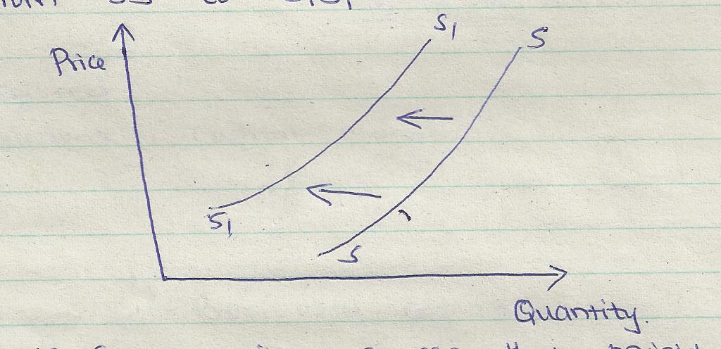

State four possible causes that might have led to this situation. (4 marks)

.....................................................................................................................................................................................................................................................................................................................................................................................................................................................................................................................................................................................................................................................................................................................................................................................................................
............................................................................................................................................................................................................................................................................................................................

12. The following balance sheet relates to Uzuri traders

UZURI TRADERS
Balance Sheet
As at 31st May 2015

sh. Sh.  Fixed Assets  Land 1,800,000  Motor vehicle 1,000,000  Furniture 30,000 2,830,000  Current assets  Stock 80,000  Debtors 50,000  Cash at bank 32,000  Cash in hand 20,000 182,000  3,012,000  ======= | Capital and Liabilities  Capital 2,172,000  Long term liabilities  Loan from KCB 400,000  Loan from K.I.E 300,000 700,000  Short term liabilities  Creditors 100,000  Salary owing 40,000 140,000  ________  3,012,000  =======

Required:
Calculate (i) Capital owned (1 mark)
.........................................................................................................................................................................................................................................................................................................................................................................................................................................................................................
(ii) Borrowed capital (1 mark)
.........................................................................................................................................................................................................................................................................................................................................................................................................................................................................................
(iii) Working capital (1 mark)
.........................................................................................................................................................................................................................................................................................................................................................................................................................................................................................
(iv) Capital employed (1 mark)
.......................................................................................................................................................................................................................................................................................................................................................................................................................................................................................................................................................................................................................................................

13. Record the following transaction in a two column cash book.

2012
Jan 1: Started business with capital of sh20,000 cash and sh 50,000 at bank.
2: Bought stock in cash sh 120,000
3: Cash sales sh 5,000
7: Bought stock worth sh 10,000 on credit.
12: Withdrew cash from bank for office use sh.8,000.
15: Paid rent by cheque shs 6000.
20: Received shs 4000 by cheque from a debtor.

14. Highlight four problems that Kenyan government may experience in implementing a development
plan. (4 marks)
.....................................................................................................................................................................................................................................................................................................................................................................................................................................................................................................................................................................................................................................................................................................................................................................................................................

15. Outline four ways in which the government creates an enabling environment for business operations.
(4 marks)
.....................................................................................................................................................................................................................................................................................................................................................................................................................................................................................................................................................................................................................................................................................................................................................................................................................

16. Highlight four advantages to the government of Kenya for setting up Export Processing Zones (EPZs)
(4 marks)
.....................................................................................................................................................................................................................................................................................................................................................................................................................................................................................................................................................................................................................................................................................................................................................................................................................

17. Enter the following transactions in the relevant ledger accounts. (4 marks)

2011
July 1: Opening balances cash ksh 24,000, bank kshs 8000 (cr)
3: Paid rent kshs 4,000 in cash
4: Bought goods worth ksh 8,000 and paid by cheque
5: Deposited ksh. 5,000 from the business into the bank.

18. Give four reasons why firms choose to remain small in an economy dominated by large firms.
(4 marks)
.....................................................................................................................................................................................................................................................................................................................................................................................................................................................................................................................................................................................................................................................................................................................................................................................................................
19. Outline four features of a perfect competition market. (4 marks)

.....................................................................................................................................................................................................................................................................................................................................................................................................................................................................................................................................................................................................................................................................................................................................................................................................................

20. Highlight four factors that may determine the amount of revenue to be collected through taxation.
(4 marks)
.....................................................................................................................................................................................................................................................................................................................................................................................................................................................................................................................................................................................................................................................................................................................................................................................................................

21. Peterson started a handware business on 1st Janaury 2010. The following is a summary of his transaction during the month
Invoices issued
- Jan 2: Mwiti Traders kshs 50,000
Jan 5: Mutahi Traders ksh 150,000

Invoices received
2010 Jan 3: Solomon Traders kshs 80,000
4: Kanake Enterprises kshs 160,000

Required:
Record the above details in the appropriate subsidiary books. (4 marks)

22. State four errors that do not affect the agreement of a trial balance. (4 marks)

.....................................................................................................................................................................................................................................................................................................................................................................................................................................................................................................................................................................................................................................................................................................................................................................................................................

23. With the advancement of information technology (I.T), there has been a lot of revolution in
communication, identify four current trends in communication. (4 marks)

.....................................................................................................................................................................................................................................................................................................................................................................................................................................................................................................................................................................................................................................................................................................................................................................................................................
24. Draw four differences between whole life policy and endowment policy. (4 marks)

Whole life Endowment policy
a)

b)

c)

d)

25. Outline four factors that affect the circular flow of income. (4 marks)

.....................................................................................................................................................................................................................................................................................................................................................................................................................................................................................................................................................................................................................................................................................................................................................................................................................

