NAME ………………………………………………………………………….. INDEX NO …………………….
Candidates signature …………………..
Date ………………………………………
GATUNDU SOUTH SUB-COUNTY FORM FOUR 2015 EVALUATION EXAM
233/1
CHEMISTRY
PAPER 1
(THEORY)
TIME; 2HRS

Instructions;
- Answer all the questions in the space provided
- Mathematical tables or electronic calculators may be used
- All working must be clearly shown where necessary
- Candidates may be penalized for not following instructions in this paper

QUESTION | MAXIMUM SCORE | CANDIDATES SCORE
1-28 | 80

THIS PAPER CONSISTS OF 13 PRINTED PAGES

- The diagram below represents a method of separation used to separate two liquids A and B. use it to answer the questions that follow

X
A
B

beaker
- Name two properties that makes it possible for the two liquids to be separated. (2mks)
……………………………………………………………………………………………………………………………………………………………………………………………………………………………………………………………………………………………………………………………………………………………………………………………………………………………………………………………………….
- Give one alternative method that may be used to separate the two liquids. (1mk)
……………………………………………………………………………………………………………………………………………………………………………………………………………………………………………………………………………………………
- Name the following organic compounds (2mks)
- CH₃

CH₃CHCHCHCHCH₂CH3 ……………………………………………………………………………………………………………
CH₃

CH₃COOCH₂CH₂CH₂CH3 ………………………………………………………………………………………………………………………….

- Name the following processes;
- When anhydrous calcium chloride is left in an open beaker overnight a solution was formed. (1mk)
……………………………………………………………………………………………………………………………………………..

- When sodium carbonate decahydrate crystals are left in an open beaker for some days it turned into a powder. (1mk)
…………………………………………………………………………………………………………………………………………………….

- In 35 seconds, it was found that 140cm³ of nitrogen (N₂) had diffused through a strip of porous porcelain. How long will it take 400cm³ of carbon (IV) oxide to diffuse through the same strip of porous porcelain? (3mks)
………………………………………………………………………………………………………………………………………………………………………………………………………………………………………………………………………………………………………………………………………………………………………………………………………………………………………………………………………………………………………………………………………………………………………………………………………………………………………………………………………………………………………………………………………………………………………………………………………………………………………………………………………………………………………………………………………………
- The chromatogram below shows the constituents of a flower extract. Study it and answer the questions that follow
Y

red
yellow

X
- Explain the different positions of red and yellow pigments. (2mks)
…………………………………………………………………………………………………………………………………………………………………………………………………………………………………………………………………………………………………………………………………….

- What does lines X and Y represent (1mk)
X ………………………………………………………………………

Y …………………………………………………………………….
- Name the chief ore of iron and write its formula (2mks)
………………………………………………………………………………………………………………………………………………………………………………………………………………………………………………………………………………………………………………………………………………………………………………………………………………………………………………………………
- In an experiment, two pieces of iron sheets were wrapped in each case with zinc and copper metal sheets as shown below. They were left in the open for some months.
iron

zinc copper
(I) (II)

State and explain the observations made in the experiments; (3mk)
- ………………………………………………………………………………………………………………………………………………………………………………………………………………………………………………………………………………………………………………………………………………………………………………………………………………………………………………………………..
- ……………………………………………………………………………………………………………………………………………………………………………………………………………………………………………………………………………………………………………………………………………………………………………………………………………………………………………………………….
- Compare the atomic sizes of sodium and magnesium. Explain. (2mks)
……………………………………………………………………………………………………………………………………………………………………………………………………………………………………………………………………………………………………………………………………………………………………………………………………………………………………………………………………………………………………………………………………………………………………………………………………………………

- The set up below was used to prepare gas X. study it and answer the questions that follow;

50cm³ HNO₃ +
50cm³ water

Gas X

water

Copper turnings

- Name gas X (1mk)

…………………………………………………………………………………………………………………………………………………
- Write an equation for production of gas X in the set up (1mk)

…………………………………………………………………………………………………………………………………………………..

- It’s hard to test whether gas X supports burning using a glowing splint. Explain. (1mk)

……………………………………………………………………………………………………………………………………………………………………………………………………………………………………………………………………………………………………………………………………………………………………………………………………………………………………………………………………………………………………………………………………………………………………………………………………………………

- When solid M is dissolved in water, it dissolves and forms a blue solution. Addition of ammonia solution to this solution forms a blue precipitate which dissolves in excess to form a deep blue solution. Write the formula and name of the ion responsible for the deep blue solution. (2mks)

……………………………………………………………………………………………………………………………………………………………………………………………………………………………………………………………………………………………………………………………………………………………………………………………………………………………………………………………….

- The diagram below represents the structure of aluminium chloride.

N

Cl Cl Cl

Al Al

Cl Cl Cl

M

- Identify the bonds labeled M and N. (2mk)

M ………………………………………………………………………

N …………………………………………………………………………

- What Is the difference between bonds M and N ( 1mk)

………………………………………………………………………………………………………………………………………………………………………………………………………………………………………………………………………………………………………………………………………………………………………………………………………………………………………………………………

- Study the diagram below and answer the questions that follow
+ve
A

B

C

-ve

- Name particles A and B
- A ……………………………………………………. (1mk)

- B …………………………………………………… (1mk)

- What property of B makes it not to be deflected by magnetic/electric field (1mk)

………………………………………………………………………………………………………………………………………………………………………………………………………………………………………………………………………………………………………….

- The table below shows the first ionization energies of elements Y and Z.

element | Ionization energy kJ/mol
Y | 494
Z | 418

- What is ionization energy? (1mk)
……………………………………………………………………………………………………………………………………………………………………………………………………………………………………………………………………………………………………………………………………………………………………………………………………………………………………………….
- Which of the two elements is the most reactive? Explain (2mks)
…………………………………………………………………………………………………………………………………………………………………………………………………………………………………………………………………………………………………………………………………………………………………………………………………………………………………………………………………………………………………………………………………………………………………………………………………………………….

- The standard enthalpies of combustion of ethyne (C₂H₂), carbon (c) and hydrogen (H₂) are -1300,-394 and -286 kJ/mol respectively. Calculate the enthalpy of formation of ethyne. (3mks)

………………………………………………………………………………………………………………………………………………………………………………………………………………………………………………………………………………………………………………………………………………………………………………………………………………………………………………………………………………………………………………………………………………………………………………………………………………………………………………………………………………………………………………………………………………………………………………………………………………………………………………………………………………………………………………………………………………………………………………………………………………………………………………………………………………………………………………………………………………………………………………………………………………………………………..

- Study the diagram below and answer the questions that follow.

Iron wool

wet sand gas J
heat

- Name gas J (1mk)
…………………………………………………………………………………………………….

- Explain why its important to heat the wet sand before heating the iron wool. (1mk)
………………………………………………………………………………………………………………………………………………………………………………………………………………………………………………………………………………………………………………………………………………………………………………………………………………………………………………………………

- Name the product formed in the combustion tube. (1mk)
………………………………………………………………………………………………………………………………………………
- An element X has a relative atomic mass of 44. When a current of 0.5 A was passed through the molten chloride of X for 32 minutes and 10 seconds, 0.22g of X were deposited at the cathode
Determine the charge on an ion of X (1F=96,500c) (3mks)
………………………………………………………………………………………………………………………………………………………………………………………………………………………………………………………………………………………………………………………………………………………………………………………………………………………………………………………………………………………………………………………………………………………………………………………………………………………………………………………………………………………………………………………………………………………………

- Study the reaction below and answer the questions that follow

2NO₂ _{(g)} N₂O₄ _{(g)} _{ΔH = -ve}

- State and explain the observation made when a mixture at equilibrium is heated. ( 2mks)

…………………………………………………………………………………………………………………………………………………………………………………………………………………………………………………………………………………………………………………………………………………………………………………………………………………………………………………………………………………………………………………………………………………………………………………………………………………..

- If pressure is exerted at the mixture at equilibrium, what observation will be made? (1mk)

…………………………………………………………………………………………………………………………………………………………………………………………………………………………………………………………………………………………………………
- State and explain the trend in the boiling points of group (VII) elements down the group. (2mks)
……………………………………………………………………………………………………………………………………………………………………………………………………………………………………………………………………………………………………………………………………………………………………………………………………………………………………………………………….............................................................................................................................................................

- The diagram below shows electrolysis of dilute copper (II) sulphate solution using copper electrodes;

B
A

Copper (II) sulphate solution

- State the observations made at electrode A and B (2mks)

A…………………………………………………………………………………………………………………………………………………………………………………………………………………………………………………………………………………………………………..

B…………………………………………………………………………………………………………………………………………………………………………………………………………………………………………………………………………………………………………..

- Write the equation of reaction at electrode A (1mk)

……………………………………………………………………………………………………………………………………………………………………………………………………………………………………………………………………………………………………………………………………………………………………………………………………………………………………………………..........
- The flow chart shows a process of preparation of salt P.

HCl _{(aq)} Colourless solution
Barium carbonate filter
Salt P

water
Sodium sulphate colourless solution

- Name salt P. …………………………………………………………………………………(1mk)
- What type of reaction takes place in the formation of salt P. (1mk)
………………………………………………………………………………………………………………..

- Write the equation for the reaction that forms salt P. (1mk)
…………………………………………………………………………………………………………………………………………….

………………………………………………………………………………………………………………………………………………..

- The structure of synthetic rubber is shown below;

H H H
C - C = C - C
H Cl H n

- Determine the relative molecular mass of a polymer made of 250 monomers (2mks)
(c=12,H=1 and Cl=35.5)

………………………………………………………………………………………………………………………………………………………………………………………………………………………………………………………………………………………………………………………………………………………………………………………………………………………………………………………………

- Give one advantage of natural polymers over synthetic ones. (1mk)
……………………………………………………………………………………………………………………………………………………………………………………………………………………………………………………………………………………………………………………………………………………………………………………………………………………………………………………………..

- 0.92g of ethanol were found to burn in excess air producing a temperature rise of 32.5ºC in 200cm³ of water(C=12.0,H=1.0, O=16.0) Density of water is 1g/cm³, specific heat capacity of water is 4.2KjKg⁻¹K⁻¹
(a) Write the equation for the combustion of ethanol (1mk)
…………………………………………………………………………………………………………
…………………………………………………………………………………………………………
(b) Determine the molar heat of combustion of ethanol (2mks)
……………………………………………………………………………………………………………………………………………………………………………………………………………………………………………………………………………………………………………………………………………………………………………………………………………………………………………………………………………………………………………………………………………………………………………………………………………………..

- The formula for cane sugar is (C₁₂H₂₂O₁₁). Use an equation to show what happens when sugar is added to conc. Sulphuric (VI) acid (1mk)

……………………………………………………………………………………………………………………………………………………………………………………………………………………………………………………………………………………………………………………………………………………………………………………………………………………………………………………………….

- What name is given to the type of reaction above? (1mk)

…………………………………………………………………………………………………………………………………………………….

- Calculate the oxidation state of sulphur in sodium thiosulphate (Na₂S₂O₃) (1mk)

……………………………………………………………………………………………………………………………………………
……………………………………………………………………………………………………………………………………………
……………………………………………………………………………………………………………………………………………

- Iron (III) chloride can be prepared in the laboratory by passing dry chlorine gas over hot steel wool.
- Name the above method of preparing salts (1mk)

……………………………………………………………………………………………………………………………………………….

- Why should we prepare the salt in a dry environment? (1mk)

…………………………………………………………………………………………………………………………………………………
- A solution of iron (III) chloride in water changes a blue litmus paper to red. Explain. (1mk)
………………………………………………………………………………………………………………………………………………………………………………………………………………………………………………………………………………………………………………………………………………………………………………………………………………………………………………………………
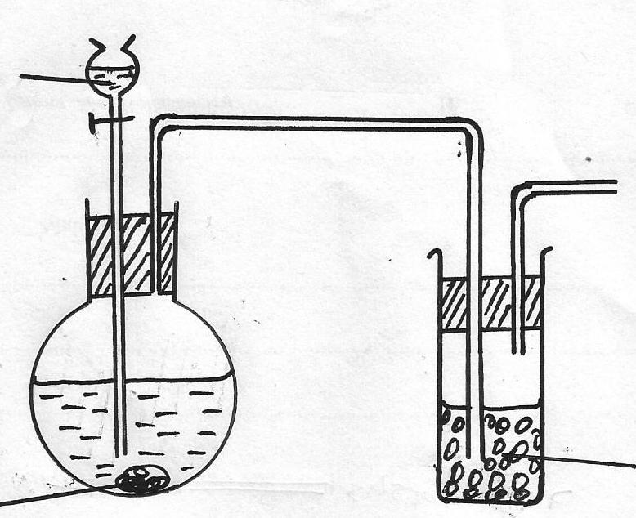
- The set-up below was used to prepare dry sample of hydrogen Sulphide gas
Solid J
Solid H
Dil. Hydrochloric acid

(a)(i) Complete the diagram to show how the gas was collected (2mks)
(ii) Identify the following
I: Solid H (¹/₂mk)
…………………………………………………………………………………………………………
II.Solid J (¹/₂mk)
…………………………………………………………………………………………………………

- Study the structures below and answer the questions that follow.

O

R O-S-O⁻ Na⁺ ^{structure A}

O

O
R C O⁻ Na⁺ ^{structure B}

- Which structure represents a detergent suitable for washing in water containing calcium ions? (1mk)

…………………………………………………………………………………………………………………………………………………

- Give one advantage of continued use of detergent B over A (1mk)

………………………………………………………………………………………………………………………………………………………………………………………………………………………………………………………………………………………………………….

- Name the process of manufacturing detergent B (1mk)

…………………………………………………………………………………………………………………………………………………….
- Aluminium is used in making cooking vessels and overhead cables. State the property of aluminium that makes it suitable for the two uses separately.
Cooking vessels………………………………………………… ( ½ mk)
Overhead cables ………………………………………………. ( ½ mk)
(b) Explain why it is not advisable to clean surfaces of cooking vessels made of aluminium using wood –ash solution (2mks)
……………………………………………………………………………………………………………………………………………………………………………………………………………………………………………………………………………………………………………………………………………………………………………………………………………………………………………………………………….

- 10g of an oxide of sodium contains 5.9g sodium. Its molar mass is 78. Determine its molecular formula. (3mks)

……………………………………………………………………………………………………………………………………………………………………………………………………………………………………………………………………………………………………………………………………………………………………………………………………………………………………………………………………………………………………………………………………………………………………………………………………………………………………………………………………………………………………………………………………………………………………………………………………………………………………………………………………………………………………………………………………………………………………………………………………………………………………………………………………………………
- Differentiate between the terms atomic number and mass number (2mks)
……………………………………………………………………………………………………………………………………………….
………………………………………………………………………………………………………………………………………………..
………………………………………………………………………………………………………………………………………………….

