NAME........................................................................................... INDEX NO.................................. ..........
DATE........................................
SIGN......................................

GATUNDU SOUTH FORM FOUR 2015 EVALUATION EXAM

233/2
CHEMISTRY
PAPER II (THEORY)
JULY/AUGUST 2015
TIME: 2 HOURS

INSTRUCTIONS TO CANDIDATES

- Write your name and index number in the spaces provided above.
- Answer ALL questions in the spaces provided.
- Mathematical tables and electronic calculators may be used.
- All working must be clearly shown where necessary.

FOR EXAMINERS USE ONLY

QUESTION | MAXIMUM SCORE | CANDIDATES’ SCORE
1  2  3  4  5  6 | 13  13  15  12  13  14
TOTAL  SCORE | 80

- The diagram below shows the apparatus for the preparation of gas A and investigate on its properties . Study it and answer the questions that follow.

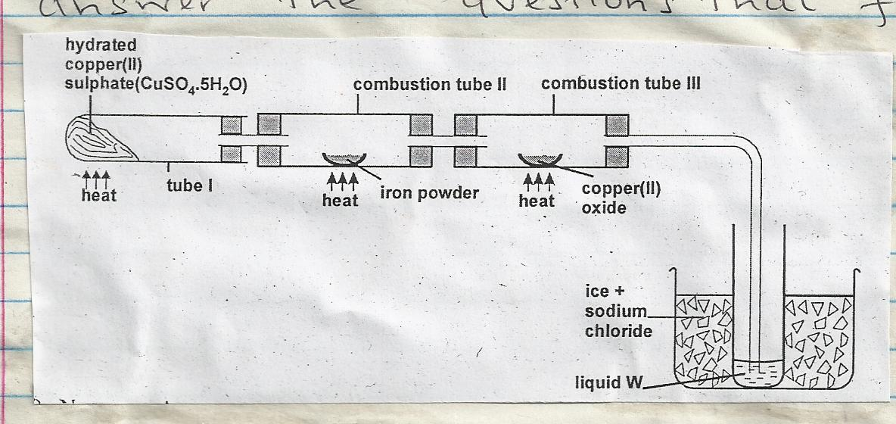

  - (i) Name gas A. ………………………… (1 mark)

(ii)Suggest the property of gas A under investigation. (1 mark)
..................................................................................................................................................
..................................................................................................................................................

(iii) Write chemical equations for the reactions in the;

Boiling tube I (1 mark)
..................................................................................................................................................
..................................................................................................................................................

Combustion tube II (1 mark)
..................................................................................................................................................
..................................................................................................................................................

  - (i) State and explain the observation made in

Tube I. (2 marks)
..................................................................................................................................................
..................................................................................................................................................

      - Combustion tube II (2 marks)
..................................................................................................................................................
..................................................................................................................................................

  - What is the use of hydrated copper (II) sulphate in the experiment. (1 mark)
.................................................................................................................................................
..................................................................................................................................................

(ii) Name one other substance that comes out of tube III. (1 mark)
..................................................................................................................................................
..................................................................................................................................................

(iii) Name liquid W. (1 mark)
..................................................................................................................................................
..................................................................................................................................................

(iv) What is the role of sodium chloride in the ice (freezing mixture) (1 mark)
..................................................................................................................................................
..................................................................................................................................................

(v) Explain why hydrogen gas has been replaced by helium in filling of aeroplane tyres.
(1 mark)
..................................................................................................................................................
..................................................................................................................................................
- The flow diagram below shows the reactions involved in the process for the preparation and reactions of salt C. Study it and answer the questions that follow.

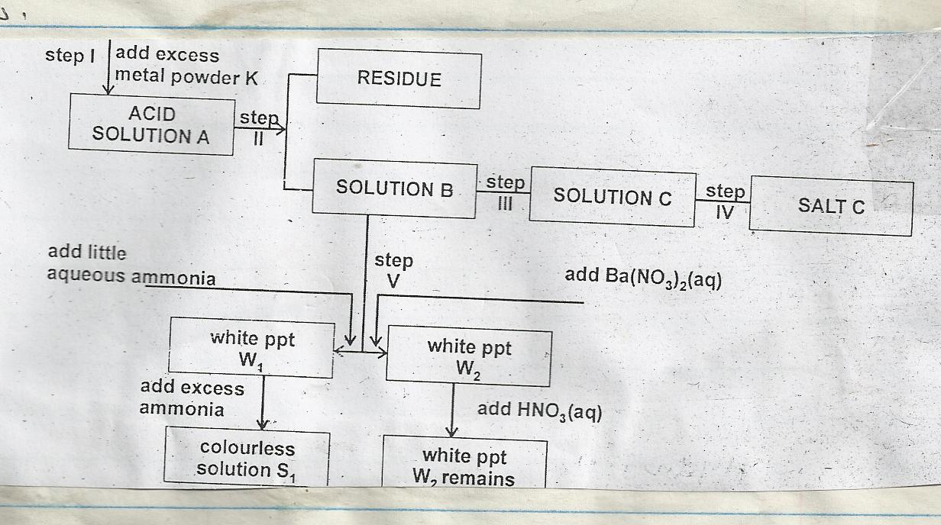

  - Identify (3 marks)

- Metal K
......................................................................................................................................
- Acid A
......................................................................................................................................
- Salt C
......................................................................................................................................

  - In step III the solution B is transferred into an evaporation dish and heated in a water bath until it is saturated.

- What is a saturated solution? (1 mark)
......................................................................................................................................
......................................................................................................................................
- Why is heating done over a water bath? (1 mark)
......................................................................................................................................
......................................................................................................................................
- How would one determine whether a solution is saturated? (1 mark)
......................................................................................................................................
......................................................................................................................................
  - Explain why metal powder K is used in excess. (1 mark)
......................................................................................................................................
....................................................................................................................................

  - Name step (II) and state its importance. (1 mark)
......................................................................................................................................
......................................................................................................................................
  - Identify (3 marks)
- White precipitate W₁
......................................................................................................................................
......................................................................................................................................
- White precipitate W₂
......................................................................................................................................
......................................................................................................................................
- Colourless solution S₁
......................................................................................................................................
......................................................................................................................................
  - Write equations for step I and for the formation of S1

Equation step I (1 mark)
......................................................................................................................................
......................................................................................................................................
Formation of S₁ (1 mark)
......................................................................................................................................
......................................................................................................................................

- a. (i) Sulphur is allotropic. What does this mean? (1 mark)
......................................................................................................................................
......................................................................................................................................
(ii) Give two differences between rhombic and monoclinic sulphur. (2 marks)
......................................................................................................................................
......................................................................................................................................
......................................................................................................................................
......................................................................................................................................
(iii) State and explain using an equation the observations made when sulphur reacts with hot concentrated nitric (v) acid. (3 marks)

Observations
......................................................................................................................................
......................................................................................................................................
......................................................................................................................................
Equation
......................................................................................................................................
......................................................................................................................................
......................................................................................................................................

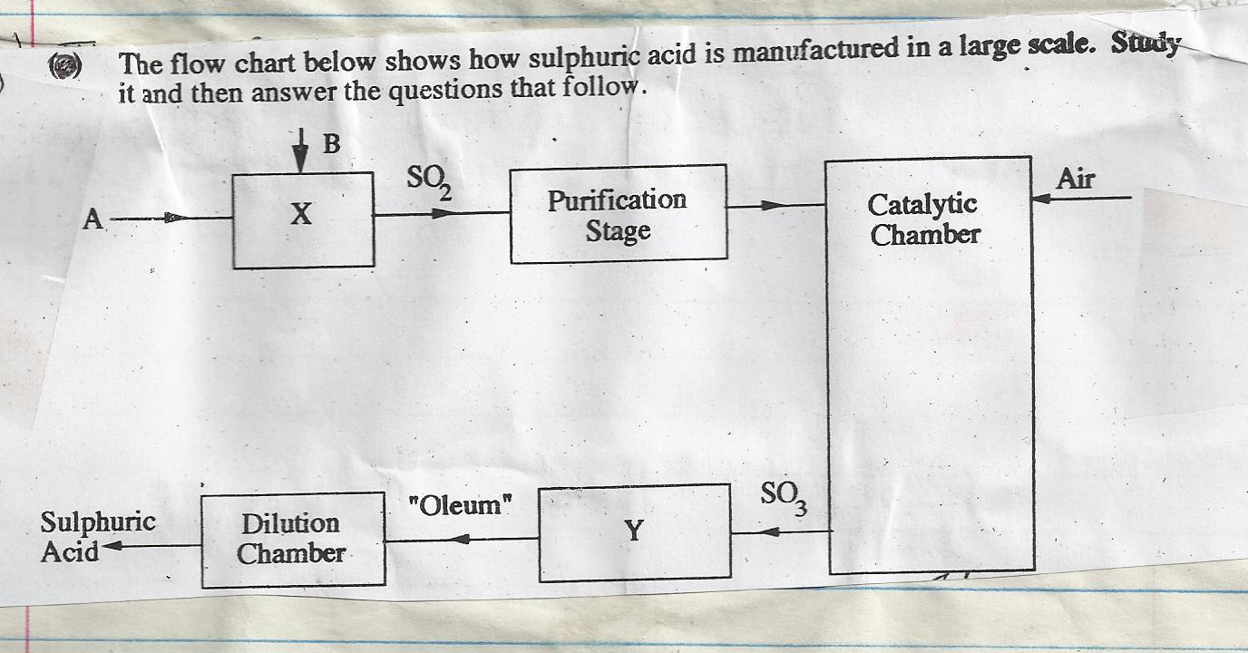

I. (i) Name the raw materials A and B. (2 marks)

A...................................................................................................................................
B...................................................................................................................................
(ii) Name the chambers X and Y. (2 marks)

......................................................................................................................................
......................................................................................................................................

II. (i) Name two impurities that are removed during the purification stage. (2 marks)
......................................................................................................................................
......................................................................................................................................
......................................................................................................................................
(ii) Why must the impurities in (i) above be removed. (1 mark)
......................................................................................................................................
......................................................................................................................................
III. (i) Name the catalyst used in this process. (1 mark)
......................................................................................................................................
......................................................................................................................................

(ii) The equation below shows what happens in the catalytic chamber.

2SO_{2(g)} + O_{2(g )} 2SO₃ ∆ H = -197KJ/Mol

State the two conditions that are necessary for maximum production of SO₃ (1 mark)
......................................................................................................................................
......................................................................................................................................
- a) Define the term standard heat of formation of a substance. (1 mark)
......................................................................................................................................
......................................................................................................................................
b) Butane cannot be prepared directly from it’s elements and so it’s standard heat of formation
( ∆ Hºf) must be obtained indirectly.
Write down an equation;

- For the formation of butane from it’s elements in their normal physical states at standard condition of temperature and pressure. (1 mark)
......................................................................................................................................
......................................................................................................................................
- For the combustion of 1 mole of butane. (1 mark)
......................................................................................................................................
......................................................................................................................................
c) (i) State the Hess’s law. (1 mark)
......................................................................................................................................
......................................................................................................................................
If the following heats of combustion are given.

∆H_{c}^{ө} carbon(s) = -393Kj/Mol
∆H_{c}^{ө} H_{2(g)} = 286Kj/Mol
∆H_{c} C₄H₁₀ = -2877 Kj/Mol

II. Draw an energy cycle diagram linking the heat of formation of butane with its heat of
combustion and the heat of combustion of constituent elements. (2 marks)

III. Calculate the heat of formation of butane ∆H^{θ}_{f} (C₄H₁₀) (2 marks)

d) Use the equations below to answer the questions that follow.

MX_{(s)} M^{n+}_{(g)} + X^{p-}_{(g)}

water
M^{n+}_{(g)} M^{n+}_{(aq)}

X^{p-(}_{g)} water X^{p-}_{(aq)}

- Name the types of enthalpy changes represented by

∆H₁ ..................................................................(1 mark)

∆H₂ ..................................................................(1 mark)

- Given that enthalpy change of ∆H₁ is +690Kj/Mol, and ∆H₂ and ∆H₃ are -322Kj and -364Kj respectively, Calculate the enthalpy change of solution of MX_{(s).} (2 marks)
......................................................................................................................................
......................................................................................................................................
......................................................................................................................................
......................................................................................................................................
- A student set up the apparatus as shown in the diagram below to prepare and collect dry ammonia gas.

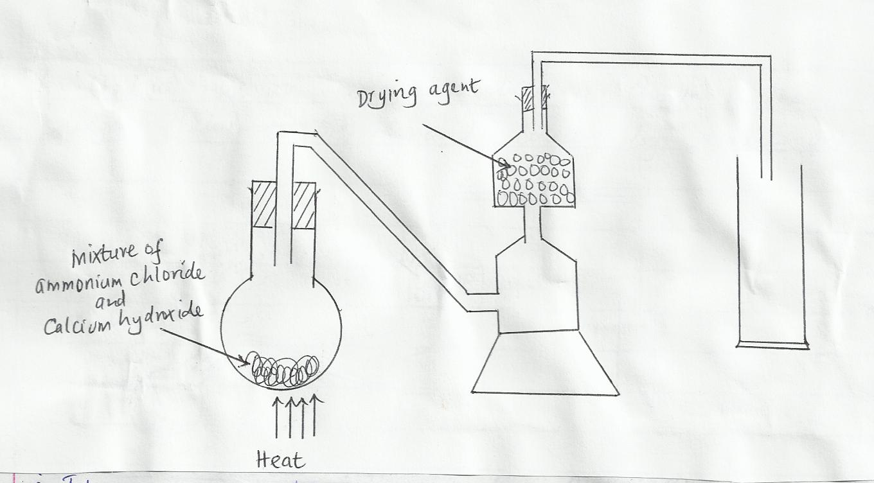

  - Identify two mistakes in the set up and give a reason for each mistake. (2 marks)
.....................................................................................................................................
  - Name a suitable drying agent for ammonia. (1 mark)
.....................................................................................................................................
......................................................................................................................................

  - Write an equation for the reaction that occurred when a mixture of ammonium chloride and calcium hydroxide was heated. (2 marks)
......................................................................................................................................
......................................................................................................................................
......................................................................................................................................
......................................................................................................................................
  - Ammonia gas is used in the manufacture of nitric (v) acid as shown below;
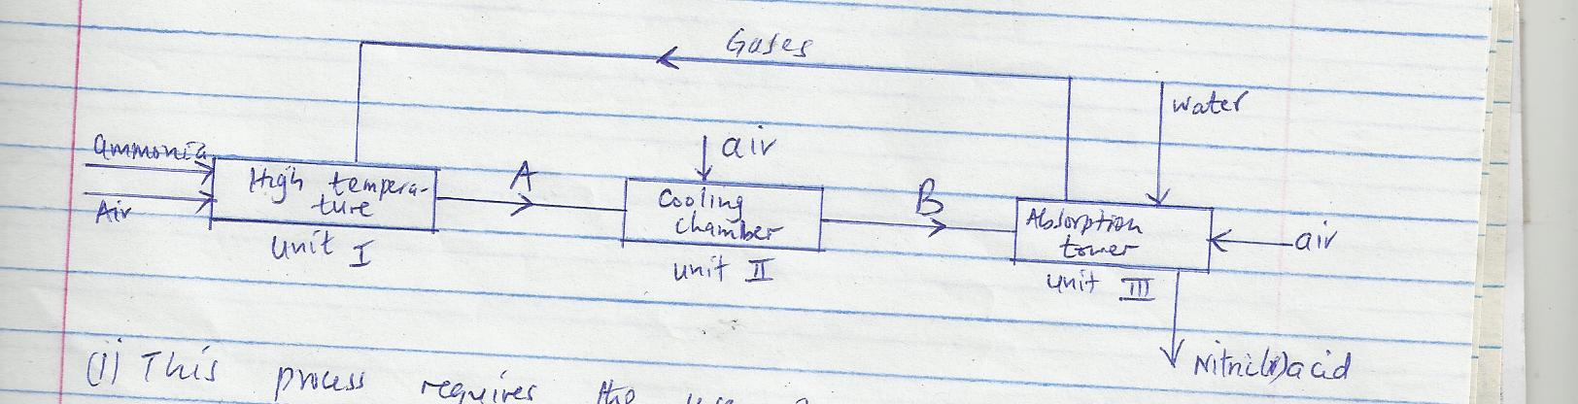

- This process requires the use of a catalyst. What is the name of catalyst used and in which unit is the catalyst used? ( 2mks)

      - Catalyst –

      - Unit;-

- Identify compounds A and B. (2 marks)

A ………………………………………….

B ………………………………………….

- Ammonia and nitric (v) acid are used in the manufacture of ammonium nitrate fertilizer. Calculate the amount of nitric (v) acid required to manufacture 1000kg of ammonium nitrate using excess ammonia (N = 14.0, H = 1, O=16) (3 marks)

- Nitric (v) acid is packed in dark containers. Explain. (1 mark)

- During the extraction of copper from copper pyrites (CuFeS₂) some of the processes include
  - Crushing the ore
  - Mixing the crushed ore with water and oil and then bubbling air through it.
  - Roasting the ore

- (i) Name two other ores that can be used. (2 marks)
......................................................................................................................................
......................................................................................................................................

(ii)Name the process marked (b) above and give its use. (2mks)

Name -

Use -

- Write an equation for the roasting of copper pyrites. (1 mark)

- (i) Pure copper is obtained from impure copper by electrolysis. Name the; (3 marks)

Anode ……………………………………

Cathode…………………………………….

Electrolyte…………………………………….

(ii)Write equations for the reactions at (2 marks)

I Anode………………………………………………………….

II Cathode……………………………………………………..

- Calculate the time taken for a current of 10 amps to deposit 32g of pure copper
(Cu=64, IF = 96500c) (3 marks)

- Give one use of copper metal (1 mark)

