312/1
GEOGRAPHY
Paper 1
June 2015
Time: 2¾ Hours

STAREHE BOYS’ CENTRE & SCHOOL
Form 4 Mock Examination 2015
GEOGRAPHY PAPER 1
2¾ Hours

INSTRUCTIONS

- Answer all the questions in section A.
- In section B, answer question 6 and any other two questions.
- Answer section A and each question attempted in section B on a separate answer sheet.
- Failure to follow instructions will be penalized.

SECTION A
Answer all questions in this section
1(a) What is physical environment? (2 marks)
b) Identify three areas of study under physical geography. (3 marks)

2(a) Differentiate between extensional boundary and compressional boundary. (2 marks)
b) Briefly describe the continental drifting theory. (3 marks)

3(a) What is natural vegetation?
b) State three characteristics of Mediterranean type of vegetation. (3 marks)

4(a) What is a seismic zone? (1 mark)
b) State two ways in which people have responded to the occurrence of earthquakes. (2 marks)

5(a) State two conditions which influence the occurrence of landslides. (2 marks)
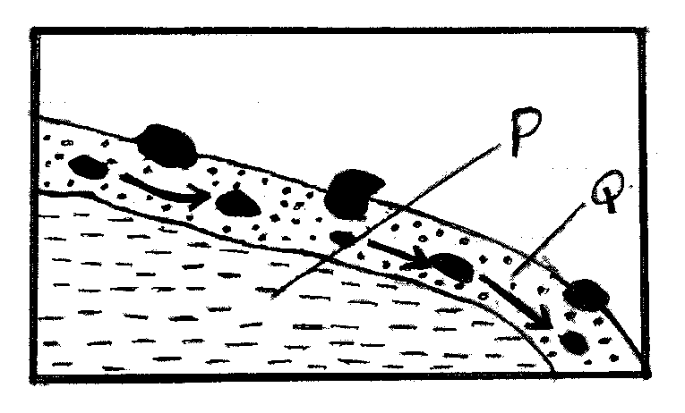

b) Using the diagram above, name:
i) The type of mass movement shown (1 mark)
ii) The features marked P and Q (2 marks)

SECTION B – MAP WORK

6. Study the map of Migwani provided and answer the questions that follow:
a) i) Identify two natural features in the grid square 0383 (1 mark)
ii) Give the six figure grid reference of the trigonometrical station in the grid square 9374 (2 marks)
iii) Calculate the area to the West of the Road marked C94 and North of Northing 78 (2 marks)
b) i) Measure the distance of the road D502 from Grid Reference 000806 up to the end in
the grid reference 000842. Give your answer in kilometers. (2 marks)
ii) Calculate the bearing and direction of Mboni Dam min the grid square 0878 from air photo principal point in the grid square 0580 (3 marks)
iii) Convert the scale of the map into a statement scale (2 marks)
iv) Name one administrative unit in the area covered by the map (1 mark)
c) Describe the relief of the area covered by the map (5 marks)
d) Draw a cross section along Northing 80 East Easting 04 and indicate the following:
- A hill
- River Ngoo
- Scrub with scattered trees (3 marks)
Use the vertical scale 1cm represents 20 meters

7(a) Give three examples of chemically formed sedimentary rocks (3 marks)
b) i) State three conditions necessary for the growth of coral (3 marks)
ii) Describe how coral rocks are formed. (4 marks)
c) Explain four ways in which rocks contribute to the economy of Kenya (8 marks)
d) Some students are planning to carry out a field study on rock weathering around their school.
i) List three secondary sources of information they are likely to use as they prepare for the
field study (3 marks)
ii) Apart from using secondary sources, state four other ways in which the students would
prepare themselves for the field study (4 marks)

8(a) i) State three factors that determine the size of a Lake in an area (3 marks)
ii) Give two reasons why the Rift Valley Lakes are saline (2 marks)
b) i) Explain how the following Lakes are formed siring an example of each:
- Lava Dammed Lakes (3 marks)
- Ox bow lake (4 marks)
ii) State three negative impact of human activities on lakes (3 marks)
c) i) Differentiate between porous and pervious rocks in relation to underground water (2 marks)
ii) Name the parts labeled a, b and c in the diagram below (3 marks)

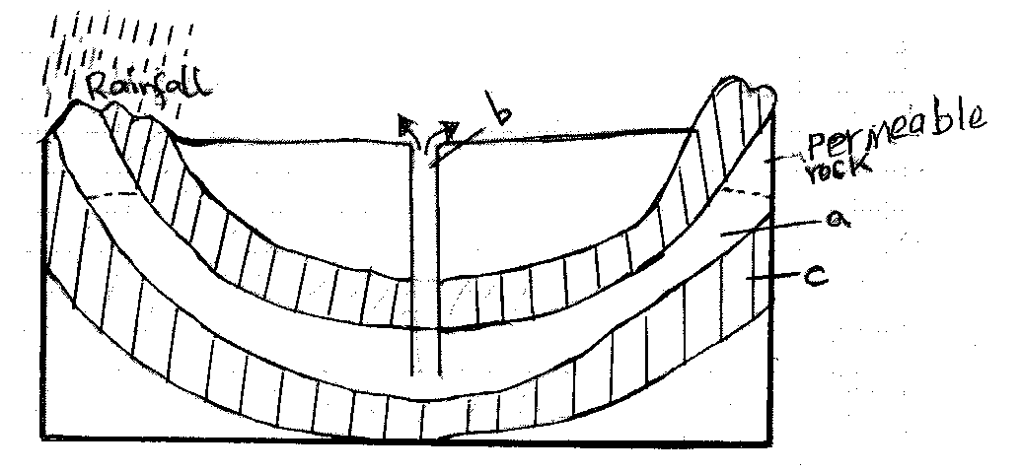
iii) State two conditions that are necessary for the formation of the artesian basins (2 marks)
d) State the significance of underground water to man (3 marks)

9(a) i) Differentiate between a desert and desertification (2 marks)
ii) Explain how wind erosion occurs by the following processes:
- Attrition
- Deflation (4 marks)
iii) State three factors that influence wind erosion (3 marks)
b) i) With the aid of a diagram, explain how yardangs are formed (4 marks)
ii) Give three ways by which wind transports its load in arid areas (3 marks)

c) i) Using the diagram answer the questions that follow.
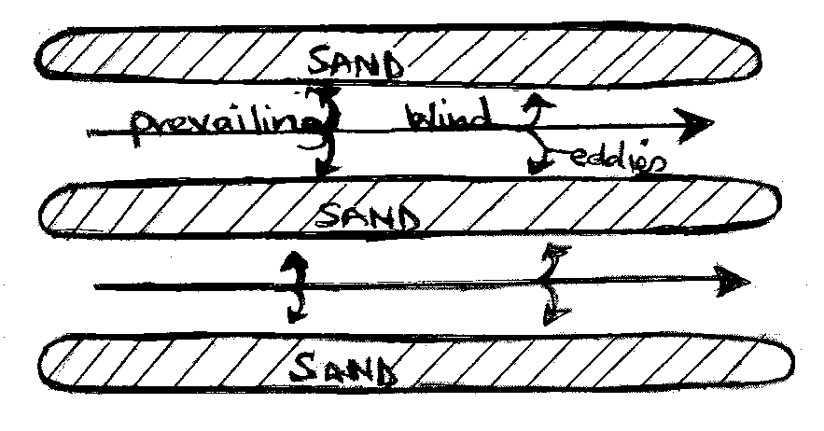
ii) Name the feature represented by the diagram (1 mark)
iii) Explain how the feature in C (I) is formed. (3 marks)

d) i) State four factors that influence formation of features by water action in deserts (2 marks)
ii) State three effects of desert landforms on human activities (3 marks)
10(a) i) Differentiate between soil catena and soil profile (2 marks)
ii) Draw a well labeled diagram showing a mature soil profile (3 marks)
b) Explain how the following factors influence of soil formation:
i) Parent Rock (4 marks)
ii) Topography (3 marks)
c) i) State four soil structures (4 marks)
ii) Give five significances of soil humus (5 marks)
iii) List four characteristics of desert soils (4 marks)

