312/2
GEOGRAPHY
PAPER 2.
July, 2015
TIME: 2 ¾ Hours
STAREHE GIRLS’ CENTRE
KCSE MOCK EXAMINATION.
FORM FOUR 2015
INSTRUCTIONS TO CANDIDATES
- Answer all the questions in section A
- In Section B answer question 6 and any other two questions.
- Answer section A and each question attempted in Section B on a separate answer sheet.
- This paper consists of 5 printed pages
- Students should check the question paper to ensure that all pages are printed as indicated and that no questions are missing

SECTIONA
Answer ALL the questions in this section.

1(a) Give two methods used to control land pollution in Kenya (2marks)

(b) State three physical factors which influence maize growing in Trans-Nzoia county (3marks)

2(a) Give three characteristics of sedentary subsistence agriculture. (3marks)

( b) Identify two types of indigenous softwood tree species grown in Canada (2marks)

3(a) State three factors that lead to growth and development of major urban centres in East Africa (3marks)

(b) State three differences in the functions of Mombasa and Rotterdam. (3marks)

4 Give four problems facing marine fishing in Kenya. (4marks)

5. The map below shows some irrigation schemes in Kenya. Use it to answer the questions that follow

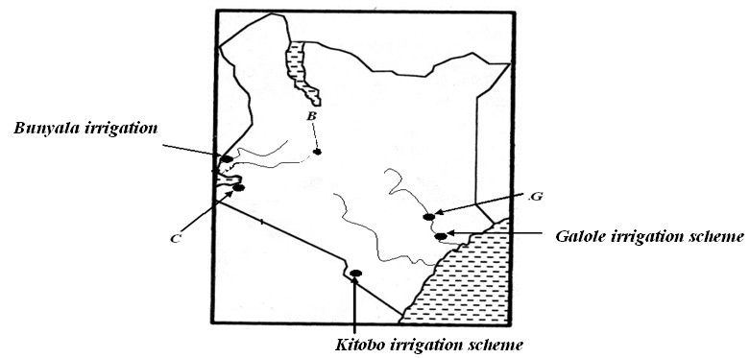

(i) Name three irrigation schemes above labelled C and G and crops grown in them (2mks)

(ii) State three factors which influenced the establishment of the scheme labeled B (3mks)

SECTION B
Answer question 6 and any other two questions from this section.

6. Study the photograph below and use it to answer questions (a) and (b).
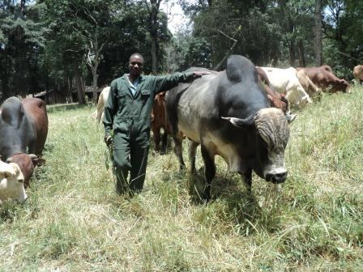

- (i)Identify three types of breeds of cattle in the photograph. (3marks)

(ii)What type of livestock farming is shown in the photograph? (1marks)

(iii) Describe the activity shown in the photograph (2marks)

(iv) Draw a rectangle measuring 14cm by 9cm. (1marks)
On it sketch and label the main features shown on the photograph. (5 marks)
- Citing evidence from the photograph, explain three physical conditions that favour livestock farming in the region shown. (6 marks)
(c) Give three differences between livestock farming in Kenya and Argentina (3marks)
(d) State four economic importance of dairy farming in Denmark. (4 marks)

7 (a)(i)What is containerization? (1marks)

(ii)Identify two canals in Africa. (2marks)

(iii) State three reasons why it is difficult to transport goods from Mombasa to Lagos along the highway. (3marks)
( b) Explain three factors influencing air transport in Africa. (6marks)
(c) Give four ways through which the Kenyan government promotes internal trade(4mks)
(d) (i)State three recent development that have taken place in Kenya to improve Communication of information. (3marks)
(ii)Explain the three ways through which Kenya is likely to benefit from renewed East African Co-operation. (6marks)

8(a) Identify two counties where wheat is grown in Kenya. (1marks)

(b) Describe the processing of sugarcane after harvesting (5marks)

(c) The data below represents crop exports from Kenya between 1995 and 1998. Use it to answer the questions that follow
Crop /year | 1995 | 1998
Sugar | 224 | 286
Coffee | 168 | 310
Tea | 320 | 388
Others | 200 | 461
Total | 912 | 1445
Using a scale 1cm represents 10 units, prepare proportional divided circles from the data above using square root method (5mks)
d(i)Give three characteristics of cottage industry in India. (3mks)

(ii)Explain four factors favoring Iron and steel industry in Ruhr region of Germany(4mks)

(i) State three benefits of decentralizing industries in Kenya. ( 3mks)
(d) You intend to carry out a field study of furniture – making industry in the local market centre
(i) For your field study you have prepared a work schedule. State two items you would include in the schedule ( 2 mks)
(ii) Give two advantages of studying about furniture making through fieldwork. ( 2 mks)
9.a)(i) Define the term tourism. (1mks)
(ii) Give three ways through which the Kenyan government promotes eco-tourism (3mks)
(b)The pyramid below represents the population structure of country X. Use it to answer question

(i)Identify the country represented by the pyramid (1marks)
(ii)Describe the characteristic of the population represented by the pyramid (5mks)

( c)State three problems which may result from high population growth rate (3mks)

(d) Describe three measures that the Kenya government has implemented to reduce infant mortality (6mks)

(e)Explain three factors that have led to a high population density in the Lake Victoria basin (6mks)
10 a) (i) Name two minerals mined by alluvial method. (2mks)
(ii) Explain how the following factors influence the occurrence of minerals. (6mks)

- Evaporation
- Vulcanicity
- Metamorphism
(iii)Describe the processing of soda ash at Lake Magadi in Kenya. (5marks)

(b)(i)State two advantages of using uranium as source of energy. (2marks)
(ii)Explain three ways in which most governments are trying to reduce on consumption and importation of oil (6marks)
( iii) State four problems that affect hydro-electric power project along River Tana in Kenya. (4marks

