Name …………………………………………………………………………………………….….. Index No. ………………. Class …….
121/2
MATHEMATICS

STAREHE BOYS’ CENTRE & SCHOOL
MOCK EXAMINATION 2015
Paper 2
Time: 2½ Hours

Instructions to candidates
- Write your name, admission number and class in the spaces provided above.
- The paper contains two sections: Section I and Section II.
- Answer ALL the questions in Section I and ANY FIVE questions from Section II.
- All working and answers must be written on the question paper in the spaces provided below each question.
- Marks may be awarded for correct working even if the answer is wrong.
- Negligent and slovenly work will be penalized.
- Non-programmable silent electronic calculators and mathematical tables are allowed for use.

For Examiner’s use only

Section I
1 | 2 | 3 | 4 | 5 | 6 | 7 | 8 | 9 | 10 | 11 | 12 | 13 | 14 | 15 | 16 | Total

Section II
17 | 18 | 19 | 20 | 21 | 22 | 23 | 24 | Total
 |  |  |  |  |  |  |  |  | Grand Total %

This booklet contains 17 printed pages. Please confirm that all the pages exist and are properly printed before starting the exam.

Section I (50 marks)
Answer all the questions in this section in the spaces provided

1. Solve the equation 2 sin (4x – 30)º = -1 for 0º < x < 180º {3 marks}

2. The numbers x – 2, x and x + 3 are the first three terms of a geometric progression. Find the sum of the first thirty terms of this progression. {3 marks}

3. A man deposited Ksh. 48,000 in a bank that compounded at the rate of r% p.a semi-annually for two years and realized Ksh. 54,968. Find r giving your answer correct to 4 s.f. {3 marks}

4. The tangent to the curve y = a- 5 at the point (4, k) is perpendicular to the line y – 2x = 11. Find the constants a and k. {3 marks}

5. Town A is 825 km from town B on a bearing of 125º and 790 km from C on a bearing of 201º. Calculate the distance between town B and C. {3 marks}

6. The absolute errors of the radius and height of a cylinder are 3 mm and 2 mm respectively. If the actual radius and height are 8 cm and 9.5 cm, calculate the percentage error in the volume of the cylinder. {3 marks}

7. A point (a, b) undergoes a transformation represented by the matrix followed by another transformation represented by the matrix . Determine the value of (a, b) if the final image is (4, 5). {3 marks}

8. A point M(60ºN 18ºE) is on the surface of the earth. Another point N is situated at a distance of 630 nautical miles West of M. Find the position of N. {2 marks}

9. A bag has 5 green marbles, 9 red marble and some blue ones, all identical except for colour. The total number of marbles in the bag is two more than double the number of blue marbles. Three marbles are then randomly picked one at a time from the bag without replacement. Find
a) the number of blue marbles. {1 marks}

b) the probability that the first marble picked is blue and the other two are of the same colour.
{2 marks}

10. Find the area enclosed by the curve y = x² – 10x + 9 the x – axis and the line x = 4 and x = 10.
{5 marks}

11. The table below shows income tax rates for the year 2015.

Income in Ksh. P.a | Tax rate %
1 - 121968 | 10
121968 - 236880 | 15
236881 - 351792 | 20
351793 - 466704 | 25
Excess over 466704 | 30

An artisan pays a net tax of Ksh. 3,700 p.m. after a monthly tax relief of Ksh. 1,064. Calculate his taxable income. {4 marks}

12. A, B and C are points on a patch of level ground. An electric pole 12 m high stands at point A. The bearing of B from A is 050º and the bearing of C from B is 096º. If AB = 23 m and BC = 14 m, calculate
a) the distance AC. {2 marks}

b) the angle of elevation of the top of the pole from C. {2 marks}

13. The product of the matrices and is a singular matrix. Find the value of p.
{3 marks}

14. Use logarithm tables to evaluate {3 marks}

15. Draw a square ABCD having area 16 cm² Q is a point within the square such that AQ < 2.5 cm,
AQ > BQ and that Q is nearer to AB than AD. Shade the region for all possible position of Q. {3 marks}

16. If the area of the shaded region is 40.4 cm², find the radius of the circle.

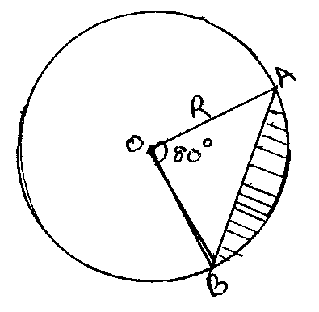

SECTION II (50 MARKS)
Answer any five questions in this section

17. The probability that Margaret, Olivia and Emmy will be late for breakfast are ¹/₄, ¹/₃ and ³/₅ respectively on any one morning.
a) Draw a probability tree diagram to represent this information. {2 marks}

b) Find the probability that
i) none of them will be late. {2 marks}

ii) only one of them will be late. {2 marks}

iii) at least one of them will be late. {2 marks}

iv) atmost one of them will be late. {2 marks}

18(a) The first term of an Arithmetic progression AP with six terms is P and its common difference is C. Another AP with five terms has also its first term as P and a common difference of d. The last terms of the two Arithmetic progressions are equal.
i) Express d interms of c. {3 marks}

ii) Given that the 4th term of the second AP exceeds the 4th term of the first by ³/₂ find the values of c and d. {3 marks}

b) The second and third terms of a geometric progression are 24 and 12(x + 1) respectively. Find x if the sum of the first three terms of the progression is 76. {4 marks}

19. A tetrahedron ABCD has its horizontal base ABC, an equilateral triangle of side 5 cm.
If DA = DB = DC = 9 cm, find
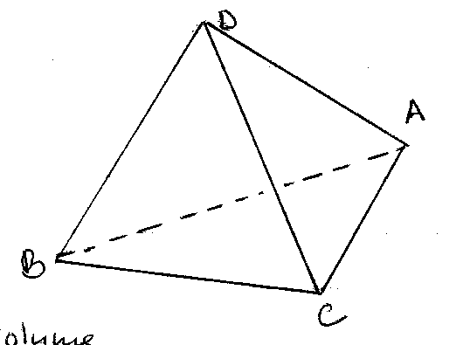

i) the volume of the tetrahedron. {3 marks}

ii) the angle DA makes with the plane ABC. {2 marks}

iii) the angle between the plane ADC and the plane ABC. {2 marks}

iv) The angle between the planes BCD and ACD. {3 marks}

20. A rectangular box open at the top has a square base. The internal side of the base is x cm long and the total internal surface area of the box is 432 cm².
a) Express interms of x
i) the internal height h of the box. {3 marks}

ii) the internal volume V of the box. {1 mark}

b) Find
i) the value of x for which the volume V is maximum. {4 marks}

ii) the maximum internal volume of the box. {2 marks}

21. A plane leaves an airport A (42ºN, 35ºW) at 9.00 a.m. and flies due North to airport B on latitude 75ºN.
a) Calculate the distance covered by the plane in
i) Km (take the radius of the earth R = 6371) π = ²²/₇ {2 marks}

ii) Nautical miles {1 mark}

b) After stopping at B for 40 minutes, the plane flew due East to an airport C 1500 km from B. Find
i) the position of C. {3 marks}

ii) the local time at C when the plane landed there given that the plane maintained a constant
speed of 500 km/h. {4 marks}

22(a) Using mid-ordinate rule with 5 strips, estimate the area enclosed by the curve
y = x² + 2x and the x-axis for -2< x < 3. {4 marks}

b) Find the exact area by integration. {4 marks}

c) Find the percentage error in the estimation made in (a) above. {2 marks}

23(a) Complete the table below for the function y = x³ – 4x. For -3 < x < 3

x | -3 | -2.5 | -2 | -1.5 | -1 | -0.5 | 0 | 0.5 | 1 | 1.5 | 2 | 2.5 | 3
y | -15 | -5.625 |  |  |  | 1.875 |  |  | -3 |  | 0 |  | 15
{2 marks}
b) Draw the graph of y = x³ – 4x on the grid provided. {3 marks}
c) Use your graph to solve
i) x³ – 4x = 0 {1 mark}

ii) x³ – 4x – 3 = 0 {2 marks}

iii) x³ – 4x – 4 < 0 {2 marks}

24. A building contractor has two lorries P and Q used to transport at least 42 tonnes of sand to a building site. Lorry P carries 4 tonnes of sand per trip while lorry Q carries 6 tonnes of sand per trip. Lorry P uses 2 litres of fuel per trip while lorry Q uses 4 litres of fuel per trip. The lorries are to use less than 32 litres of fuel. The number of trips made by lorry P should be less than 3 times the number of trips made by lorry Q. Lorry P should make more than 4 trips.
a) Taking x to represent the number of trips made by lorry P and y to represent the number of trips made by lorry Q, write the inequalities that represent the above information. {4 marks}

b) On the grid provided, draw the inequalities. {4 marks}
c) Use the graph in (b) above to determine the number of trips made by lorry P and by lorry Q to deliver greatest amount of sand.

