NAME.................................................................................................. INDEX NO.......................................
CANDIDATE’S SIGNATURE...................
DATE:.....................

GATUNDU SOUTH FORM FOUR 2015 EVALUATION EXAM

121/1
MATHEMATICS
PAPER I
JULY/AUGUST 2015
TIME: 2 ½ HOURS

INSTRUCTIONS TO CANDIDATES
- Write your name and index number in the space provided above.
- This paper consists of two sessions: Section I and section II.
- Answer all the questions in the section I and only five questions from section II.
- All answer and working must be done on the question paper in the space provided below each questions.
- Show all the steps in your calculations, giving your answers at each stage in the spaces provided.
- Candidates should check the question paper to ascertain that all the pages are printed as indicated and no questions are missing.

SECTION I

ANSWER ALL QUESTIONS IN THE SPACES PROVIDED BELOW EACH QUESTION

- Without using Logarithms tables or a calculator evaluate.

(3 marks)
384.16 x 0.0625
96.04

- Simplify completely
(4 marks)
2x² – 98 ÷ x + 7
3x² – 16x – 35 3x + 4

- Solve the following inequality and show your solution on a number line. (3 marks)

4x – 3 ≤ ½ (x + 8) < x + 5

- Rose bought a golden necklace for ksh.6000 and sold it to Betty at a loss of 30%. Betty later sold it at a profit of 20%. What was Betty’s selling price. (2 marks)

- If x = ²/₃ is a root of 6x² + kx – 2 = 0, find the value of k and the other root. (4 marks)

- Tap A takes 4 minutes to fill a tank and tap B takes 6 minutes to empty the tank. If the tank has a capacity of 3000 litres find the volume of the tank after 2 minutes when both taps are open.
(3 marks)

- From a viewing tower 30 metres above the ground, the angle of depression of an object on the ground is 30º and the angle of elevation of an aircraft vertically above the object is 42º. Calculate the height of the aircraft above the ground. (3 marks)

- Find the equation of the perpendicular bisector of line AB where A is (3, 9) and B(7,5) giving your answer in the form ax + by + c = 0 (3 marks)

- Solve the simultaneous equations. (4 marks)

xy = 4
x + y = 5

- Vectors A and B are 2i + 5i and 8i – 7j respectively. Find the coordinates of M which divide AB in the ratio 1:2. (3 marks)

- Ruto is 12 years old. In three years time he will be 1/3 of his father’s present age. How old was his father 12 years ago. (3 marks)

- Given a:b = 6:7 and b:c = 14.17 find a:b:c. (2 marks)

- The figure below is a velocity time graph for a car.

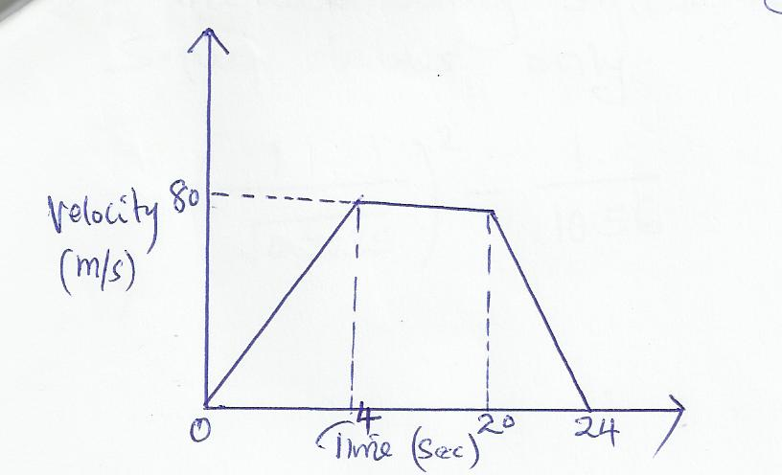

  - Find the total distance traveled by the car. (2 marks)

  - Calculate the deceleration of the car. (2 marks)

- Two sides of a triangular piece of land are 21km and 32km long. If its area is 240km², find the obtuse angle between the sides. (3 marks)

- Evaluate using square root, reciprocal and square tables only. (3 marks)

1 ² 1__
-
0.7235 10.56

- A cylinder of diameter 28m was drilled right through it as shown below. Calculate its surface area.

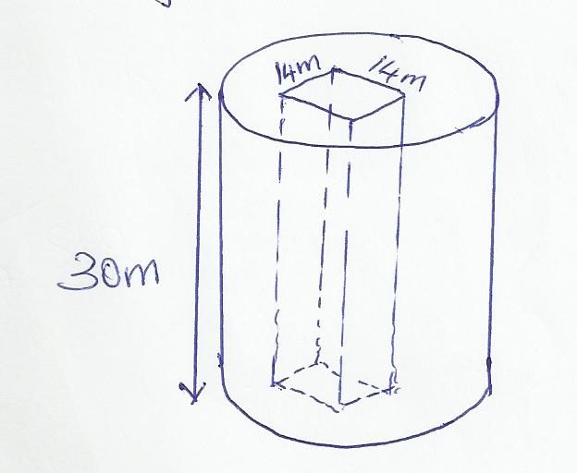

SECTION II

ANSWER ANY 5 QUESTIONS FROM THIS SECTION

- A bus left Makindu at 11.45 a.m and traveled towards Mombasa at an average speed of 80km/h. A Nissan Matatu left Makindu at 1.15 p.m on the same day and traveled along the same road at an average speed of 120km/hr. The distance between Makindu and Mombasa is 400km.

  - Determine the time of the day the Nissan overtook the bus. (5 marks)

  - Both vehicles continue towards Mombasa at their original speeds. Find how long the Matatu had to wait at Mombasa before the bus arrived. (5 marks)

- Given that y = 7 + 3x – x², complete the table below

x | -3 | -2 | -1 | 0 | 1 | 2 | 3 | 4 | 5 | 6
y | -11 |  |  | 7 |  |  |  |  |  | -11

b) On the grid provided and using a suitable scale draw the graph of y=7 + 3x – x². (3 marks)

c) On the same grid draw a straight line using the graph to solve x² – 4x -3 = 0 (3 marks)

d) Determine the coordinates of the turning point of the curve. (2 marks)

19. From a reservoir, water flows through a cylindrical pipe of diameter 0.2m at a rate of 0.35m/s.

- Determine the number of litres of water discharged from the reservoir in one hour. (4 marks)

- The water flows from the reservoir for 18 hours per day for 25 days per month and serves a population of 2500 families. Determine the average consumption of water per family per month giving your answer to nearest 100 litres. (4 marks)

- The water is charged at the rate of sh.450 per 100 litres. Calculate the average water bill per family per month. (2 marks)

  - A room is constructed such that its external length and breadth are 7.5m and 5.3m respectively. The thickness of the wall is 15cm and its height is 3.3 metres. A total space of 5m² is left for doors and windows on the walls.

  - Calculate the volume of:

    - the materials needed to construct the walls without the doors and windows.
(4 marks)

    - the materials needed to construct the walls with doors and windows.
(2 marks)

  - The blocks used in constructing the walls are 450mm by 200mm by 150mm. 0.225m³ of cement is used to join the blocks. Calculate the number of blocks. Calculate the number of blocks needed to construct the room. (4 marks)

  - Every Sunday, Chalo drives a distance of 80km on a bearing of 074º to pick up his brother Ben to go to church. The church is 75km from Ben’s house on a bearing of S50ºE. After church they drive a distance of 100km on a bearing of 260º to check on their father before Chalo drives to Ben’s home to drop him off then proceeds to his house.

- Using a scale of 1cm represent 10km show the relative positions of these places.
(4 marks)

- Use your diagram to determine

(i) The true bearing of Charo’s

(ii) The compass of bearing of the father’s home from Ben’s home (1 marks)

(iii) The shortest distance between Ben’s home and father’s home. (2 marks)

(iv) The total distance Charo travels’ every Sunday. (2 marks)

  - The following measurement were recorded in a field book using XY as the baseline. XY = 400m.
C60  B100  A120 | Y  340  300  240  220  140  80  X | 1200  160E  160F

- Using a scale of 1:4000 draw an accurate map of the farm. (4 marks)

- Determine the actual area of the farm in hectares. (4 marks)

- If the farm is on sale at sh.80,000 per hectare find how much the farm costs.
(2 marks)

  - A tailor bought a number of suits at a cost of sh.57,000 from Ken-suit wholesalers. Had he bought the same number of suits from Umoja wholesalers it would have costed him sh.480 less per suit. This would have enabled him to buy 4 extra suits for the same amount of money.

- Find the number of suits the tailor bought. (6 marks)

- The tailor later sold each suit for sh.720 more than he had paid for it. Determine the percentage profit he made. (4 marks)

  - A particle P moves in a straight line such that t seconds after passing a fixed point Q. it’s velocity is given by the equation 2t³ -10t + 12 find:

- The values of t when p is instantaneously at rest. (2 marks)

- An expression for the distance moved by P after t seconds. (2 marks)

- The total distance traveled by P in the first 3 seconds after passing point O.
(3 marks)

- The distance of P from O when acceleration is zero. (3 marks)

