NAME................................................................................................... INDEX NO.......................................
CANDIDATE’S SIGNATURE...................
DATE:.....................

GATUNDU SOUTH FORM FOUR 2015 EVALUATION EXAM

121/2
MATHEMATICS
PAPER II
JULY/AUGUST 2015
TIME: 2 ½ HOURS

KENYA CERTIFICATE OF SECONDARY EDUCATION
FORM FOUR EVALUATION EXAMINATION
INSTRUCTIONS TO CANDIDATES
- Write your name and index number in the space provided above
- Sign and write the date of examination in the spaces provided above
- This paper consists of two sections: Section I and section II.
- Answer all the questions in section I and only five questions from section II.
- Show all the steps in your calculations giving your answers at each stage in the spaces provided in each question.
- Marks may be awarded for correct working even if the answer is wrong.
- Non-programmable silent electronic calculators and KNEC Maths tables may be used except where stated otherwise.

FOR EXAMINERS’ USE ONLY
SECTION I

QUESTION | 1 | 2 | 3 | 4 | 5 | 6 | 7 | 8 | 9 | 10 | 11 | 12 | 13 | 14 | 15 | 16
MARKS

SECTION II

17 | 18 | 19 | 20 | 21 | 22 | 23 | 24

GRAND TOTAL

SECTION I (50 MARKS) ANSWER ALL QUESTIONS

- Use mathematical tables to evaluate.
(4 marks)

  - 4cos60º x 0.1324²
5log7

- Solve for x in the equation
(3 marks)
Sin(4x - 10)º – Cos (x + 60º)º = 0

- A radio cassette is offered for sale at shs 8,000 or a deposit of shs. 1,000 and 15 monthly repayments of shs 840. Find the rate of interest compounded monthly that is being charged under hire purchase terms. (4 marks)

- A colony of insects was found to have 250 insects at the beginning. Thereafter the number of insects doubled every 2 days. Find how many insects there were after 16 days. (3 marks)

- Under a shear with x-axis invariant a square with vertices A(1,0), B(3,0), C(3,2) and D(1,2) is mapped onto a parallelogram with vertices A¹(1,0) B¹(3,0), C¹(7,2) and D¹(5,2). Find the shear matrix. (3 marks)

- Using a ruler and a pair of compasses only construct a triangle PQR in which QR is 6.6cm, P=3.8cm and PQ = 5.6cm. Locate point x inside triangle PQR which is equidistant from P and R such that angle PXR = 90º. (3 marks)

- Find the variance and standard deviation of 3, 5, 7, 9, 11 (3 marks)

- P and Q are two points such that OP = i + 2j + 3k and OQ = 4i + 5j – 3k. M is a point that divides PQ externally in the ratio 3:2. Find the co-ordinates of M. (3 marks)

- The sector below has a radius of 12cm and an angle AOC = 60º is folded to form a cone. Find the volume of the cone formed. (4 marks)

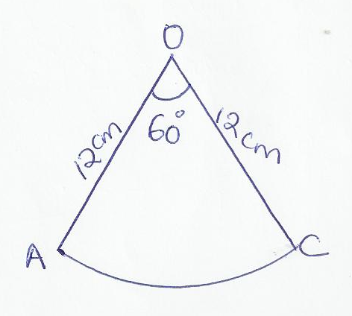

- Find the equation of the normal to the tangent of the curve y=x³ – 3x² + 2x + 1 at the point where x=3. Leave your answer in the form y=mx + c. . (3 marks)

- Without using mathematical tables or calculator; evaluate:
(3 marks)
Cos 135º – Sin 30º
Sin 135º + Sin 30º

- Find the midpoint of the straight line joining A (2,1) and D (6,5). (2 marks)

- The equation of a circle centre ( h , k ) is 2x² + 2y – 8x + 5y + 10 = 0. Find the values of h and k.
(3 marks)

- Make y the subject of the formula given

H = __t____ (3 marks)
q-y²

- If 1 - 1 = c for all values of a , evaluate c and b. (3 marks)
a -2 a+2 a²-b

- X and Y are two variables such that Y is partly constant and partly varies inversely as the square of X. If Y = 3 when X = 2 and Y = 5 when X = 1, find Y when X = 4. (3 marks)

SECTION II
ANSWER ONLY FIVE QUESTIONS IN THIS SECTION IN THE SPACES PROVIDED.

- The table below shows the number of students who scored marks in mathematics test.

Marks | 1-10 | 11-20 | 21-30 | 31-40 | 41-50 | 51-60 | 61-70 | 71-80 | 81-90 | 91-100
Frequency | 3 | 6 | 10 | 10 | 12 | 17 | 15 | 16 | 7 | 4

- Draw a cumulative frequency graph for the data. (4 marks)

- Use the graph to estimate the median mark. (2 marks)

- If students who score over 40 marks pass the tests estimate the percentage of the students

i ) who passed (2 marks)

ii) who failed (2 marks)



- In a geometrical progression, the sum of the second and third terms is 6; and the sum of the third and fourth terms is -12. Find:

    - (i) The first term (3 marks)

      - The common ration (3 marks)

    - The sum of number of consecutive terms of an arithmetical progression is -19 ½ ; the first term is 16 ½ ; and the common difference is -3. Find the number of terms. (4 marks)

- a) PQRS is a quadrilateral with vertices p(1, 4) Q(2, 1), R(2, 3) and S(6, 4). On the grid provided plot the quadrilateral (1 mark)

b) Draw P¹Q¹R¹S¹ the image of PQRS under a positive quarter turn about the origin and write down its co-ordinates. (3 marks)

- Draw P¹¹Q¹¹R¹¹S¹¹ the image of P1Q1R1S1 under the transformation whose matrix is
1 0 and write down its co-ordinates. (3 marks)
-2 1

- Determine the matrix T of a single transformation that maps PQRS onto P¹¹Q¹¹R¹¹S¹¹ (3 marks)

- In the figure below, E is the midpoint of AB, OD:DB=2:3 and F is the point of intersection of OE and AD.

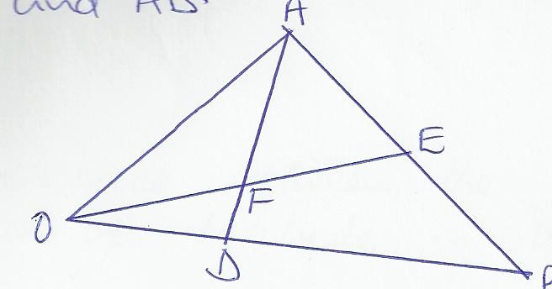
→ →
    - Given that OA = a and OB = b , express in terms of a and b
→
i) OE (1 mark)

→
ii) AD (1 mark)

→ → → →
    - Given further that AF = tAD and OF = sOE where s and t are scalars, find the values of s and t. (5 marks)

    - Show that O, F and E are collinear. (3 marks)

- The position of two towns P and Q are given to the nearest degrees as P(45ºN, 110ºW) and
Q (45ºN, 70ºE) Take II= 3.142, Radius of the earth R = 6370km. Find

    - The distance between the two towns along the parallel of latitude in km.
(3 marks)

    - The distance between the towns along a parallel of latitude in nautical miles.
(3 marks)

    - A plane flew from P to Q taking the shortest distance possible. It took the plane 15 hours to move from P and Q. Calculate it’s speed in knots
(4 marks)

- Compete the table below (2 marks)

Xº | -180º | -150º | -120º | -90º | -60º | -30º | 0º | 30º | 60º | 90º | 120º | 150º | 180º
Y=sin(x+30)º |  |  | -1 |  |  |  | 0.50 |  |  |  | 0.50
Y=2cos(x+30)º |  |  | 0 |  |  |  | 1.73 |  |  |  | -1.73

b) On the same axes draw the graphs of y= sin(x+30)º and y= 2cos(x+30)º. (5 marks)

c) Use your graphs to solve the equation 2cos(x+30)º – sin(x+30)º = 0 (2 marks)

- State the amplitude of each wave. (1 mark)

- Two wheels have radii 20cm and 30cm. Their centres are 70cm apart. A belt, passes tightly round the wheels as shown below.
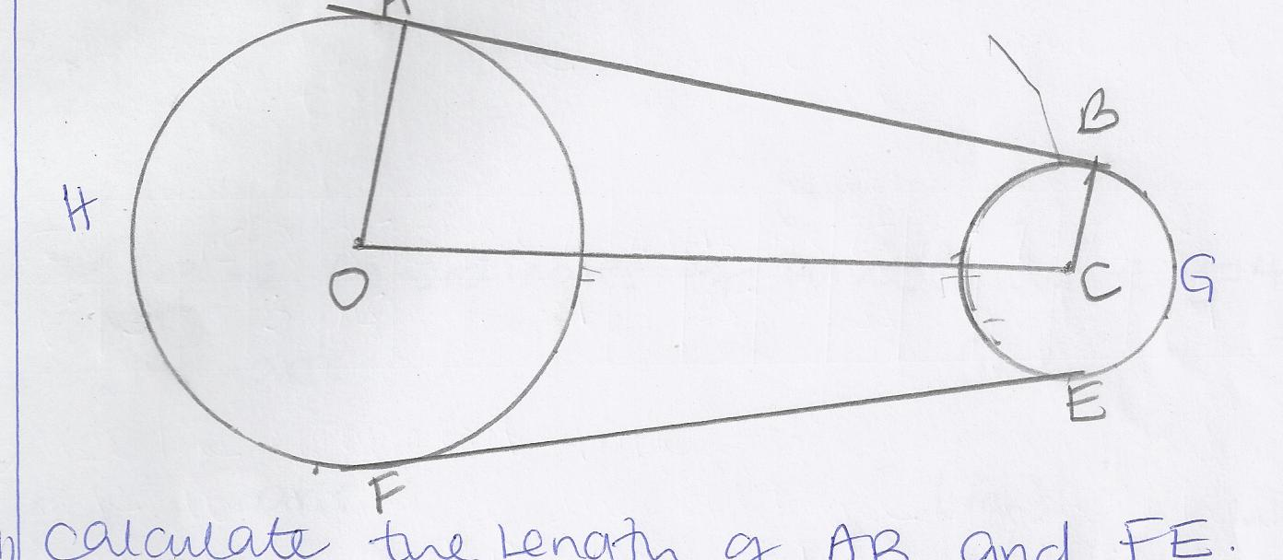

    - Calculate the length of AB and FE . (3 marks)

    - Evaluate the angles AOC and BCO. (3 marks)

    - Calculate the total length of the belt A B G E F H A (4 marks)

- Given the equations: y=4 -x² and y=x²-2x;

    - Find the co-ordinates of the points where the two curves meet. (2 marks)

    - Find the co-ordinates of points where y=4 -x² meet:

(i) The x-axis. (1 mark)

      - The y-axis (1 mark)

    - Find the co-ordinates of the points where y=x² – 2x meet;

(i) The x-axis (1 mark)

      - The y-axis (1 mark)

    - Sketch the two curves above on the same axes (1 mark)

    - Find the area enclosed between the curves y=4-x² and y=x² – 2x. ( 3 marks)

