Name………………………………………………Index No…………………………..
Candidates Signature…………….
Date………………………………

511/3
MUSIC
Paper 3
June 2015

KASSU JET

Kenya Certificate of Secondary Education
MUSIC
2 ½ hours.

Answer all questions in this paper
In question 1 choose either (a) or (b)
In question 4 choose any two of the questions numbered (a), (b), (c) and (d)

QUESTION | 1 | 2 | 3 | 4 | 5 | 6 | 7 | Total(%)
MAX MARKS | 12 | 20 | 14 | 14 | 10 | 10 | 20 | 100
MARKS
OBTAINED

This paper consists of 9 printed pages. Candidates should check the question paper to ensure that all the pages are printed as indicated and no questions are missing.

SECTION A: BASIC SKILLS

1. (a) Continue the following opening to make a melody of 16 bars long for voice. Modulate to the relative minor key before returning to the tonic key. Include an inversion and dynamic change appropriately. (12 marks)

Or (b) Using staff notations compose a melody and set to it the following text. (12marks)

NangojaniniDunianiee, Bilakuwanawewemwenyeshingoyaupanga,

2. Harmonize the following melody for Soprano, Alto, Tenor, and Bass (SATB). Choose appropriate chords from i, iiº, iv, V and VI. (20 marks)

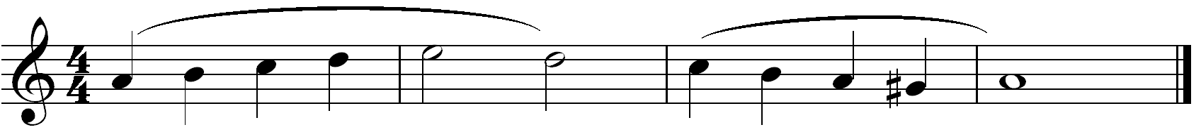

SECTION B: HISTORY AND ANALYSIS (48 marks)

3. AFRICAN MUSIC

a) How is the chepkesem held and played (2 marks)
………………………..………………………………………………………………………………………………..…………………………………………………………………………………
b) Identify Four parts of the instrument in (a) above and state how each one of them contributes to the production of sound. (4 marks)
………………………………………………………………………………………………………………………………………………………………………………………………………………………………………………………………………………………………………………………………………………………………………………………………………………………………………………………………………………………………………………………………………

c) Identify the following dances. (4 marks)
- Okeng’o.…………………………………………………………………………………
- Lelemama…………………………………………………………………………………
- Kigaru….…………………………………………………………………………………
- Sioyayo……………………………………………………………………………………

d) State two roles of music in dance. (4 marks)
………………………………………………………………………………………………………………………………………………………………………………………………………………

4. WESTERN MUSIC
Answer any twoof the questions (a), (b),(c) and (d)
- Claudio Monteverdi
- For what purpose was the Opera Orfeo written? (1mark)
……………………………………………………………………………........................................
- State the two styles of composition Monteverdi developed as a change from Renaissance to Baroque. (2 marks)
……………………………………………………………………………................……………………………………………………………………………................……………………………………………………………………………........................................................................................
- State any two contributions Monteverdi made to vocal music (1mark)
……………………………………………………………………………................……………………………………………………………………………................……………………………………………………………………………................…………………………………………………………………………….................................................................................................................
- Name any two other works by Monteverdi other than operas. (2marks)
……………………………………………………………………………................................................................……………………………………………………………………………................

b) G.F Handel
i. State any four aspects of Handel’s styles of composition. (4 marks)
………………………………………………………………………………………………………………………………………………………………………………………………………………………………………………………………………………………………………………………………………………………………………………………………………………………………
ii. What kind of composition is Royal fireworks and for what purpose was it composed? (3 marks)
………………………………………………………………………………………………………………………………………………………………………………………………………………………………………………………………………………………………………………………

c) Sir Edward Elgar
- State the period in which Elgar lived. (1 mark)
………………………………………………………………………………………………………
- Name any three sources from which Elgar derived his music education.
(3marks)
………………………………………………………………………………………………………
………………………………………………………………………………………………………
………………………………………………………………………………………………………
- State any three styles of composition Elgar used. (3marks)
………………………………………………………………………………………………………
………………………………………………………………………………………………………
………………………………………………………………………………………………………
d) Sergei Prokofiev
i. Name Prokofiev’s first symphony. (1 mark)
………………………………………………………………………………………………………
ii. Describe any three of prokofieve’s compositional styles in instrumental music. (3marks)
………………………………………………………………………………………………………………………………………………………………………………………………………………………………………………………………………………………………………………………
iii. Outline three views that led to the soviet authorities criticize prokofieve’s music for formalism. (3 marks)
………………………………………………………………………………………………………………………………………………………………………………………………………………………………………………………………………………………………………………………………………………………………………………………………………………………………………………………………………………………………………………………………………
5 African Traditional Music Analysis
Folk music of East Africa: Mijikenda Ensemble
Listen to the recording and answer the questions that follow.
(a) Describe the introductory section of this recording. (2 marks)
…………………………………………………………………………………………...................
(b) Name any three instruments played in this recording. (3 marks)
…………………………………………………………………………………………....................
(c) Give any three ways in which variety has been created. (3 marks)
………………………………………………………………………………………….......…………………………………………………………………………………………........………………………………………………………………………………………….......………………………
(d) State any two characteristic features African music in this recording. (2 marks)
………………………………………………………………………………………….......…………………………………………………………………………………………........………………………………………………………………………………………….......………………………

6. Prescribed Western Music:
G.F. Handel: Recitative: I tell you a Mystery and Aria: The Trumpet shall sound
- Give the English equivalent for Tromba and Bassi (2 marks)
………………………………………………………………………………………………………
- Differentiate the accompaniment between the recitative and aria. (2 marks)
………………….……………………………………………………………………………………………………………………………………………………………………………………….
- What is an interlude? (1 mark)
………………………………………..……………………………………………………………
- With reference to bar numbers, identify any two interludes in the Aria. (1 mark)
……………………………..………………………………………………………………………………………………………………..……………………………………………………………
- Briefly describe the recitative I tell you a Mystery (2 marks)
………………………………………………………………………………………………………………………………………………………………………………………………………………………………………………………………………………………………………………………………………………………………………………………………………………………………
- Identify any two forms of syncopation used in part III of the Aria. (2 marks)
………………………………………………………………………………………………………………………………………………………………………………………………………………

SECTION C: GENERAL MUSIC KNOWLEDGE (20MARKS)
7. a) Briefly define any five of the following musical terms. (10marks)
- Inverted pedal…………………………………………………………………………
.......................................................................................................................................
- Recitative…………………………………………………………………………………………………………………………………………………………………………
- Oratorio……………………………………………………………………………………………………………………………………………………………………………..
- Ensemble…………………………………………………………………………………………………………………………………………………………………………
- Bassocontinuo……………………………………………………………………….....
…………………………………………………………………………………………..
- Ostinato……………………………………………………………………………………………………………………………………………………………………………
- Polyrhythm………………………………………………………………………………………………………………………………………………………………………

- i) State any three benefits of patenting ones music. (3marks)
………………………………………………………………………………………………………………………………………………………………………………………………………………………………………………………………………………………………………………………
ii) Construct the harmonic chromatic scale of C ascending using semibreves and key signature. (3marks)

- Study the following music excerpt and answer the questions that follow.
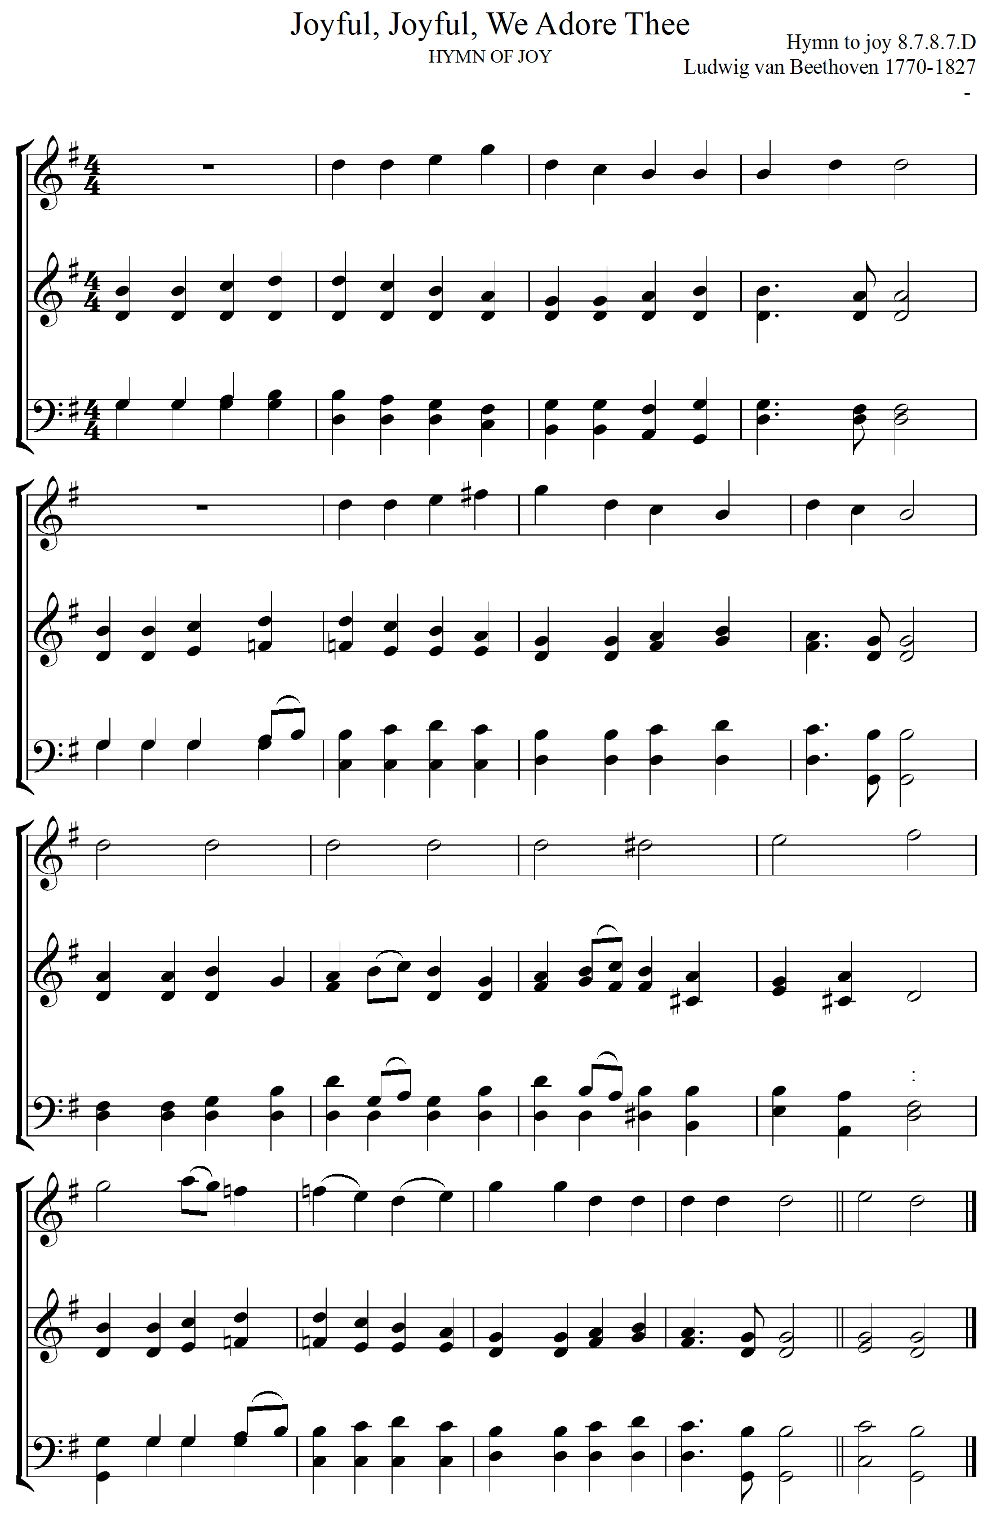

- Identify the genre of this music and state the period in which it was written. (1mark)

…………………………………………………………………………………………

- Name the key to which the music modulates in bar 12 in the last system. (1mark)

…………………………………………………………………………………………

- What name is given to the high pitched voice written above the other voices? (1mark)

…………………………………………………………………………………………

- Name the final cadence in this work and indicate the chords. (1mark)

…………………………………………………………………………………………

