511/1
MUSIC
PAPER 1
PRACTICAL
JULY /AUGUST 2015

MACHAKOS COUNTY KCSE TRIAL AND PRACTICE EXAM 2015.
Kenya Certificate of Secondary Education.
MUSIC
PAPER 1
PRACTICAL.
JULY /AUGUST 2015

INSTRUCTIONS
- The candidate will be required to perform before a panel of examiners.
- Each candidate performance will take about 10 minutes.
- The practical performance will consist of:-
- The technical exercises 10 marks
- Sight singing 10 marks.
- Western set piece 15 marks
- African folk song or drum set 15 marks
Fiddle, lyre or flute

A Special Performance Improvement Project by His Excellency Dr. Alfred Mutua
Sponsored by the Government of Machakos County
TEST 1:
Singing of major scale up and down using any vowel sound or playing the scale with an instrument.
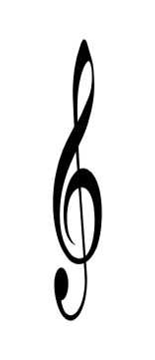
(2 Marks)
f First time
p Second time

$$\begin{matrix}4 \\ 4\end{matrix}$$

TEST 2:
Singing/playing the minor scale up and down. (Use vowel sound while singing) (2 Marks)

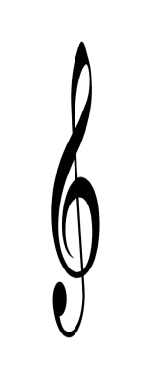
Harmonic
or melodic

Melodic

TEST 3:
Singing/playing of the sequence (Broken scale) Use ‘la’ sound while singing. (2 Marks)
$$\begin{matrix}6 \\ 8\end{matrix}$$

TEST 4:
Singing of major scale arpeggio. Use any vowel sound. (2 Marks)
First time f
2nd time P

TEST 5:

Singing of the minor scale arpeggio. Use any vowel sound. (2 Marks)

SIGHT SINGING/READING:
The candidate will be expected to sight sing any one of the following melodies. (10 Marks)
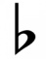
$$\begin{matrix}3 \\ 4\end{matrix}$$

$$\begin{matrix}3 \\ 4\end{matrix}$$

