NAME............................................................................................................... INDEX NO......................

GATUNDU SOUTH FORM FOUR 2015 EVALUATION EXAM

232/1
PHYSICS
PAPER 1
JULY/AUGUST 2015
TIME: 2 HOURS

KENYA CERTIFICATE OF SECONDARY EDUCATION
GATUNDU SOUTH DISTRICT EVALUATION EXAM

INSTRUCTIONS TO CANDIDATES

- Write your name and index number in the spaces provided above.
- Answer ALL questions in section A and B in the spaces provided.
- All working must be clearly shown.
- Non programmable silent electronic calculators and KNEC mathematical tables may be used.

- Take g = 10m/s²
Specific heat capacity of water is 4200Jkg⁻¹K⁻¹
Density of water = 1000kgm⁻³
Density of mercury = 1.36 x 10⁴kgm³

SECTION A (25 MARKS)

- The figure below shows a wire wound on a metal rod. The windings just touch each other. If the total number of complete loops was found to be 25 and the distance covered by the windings on the rod is 0.6cm, find the radius of the wire giving your answer in standard form. (2 marks)

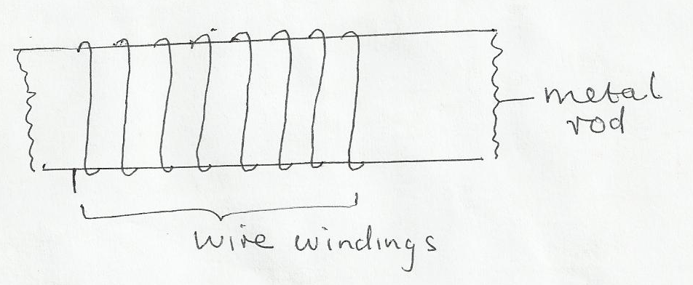

- The diagram below shows a section of a micrometer screw gauge.
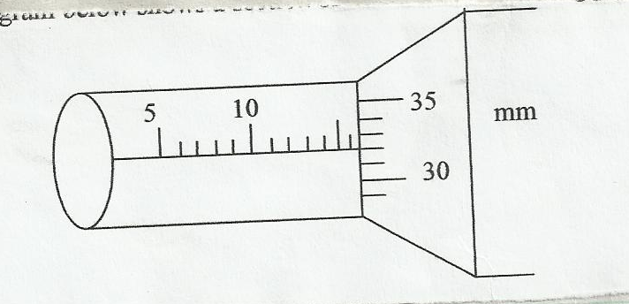

  - State the smallest measurement that can be made by the measurement that can be made by the micrometer screw gauge. (1 mark)

  - The thimble of the micrometer screw gauge is rotated through 2 ½ revolutions in the clockwise direction in order to measure the diameter of a marble. State the diameter of the marble. (1 mark)

- The figure below shows two identical containers A and B containing hot water and ice block.

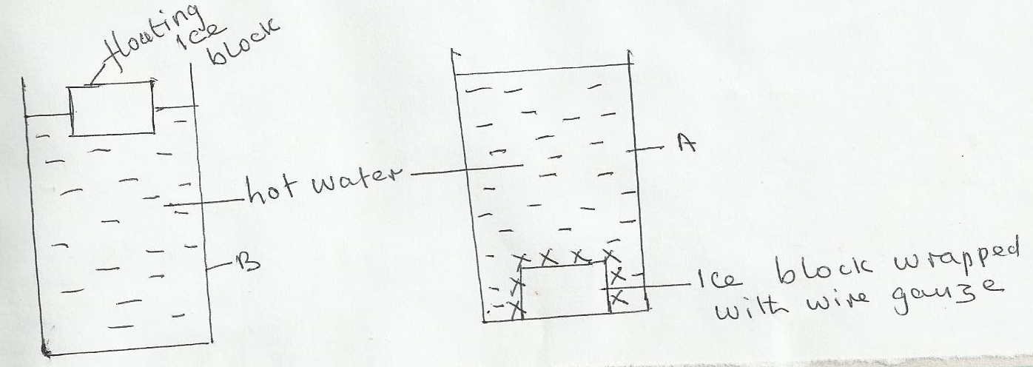

State with reason which water cools faster assuming that the wire gauge absorbs negligible heat.
(2 marks)

- A bus that carries goods in the under seats carrier is more stable than one that carries goods in the carrier at the top. Explain why this is so. (1 mark)

- A turntable of radius 16cm is rotating at 960 revolutions per minute. Determine the angular speed of the turntable. (2 marks)

- Sketch a velocity – time graph for a body initially moving at a velocity u before a force F is applied to it for 5 seconds and there after the force F is withdrawn. (2 marks)

- The figure below shows a pith ball in a container. (2 marks)

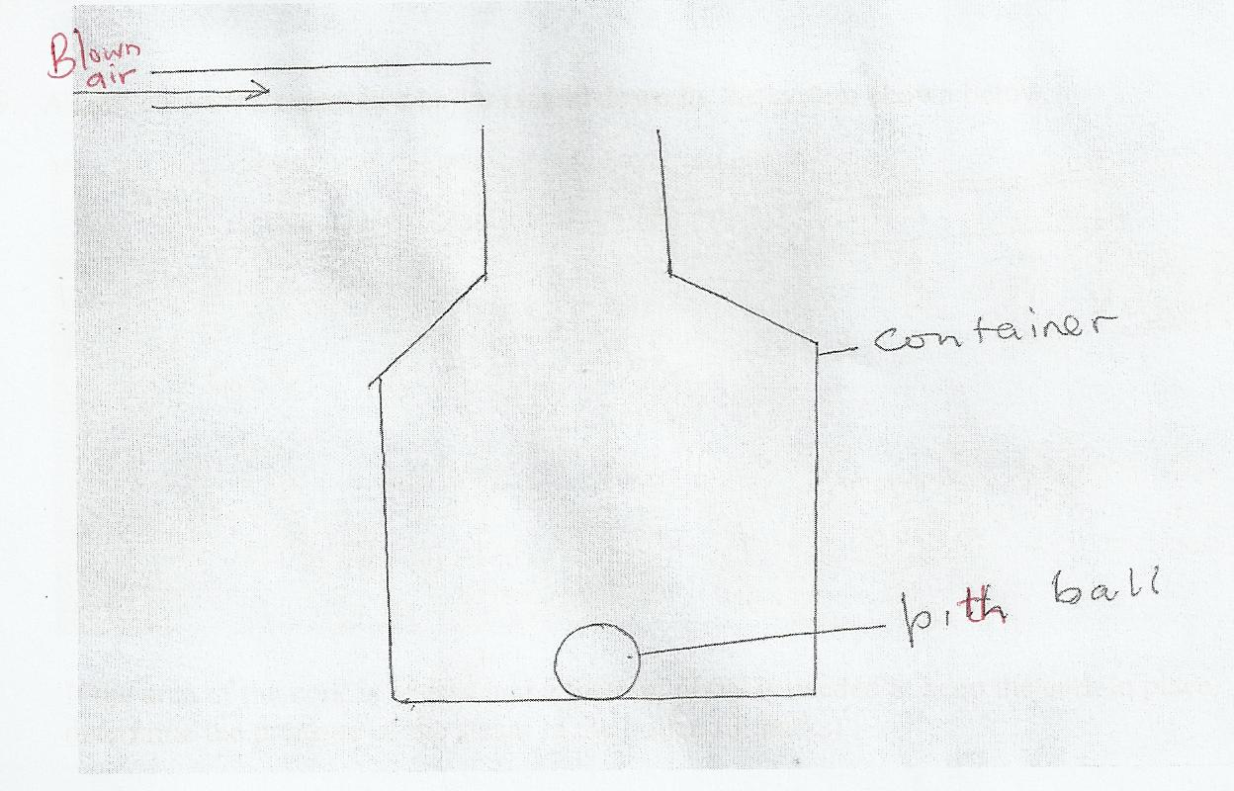

State and explain what would happen if air is blown over the mouth of the container. (2 marks)

- The figure below shows a capillary tube placed in a trough of mercury.

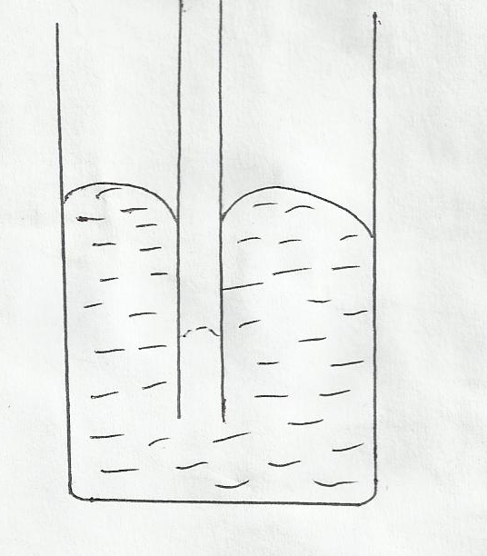
Give a reason why the level of mercury in a capillary is lower than in the beaker. (1 mark).

- A cork enclosing steam in a boiler is held down by the system shown below.

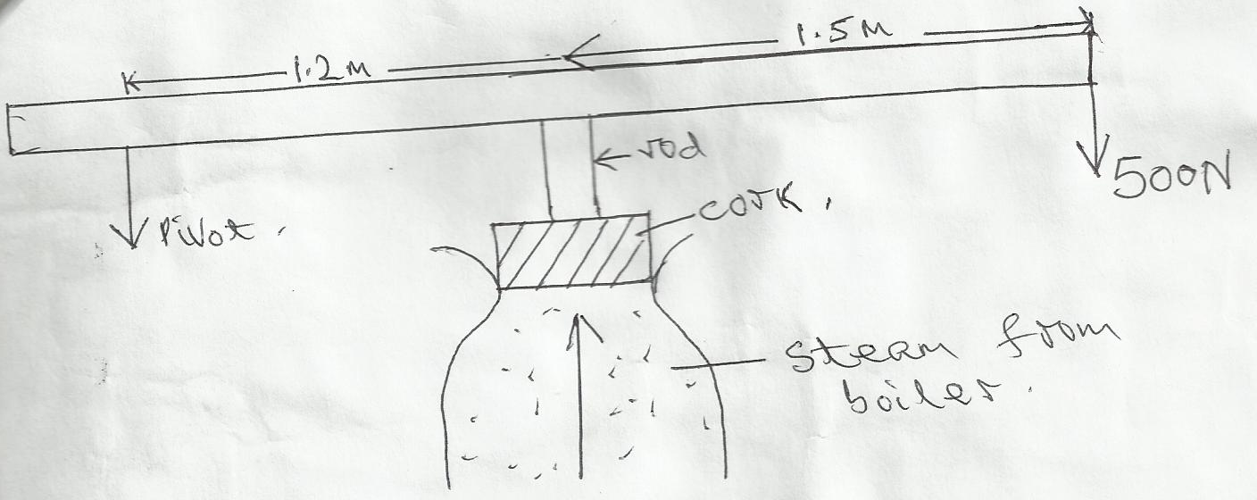

If the area of the cork is 15cm³ and a force of 500N is needed to keep the cork in place,
determine the pressure of the steam in the boiler. (3 marks)

- In an experiment a crystal of potassium permanganate was placed in water as shown below.

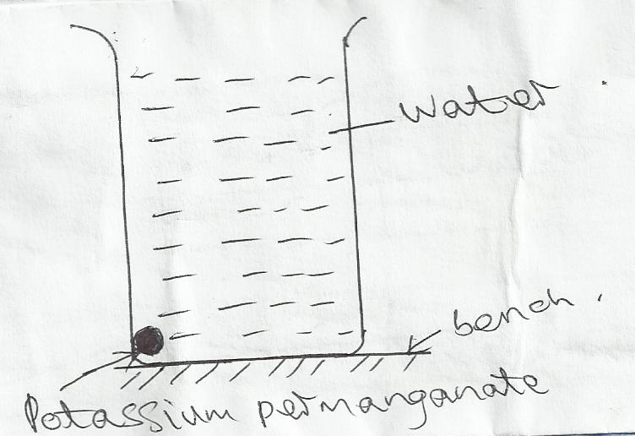

After sometime, it was observed that the water turned purple. Explain this observation. (1 mark)

- An aircraft 300m from the ground traveling horizontally at 400m/s releases a parcel. Calculate the horizontal distance covered by the parcel from the point of release.
(Ignore air resistance). (2 marks)

- A 20kw immersion water heater is used to heat 5.0 x 10⁻³m³ of water from 23ºC to 100ºC. Given that 30% of heat is lost to the surroundings, determine the time used in heating the water.
(2 marks)

- When the flask is placed in iced water the level on water rose and then fell. Explain this observation. (1 mark)
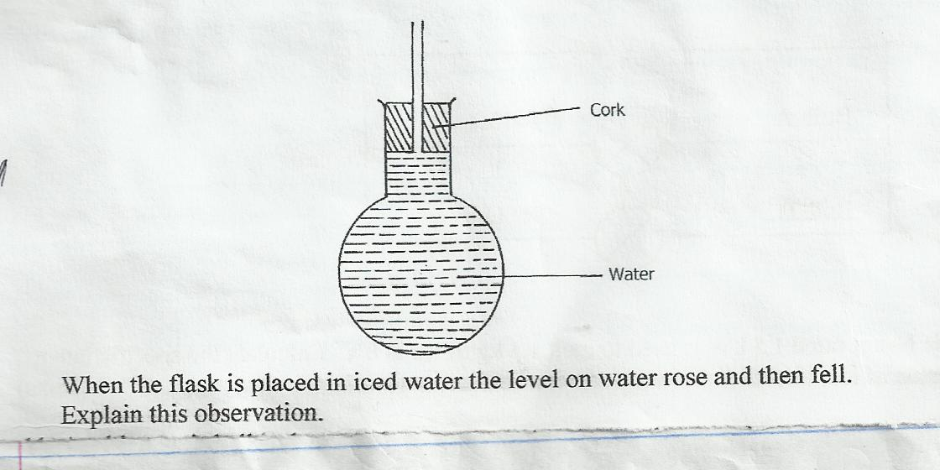

- The graph (curve) below show the variation of force against extension (cm) of two spiral springs of same material, same wire thickness length but of different diameters (one large and the other small). Identify which graph (A or B) represents which spring. (2 marks)
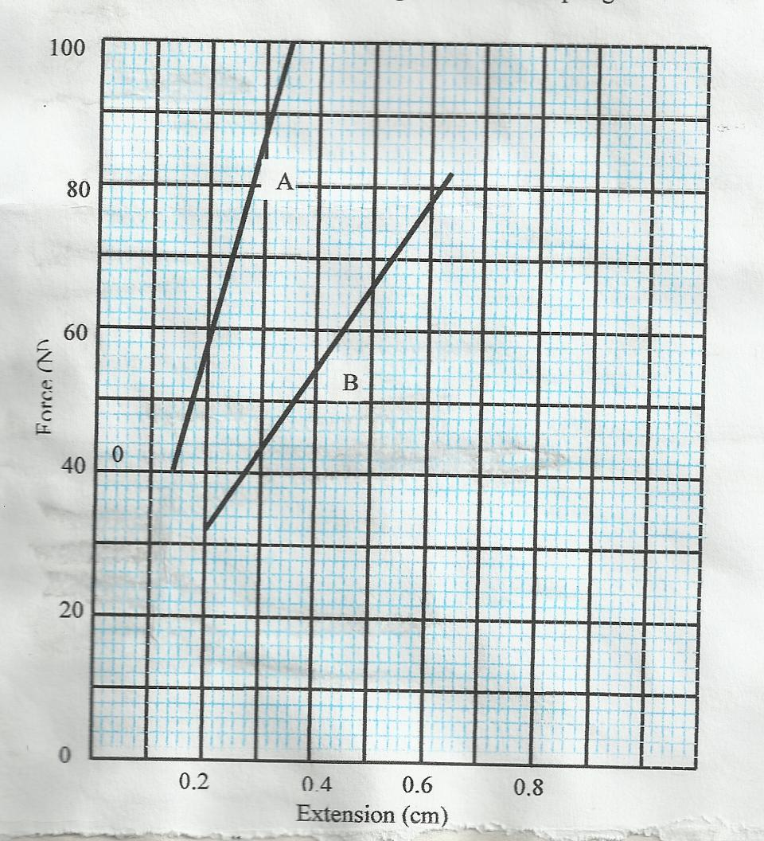

- a)State the principle of moments. (1 mark)

b)A uniform metal strip is 3.0cm wides 0.6cm thick and 100cm long. The density of the metal
is 2.7g/cm³.

    - Determine the weight of the metal strip. (3 marks)

    - The strip is placed on a pivot and kept in equilibrium by forces as shown.

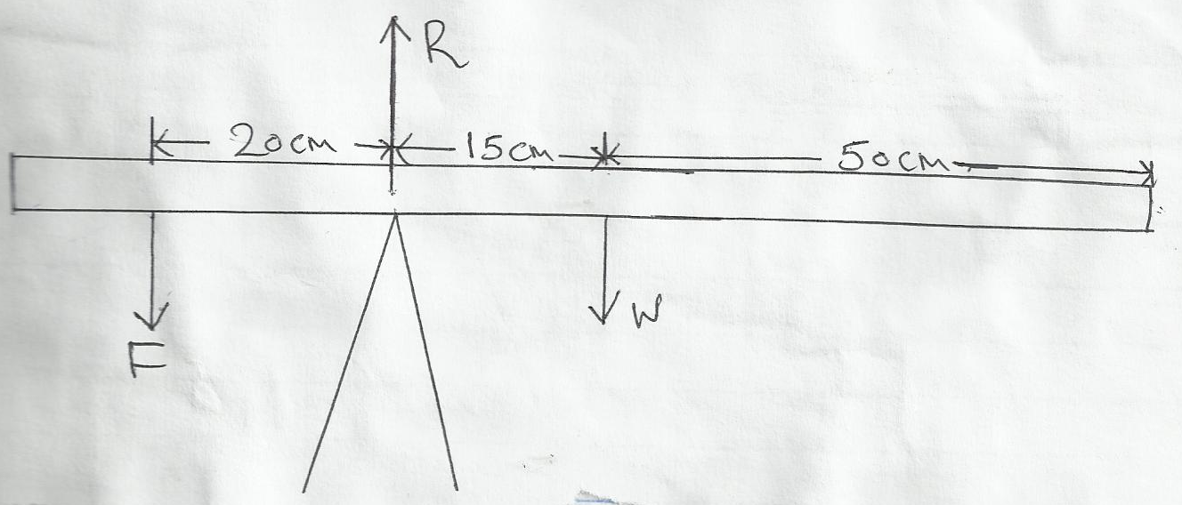

Determine the value of F and R. (3 marks)

- The figure below shows an inclined plane, a trolley of mass 60kg being pulled up the slope by a force of 200N parallel to the slope. The trolley is moved from X to Y.

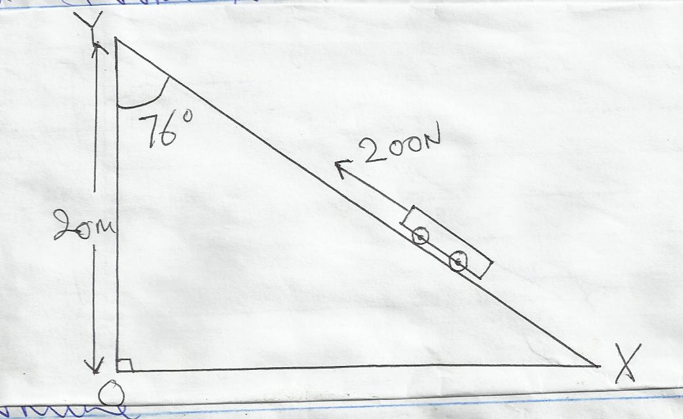

Determine the
    - Work output of the system. (2 marks)

    - Work input of the system. (2 marks)

    - The frictional force between the wheels of the trolley and the inclined plane. (2 marks)

    - The efficiency of the system. (2 marks)

    - The velocity ratio of the system. (2 marks)

- A glass capillary contains enclosed air by a thread of mercury 15cm long when the tube is horizontal, the length of the enclosed air column is 24cm as shown.

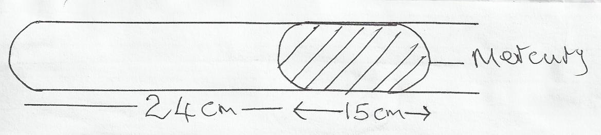

    - What is the length of the enclosed air column when the tube is vertical with the open end uppermost if the atmospheric pressure is 750mmHg? (2 marks)

    - What is the length of the enclosed air column when the tube is vertical with the closed end upper most if the atmospheric pressure is 750mmHg. (2 marks)

    - Explain why the mercury does not run out when the tube is vertical with the closed end uppermost. (1 mark)

  - Explain why an air bubble increase in volume as it rises from the bottom of a lake to the surface. (2 marks)

  - When an inflated balloon is placed in a refrigerator it is noted that its volume reduces, use the kinetic theory of gases to explain this observation. (2 marks)

  - A certain mass of hydrogen gas occupies a volume of 1.6m³ at a pressure of 1.5 x 10⁵ N/M² and a temperature of 27º C. Determine the volume when the temperature is 0º C at a pressure of 8.0 10⁴ N/M². (3 marks)

  - State the pressure law. (1 mark)

- a) State Archimedes principle. (1 mark)

b) A block of wood measuring 0.8m by 0.5m by 2m floats in water. 1.2m of the block is submerged.

    - Determine the weight of the water displaced. (2 marks)

    - Find the force required to just make the block fully submerged. (3 marks)

c) A block of glass of mass 250g floats in mercury. What volume of the glass lies under the surface
of mercury. (3 marks)

d) A piece of sealing wax, weight 3N in air and 0.22N when immersed in water, calculate the
density of the wax. (3 marks)

e) A balloon weighs 10N and has a gas capacity of 2m³. The gas in the balloon has a density of 0.1kg/m³.
If density of air is 1.3kgm⁻³, calculate the resultant force of the balloon when it is floating in air.
(3 marks)

- a) Distinguish between speed and velocity. (1 mark)

b) The figure below shows the motion of a ticker tape through a ticker timer whose frequency is
100Hz.
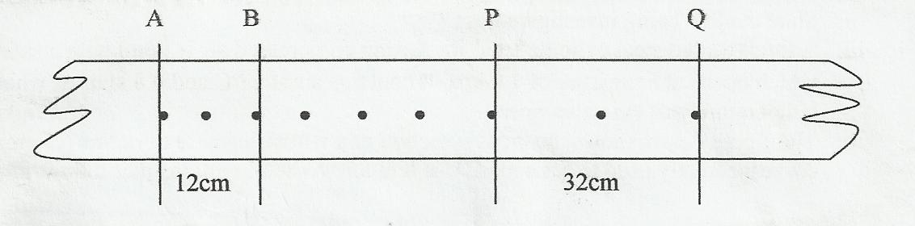

Determine
- Velocity at AB and PQ. (5 marks)

- Constant acceleration of the tape. (3 marks)

c) State Newton’s second law of motion. (1 mark)

