NAME ..................................................................... CLASS .........................ADM.NO. …………..…….
INDEX NO. ............................................................DATE ...............................SIGN………..………..
232/2
PHYSICS
PAPER 2
JUNE 2015

KASSU JET EXAMINATION - 2015
Kenya Certificate of Secondary Education
Physics Paper 2

INSTRUCTIONS TO CANDIDATES:
- Write your name, class, admission number and index number is the spaces provided above.
- Sign and write the date of examination in the spaces above.
- Answer ALL the questions in section A and B in the spaces provided.
- All working MUST be clearly shown.
- Non-programmable silent electronic calculators and KNEC mathematical tables may be used.
- This paper consists of 12 pages.
- Candidates should check the question paper to ascertain that ALL the pages are printed and that no questions are missing.

FOR EXAMINER’S USE ONLY.

SECTION | QUESTIONS | MAX. SCORE | CANDIDATE’S SCORE
A | 1 -13 | 25
B | 14 | 09
B | 15 | 12
B | 16 | 14
B | 17 | 11
 | 18 | 9
 | TOTAL | 80
SECTION A (25marks)
Attempt all the questions in the spaces provided.

1.The recording below shows the reading of a stop watch as seen through a plane
mirror. What was the actual reading time of the watch? (1mark)
18:81:80

2.State two conditions for generation of e.m.f from a magnet. (2marks)

3.A T.V tube is a modified cathode ray tube. State two modifications (2marks)

4.The figure below shows a wave profile for a wave whose frequency is 2 Hz.
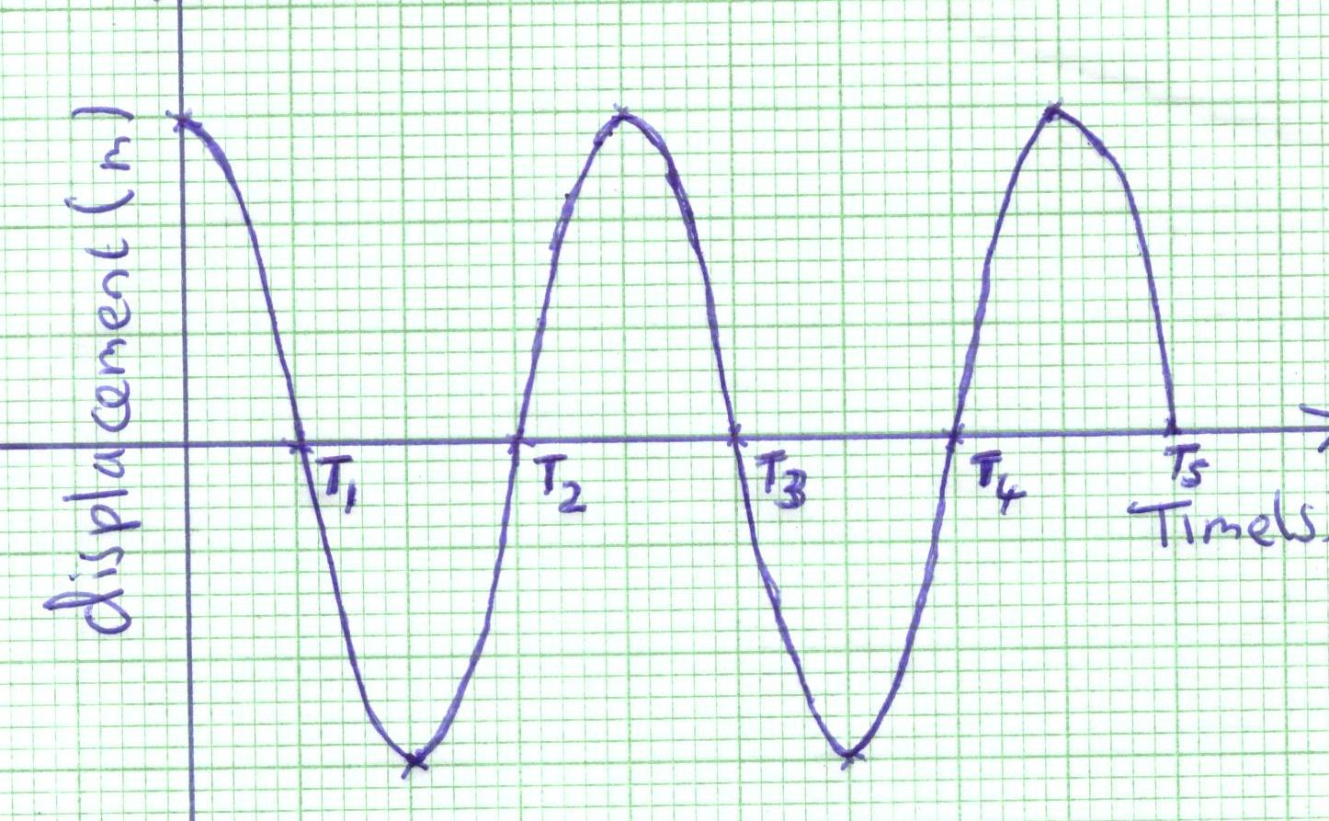

Determine the value of T4 (2marks)

5.What is meant by positive and negative sign convention as applied to curved mirrors. (1mark)

6.Explain why alternating current is preferred to direct current in power transmission. ( 1mark)

7.Distinguish between deviation and dispersion as used in light. (1mark)

8.Describe how the type of charge on a metal rod may be detected. ( 1mark)

9.Radon ²²⁴ Ra disintegrates with the emission of an alpha particle to form
⁸⁶
an element P. Show how this element may be represented. (2marks)

10.The figure below shows a circuit of three capacitors and a dc source of 12V.
C

10µF 15µF

A B
15µF

12V

Determine;
(a)Total capacitance (2marks)

(b) Total charge (1mark)

(c)Energy stored between A and B. (2marks)

11.What is the frequency of an alternating p.d which is applied to the Y- plate of the C.R.O and produce five complete waves covering 10 horizontal divisions on the screen when the time base setting is 10ms/div. (2marks)

12. Give two differences between sound waves and light waves. (2marks)

13.The figure below shows a wire AB of uniform cross-sectional area 0.2 mm ² and length 2m connected in a circuit as shown. Calculate the resistivity of the metal if the current flowing is 0.5A. (3marks)

5V

A B 5 Ω

SECTION B (55 MARKS)
Attempt ALL the questions in the spaces provided.

14 (a)The size and direction of an induced current can be predicted using two specific laws of an electromagnetic induction..State the law that governs the direction of an induced current. (1mark)

(b).The figure below shows a perfectly efficient transformer. The number of turns in the secondary coil S is six times that of the primary coil P.

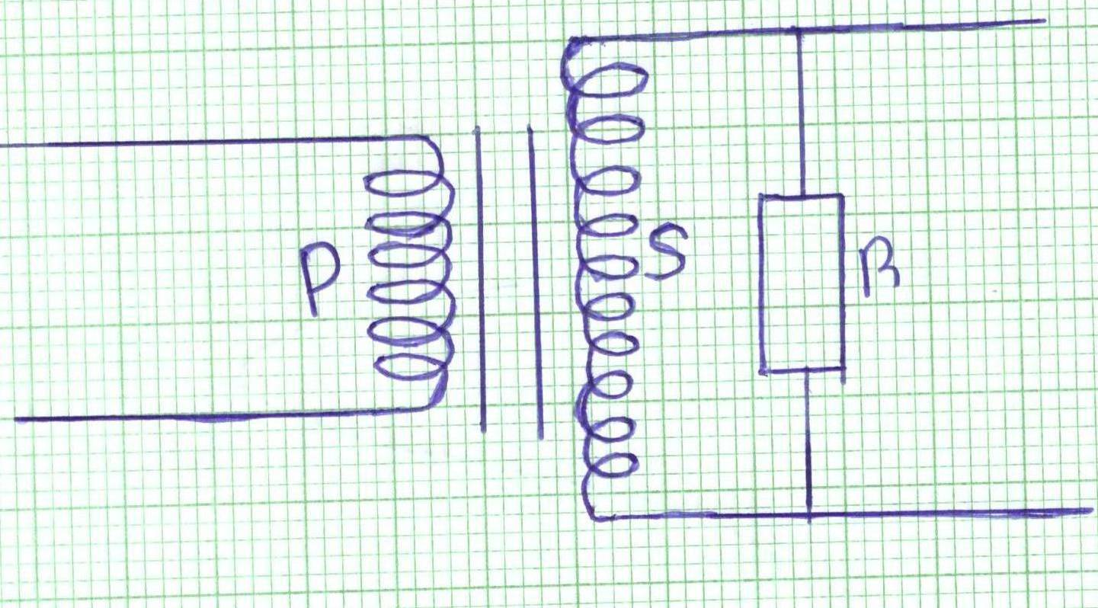
(i). Given that the supply voltage of 4 V a.c is operative across P, determine the p.d
across R. (3marks)

(ii) If the supply voltage of 4 V d.c is connected across P, state with reason what
happens to the voltage across R. (2 marks)

(c) A rectangular coil of wire is placed between the poles of a permanent magnet. What two factors determine the magnitude of the induced current if the coil is rotated? (2marks)

(d) State how a simple generator can be modified to produce a direct current. (1mark)

15 (a). The diagram below shows a convex lens with principal foci as shown. The Image I₁ of an object is as shown.

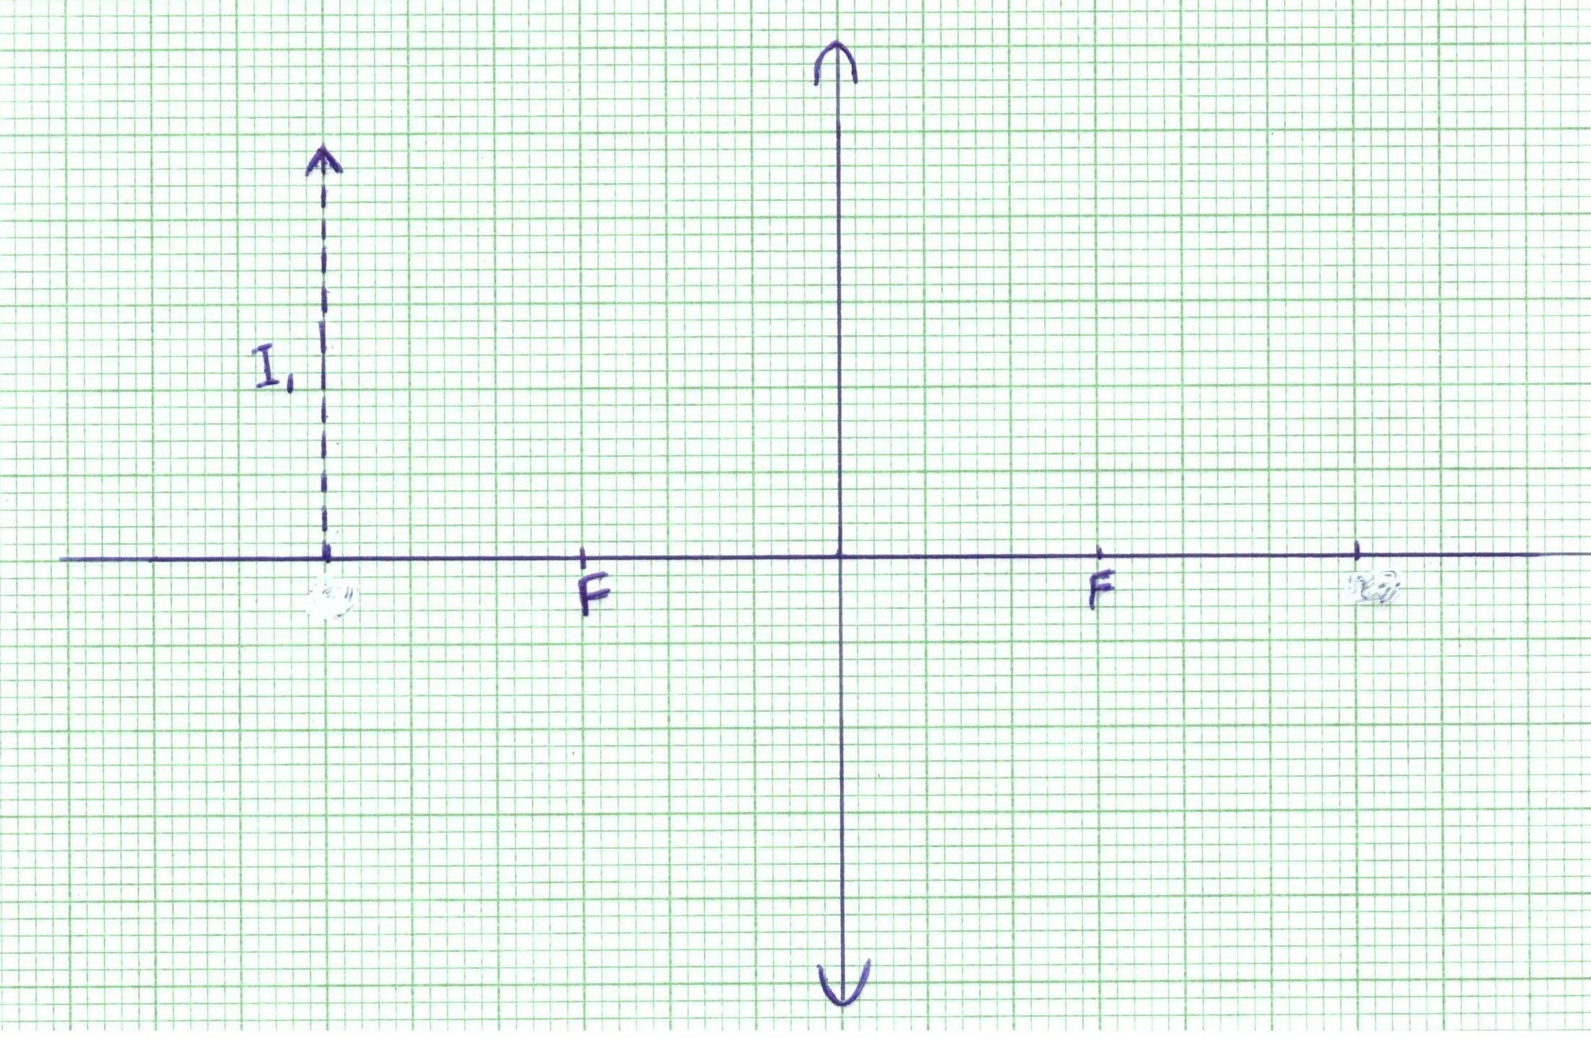

( i) Draw a ray to show the object of I₁ using a pencil. (3marks)

(ii)State two characteristics the object formed. (2 marks)

(b) The near point for a defective eye is found to be 40cm.What kind of lens is
needed to correct this defect. (1mark)

(c) The power of lens is defined as P = 1/f, where f is the focal length of the lens.
What happens to the power of the eye lens for the eye to be myopic?
(2 marks)

(d) The diagram below shows a ray passing into a triangular glass prism. n=1.5

60 ⁰

65 ⁰

- Determine the critical angle of the prism. (2 marks)

- What do you understand by the term critical angle? (1mark)

(ii) Indicate on the diagram the emergent ray after passing through the prism. (1 mark)

16.(i)Differentiate between thermionic emission and photoelectric effect. (1mark)

(ii) Explain how intensity of light affects photoelectric emission. (1mark)

(b) A cathode ray tube operates at 30kV and the current through is 2mA. Calculate:
(i) the rate at which heat is being removed. (2 marks)

(ii)The number of electrons striking the target per second.
(Take charge of an electron, e = 1.6x10 ⁻¹⁹ C ) (2marks)

(iii)The lower wavelengths limit of X- rays emitted. (2marks)
( Take c = 3.0x10 ⁸ m/s h = 6.63x10 ⁻³⁴Js)

( c). The graph below shows stopping potential against frequency in hertz.
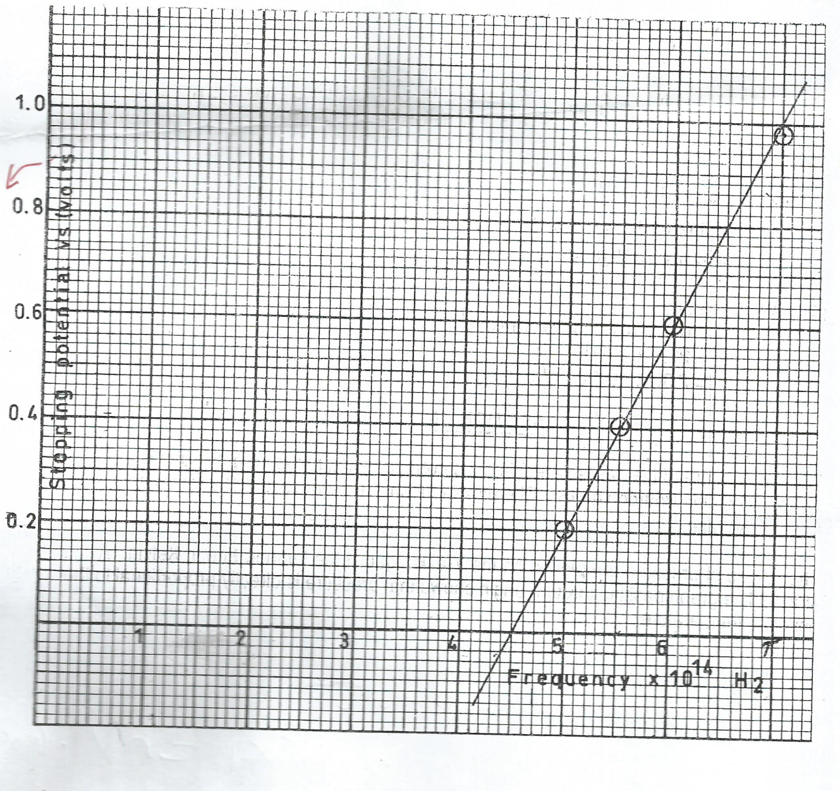

Using the graph, determine the following;

(i)Threshold wavelength. (2marks)

(ii)Planks constant. (2marks)

(iii)Work function in eV. (2marks)

17(a). Distinguish between forward and reverse bias of a P-N junction (1mark)

(b). A student set up two spheres P and R as shown in the diagram below. He brought a charged glass rod near the sphere R. He then touched sphere P with a finger, removed the finger, separated the spheres before removing the glass rod.

P Q R charged rod

What observation is made when;

- R is brought near the cap of a negatively charged electroscope. (1mark)

(ii)P is brought near the cap of a positively charged electroscope. (1mark)

(iii)A lit match stick is held above the cap of a positively charged electroscope. State and explain the observation made. (2marks)

(c).The diagram below is an electric circuit used to experiment a certain phenomenon in physics.

6V

V
mA

A B

C

(i)Name the phenomenon being investigated. (1mark)

(ii)Explain the process involved in the experiment. (3marks)

(iii). Sketch and label graphical representations of the results from the above experiment when current and voltage quantities are plotted against time on the same axes. (2marks)

I(mA) V(Volts)

time(s) time(s)

18.(a) The emf of a cell is 3.0 V. A current of 0.2 A flows across a 20 Ω resistor when the p.d between the ends is 2.5 V. Determine the internal resistance of the cell. (3marks)

(b) A domestic house has the following appliances;

- Three lighting bulbs each rated as 90 watts used for two hours per day.
- An electric iron box operated one hour twice per week rated 300 watts
- An electric cooker operated 4 hours daily rated 500 watts
- A tv set connected for 6 hours daily connected to 5 A, 240 V mains.
- An electric fan rated as 3 A, 220 V operating 30 minutes daily

Using the above information determine the cost of using electricity for 30 days if cost per unit is 0.50 cents, monthly standing charge of Ksh 3.75 and fuel levy of 0.25 cents per unit in addition are taxed. (4marks)

(c). In a domestic wiring circuit parallel arrangement of lighting bulbs is preferred to series connection although most consumers prefer series. Explain. (2marks)

